Corporate Plan 2023-24
Ambitious for Australia

CEO’s introduction
Austrade’s core purpose is to grow Australia’s prosperity and promote Australia on the global stage. We achieve this by helping Australian businesses to generate tangible commercial trade outcomes, facilitating high-quality international investment, boosting Australia’s visitor economy, and delivering commercial insights to inform government policy and deliver government programs.
In a globalised world, Australia’s economic growth, security and standard of living rely heavily on international trade, productive inbound investment, and the visitor economy.
International trade and capital markets continue to be affected by geopolitical tensions and economic uncertainty. However, the Australian economy has continued to demonstrate resilience and relative stability.
Austrade has an important role to play in supporting Australian businesses to take advantage of emerging opportunities and expand into new markets to achieve strong growth in exports and foreign direct investment. Our nation is strongly placed to grow and diversify both exports and inbound investment and we were pleased to welcome growing numbers of international visitors and students back to our shores.
As the Chief Executive Officer and accountable authority for the Australian Trade and Investment Commission, I am pleased to present the 2023–24 Austrade Corporate Plan, as required under paragraph 35(1) (b) of the Public Governance, Performance and Accountability Act 2013 (PGPA Act) and Part 7 of the Australian Trade and Investment Commission Act 1985 (the Austrade Act). As our primary planning document for the reporting period 2023-24 to 2026-27, it has been prepared in accordance with the requirements of the PGPA Act.
Our Corporate Plan sets out our strategy to support Australia to achieve strong commercial trade, investment and policy outcomes through high-quality client-focused services and programs, in line with the government’s key priorities: diversification, economic security, First Nations, net zero, the visitor economy and trade modernisation.
Trade and Investment: We will continue promoting and connecting Australian businesses to the world, accelerating the delivery of sustainable and diversified commercial results in both outbound trade and inbound investment. Austrade will expand inclusive trade and support the diversification of export markets, products and exporters, with a particular focus on assisting exporters to take advantage of net zero opportunities and attracting investment that helps facilitate Australia’s transition to net zero. We will also work with the international education sector to recapture and grow international student enrolments. The Export Market Development Grants program will continue to be refined, with the goal of supporting Australian exporters to develop and expand into offshore markets, as well as supporting simplified trade system reforms to reduce business costs for all exporters.
Promotion: Austrade will protect, enhance and evolve Australia’s reputation through the adoption of Australia’s Nation Brand and the delivery of effective campaigns aligned to key sectors and priority areas such as net zero and diversification. We will continue to amplify the success stories of diverse Australian exporters, with a key focus on First Nations businesses.
Visitor economy: Austrade continues to lead THRIVE (The Re-Imagined Visitor Economy) 2030 Revised, focused on returning Australia’s visitor economy to long-term sustainable growth. The strategy has been updated to reflect the government’s prioritisation of First Nations tourism, climate change and sustainability.
Consular services: Austrade delivers responsive and quality consular services, manages passport requests, and delivers in-person voting via our network of 11 offshore consular locations. Our resourceful, compassionate consular teams do invaluable work supporting Australians overseas.
Austrade succeeds by uniting passion with a keen commercial focus, informed by a large diversity of backgrounds, experiences and technical knowledge among our staff, who operate around the world as a single team.
Our ability to deliver relies on fostering strong and productive partnerships with businesses, industry and peak bodies, other Australian Public Service departments and agencies, and state and territory governments. It is underpinned by our enabling functions who support our global team of professionals and enable us to maximise our impact and return on investment for government.
I am grateful to Austrade’s staff for their continued enthusiasm and tenacity as we work together to deliver for Australia.

Xavier Simonet
Chief Executive Officer

Our purpose
We deliver quality trade and investment services to businesses and policy advice to government to grow Australia’s prosperity.

Summary

Our purpose
We deliver quality trade and investment services to businesses and policy advice to government to grow Australia’s prosperity.

Our operating context
Australia’s trade and investment outlook, and Austrade’s operating environment, will be shaped by:
- geopolitical tensions and inflationary pressures
- capitalising on key opportunities, including diversification and net zero
- maintaining economic stability and resilience.

Our outcomes and key activities
To achieve our purpose, Austrade has two core outcomes (set out in the 2023–24 Portfolio Budget Statements and detailed on page 13) and five key activities:

Outcomes
Outcome 1:
Contribute to Australia’s economic prosperity by supporting Australian exporters to expand internationally, attracting productive international investment, and growing the visitor economy
Outcome 2:
The protection and welfare of Australians abroad though timely and responsive consular and passport services in specific locations overseas

Key Activities
- Trade
- Investment
- Promotion
- Policy
- Consular and Passport Services

Whole-of-government priorities
Austrade’s activities are underpinned by our contribution to whole-of-government priorities, including:
- Diversification: Broadening trade and investment across markets, sectors and business-types
- Net zero: Supporting Australia’s decarbonisation transition
- Economic security: Deepening our strategic relationships and economic resilience
- First Nations: Supporting equitable economic ownership and growth for First Nations businesses and communities
- Visitor economy: Returning the visitor economy to long-term sustainable growth
- Trade modernisation: Improving cross-border trade and digital services.

Our capabilities
We are focused on ensuring our people have the right skills and support. Our priorities are:
- people and leadership
- improving efficiency by streamlining processes
- technology for collaboration
- diversity, inclusion, wellbeing and safety
- building on our environmental, social and governance (ESG) credentials.
We will continue to deliver through our international network of 67 offshore locations and leverage our strong partnerships and networks.

Our locations

Worldwide
- 108 locations worldwide
- 66 locations outside Australia
- 11 locations outside Australia provide consular services
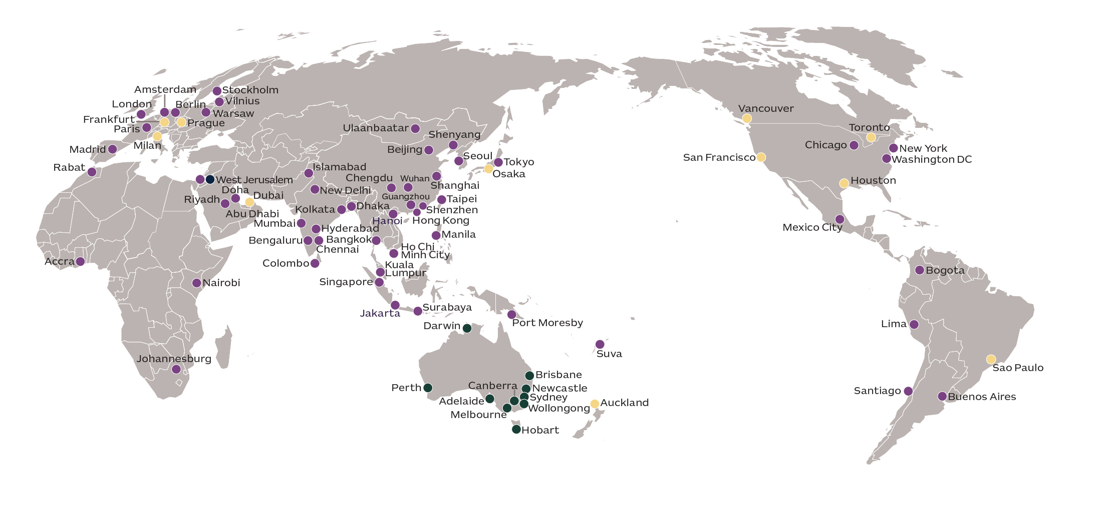

Australia
- 8 Australian offices
- 32 TradeStart offices
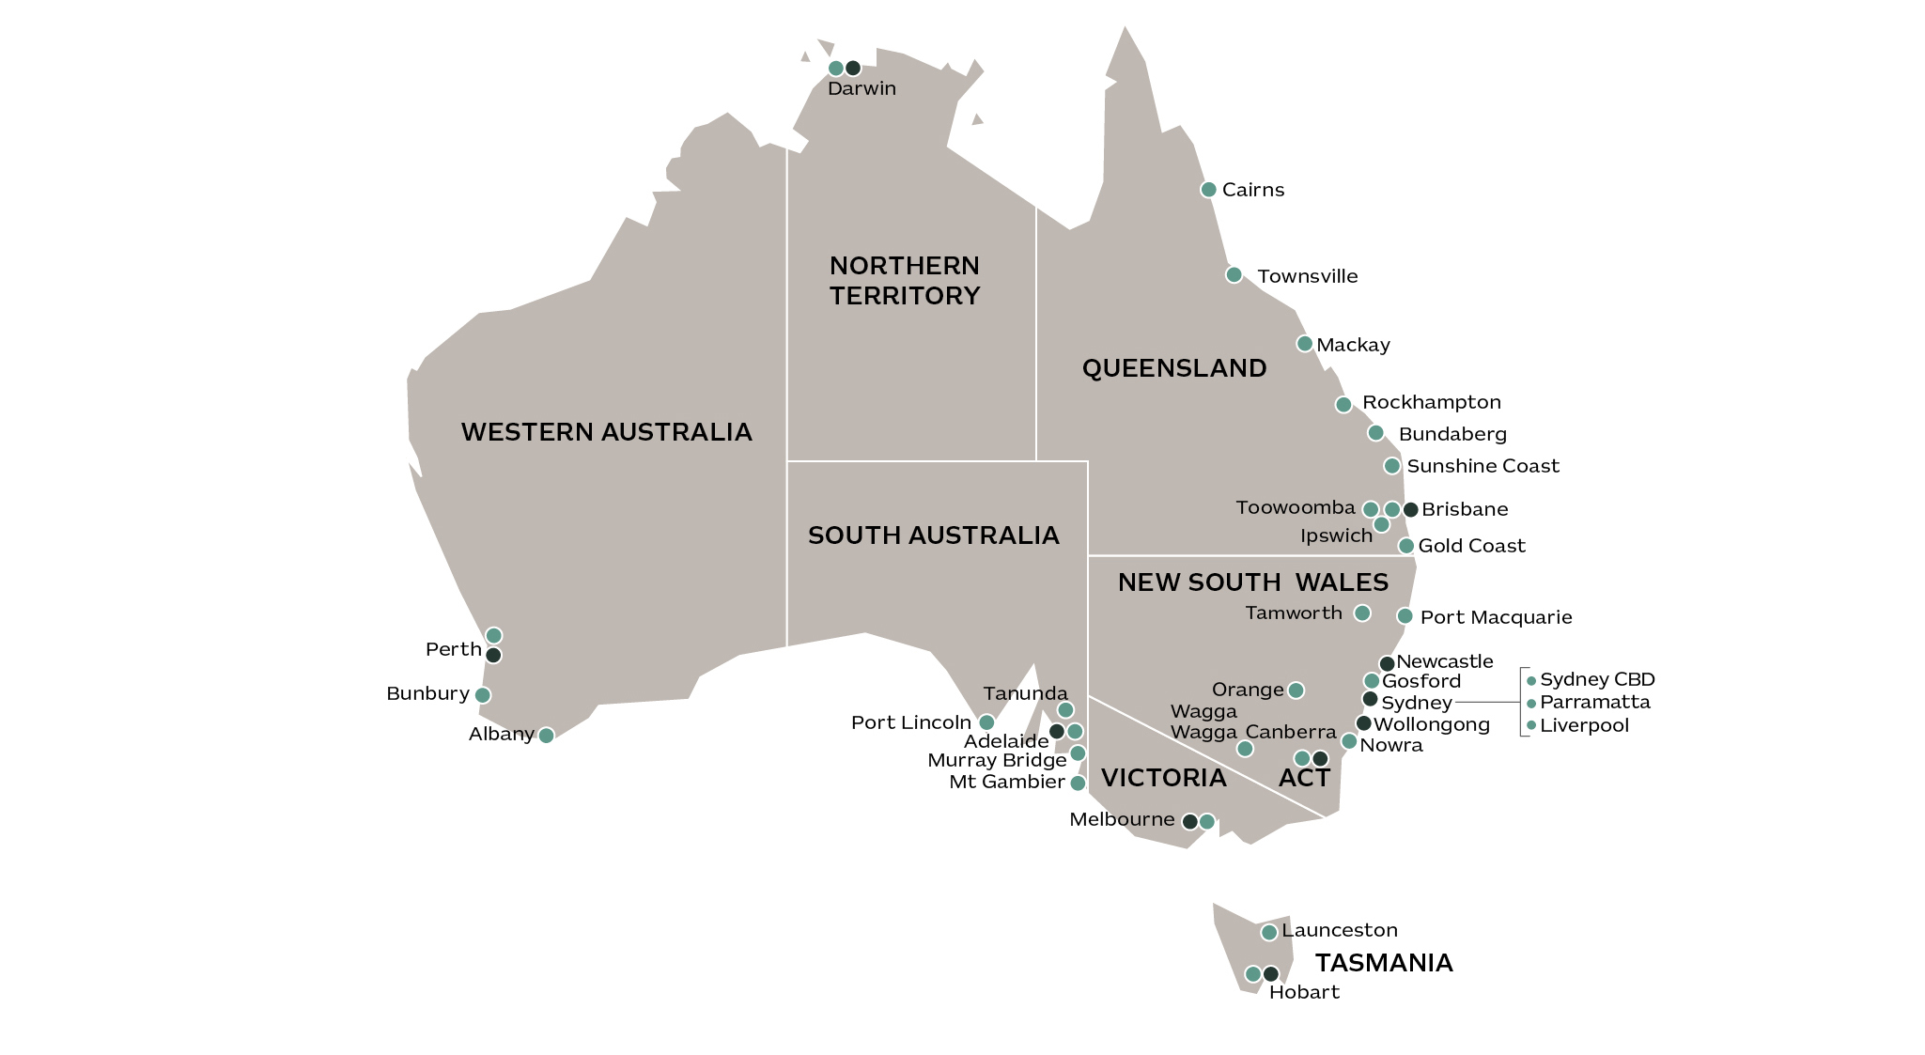

Our operating context
While financial system risks and monetary tightening continue to impact the global economic outlook, Australia is well-positioned to navigate these challenges by capitalising on growth in emerging Asian markets. Due to our relative economic stability and low unemployment, Australia remains an attractive destination for international students, tourists, investors, and businesses. Austrade will continue to support Australian businesses to grow internationally through diversification opportunities and to navigate geopolitical tensions and other emerging trends.

The global economy continues to face geopolitical and monetary policy challenges
The global trading environment continues to be challenged by geopolitical tensions and tighter financial conditions, with some major economies at risk of recession or low economic growth over the next year.
According to the International Monetary Fund (IMF), advanced economies are likely to experience an average growth rate of 1.6% over the next five years, compared with the average rate of 1.9% between 2011 and 2019. The global economy is also predicted to slowdown, with the IMF forecasting an average growth rate of 3.0% between 2023 and 2028.
Austrade is continuing to monitor and respond to a changing and uncertain global landscape and to support our clients accordingly. Businesses are also facing challenges around access to skills and labour shortages in certain sectors as they plan for future expansion.
Austrade’s role in providing quality trade and investment support to business remains our core purpose. Austrade is increasing our support for business to capture opportunities for Australia. Key initiatives include:
- supporting more high-impact exporters to expand into new markets
- facilitating high-quality international investment and developing an outward investment service focused on key diversification markets
- aligning global marketing initiatives to maximise value to Australian exporters.

Australia’s economy remains resilient
Australian businesses continue to demonstrate their resilience through their flexibility in adapting business models, transforming processes, and expanding into new markets.
In Australia, inflation is moderating as global price shocks and supply constraints continue to ease and is expected to return to the target rate of 2-3% by 2024-25.
While many major economies are at risk of recession in 2023, the International Monetary Fund (IMF) has forecast that the Australian economy will continue to grow at a rate of 1.6% in 2023 and at a rate of 1.5% in 2024. Securing Australia’s economic prosperity will require Australia to capitalise on the prosperity of our major trading partners and growth bright spots in emerging Asian markets such as Vietnam (5.8%), India (5.9%), Indonesia (5.0%), and the Philippines (6.0%)¹.

Capitalising on key opportunities
To achieve strong growth in exports and foreign direct investment, Austrade’s role is to anticipate changes in the global economy and support businesses to take advantage of emerging commercial opportunities.
Our focus areas for the reporting period include:

Diversifying trade and investment sectors, markets, and clients
A diversified economy that harnesses Australian ingenuity will help build our resilience to future geopolitical and economic shifts. This includes diversifying export destinations, products and clients.
Austrade is helping Australian businesses diversify their overseas markets, positioning the Indo-Pacific as a region of choice for Australian exporters due to market access, strengthened strategic ties and cultural links with Asia. Rapid economic development in the Indo-Pacific is creating significant opportunities for Australian exporters in key growth markets such as Indonesia, Vietnam and in India, where Austrade’s Australia India Business Exchange (AIBX) is focused on growing trade outcomes.
Austrade is also focused on expanding our client base to be more inclusive of First Nations and small and medium enterprises (SMEs). We are also boosting support for regional businesses through Austrade’s TradeStart network.

Building on Australia’s trade agreements by deepening strategic relationships
Australia has 18 free trade agreements (FTAs) currently in force, including multiple regional trade agreements in the Asia-Pacific region. Trade agreements continue to present significant future opportunities for Australian businesses.
Austrade will continue to work with our clients to unlock opportunities and realise the benefits from FTAs, including through the Australia-United Kingdom Free Trade Agreement (A-UKFTA), the Australia-India Economic Cooperation and Trade Agreement (AI-ECTA), and the Australia-European Union Free Trade Agreement currently under negotiation.
We also contribute to whole-of-government efforts to deepen strategic relationships through our participation in the Southeast Asia Economic Strategy to 2040, Pacific Strategy, QUAD and AUKUS initiatives.

Net Zero
The Australian economy is well positioned to take advantage of the global transition towards net zero and to capitalise on changing customer and investor expectations and emerging opportunities presented by new technologies. This activity will be spurred further by an additional $4bn investment by the Federal Government in the 2023-24 Budget to assist with Australia’s transformation into a renewable energy superpower to meet the legislated target of net zero by 2050.
Austrade’s investment teams will play a key role in attracting close to $30bn of net zero aligned investment over the next five years, positioning Australia as a global destination of choice. Austrade’s clients are already achieving successes in commercialising new net zero technologies and realising export opportunities.
First Nations
Austrade is undertaking a broad range of initiatives to create opportunities for First Nations people and businesses. Austrade is working with partners such as Supply Nation and other Indigenous Business Chambers to support First Nations businesses. In 2023, Austrade also launched its third Innovate Reconciliation Action Plan (RAP), endorsed by Reconciliation Australia.
Austrade is prioritising increasing our engagement with more of the ~4,000 First Nations businesses operating across Australia by targeting export support to these businesses. Austrade’s THRIVE 2030 Revised strategy also has a key focus on increasing the participation and success of First Nations businesses across the visitor economy.
Visitor Economy
The pace of recovery of Australia’s visitor economy following the COVID-19 pandemic is increasing but remains uneven across sub-areas. Domestic tourism has led the sector’s recovery to date, and Tourism Research Australia (TRA) forecasts that international spend will return to pre-pandemic levels in 2024, with yearly visitor arrivals expected to total 11.0 million by 2027. In the international education sector, one of Australia’s major services exports, the year-to-date count of international students in Australia reached over 546,000 in February 2023. This number is forecast to grow in future years to surpass the peak student count of 582,712 international students in 2020.
Much has already been achieved since THRIVE 2030 was launched, with the aim of returning visitor economy expenditure to 2019 levels by 2024 and expanding expenditure to $230bn by 2030. As the visitor economy continues to recover, Austrade will work with our government and industry partners to lead and support the implementation of ‘THRIVE 2030 Revised: The Re-Imagined Visitor Economy’ strategy, focused on building the tourism workforce and business capability, refreshing infrastructure, supporting the development and growth of First Nations tourism, and enabling the transition to a net zero visitor economy.
Trade Modernisation
Austrade is improving how Australian businesses export through the simplification of cross-border trade and enhanced digital trade services such as the GoGlobal Toolkit. Supporting the implementation of simplified trade system reforms, including streamlined cross-border regulations and government processes, will reduce the cost of exporting and allow more businesses to expand internationally.

Our key activities

Overview
To achieve our purpose, we will pursue two outcomes through five key activities. These activities are underpinned by whole-of-government strategic priorities and will be shaped by emerging trends in our operating context.

Outcomes
Outcome 1:
Contribute to Australia’s economic prosperity by supporting Australian exporters to expand internationally, attracting productive international investment, and growing the visitor economy.
Outcome 2:
The protection and welfare of Australians abroad though timely and responsive consular and passport services in specific locations overseas.

Key Activities
            - Trade
            - Investment
            - Promotion
            - Policy
            - Consular and Passport Services

Key activities

Key activity 1: Trade
Supporting Australian businesses to expand, through trade advice, connections and support, and program support.

Key initiatives:
1.1 Accelerate the growth and diversification of Australia’s exports by targeting and servicing more high potential exporters with bespoke support.
1.2 Deepen trade relationships with key economic partners to promote opportunities for Australian exporters in Southeast Asian markets, maximise the value of existing and new international trade agreements with India, the UK and the EU, and support infrastructure development in the Pacific through targeted support.
1.3 Support exporters to take advantage of net zero opportunities by partnering with industry bodies to increase awareness of export opportunities, building staff net zero capability through training, and developing net zero content to increase awareness of green export opportunities.
1.4 Broaden our export base and expand inclusive trade through targeted support and export initiatives for First Nations businesses, and for regional businesses through the TradeStart network.
1.5 Implement and administer the Export Market Development Grant (EMDG) program through leading policy development and assessing program requirements and supporting first time recipients to increase their chances of export success.
1.6 Through the Simplified Trade System Taskforce, reduce exporting costs for businesses by working across government and engaging with business to co-design regulatory, process and digital reforms that simplify Australia’s cross-border trade environment.

Key activity 2: Investment
Facilitating high-quality international investment.

Key initiatives:
2.1 Continue to focus on performance through enhanced collaboration, deepened engagement across government, and with international investment promotion agencies to build capability and maximise Austrade’s impact.
2.2 Facilitate Australia’s transition to net zero by prioritising renewable and low carbon energy sources, products, processes and technologies, supporting policy development and positioning Australia as a destination of choice for net zero aligned investment.
2.3 Diversify sectors and markets by proactively targeting FDI and reinvestment to market gaps and opportunities, including those aligned to future-focused industries, critical technologies and the digital economy, and key diversification regions such as the Indo-Pacific.
2.4 Support outward investment by developing capability to deliver an outward investment service focused on delivering outcomes in the Indo-Pacific region to align with the Government’s strategic priorities.
2.5 Collaborate across government to understand First Nations opportunities and perspectives related to foreign investment and identify opportunities to support First Nations’ needs within priority subsectors, e.g. digital health.

Key activity 3: Promotion
Conducting global marketing and promotion to create brand awareness, generate demand and support conversion of leads for trade, investment and international education.

Key initiatives:
3.1 Strengthen and evolve Australia’s nation brand to enable a coherent approach across government and business through driving the adoption and use of Australia’s Nation Brand by government and industry and delivering effective campaigns on sectors aligned to government priorities. We will promote inclusive trade initiatives and recognise businesses through the Australian Export Awards.
3.2 Protect and enhance Australia’s reputation through developing evidence-based thought leadership on First Nations exporters, trade diversification and promoting compelling content on digital channels to reach and engage the right audiences.
3.3 Maximise the impact of marketing activities by aligning marketing initiatives globally, embedding cost sharing and leveraging partnerships to support promotion activities, and measuring the impact of our marketing campaigns to better target our limited resources.

Key activity 4: Policy
Leading national visitor economy policy development and implementation, and using Austrade’s global and commercial perspectives to contribute to policy advice to Government on trade and investment.

Key initiatives:
4.1 Contribute to trade and investment diversification, and promoting inclusive trade through strategic policy contributions to the trade diversification strategy, Trade 2040 Taskforce and the First Nations trade and investment strategy.
4.2 Harness business to enhance Australia’s economic security through deepened strategic relationships through the Southeast Asia Economic Strategy to 2040, Pacific strategies, supporting QUAD and AUKUS initiatives, and engaging on whole-of-government efforts to address economic security and encourage sovereign capability.
4.3 Support the government’s net zero agenda through contributions to the green economy trade and investment strategy, climate change policies, and international agreements (e.g. the Singapore Australia Green Economy Agreement).
4.4 Build a visitor economy to achieve sustainable growth by leading national visitor economy policy under the THRIVE 2030 long-term tourism strategy, focusing on key policy areas, and driving collaborative stakeholder engagement. Tourism Research Australia (TRA) to produce impactful tourism statistics.
4.5 Lead the development of a visitor economy sustainability framework that embeds green economy, net zero and other environmental practices into visitor economy products, experiences, and processes.
4.6 Support the visitor economy to diversify through a diversification strategy focused on new markets, products and experiences, supporting unique First Nations tourism experiences, and delivering a First Nations visitor economy partnership.

Key activity 5: Consular and Passport Services
Austrade has designated consular management responsibilities in 11 overseas locations across 9 countries. Austrade will continue to place a high priority on helping Australians through the delivery of effective consular services, efficient passport services and practical contingency planning, in accordance with DFAT’s Consular Services and Passports Client Services charter.

Key initiatives:
5.1 Deliver responsive and high-quality consular services to Australian travellers and citizens living overseas, including notarial services, assistance with welfare issues, whereabouts enquiries, arrest or detention matters, deaths and medical emergencies.
5.2 Manage passport requests efficiently, including processing new passport applications, registering lost or stolen passports, issuing emergency passports and detecting passport fraud.
5.3 Deliver in-person voting at all Consular Posts for registered Australians for the 2023 Federal Referendum on an Aboriginal and Torres Strait Islander Voice to Parliament.

Our capabilities
Austrade is committed to building our capability, strengthening our Environmental, Social and Governance (ESG) credentials, and supporting our team of world-leading professionals, to ensure we deliver for our clients and for Australia.

Building our capability
Austrade’s core capabilities are our team’s skills, knowledge, networks, geographic footprint and the systems underpinning how we work. To continue enabling our team to deliver commercial outcomes and support the resilience and growth of Australia’s economy, our capability focus areas for 2023-24 are:
- people and leadership
- improving efficiency by streamlining processes
- technology for collaboration
- diversity, inclusion, wellbeing and safety
- building on our ESG credentials.

1. People and leadership – We will continue to focus on supporting our people and leadership team through workshops on prioritising employee wellbeing and delivering training on emerging trade and investment trends. We will expand the Austrade Graduate Program to build future focused skills in areas aligned to our organisational strategy.
2. Improving efficiency by streamlining processes – We will undertake a series of projects to simplify our corporate service processes, streamline onboarding, and improve self-service options. We will match available resources to priority areas to ensure our infrastructure and delivery model meet our needs.
3. Technology for collaboration – We will upgrade network performance globally and simplify digital communication channels to enable our people to support clients and collaborate across locations, sectors, and teams with ease.
4. Diversity, inclusion, wellbeing and safety – We will continue to embed Austrade’s BRAVE (Belonging, Reputation, Accountability, Values & Behaviours, Equity) Diversity and Inclusion Strategy through increased membership of employee Diversity and Inclusion networks and an agency-wide plan. We will also build on Austrade’s Wellbeing Strategy with a program of targeted wellbeing and mental health literacy initiatives that prioritise the health, wellbeing, and safety of our staff.
5. Building on our ESG credentials – We will harness our relationships and key activities set out in the Innovate Reconciliation Action Plan to create more opportunities for the international growth and success of First Nations businesses. This includes developing a cultural learning strategy and delivering organisation-wide cultural awareness training, as well as delivering education and engagement activities linked to Reconciliation and National Aborigines and Islanders Day Observance Committee (NAIDOC) week events.
To deliver on the government’s net zero agenda, we will meet and exceed the 2030 Australian Public Service (APS) Net Zero Government Initiative targets through our involvement in the reporting pilot, with a focus on reducing office energy, waste and water usage, and offsetting emissions from travel.

Delivering through our international network
Austrade’s international network is key to our success.
Austrade will continue to support our people overseas and promote alignment of our offshore footprint with sector priorities, with the aim of continuing our high-performance and exceeding Austrade’s performance targets.

Our partnerships and networks
Austrade maintains a focus on collaboration and information sharing with our portfolio partners, state and territory governments, industry networks and other government agencies.
The Senior Official Trade and Investment Group (SOTIG), National Trade Forum (NTF) and National Investment Forum (NIF) act as mechanisms for engagement between Federal and State and Territory governments to drive a co-ordinated approach on the practical operations of delivering whole-of-government trade and investment priorities across Australia.
Across the visitor economy, the Australian Standing Committee on Tourism (ASCOT) promotes cooperation and coordination of government policies and activities related to THRIVE 2030 and other tourism matters.
1. Portfolio Partners
- Department of Foreign Affairs and Trade
- Tourism Australia
- Export Finance Australia.
2. State and Territory Governments
3. Industry Networks and Non-Government Organisations
4. Other Government Agencies
- Department of Infrastructure, Transport, Regional Development, Communication and the Arts
- Department of Defence
- Department of Agriculture, Fisheries and Forestry
- Department of Education
- Department of Industry, Science and Resources
- Department of Climate Change, Energy, the Environment and Water.
Industry
Networks and
Non-Government Organisations
State and Territory Governments
Other Government
Agencies
Portfolio
Partners
Austrade

Performance
Austrade’s performance planning and targets enable us to monitor our impact over the four-year life of this plan.
Austrade’s planning process comprises the Portfolio Budget Statements, the Austrade Act and the Public Governance, Performance and Accountability (PGPA) Act.
We have developed performance measures for our key activities, including a balance between quantitative and qualitative components. Our performance measures aim to ensure Austrade delivers on our outcomes. We report on our performance in the Annual Performance Statements, contained in the Austrade Annual Report.

Outcome 1: To contribute to Australia’s economic prosperity by supporting Australian exporters to expand internationally, attracting productive international investment, and growing the visitor economy.

Trade
This activity aims to support Australian businesses to expand through trade facilitation, program support and the promotion of our capabilities
Performance  measures | Targets |  |  |  | Source
 | 2023–24 | 2024–25 | 2025–26 | 2026–27
High level of satisfaction for Austrade’s clients with Austrade’s services | At least 85 per cent |  |  |  | Survey
Number of trade outcomes facilitated | At least 1200 outcomes | At least 1200 outcomes | At least 1200 outcomes | At least 1200 outcomes | Customer Relationship Management (CRM) system entry from client notification
EMDG recipients report that the receipt of a grant encouraged them to increase their export promotion activities | At least 70 per cent of EMDG recipients to report that receiving a grant encouraged them to increase their export promotion activities |  |  |  | Survey

Investment
This activity aims to attract inbound investment through the promotion and facilitation of high-value opportunities.
Performance  measure | Targets |  |  |  | Source
 | 2023–24 | 2024–25 | 2025–26 | 2026–27
Number of investment outcomes facilitated | At least  110 investment outcomes | At least 120 investment outcomes | At least 120 investment outcomes | At least 120 investment outcomes | CRM from investor notification

Policy
This activity aims to lead visitor economy policy development and use Austrade’s global and commercial perspectives to contribute to policy advice to Government on trade and investment.
Performance  measure | Targets |  |  |  | Source
 | 2023–24 | 2024–25 | 2025–26 | 2026–27
Effective contribution to whole-of-government policy development including using Austrade’s commercial insights | Net zero, strategic relationships  in the  Indo-Pacific,  and visitor economy | Focus areas to be determined before the beginning of each year |  |  | Internal  assessment  and case  studies  where appropriate

Outcome 2: The protection and welfare of Australians abroad through timely and responsive consular and passport services in specific locations overseas.

Consular and passport services
This activity aims to ensure that Austrade provides consular and passport services in designated locations where the Department of Foreign Affairs and Trade (DFAT) is not present.
Performance  measure | Targets |  |  |  | Source
 | 2023–24 | 2024–25 | 2025–26 | 2026–27
Effective delivery of consular and passport services to Australians overseas | At least 97 per cent of passports processed by Austrade are without administrative errors |  |  |  | DFAT Passport and Consular Information System databases

Governance and key agency risks

Governance
Austrade’s governance arrangements are designed to foster effective leadership and collaboration to support the delivery of our strategic organisational and government priorities.
Austrade’s Governance Committee Structure, at 30 June 2023
Minister for Trade
and Tourism

Chief Executive Officer
Executive Committee
Audit and Risk Committee

Enterprise risk framework
Our robust risk management ensures that Austrade can anticipate and respond effectively to challenges. Austrade’s Enterprise Risk Management Framework and Policy are in line with the expectations of the Commonwealth Risk Management Policy.
Austrade operates a strong internal risk management framework and conducts risk management planning to support oversight through the Audit and Risk Committee. Austrade’s risk management and reporting framework includes establishing risk context, undertaking risk assessment, setting risk tolerances and determining key enterprise risk focus areas.

Our key strategic risks and mitigations
Enterprise Risks
- Austrade service strategies and policy advice do not align with the needs or expectations of Australian businesses, international investors, Government, key stakeholders and Australian citizens.
- Austrade fails to rapidly align resources and staff capabilities to support strategic priorities and key deliverables.
- Austrade’s management of operations including governance, business continuity, planning, risk management, financial management and staff capability is not fit for purpose.
- Austrade does not balance the use of digital tools with appropriately managing personal and Government information, whilst meeting mandatory government cyber security or information management requirements.
- Austrade’s operations and activities do not meet legal and regulatory obligations or standards.
- Austrade’s internal culture and behaviour do not align with organisational values, foster ethical behaviour, or support the attraction and retention of suitably skilled staff.
- Austrade fails to protect the health, safety and wellbeing of staff, contractors, those requiring Consular assistance or other visitors to our offices.
- Austrade fails to adequately protect staff or visitors from security threats at our work locations.

Mitigation Strategies
- Building a positive work culture through Australian Public Service Values, Code of Conduct and Austrade Values
- Ongoing oversight by the CEO and Executive Committee
- Independent advice from the Audit and Risk Committee
- Regular financial and performance reporting
- Application of risk management, auditing, and reviews
- Close engagement with our clients and stakeholders to support the design and delivery of services
- Effective Governance, Security, Work, Health and Safety, Capability and Leadership frameworks, with policies and procedures that support the delivery of operations and compliance with legislative and administrative requirements.
Acknowledgement of Country
In the spirit of reconciliation, Austrade acknowledges the Traditional Custodians of country throughout Australia and their connections to land, sea and community. We pay our respect to their Elders past and present and extend that respect to all Aboriginal and Torres Strait Islander peoples today.
Disclaimer
This document has been prepared by the Commonwealth of Australia represented by the Australian Trade and Investment Commission (Austrade). All dollar amounts included refer to Australian Dollars (AUD) unless otherwise stated.
Austrade has exercised due care and skill in preparing and compiling the information and data in this document. Austrade, its employees and advisers disclaim all liability, including liability for negligence and for any loss, damage, injury, expense or cost incurred by any person as a result of accessing, using or relying on any of the information or data in this document to the maximum extent permitted by law.
Austrade recommends the person exercise their own skill and care, including obtaining professional advice, in relation to their use of the information in this document for their purposes. The Australian Government does not endorse any company or activity referred to in the document and does not accept responsibility for any losses suffered in connection with any company or its activities.
Copyright © Commonwealth of Australia 2023
The material in this document is licensed under a Creative Commons Attribution – 4.0 International licence (CC BY licence), except for:
- any third-party material
- any material protected by a trademark
- any images and photographs.
More information on this CC BY licence is set out at the creative commons website: https://creativecommons.org/licenses/by/4.0/legalcode.

Attribution
Before reusing any part of this document, including reproduction, public display, public performance, distribution, dissemination, communication, or importation, you must comply with the Attribution requirements under the CC BY licence. Enquiries about this licence and any use of this document can be sent to: advisory@austrade.gov.au.

Using the Commonwealth Coat of Arms
The terms of use for the Coat of Arms are available from the It’s an Honour website (www.itsanhonour.gov.au).

Publication date: August 2023

IMF World Economic Outlook, April 2023
From 2023-24 onwards, Austrade is planning to better align the methodology of the customer satisfaction measure to include only those clients who received Austrade’s services (as opposed to those applying for grants or participating in lapsing programs). To assist with comparability over time, this change will be clearly outlined in Austrade’s 2023-24 Annual Performance Statement.
Austrade has increased our trade outcome targets to reflect our improved performance in 2022-23 and changes to our methodology.

