

Corporate Plan 2024-25

Ambitious for Australia

# CEO’s introduction

Austrade’s core purpose is to grow Australia’s prosperity and promote Australia on the global stage. We achieve this by helping Australian businesses to generate tangible commercial trade outcomes, facilitating high-quality international investment, boosting Australia’s visitor economy, and delivering commercial insights to inform government policy and deliver government programs.

Australia’s economic growth, security and standard of living rely heavily on international trade, productive inbound investment, and the visitor economy.

International trade and capital markets continue to be affected by geopolitical tensions, economic uncertainty, and intensifying competition. However, the Australian economy is resilient.

Austrade supports Australian businesses to take advantage of emerging international opportunities and expand into new markets to achieve strong growth in exports and foreign direct investment. Our nation is well placed to grow and diversify both exports and inbound investment and continue welcoming international visitors and students to our shores to foster a sustainable visitor economy.

As the Chief Executive Officer and accountable authority for the Australian Trade and Investment Commission, I am pleased to present the 2024–25 Austrade Corporate Plan, as required under paragraph 35(1) (b) of the *Public Governance, Performance and Accountability Act 2013* (PGPA Act) and Part 7 of the Australian Trade and Investment Commission Act 1985 (the Austrade Act). As our primary planning document for the reporting period 2024-25 to 2027-28, it has been prepared in accordance with the requirements of the PGPA Act.

Our Corporate Plan sets out Austrade’s strategy to support Australia to achieve strong trade, investment and policy outcomes through high-quality client-focused services and programs, in line with the government’s key priorities such as: diversification, economic security, First Nations, net zero, the visitor economy and trade modernisation. We move into 2024-25 strongly focused on delivering on core priorities and functions outlined in this plan, having streamlined our operations following the end of pandemic-related programs.

**Trade and Investment:** Austrade will continue supporting businesses to expand internationally to deliver sustainable commercial results for Australia. We will focus on accelerating the growth and diversification of exports in priority industry sectors via new programs and networks, including assisting exporters to take advantage of opportunities in the green economy. Austrade will extend our targeted support, programs and partnerships in support of First Nations businesses, and implement the Export Market Development Grant (EMDG) Strategic Refocus to deliver impactful grants to high-quality exporters. Our investment team will continue to prioritise projects of strategic importance to Australia, contributing to the ‘future made in Australia’ by attracting and facilitating investment opportunities that support Australia’s industrial capability and deliver on our net zero commitments and renewable energy. We will also strengthen our economic security by enabling trade and investment via the Southeast Asia Investment Deal Teams.

**Promotion:** Austrade will protect, enhance and evolve Australia’s reputation, leveraging Australia’s Nation Brand to showcase Australia’s sovereign capabilities and deliver effective campaigns aligned to priority areas such as diversification and the net zero transformation. We will continue to amplify the success stories of diverse Australian exporters, with a key focus on stories of First Nations businesses succeeding in strategic markets and sectors.

**Visitor economy:** Austrade will continue to lead THRIVE (The Re-Imagined Visitor Economy) 2030 Revised, focused on returning Australia’s visitor economy to long-term sustainable growth. A vision, targets and action plan for Phase 2 of the Strategy will be developed in 2024-25, with a focus on supporting the growth of First Nations tourism and promoting sustainable, green and net zero practices across the visitor economy.

**Consular services:** Austrade will continue to deliver responsive and appropriate consular services, manage passport requests, and deliver in-person voting via our network of 11 offshore consular locations. Our resourceful, compassionate consular teams do invaluable work supporting Australians overseas.

Austrade succeeds by uniting passion with a keen commercial focus, informed by a large diversity of backgrounds, experiences and technical knowledge among our staff, who operate around the world as a single team.

Our ability to deliver relies on fostering strong and productive partnerships with businesses, industry and peak bodies, other Australian Public Service departments and agencies, and state and territory governments. It is underpinned by our enabling functions who support our global team of professionals and enable us to maximise our impact and return on investment for government.

I remain grateful to Austrade’s staff for their dynamism and clear sense of purpose as we continue to work together to deliver for Australia.

**Xavier Simonet  
Chief Executive Officer**

# Our purpose

We deliver quality trade and investment services to businesses and policy advice to government to grow Australia’s prosperity, including leading on national tourism policy.

# Summary

## Our purpose

We deliver quality trade and investment services to businesses and policy advice to government to grow Australia’s prosperity, including leading on national tourism policy.

## Our operating context

Australia’s trade and investment outlook, and Austrade’s operating environment, will be shaped by:

* An increasingly complex geopolitical environment and intensifying trade and investment competition
* Opportunities presented by global decarbonisation efforts and Australia’s ambition to be a renewable energy superpower and support the Indo-Pacific region’s transition;
* Strengthening strategic relationships with key partners to enhance Australia’s economic resilience and capitalise on emerging opportunities for diversification.

## Our outcomes and key activities

To achieve our purpose, Austrade has two outcomes (set out in the 2024–25 Portfolio Budget Statements) and five key activities:

### OUTCOMES

#### Outcome 1:

Contribute to Australia’s economic prosperity by supporting Australian exporters to expand internationally, attracting productive international investment, and growing the visitor economy

#### Outcome 2:

The protection and welfare of Australians abroad through timely and responsive consular and passport services in specific locations overseas

### key activities

1. Trade
2. Investment
3. Promotion
4. Policy, Programs and Official Tourism Statistics
5. Consular and Passport Services

## Whole-of-government priorities

Austrade’s activities are underpinned by our contribution to government priorities, including:

* **Diversification:** Broadening trade and investment across markets, sectors and business-types;
* **Net zero:** Enabling net zero transformation and positioning Australia as a net zero partner of choice;
* **Economic security:** Deepening our strategic relationships and economic resilience;
* **First Nations:** Supporting equitable economic ownership and growth for First Nations businesses and communities;
* **Visitor economy:** Returning the visitor economy to long-term sustainable growth; and
* **Trade modernisation:** Improving cross-border trade and digital services

## Our capabilities

We are focused on ensuring our people have the right skills and support. Our priorities are:

* People and leadership;
* Processes;
* Technology;
* Evaluation and economic impact;
* Diversity, inclusion and wellbeing;
* Reconciliation and representation of First Nations; and
* APS net zero commitments.

# Our locations

## Worldwide

* **100** locations worldwide
* **61** locations outside Australia
* **11** locations outside Australia provide consular services

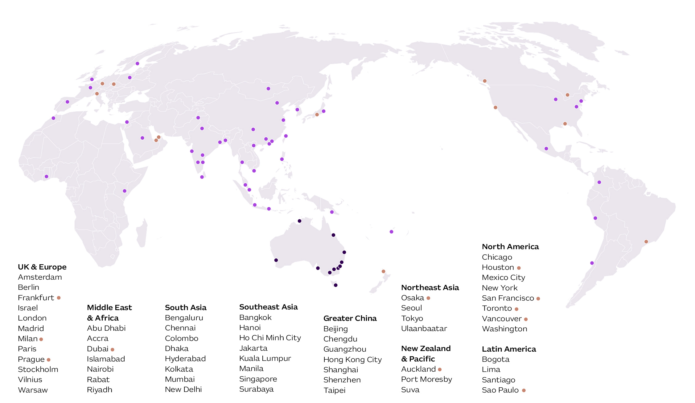

* Austrade office or presence outside Australia
* Austrade presence outside Australia where consular services are also provided
* Austrade office in Australia

## Australia

* **10** Australian offices
* **29** TradeStart locations

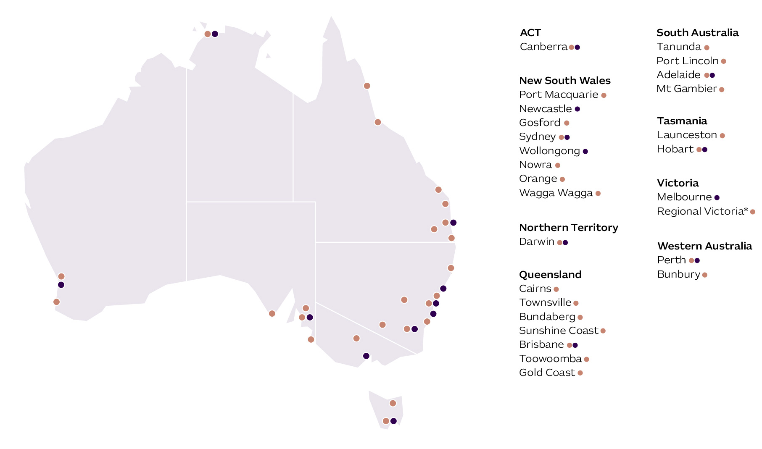

* Austrade location
* TradeStart location

*\*The locations of five regional TradeStart offices in Victoria will be confirmed following publication.*

# Our operating context

Australia remains an attractive destination for international students, tourists, investors, and businesses due to our relative economic stability and strong growth relative to other advanced economies. In 2024-25, Austrade will continue to support Australian businesses to take advantage of emerging opportunities to diversify into new sectors and export markets and to attract investment at scale to build sovereign capability.

## A global economic shift is underway

A further escalation in geopolitical tensions remains a key risk to inflation and global growth, with the potential to disrupt energy and commodity markets and increase shipping costs by compromising traditional trade routes.

Global growth is expected to remain subdued over the next few years as the effects of high inflation, restrictive macroeconomic policies, geopolitical tensions, and challenges in the Chinese economy weigh on the outlook. If inflationary pressures continue to ease as expected, the global policy focus will increasingly shift to managing risks to growth.

Global growth is forecast to remain at around 3¼ per cent in 2024, 2025 and 2026. Major trading partner growth is also expected to remain at 3¼ per cent in 2024, 2025 and 2026 as a forecast softening in China offsets a modest pickup elsewhere.[1]

Austrade is continuing to support our clients adapt to changes in the global economic landscape, including responding to trade barriers and challenges related to supply chains, commodity markets, and policy changes.

To keep pace with change and secure our future prosperity, Australia will need to deepen strategic ties, build sovereign capability in areas of national interest and take advantage of stronger economic growth in emerging Indo-pacific markets.

* Promoting opportunities for Australian exporters to diversify into new markets and offer new products and services;
* Attracting and facilitating high-quality foreign direct investment at scale and enabling greater outbound investment to deepen ties in our region;
* Implementing the national strategy for the recovery of Australia’s Visitor Economy, Australia’s largest services export and 4th largest export overall; and
* Leveraging Australia’s Nation Brand to promote the capabilities and successes of Australian exporters and highlight Australia’s competitive advantages globally.

## Capitalising on key opportunities

To achieve strong growth in exports and foreign direct investment, Austrade’s role is to support businesses to take advantage of emerging commercial opportunities.

Our focus areas for the reporting period include:

#### Broadening trade and investment opportunities and outcomes

Diversifying trade and investment across sectors, markets, products and clients will continue to support Australia’s economic diversification and our resilience to the impacts of future geopolitical and economic shifts.

We will provide additional support to Australian agricultural exporters to re-establish commercial connections in China, and help drive additional international demand for sheep products.

Austrade is focused on strengthening trade relationships in the Indo-Pacific region. We are supporting Australian businesses to identify opportunities, diversify their exports and achieve trade outcomes in Southeast Asia via the Australia Southeast Asia Businesses Exchange (SEABX), and Australia’s relationships in South Asia by extending and expanding the successful Australia India Business Exchange (AIBX).

Building on the successful ASEAN-Australia Special Summit in March 2024, Austrade will play a key role in the implementation of summit outcomes aimed at increasing pathways and support for Australian businesses seeking to expand their presence in Southeast Asia. These include newly launched regional Technology Landing Pads in Jakarta and Ho Chi Minh City, and establishing regional deal team hubs in Singapore, Jakarta and Ho Chi Minh City focused on identifying and pursuing new investment opportunities.

Austrade supports Australian exporters to maximise the benefits of the 18 free trade agreements (FTAs) currently in force, encouraging businesses to leverage agreements such as the Australia-United Kingdom Free Trade Agreement (A-UKFTA), the Australia-India Economic Cooperation and Trade Agreement (AI-ECTA) to diversify their export markets, and attracting and facilitating investment from source markets that leverage free trade and other bilateral agreements.

Austrade will also finalise the strategic refocus of the Export Market Development Grant program and open a new grant round with improved grant sizes, eligibility that aligns with exporter success factors, improved sustainability and better integration for businesses across Austrade’s services.

#### Deepening Australia’s ongoing economic security

Austrade is contributing to the economic security of the nation, with a focus on supporting Australia’s strategic relationships, sovereign capability, and economic resilience. Our trade, investment, visitor economy policy activities and commercial insights play a vital role in supporting Australia’s economic security and delivering on the Government’s strategic objectives.

Austrade works closely across government to influence policy considerations to support commercial opportunities that strengthen Australia’s economic security. Our business connections and capability are critical to delivering government policy priorities, such as a future made in Australia and attracting investment in renewable energy. Austrade’s contributions to whole-of-government priorities include facilitating trade investment in Southeast Asia and the Pacific, attracting productive foreign direct investment aligned with sovereign capability priorities (including critical minerals, advanced manufacturing, critical technologies, clean energy, green metals, battery manufacturing, and defence and space industries) and supporting Australian companies to reach global markets.

#### Enabling Australia’s success in a net-zero future

Around the world action to achieve net zero greenhouse gas emissions is accelerating. This net zero transformation is leading to significant economic shifts globally and is expected to lead to major economic, employment and regional change across Australia in the years ahead.

The Australian Government is making significant investments to achieve the ambition of making Australia a renewable energy superpower, committing to achieve net zero by 2050 and grow the share of renewable energy generation in major electricity networks to 82% by 2030. Australia is ensuring our success in a net zero future by decarbonising our economy, transforming the energy system to deliver cheap, clean, reliable energy for industry and consumers, and building new clean energy industries for the benefit of the nation and our global partners, with an ambition of becoming a renewable energy superpower. These goals are being achieved through collaborative partnerships with industry, First Nations peoples, communities, unions, researchers, state and territory governments, and international partners.

Austrade is undertaking a broad range of initiatives to enable Australia’s net zero transformation and position Australia as a net zero partner of choice. Austrade’s investment teams are playing a key role in attracting and facilitating foreign direct investment that delivers the capital, technology and capability to drive Australia’s net zero transition, with a specific focus on renewable energy and storage, circular economy, battery manufacturing, future transport, hydrogen and green steel.

We are committed to facilitating exports growth and investment to support a future made in Australia and Australian success in a global green economy via tailored events and services and market insights. Austrade produced an updated Critical Minerals Prospectus and Green Economy Prospectus to showcase Australia’s green economy capabilities internationally and strengthen Australia’s reputation as a key partner with industry.

#### Prioritising the economic growth of First Nations businesses and communities

Austrade is committed to supporting more First Nations businesses via targeted, customised export support and pathways to international success. We are continuing to partner with organisations such as Supply Nation to promote the successes of First Nations businesses in international markets. We are working with the National Indigenous Australians Agency (NIAA), Tourism Australia, State and Territory Governments and First Nations representatives to co-design the First Nations Visitor Economy Partnership (FNVEP).

Austrade supports First Nations success through our visitor economy, trade, investment and broader policy activities, aligned to the First nations foreign policy agenda, complementing the work of DFAT and Australia’s Ambassador for First Nations People.

As part of the Australian Export Awards 2024, Austrade has set a target to increase applications across all award categories for First Nations Businesses and is working closely with the State and Territory Governments to encourage applications.

#### Returning the visitor economy to long-term sustainable growth

Recovery of the international tourism sector is continuing. International visitor numbers and international spend in Australia exceeded 75% of pre-pandemic levels in 2023, with Tourism Research Australia (TRA) forecasting that international spend will return to pre-pandemic levels in 2024. International visitor arrivals are expected to surpass the pre-pandemic peak in 2025, then continue to rise annually to reach 12 million in 2028.

Domestic tourism growth was more moderate in 2023, following rapid growth in 2022. Data indicated that whilst Australians maintained a strong desire to travel domestically throughout the year, they responded to tighter economic conditions, by travelling closer to home and for shorter durations.

The THRIVE 2030 interim target of $166 billion in total visitor economy spend by 2024 has already been comfortably achieved. Total visitor economy spend (including long term international students) reached $207.7 billion (25 per cent or $41.7 billion above the 2024 target) in nominal terms at the end of 2023. Of this spend, $82.5 billion was spent in regional Australia ($12.5 billion above the 2024 target of $70 billion).

In consultation with industry, government agencies, stakeholders and relevant businesses, Austrade is developing the Phase 2 Action Plan of the THRIVE 2030 Strategy and refreshing targets to expand visitor economy expenditure to $230bn by 2030. As the visitor economy continues to recover, Austrade will:

* Support the increased use of official tourism data and analysis for decision making;
* Build the capability of tourism operators to meet the needs of new markets;
* Support the growth of First Nations tourism via the First Nations Visitor Economy Partnership (FNVEP) and the National Indigenous Australians Agency (NIAA) Indigenous Mentoring program for tourism operators;
* Promote sustainable, green and net zero practices by ensuring take up of the Sustainable Tourism Toolkit; and
* Improve delivery of the Approved Destination Status Scheme to support the increased return of Chinese group travel.

#### Modernising trade

Austrade is coordinating the implementation of simplified trade system reforms, including streamlining cross-border regulations and government processes, reducing the cost of trade and simplifying the process for Australian importers and exporters.

Leveraging enhanced digital trade services via an expanded Go Global Toolkit will enable Austrade to reach more potential exporters in metropolitan, regional and remote Australia, across both goods and services. New personalisation features and tools, insights and content focused on strategic markets and sectors will aid trade diversification and exporter growth through increased use of Australia’s FTAs.

# Our key activities

## Overview

To achieve our purpose, we will pursue two outcomes through five key activities. These activities are underpinned by whole-of-government strategic priorities and will be shaped   
by emerging trends in our operating context.

### OUTCOMES

#### Outcome 1:

Contribute to Australia’s economic prosperity by supporting Australian exporters to expand internationally, attracting productive international investment, and growing the visitor economy

#### Outcome 2:

The protection and welfare of Australians abroad through timely and responsive consular and passport services in specific locations overseas

### key activities

1. Trade
2. Investment
3. Promotion
4. Policy, Programs and Official Tourism Statistics
5. Consular and Passport Services

## Key activities

**Key activity 1: Trade**

Supporting Australian businesses to expand, through trade advice, connections, support, and programs

**Key initiatives:**

1.1 **Accelerate the growth and diversification of Australia’s exports through Australia Southeast Asia Business Exchange** business missions, marketing and diaspora engagement and extending **Australia India Business Exchange (AIBX)** initiatives.

1.2 **Implement the Export Market Development Grant (EMDG) Strategic refocus** to deliver more impactful grants to high-quality exporters, with a greater focus on key diversification markets.

1.3 **Facilitate growth in green economy exports** via tailored trade support, events and market insights for new and existing exporters, leveraging the Green Economy Prospectus to showcase Australia’s capabilities internationally.

1.4 **Through targeted programs, support high-growth exporters to take advantage of opportunities**, such as technology Landing Pads and supporting Australian agricultural exporters to re-establish commercial connections in China and continue to diversify into other markets.

1.5 **Support the equitable economic growth for First Nations businesses and communities** through targeted support, programs and partnerships with industry groups, to grow the number of First Nations businesses successfully exporting with Austrade’s support.

1.6 **Deliver an enhanced Go Global Toolkit** to reach more potential exporters and develop new personalisation features and content that supports priority industry sectors and export markets.

**Key activity 2: Investment**

Facilitating high-quality inwards foreign investment, and outward investment via the Southeast Asia Investment Deal Teams

**Key initiatives:**

2.1 Contribute to the government’s **Future Made in Australia agenda by attracting and facilitating large scale investment opportunities** that rebuild Australia’s industrial capability and deliver on our net zero commitments and renewable energy superpower ambitions.

2.2 Attract and facilitate inward investment that delivers **capital, technology, and capability to drive Australia’s net zero transformation** promotes net zero reinvestment, and drives diversification and resilience in net zero supply chains.

2.3 Attract and facilitate inward investment that **enhances Australia’s economic security, by building sovereign capability, and filling identified gaps** in critical technologies, defence capabilities, and critical minerals supply chains.

2.4 Attract and facilitate inward investment that **supports Australia’s economic diversification**, including from source markets that leverage free trade and other bilateral agreements.

2.5 **Strengthen economic security** by enabling greater outbound investment via the **Southeast Asia Investment Deal Teams** initiative.

2.6 **Collaborate across government to understand First Nations opportunities and perspectives related to foreign investment**, and develop a common narrative to support investor engagement.

**Key activity 3: Promotion**

Conducting global marketing and promotion to create brand awareness, generate demand and support conversion of leads for trade and investment

**Key initiatives:**

3.1 **Leverage Australia’s Nation Brand** to grow audience engagement and present a consistent and compelling value proposition to the world, delivering content that showcases Australia’s sovereign capabilities, strengthens our position in the green economy and supports diversification through telling the stories of unique Australian business making an impact in diverse markets.

3.2 **Maximise the influence of Australian thought leadership on the net zero transformation** through additional National Brand assets that strengthen Australia’s reputation as a climate leader and key partner for government and industry.

3.3 **Collaborate with State and Territory governments to establish a First Nations category in the Australian Export Awards** and prioritise stories of First Nations businesses succeeding in strategic markets and sectors.

3.4 **Promote the Visitor Economy THRIVE 2030 Strategy across industry and government** and increase targeted marketing and communications activity to grow awareness and preference for Australia as the global education and skills partner of choice.

**Key activity 4: Policy, Programs and Official Tourism Statistics**

Leading national visitor economy policy development and implementation, publication of official tourism statistics through TRA, and using Austrade’s global network and commercial perspectives on trade and investment to contribute to Government policy development and implementation

**Key initiatives:**

4.1 **Support Australia’s economic security**, harnessing business to deepen strategic relationships (e.g. Southeast Asia Economic Strategy to 2040, Pacific, AUKUS) and working across government to inform the government’s policy development and implementation to enhance sovereign capability and economic resilience (e.g. foreign investment framework).

4.2 **Support the government’s net zero agenda**, including related ambitions for a future made in Australia and to become a **renewable energy superpower**, through coordinating the delivery of Austrade’s Net Zero Strategy, providing timely and informative industry insights to government, influencing relevant Government priorities and support, and determining new THRIVE Phase 2 actions which deliver on the objectives of the new National Sustainability Framework for the Visitor Economy.

4.3 **Influence the trade diversification agenda**, activities and priorities through government forums, implementation and promotion of Free Trade Agreement opportunities, stabilisation of our trading relationship with China, and deliver initiatives that support business in key diversification markets, including via the Export Market Development Grant program.

4.4 **Support the government’s First Nations Foreign Policy Agenda** and boost First Nations tourism, trade, and investment activities through engagement with the Office of the First Nations International Engagement, elevation of First Nations aspirations, people and enterprises across the visitor economy through collaboration on the First Nations Visitor Economy Partnership (FNVEP) and consideration of the First Nations value proposition and outcomes during new policy design.

4.5 **Through TRA, produce and publish leading-edge tourism statistics** in line with international standards, continue to innovate statistical collections through use of new data sources, and deliver insightful research and analysis which supports development of the visitor economy.

4.6 **Coordinate work across government** in support of the simplified trade agenda, including engaging closely with business to support regulatory, process and digital reforms.

**Key activity 5: Consular and Passport Services**

Helping Australians through the delivery of effective consular services, efficient passport services and practical contingency planning in designated locations, in accordance with DFAT’s Consular Services and Passports Client Services charter

**Key initiatives:**

5.1 **Deliver responsive and appropriate consular services** to Australian travellers and citizens living overseas, including notarial services, assistance with welfare issues, whereabouts enquiries, arrest or detention matters, deaths and medical emergencies.

5.2 **Work collaboratively with DFAT to improve systems access and manage passport requests efficiently and accurately**, including processing new passport applications, registering lost or stolen passports, issuing emergency passports and detecting passport fraud.

5.3 **Prepare to support in-person overseas voting** for registered Australians at all Consular Posts for the next Australian federal election.

# Our capabilities

Austrade is committed to building on our capabilities and supporting our team of world-leading professionals to ensure we continue to deliver for our clients and for Australia.

All of Austrade’s core work is conducted in-house by Austrade employees. Any use of contractors or consultants by Austrade is consistent with Australian Public Service (APS) Strategic Commissioning Framework requirements.

## Building our capability

Austrade’s core capabilities are our team’s skills, knowledge, networks, geographic footprint and the systems underpinning how we work. To continue enabling our team to deliver commercial outcomes and support the resilience and growth of Australia’s economy, our focus areas for 2024-25 are:

**1. People and leadership** – We will maintain a focus on supporting our people and leadership team through capability development and training opportunities. We will continue to connect Austraders globally, and enhance recognition of exemplary performance, service, and demonstration of Austrade values.

**2. Processes** – We will undertake further projects to simplify our corporate service processes and systems, improve data accuracy, visibility and accessibility, and ensure consistent service delivery and governance.

**3. Technology** – We will upgrade network performance globally and simplify digital communication channels to enable our people to support clients and collaborate across locations, sectors, and teams securely with ease.

**4. Evaluation and economic impact** – We will support the embedding of evaluation disciplines across Austrade to improve the monitoring and accountability of outcomes and programs, and generate insights on trends and Austrade’s economic impact.

**5. Diversity, inclusion and wellbeing** – We will launch the Wellbeing Strategy 2024-26 and implement new Enterprise Agreement conditions, as well as continue embedding our Diversity and Inclusion Strategy 2022-25 to empower Austraders and achieve our BRAVE goals for belonging, reputation, accountability, values and behaviours, and equity.

**6. Reconciliation and representation of First Nations** – We will continue to focus on the recruitment and retention of First Nations staff employed by Austrade, enhance staff awareness and engagement with reconciliation through incorporating First Nations perspectives into core activities, and develop Austrade’s next Reconciliation Action Plan (RAP) in collaboration with Reconciliation Australia.

**7. APS net zero commitments** – We will continue to meet and exceed 2030 Australian Public Service (APS) Net Zero Government Initiative targets, with a focus on reducing the environmental impact of Austrade’s activities in relation to office energy, waste and water usage, offsetting emissions and digital technologies.

## Our partnerships and networks

Austrade maintains a focus on collaboration and information sharing with our portfolio partners, state and territory governments, industry networks and other government agencies.

The Ministerial Council on Trade and Investment supports collaboration and information sharing across jurisdictions.

The Senior Official Trade and Investment Group (SOTIG), National Trade Forum (NTF) and National Investment Forum (NIF) act as mechanisms for engagement between Commonwealth and State and Territory governments to drive a coordinated approach on the practical operations of delivering whole-of-government trade and investment priorities across Australia.

In 2024-25, the NTF will focus on enhancing the approach to international events, standardising digital export training support, and improving information sharing. The NIF priority areas are Net Zero, First Nations, Capability and Events.

Across the visitor economy, the Tourism Ministers’ Meeting acts as a forum for ongoing leadership and communication at a Federal level, with the Australian Standing Committee on Tourism (ASCOT) promoting cooperation and coordination of government policies and activities related to THRIVE 2030 and other tourism matters across State and Territory governments and Tourism Australia. The Australian Government Visitor Economy Taskforce drives collaboration in implementation of THRIVE 2030 activities while Austrade’s quarterly Visitor Economy Stakeholder Engagement Forum further supports industry engagement.

#### 1. Portfolio Partners

* Department of Foreign Affairs and Trade;
* Tourism Australia; and
* Export Finance Australia.

#### 2. State and Territory Governments

#### 3. Industry Networks and Non-Government Organisations

#### 4. Other Government Agencies

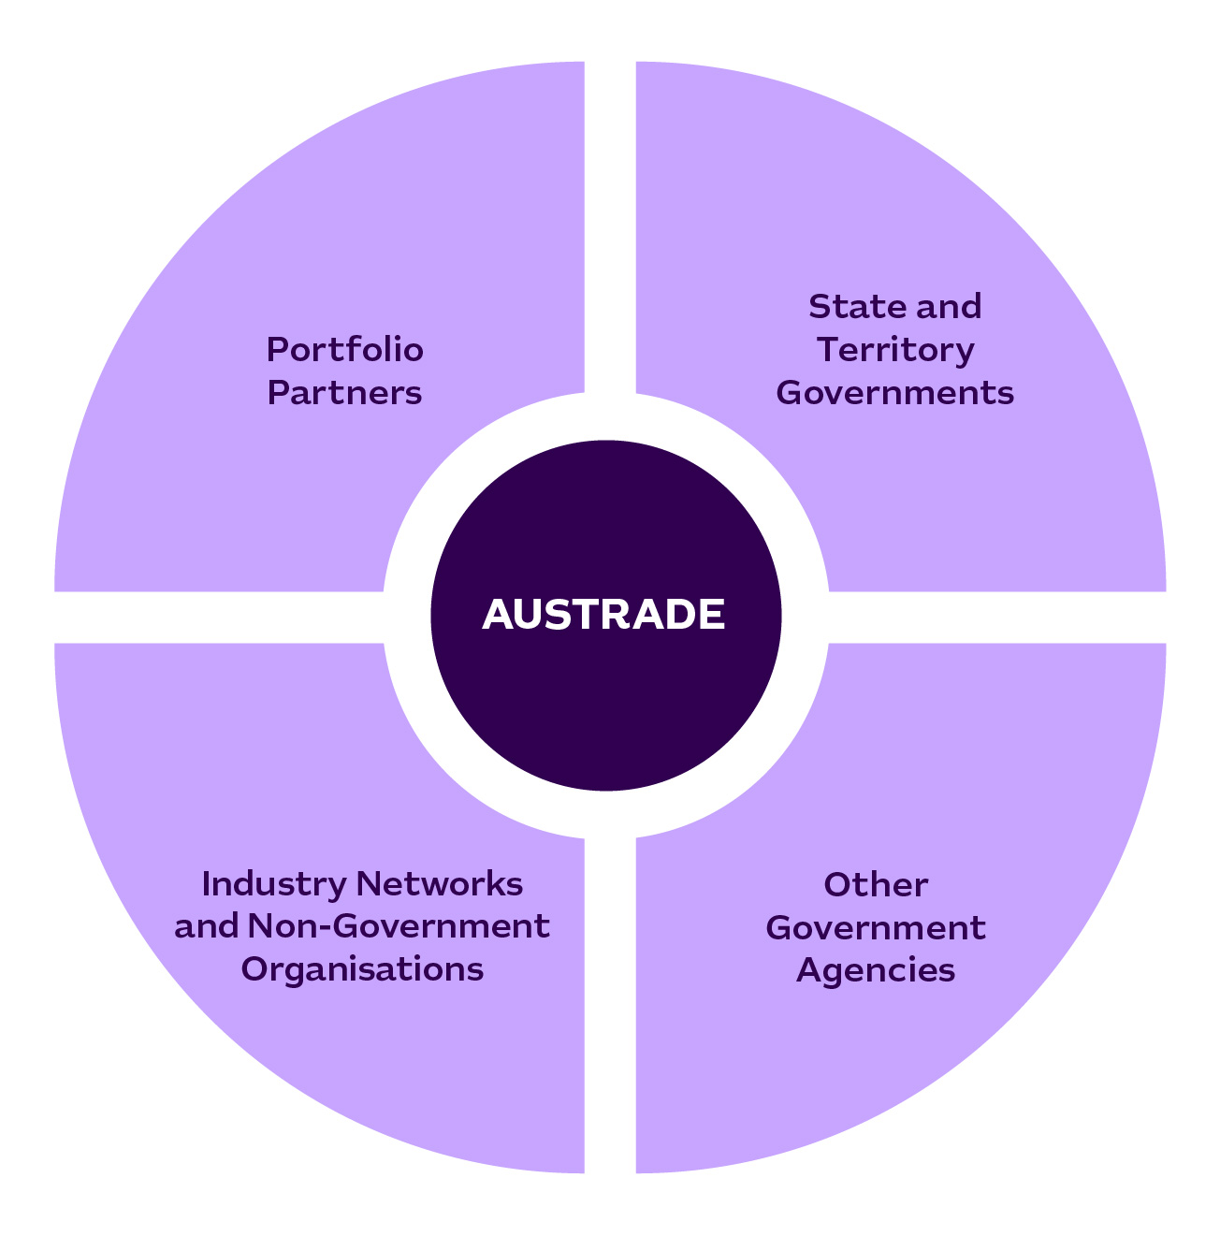

# Performance

Austrade’s performance planning and targets enable us to monitor our impact over the four-year life of this plan.

Austrade’s international network is also key to our success and ability to deliver. We will continue to support our people overseas in our network of 61 offshore locations and promote alignment of our offshore footprint with sector priorities to continue our history of high-performance.

Austrade’s planning process comprises the Portfolio Budget Statements, the Austrade Act and the Public Governance, Performance and Accountability (PGPA) Act.

We have developed performance measures for our key activities, including a balance between quantitative and qualitative components. Our performance measures aim to ensure Austrade delivers on our outcomes. We report on our performance in the Annual Performance Statements, contained in the Austrade Annual Report.

**Outcome 1:** To contribute to Australia’s economic prosperity by supporting Australian exporters to expand internationally, attracting productive international investment, and growing the visitor economy.[2]

**Trade**

The table below outlines Austrade’s three performance measures for trade and the associated target which will remain constant from 2024-25 to 2027-28.

| **Performance measures** | **Targets** | | | | **Source** |
| --- | --- | --- | --- | --- | --- |
| **2024–25** | **2025–26** | **2026–27** | **2027–28** |
| High level of satisfaction for Austrade’s clients with Austrade’s services | **At least 85 per cent** | | | | Survey |
| Number of trade outcomes facilitated | At least **1200** outcomes | At least **1200** outcomes | At least **1200** outcomes | At least **1200** outcomes | Customer Relationship Management (CRM) system entry from client notification |
| EMDG recipients report that the receipt of a grant encouraged them to increase their export promotion activities | At least **70 per cent** of EMDG recipients to report that receiving a grant encouraged them to increase their export promotion activities | | | | Survey |

**Investment**

The table below outlines Austrade’s investment performance measure and the associated target which will remain constant from 2024-25 to 2027-28.

| **Performance measures** | **Targets** | | | | **Source** |
| --- | --- | --- | --- | --- | --- |
| **2024–25** | **2025–26** | **2026–27** | **2027–28** |
| Number of investment outcomes facilitated | At least **110** investment outcomes3 | At least **110** investment outcomes | At least **110** investment outcomes | At least **110** investment outcomes | CRM from investor notification |

3 Austrade’s 2023-24 Corporate Plan set out targets for the ‘Number of investment outcomes facilitated’ of 110 investment outcomes in 2023-24, and then 120 investment outcomes each year for the period 2024-25 to 2026-27. Austrade has revised its investment targets for 2024-25 to 2026-27 to maintain the target at the 2023-24 level of 110 investment outcomes. This change reflects; a) Austrade’s focus on delivering larger, more strategically important investment outcomes that deliver the Government’s priorities in Net Zero Transition and Economic Security, and b) allocating more resources to delivering programs in Critical Minerals and Southeast Asia strategy which have deliverables not caught by this metric.

**Policy, Programs and Official Tourism Statistics**

The table below outlines Austrade’s policy, programs and official tourism statistics performance measure and the three topics chosen for 2024-25, with focus areas for 2025-26 to 2027-28 to be determined before the beginning of each year.

| **Performance measures** | **Targets** | | | | **Source** |
| --- | --- | --- | --- | --- | --- |
| **2024–25** | **2025–26** | **2026–27** | **2027–28** |
| Effective contribution to whole-of-government policy development including using Austrade’s commercial insights | Topics:  Net Zero, Economic Security, Visitor Economy | Focus areas to be determined before the beginning of each year | | | Internal assessment and case studies where appropriate |

**Outcome 2:** The protection and welfare of Australians abroad through timely and responsive consular and passport services in specific locations overseas.

**Consular and passport services**

The table below outlines Austrade’s consular and passport services performance measure, and the associated target that will remain constant from 2024-25 to 2027-28.

| **Performance measures** | **Targets** | | | | **Source** |
| --- | --- | --- | --- | --- | --- |
| **2024–25** | **2025–26** | **2026–27** | **2027–28** |
| Effective delivery of consular and passport services to Australians overseas | At least **97 per cent** of passports processed by Austrade are without administrative errors | | | | DFAT Passport and Consular Information System databases |

# Governance and key agency risks

## Governance

Austrade’s governance arrangements are designed to foster effective leadership and collaboration to support the delivery of our strategic organisational and government priorities.

Austrade’s Governance Committee Structure, at 30 June 2024:



Minister for Trade  
and Tourism

Chief Executive Officer

Executive Committee

Audit and Risk Committee

## Enterprise risk framework

Our robust risk management ensures that Austrade can anticipate and respond effectively to challenges. Austrade’s Enterprise Risk Management Framework is in line with the expectations of the Commonwealth Risk Management Policy.

Austrade operates a strong internal risk management framework and conducts risk management planning to support oversight through the Executive Committee and Audit and Risk Committee. Austrade’s risk management and reporting framework includes establishing risk context, undertaking risk assessment, setting risk tolerances and determining key enterprise risk focus areas.

### Our key strategic risks and mitigations

#### Enterprise Risks

* Austrade fails to achieve our purpose and on government priorities.
* Austrade’s management of operations including governance, business continuity, planning, risk management, financial management and staff capability is not fit for purpose.
* Austrade does not balance the use of digital tools, appropriately manage personal and Government information whilst meeting mandatory government cyber security or information management requirements.
* Austrade fails to identify unethical or illegal conduct across its operations and activities.
* Austrade fails to protect the health, safety and wellbeing of staff, contractors, those requiring Consular assistance or other visitors to our offices.
* Austrade fails to adequately protect staff or visitors from security threats at our work locations.

#### Mitigation Strategies

* Building a positive work culture through Australian Public Service Values, Code of Conduct and Austrade Values;
* Ongoing oversight by the CEO, Executive Committee and second tier committees;
* Independent advice from the Audit and Risk Committee;
* Strategic Planning process to target resources to support clients to deliver high-value commercial outcomes and government priorities;
* Regular financial and performance reporting;
* Application of risk management, auditing, and reviews;
* Close engagement with our clients and stakeholders to support the design and   
  delivery of services; and
* Effective Governance, Security, Fraud Awareness, ICT, Work, Health and Safety, Capability and Leadership frameworks, with policies and procedures and training that support the delivery of operations and compliance with legislative and administrative requirements.

**Acknowledgement of Country**

In the spirit of reconciliation, Austrade acknowledges the Traditional Custodians of country throughout Australia and their connections to land, sea and community. We pay our respect to their Elders past and present and extend that respect to all Aboriginal and Torres Strait Islander peoples today.

**Disclaimer**

This document has been prepared by the Commonwealth of Australia represented by the Australian Trade and Investment Commission (Austrade). All dollar amounts included refer to Australian Dollars (AUD) unless otherwise stated.

Austrade has exercised due care and skill in preparing and compiling the information and data in this document. Austrade, its employees and advisers disclaim all liability, including liability for negligence and for any loss, damage, injury, expense or cost incurred by any person as a result of accessing, using or relying on any of the information or data in this document to the maximum extent permitted by law.

Austrade recommends the person exercise their own skill and care, including obtaining professional advice, in relation to their use of the information in this document for their purposes. The Australian Government does not endorse any company or activity referred to in the document and does not accept responsibility for any losses suffered in connection with any company or its activities.

Copyright © Commonwealth of Australia 2024

The material in this document is licensed under a Creative Commons Attribution – 4.0 International licence (CC BY licence), except for:

* any third-party material
* any material protected by a trademark
* any images and photographs.

More information on this CC BY licence is set out at the creative commons website: [https://creativecommons.org/licenses/by/4.0/legalcode.](https://creativecommons.org/licenses/by/4.0/legalcode)

#### Attribution

Before reusing any part of this document, including reproduction, public display, public performance, distribution, dissemination, communication, or importation, you must comply with the Attribution requirements under the CC BY licence. Enquiries about this licence and any use of this document can be sent to: [advisory@austrade.gov.au](mailto:advisory@austrade.gov.au).

#### Using the Commonwealth Coat of Arms

The terms of use for the Coat of Arms are available from the It’s an Honour website ([www.itsanhonour.gov.au](http://www.itsanhonour.gov.au/)).

Publication date: August 2024

1. Australian Treasury, Budget 2024-25, Budget Paper 1 – Statement 2: Economic Outlook, May 2024
2. In relation to key activity three (Promotion), this activity contributes to Austrade’s success against the Trade and Investment performance measures.