

Corporate Plan 2025–26

CEO’s introduction
Australia’s prosperity relies on international trade across diverse markets, productive foreign direct investment, and sustainable growth in the visitor economy.
Faced with an uncertain and evolving international trading environment, Austrade’s role in supporting Australian exporters to achieve commercial outcomes, facilitating high-quality investment, boosting visitor economy growth and delivering commercial insights to inform policy development, will become even more pivotal to Australia’s prosperity and economic security.
Australia’s economic growth, security and standard of living rely heavily on international trade, productive inbound investment, and the visitor economy.
Over 2025–26, Austrade will focus on supporting the foundations for resilient growth in the Australian economy — specifically, by promoting new trade opportunities for exporters, attracting capital into projects that support the net zero transition and drive economy security, and driving the long-term sustainable growth of Australia’s visitor economy.
As the Chief Executive Officer and accountable authority for the Australian Trade and Investment Commission, I am pleased to present Austrade’s Corporate Plan for 2025–26, as required under paragraph 35(1) (b) of the Public Governance, Performance and Accountability Act 2013 (PGPA Act) and Part 7 of the Australian Trade and Investment Commission Act 1985 (the Austrade Act). As our primary planning document for the reporting period 2025–26 to 2028–29, it has been prepared in accordance with the requirements of the PGPA Act.
The Corporate Plan sets out Austrade’s strategy to achieve its purpose through key activities and initiatives that deliver quality trade, investment, and policy outcomes in alignment with the Government’s priorities. Working in close collaboration with Commonwealth, state, territory and industry partners, Austrade is focused on delivering impactful, quality services in the following areas.

Trade and investment: Austrade will continue to deliver high quality trade services which contribute to tangible commercial outcomes. To do this, our trade team will focus on administering programs to help Australian business in priority sectors to grow their exports in high potential markets. Austrade will also extend the reach of trade services via the Export Market Development Grant program, our TradeStart partnership with states, territories and industry, and digital services delivered via the Go Global Toolkit. These initiatives will help Austrade scale our support to reach more exporters, including more First Nations and rural businesses. Our investment team will help Australia compete for foreign capital to deliver the Government’s “Future Made in Australia” agenda, which promotes economic security and enables the net zero transition. We will also advance Australia’s economic ties in the Indo-Pacific by facilitating and promoting outbound investment via the Southeast Asia Deal Teams.
Promotion: Austrade will showcase Australia’s unique global offering by delivering marketing and promotion activities that leverage our Nation Brand. In alignment with the Government’s priority focus areas, we will amplify the successes of diverse Australian exporters with client stories, deliver targeted and impactful campaigns to promote trade opportunities to Australian exporters, and deliver the Australian Export Awards to recognise export achievements across 14 national categories.
Visitor economy: Austrade will deliver the consolidation phase of the Government’s national visitor economy recovery strategy, THRIVE 2030 (The Re-Imagined Visitor Economy). This includes shaping visitor economy policy and delivering support programs that help to build long-term sustainable growth in the industry. Austrade will also continue to support effective decision-making by producing quality tourism statistics and analytics via Tourism Research Australia.
Consular services: Austrade will continue to provide responsive consular services, manage passport requests, and deliver in-person voting via our network of 11 offshore consular locations. Our resourceful and committed consular teams provide vital support to Australian overseas, often during challenging circumstances.
Austrade’s global network of professionals—across 8 locations nationally, and 61 locations in international markets—bring a diverse breadth of experience which augments our technical expertise. Our ability to deliver on Austrade’s purpose is made possible by our high performing enabling functions.
Looking ahead to 2025–26, I am honoured to lead Austrade as we work together to grow Australia’s prosperity through the critical trade, investment, promotion, and policy services and programs we deliver for Australia.
Dr Paul Grimes PSM
Chief Executive Officer

Purpose
We deliver quality trade and investment services to businesses and policy advice to government to grow Australia’s prosperity, including leading on national tourism policy.

Summary

Our purpose
We deliver quality trade and investment services to businesses and policy advice to government to grow Australia’s prosperity, including leading on national tourism policy.

Operating Environment
Australia’s trade and investment outlook will be shaped by:
- An increasingly complex global economy with slowing growth, rising trade turbulence, and intensifying competition for investment and trade
- Emerging opportunities for Australian businesses to diversify and grow, particularly in Asia, driven by global decarbonisation efforts and demand for renewable energy and critical minerals
- Strengthening strategic relationships with key partners to enhance Australia’s economic resilience, attract foreign capital, and promote sustainable growth in the visitor economy
and other priority sectors

Outcomes
Outcome 1
To contribute to Australia’s economic prosperity by supporting Australian exporters to expand internationally, attracting productive international investment, and growing the visitor economy.
Key activities:
- Trade
- Investment
- Promotion
- Policy, Programs and Official Tourism Statistics

Outcome 2
The protection and welfare of Australians abroad through timely and responsive consular and passport services in specific locations overseas.
Key activities:
- Consular and Passport Services

Performance
Outcome 1
Measurement | Target
High level of satisfaction with Austrade services | At least 85%
Number of trade outcomes facilitated | At least 1,200
Export Market Development Grant recipients report that the receipt of a grant encouraged them to increase their export promotion activities | At least 70% of EMDG recipients to report that receiving a grant encouraged them to increase their export promotion activities
Number of investment outcomes facilitated | At least 110
Effective contribution to whole-of-government policy development including using Austrade’s commercial insights | Focus Areas: Tourism Data, Net Zero,  Trade Facilitation

Outcome 2
Measurement | Target
Effective delivery of consular and passport services to Australians overseas | At least 97 per cent of passports processed by Austrade are without administrative errors

Capabilities
We are focused on ensuring our people have the right skills and support. Our priorities are:
- Service Excellence
- Developing our People
- People and Leadership
- Technology
- Diversity, inclusion and wellbeing

Our values
- Innovation
- Transparency
- Generosity of Spirit
- Collaboration

Our locations

Worldwide
98 locations worldwide 61 locations outside Australia 11 locations outside Australia provide consular services

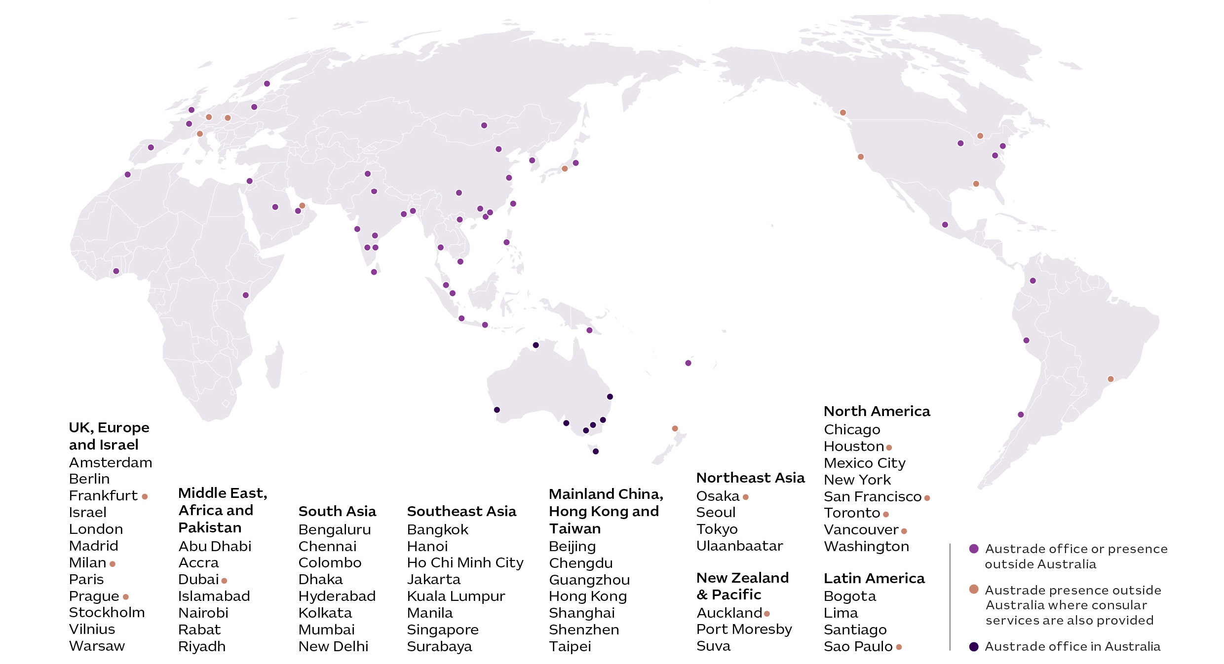

Australia
8 Australian offices
28 TradeStart locations

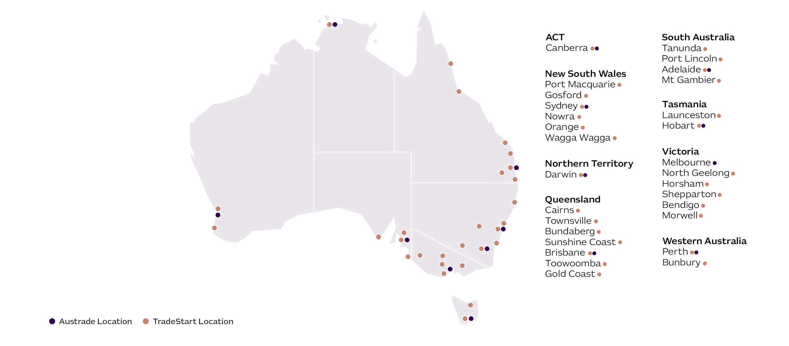

Our operating context
Rising trade tensions have led to significant uncertainty in the global economic outlook, making Austrade’s role in supporting the growth and diversification of Australian trade, the tourism industry and investment more critical than ever. Our functions of facilitating trade and investment, providing market insights, and implementing targeted initiatives are more vital than ever to Australia’s prosperity and economic security.

Economic landscape and market outlook
The global economy is slowing, with the International Monetary Fund forecasting a 2.8% world growth rate in 2025, the lowest since the pandemic. Given the uncertain trading environment, global growth is expected to remain subdued until 2028.
Despite these economic headwinds, emerging Asian markets are experiencing higher growth, with the growth rates of India and Vietnam forecasted to be 6.2% and 5.2% in 2025 respectively, presenting opportunities for Australia in terms of trade and investment.
Global foreign direct investment (FDI) flows have decreased for two consecutive years, driven by ongoing geopolitical tensions and tight fiscal conditions. At the same time, the demand for global capital is increasing as countries work to decarbonise their economies and achieve their net zero ambitions, creating new opportunities for investment and growth.
For business, the trade and investment climate is becoming increasingly complex and uncertain, with higher tariffs and disruptions to trade and global supply chains. Inflation is easing but remains higher than pre-pandemic levels. This is putting pressure on exporters and affecting investor confidence. In response to these challenges, businesses are finding opportunities to adapt and innovate, driving growth and investment in new markets and technologies.

Responding to changes in the operating environment
To address these challenges and capitalise on emerging opportunities, Austrade will focus on providing targeted support to Australian businesses. Our response will be guided by the following key objectives:
            - Building resilience through trade diversification: supporting Australian exporters to deepen existing market penetration, utilise free trade agreements (FTAs) and diversify into new markets.
            - Attracting foreign capital to grow Australia’s economy: attracting and facilitating productive foreign investment projects to support the net zero transformation and strengthen supply chains, as well as leveraging FTAs to attract new capital sources.
            - Creating a resilient, diversified visitor economy: implementing the Consolidation Phase (2025–2027) of THRIVE 2030, the Australian Government’s strategy for the sustainable growth of the Visitor Economy, which is Australia’s largest services export.
By pursuing these objectives, Austrade will play a pivotal role in supporting the growth and diversification of Australian trade, tourism, and investment, and helping Australian businesses to navigate the complexities of the global economy.

Building resilience through trade diversification
Given the scale of global disruptions, Austrade’s role in facilitating trade is crucial to support the strategic diversification of Australia’s exports. This involves expanding into a broader range of markets, products and clients – including increasing the number of First Nations exporters. Diversifying trade is essential for promoting economic resilience and mitigating the impacts of geopolitical and macroeconomic volatility.
Austrade will scale up its diversification support for exporters, targeting opportunities that offer strong growth prospects. For example:
- Southeast Asia and South Asia markets: countries such as Indonesia, Thailand, the Philippines, Vietnam, and India are expected to drive economic growth in the region over the medium term. Austrade’s work will build on the early success of the Southeast Asia Economic Strategy to 2040, the Southeast Asia Business Exchange, and the South Asia Business Exchange.
- New FTA Markets: recently negotiated agreements with the UAE, UK, and India have unlocked new opportunities for Australian businesses to expand their exports and tap into emerging markets. Austrade will continue to support new or expanded agreements.
- High Potential Scale-Up Businesses: Austrade will support the growth of innovative and ambitious Australian scale-ups by providing access to expertise and international markets, with a focus on emerging sectors such as digital, healthcare, and sustainability.
Strong collaboration with industry, government, and state and territory partners will underpin this important diversification work and ensure comprehensive support for businesses aiming to explore new opportunities.

Attracting foreign capital to grow Australia’s economy
Austrade’s FDI work has demonstrated that foreign investment into Australian businesses helps them to grow faster, export more, have higher productivity, and create more high-paying jobs.
Australia has long secured foreign capital at a rate above our global share of GDP, predominantly from traditional markets
like the US, UK and Europe. However,
this is not guaranteed to continue, with global investment flows impacted by three forces:
- The demand for global capital is increasing, driven by the drive to decarbonisation around the globe, and the rapid economic growth of regions such as Southeast Asia.
- Shifts in sources and types of capital, with new and different investment drivers.
- Protectionism, trade barriers, and re-industrialisation agendas are also influencing investment decisions, making global competition for productive investment more intense.
In response to the changing landscape, Austrade is targeting new opportunities to secure foreign investment, aiming to enhance Australia’s prosperity and economic security. Austrade is intensifying efforts to attract foreign capital from diverse and reliable sources that is in alignment with Australia’s national interest. This includes focusing on investments aligned with capabilities and sectors under the Future Made in Australia agenda, supporting private investment in critical minerals, and leveraging Free Trade Agreements (FTAs) and other bilateral agreements to diversify capital attraction.

Creating a resilient, diversified visitor economy
Australia’s visitor economy sector made significant progress during the initial Recovery Phase (2022–2024) of THRIVE 2030. Visitor spending reached $213.9 billion over the 12 months leading up to December 2024, with $79 billion of that spent in regional areas, surpassing the Recovery Phase targets.
However, the industry faces a mixed international tourism outlook. Growth in visitation from mature markets in the UK, US, and Europe is slowing, while Southeast Asia and India have rebounded strongly. The Approved Destination Status (ADS) scheme is expected to drive an influx of visitors from China, providing a significant boost to the sector.
Growing regional tourism remains a critical focus, with one in four Australian regions still experiencing a 10% decline in visits compared to pre-COVID levels. Addressing workforce challenges is essential, as shortages continue to limit growth and the ability to meet traveller demands. However, significant opportunities exist in sustainability and First Nations tourism. Emphasising environmentally conscious travel can attract new cohorts of visitors. Additionally, promoting First Nations tourism can create unique experiences for visitors and economic opportunities for First Nations Australians.
The THRIVE 2030 Consolidation Phase (2025–2027) Action Plan will build on the strong foundation delivered in the Recovery Phase and embed sustainable growth. Austrade’s role includes leveraging its convening power, extensive industry engagement, and strong partnership with Tourism Australia to ensure significant improvements in tourism outcomes. By fostering growth in valuable international visitor segments and improving the operating environment for tourism businesses, Austrade aims to ensure that Australia’s visitor economy achieves sustainable growth and remains a key driver of national prosperity.

Our key activities
To achieve our purpose, we will pursue two outcomes through five key activities. These activities are underpinned by whole-of-government strategic priorities and are shaped by emerging trends in our operating context.

Outcomes
Outcome 1:
To contribute to Australia’s economic prosperity by supporting Australian exporters to expand internationally, attracting productive international investment, and growing the visitor economy.
Outcome 2:
The protection and welfare of Australians abroad through timely and responsive consular and passport services in specific locations overseas.

Key activities
- Trade
- Investment
- Promotion
- Policy, Programs and Official Tourism Statistics
- Consular and Passport Services
Key activity 1: Trade
Delivering trade support that builds resilience of Australian businesses and allows them to become export-ready, expand internationally and diversify.

Key initiatives:
1.1 Drive Australia’s export growth and diversification in key markets by leveraging the Australia Southeast Asia Business Exchange (SEABX) and South Asia Business Exchange (SABX) programs, and Free Trade Agreements (such as Australia-UAE CEPA).
1.2 Deliver the Government’s diversification program in partnership with with peak industry bodies to support exporters to diversify into new markets, navigate emerging global trade challenges, and secure new opportunities in existing markets
1.3 Provide tailored support to export-ready technology businesses to scale globally via the expanded Landing Pads program and access to the Australian Dealroom Ecosystem.
1.4 Expand the reach of Austrade’s trade support by leveraging the new Go Global Academy, a digital platform providing tailored resources, expert insights, and trade events to empower more Australian businesses to navigate global trends and succeed in export markets.
1.5 Support the equitable economic growth for First Nations businesses and communities through targeted support, programs and partnerships with industry groups, to grow the number of First Nations businesses successfully exporting with Austrade’s support.
1.6 Deliver the Export Market Development Grants (EMDG) program to support Australian businesses in expanding their exports and promoting their products and services in international markets.

Key activity 2: Investment
Attracting productive inwards foreign investment, and outward investment via the Southeast Asia Investment Deal Teams.
Key initiatives:
2.1 Contribute to the government’s Future Made in Australia agenda by attracting foreign direct investment aligned with the Net Zero and Economic Security streams identified under the National Interest Framework, including opportunities in renewable hydrogen, green metals, and low carbon liquid fuels.
2.2 Support the design and implementation of a new ‘Front Door’ for investors with major, transformational proposals to make it simpler to invest in Australia and attract more global and domestic capital.
2.3 Connect Australian critical minerals companies with targeted international sources of investment and offtake to develop new and diversified supply chains across priority markets.
2.4 Attract and facilitate inward investment that broadens and deepens Australia’s sources of capital, including from source markets such as Europe, the Middle East, and India to leverage current and expected free trade and other bilateral agreements.
2.5 Facilitate strategic outbound investment through the Southeast Asia Investment Deal Teams, part of the government’s Southeast Asia Economic Strategy to 2040, and across the Pacific in line with government objectives for the region.
2.6 Collaborate across government, including through the National Investment Forum with state and territory investment promotion agencies, to promote inclusive engagement with foreign investors and First Nations groups, and build cultural capability within the Investment Division to support staff to engage investors about culturally sensitive investment.
Key activity 3: Promotion
Delivering marketing and promotion activities which promote Australia’s unique global offering and drive increased trade, investment and visitor economy outcomes.

Key initiatives:
3.1 Promote our unique value proposition to the world via Australia’s Nation Brand toolkit, capitalising on opportunities to promote Australian industries and products across diverse markets.
3.2 Share client success stories across government and industry to showcase Austrade’s support in action and to highlight Australia’s strengths.
3.3 Deliver the Australian Export Awards, Australia’s flagship trade awards which showcase the international success of Australian exporters across all states and territories.
3.4 Deliver consistent and targeted campaigns to Australian exporters which promote international trade opportunities, especially those in alignment with key free trade agreement markets and regions such as Southeast Asia and South Asia.

Key activity 4: Policy, Programs and Official Tourism Statistics
Delivering Australia’s visitor economy policy development and implementation, supported by the publication of official tourism statistics through Tourism Research Australia; and leveraging Austrade’s global network and local industry connections to deliver commercial perspectives which inform policy development across government, as well as leading trade simplification.

Key initiatives:
4.1 Share valuable insights from Australian businesses and our global network with government agencies to inform policy decisions, particularly in areas like economic security, green economy, First Nations development, and trade diversification.
4.2 Support the government’s Simplified Trade System agenda by coordinating cross-border trade reforms and strategy across government to make importing and exporting easier.
4.3 Lead Australia’s national visitor economy policy through leveraging our convening power and driving collaboration with key partners to implement THRIVE 2030, including delivery of a prioritised Consolidation Phase (2025–2027) action plan.
4.4 Provide advice to Australian, State and Territory Government agencies and industry stakeholders to ensure policy, programs and strategies are designed to deliver maximum outcomes in the visitor economy.
4.5 Deliver visitor economy support programs, including administering grant programs that assist state and territory governments, tourism businesses and industry bodies.
4.6 Strengthen and publish leading-edge tourism statistics and analytics via Tourism Research Australia to inform decision-making via new data sources and innovative methodologies.

Key activity 5: Consular and Passport Services
Helping Australians through the delivery of effective consular services, efficient passport services and practical contingency planning in designated locations, in accordance with DFAT’s Consular Services and Passports Client Services charter.

Key initiatives:
5.1 Deliver responsive and appropriate consular services to Australian travellers and citizens living overseas, including notarial services, assistance with welfare issues, whereabouts enquiries, arrest or detention matters, deaths and medical emergencies.
5.2 Work collaboratively with DFAT to improve systems access and manage passport requests efficiently and accurately, including processing new passport applications, registering lost or stolen passports, issuing emergency passports and detecting passport fraud.
5.3 Support in-person overseas voting for registered Australians at all Consular Posts.

Our capabilities
Austrade is committed to building on our capabilities and supporting our team of world-leading professionals to ensure we continue to deliver for our clients and for Australia. We will also work towards our 2030 Australian Public Service (APS) Net Zero Government Initiative targets, centred on reducing our environmental impact in relation to office energy, waste and water usage.
All of Austrade’s core work is conducted in-house by Austrade employees. Any use of contractors or consultants by Austrade is consistent with Australian Public Service (APS) Strategic Commissioning Framework requirements.

Building our capability
Austrade’s core capabilities are our team’s skills, knowledge, networks, geographic footprint and the systems that underpin our work. To continue supporting our team to deliver commercial outcomes that grow Australia’s economy, our focus areas for 2025–26 are:
1. Service Excellence – We will deliver quality, client-centric services that leverage our digital tools and dynamic way of working, and will continue to strive for effectiveness in our service delivery to maximise the economic impact of
our work.
2. Developing our people – We will invest in the professional capability and future skills of our staff to ensure that they have the skills in place to contribute to meaningful outcomes for businesses.
3. People and leadership – We will maintain support of our people and leadership team through an enhanced performance and capability development framework and recognise exemplary performance, service, and demonstration of Austrade values.
4. Diversity, inclusion and wellbeing – We will implement the Diversity and Inclusion Strategy to foster our diversity as an advantage that drives innovation, engagement, and the delivery of outcomes. Our culture of belonging is stronger through our focus of recruiting First Nations staff and driving engagement with Austrade’s Reconciliation Action Plan.
5. Technology – We will improve our corporate service processes and systems, advance data accuracy, visibility and accessibility, and ensure consistent service delivery and governance – including by elevating connectivity globally with enhanced digital products and empowering our people to support clients and collaborate across locations with ease.

Our partnerships and networks
Austrade maintains a focus on collaboration and information sharing with our portfolio partners, state and territory governments, industry networks and other government agencies.
This includes partnering with peak industry bodies, such as Tech Council of Australia, to expand the reach of Austrade’s trade services and drive diversification. Austrade is also partnering with industry groups to deliver live webinars and tailored content on our digital service platform, the Go Global Toolkit.
The Ministerial Council on Trade and Investment supports collaboration and information sharing across jurisdictions.
The Senior Official Trade and Investment Group (SOTIG), National Trade Forum (NTF) and National Investment Forum (NIF) act as mechanisms for engagement between Commonwealth and state and territory governments to drive a coordinated approach on the practical operations of delivering whole-of-government trade and investment priorities across Australia.
In 2025–26, the NTF will focus on digitizing export support, collaborating on key international events, and investigating avenues for co-servicing of clients. The NIF will focus on investment coordination in net zero and First Nations focus areas, as well as driving improved capability and events collaboration.
Alongside federal, state and territory government partners, Austrade convenes
several forums which support the delivery of the THRIVE 2030 strategy.
These include the Tourism Ministers’ Meeting which promotes leadership and communication at a national level, and the Australian Standing Committee on Tourism (ASCOT) which promotes coordination of government policies and activities across state and territory governments and
Tourism Australia.
Austrade also supports the Australian Government Visitor Economy Taskforce, which drives collaboration in implementation of THRIVE 2030 activities while Austrade’s quarterly Visitor Economy Stakeholder Engagement Forum supports direct industry engagement.
1. Portfolio Partners and Other Government Agencies
- Department of Foreign Affairs and Trade;
- Tourism Australia; and
- Export Finance Australia.
2. State and Territory Governments
3. Industry Networks and Non-Government Organisations
4. Austrade Clients
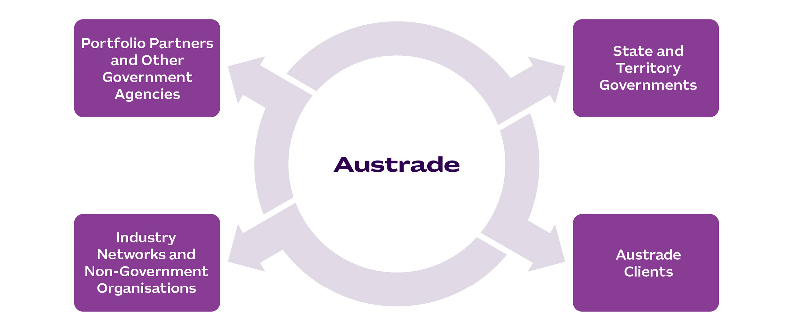

State and Territory Governments
Portfolio
Partners
Austrade
Other Government
Agencies
Industry
Networks and
Non-Government Organisations

Performance
Austrade’s performance planning and targets enable us to monitor our impact over the four-year life of this plan.
Outcome 1: To contribute to Australia’s economic prosperity by supporting Australian exporters to expand internationally, attracting productive international investment, and growing the visitor economy.

Trade
The table below outlines Austrade’s three performance measures for trade and the associated targets, which will remain constant from 2025–26 to 2028–29.
Performance  measures | Targets |  |  |  | Source
Performance  measures | 2025–26 | 2026–27 | 2027–28 | 2028–29 | Source
High level of satisfaction for Austrade’s clients with Austrade’s services | At least 85 per cent |  |  |  | Survey
Number of trade outcomes facilitated | At least 1200 outcomes | At least 1200 outcomes | At least 1200 outcomes | At least 1200 outcomes | Customer Relationship Management (CRM) system entry from client notification
EMDG recipients report that the receipt of a grant encouraged them to increase their export promotion activities | At least 70 per cent of EMDG recipients to report that receiving a grant encouraged them to increase their export promotion activities |  |  |  | Survey

Investment
The table below outlines Austrade’s investment performance measure and the associated target, which will remain constant from 2025–26 to 2028–29.
Performance  measures | Targets |  |  |  | Source
Performance  measures | 2025–26 | 2026–27 | 2027–28 | 2028–29 | Source
Number of investment outcomes facilitated³ | At least  110 investment outcomes | At least 110 investment outcomes | At least 110 investment outcomes | At least 110 investment outcomes | CRM from investor notification

Policy, Programs and Official Tourism Statistics
The table below outlines Austrade’s policy, programs and official tourism statistics performance measure and the three focus areas selected for 2025–26, with focus areas for 2026–27 to 2028–29 to be determined before the beginning of each financial year.
Performance  measures | Targets |  |  |  | Source
Performance  measures | 2025–26 | 2026–27 | 2027–28 | 2028–29 | Source
Effective contribution to whole-of-government policy development including using Austrade’s commercial insights | Focus Areas:  Tourism Data,  Net Zero, Trade Facilitation | Focus areas to be determined before the beginning of each year |  |  | Internal assessment and case studies where appropriate

Outcome 2: The protection and welfare of Australians abroad through timely and responsive consular and passport services in specific locations overseas.

Consular and passport services
The table below outlines Austrade’s consular and passport services performance measure, and the associated target that will remain constant from 2025–26 to 2028–29.
Performance  measures | Targets |  |  |  | Source
Performance  measures | 2025–26 | 2026–27 | 2027–28 | 2028–29 | Source
Effective delivery of consular and passport services to Australians overseas | At least 97 per cent of passports processed by Austrade are without administrative errors |  |  |  | DFAT Passport and Consular Information System databases

Governance and key agency risks

Governance
Austrade’s governance arrangements are designed to foster effective leadership and collaboration to support the delivery of our strategic organisational and government priorities.

Austrade’s Governance Committee Structure, at 30 June 2025:

Audit and Risk Committee
Executive Board
Chief Executive Officer
Minister for Trade
and Tourism

Enterprise risk framework
Our robust risk management ensures that Austrade can anticipate and respond effectively to challenges. Austrade’s Enterprise Risk Management Framework is in line with the expectations of the Commonwealth Risk Management Policy.
Austrade operates a strong internal risk management framework and conducts risk management planning to support oversight through the Executive Board and Audit and Risk Committee. Austrade’s risk management and reporting framework includes establishing risk context, undertaking risk assessment, setting risk tolerances and determining key enterprise risk focus areas.

Our key strategic risks and mitigations
Enterprise risks | Mitigation strategies
1. Austrade fails to achieve our purpose  and deliver on government priorities.  2. Austrade’s management of operations including governance, business continuity, planning, risk management, financial management and staff capability is not fit for purpose.  3. Austrade does not balance the use of digital tools, appropriately manage personal and Government information whilst meeting mandatory government cyber security or information management requirements.  4. Austrade fails to identify unethical or illegal conduct across its operations and activities.  5. Austrade fails to protect the health, safety and wellbeing of staff, contractors, those requiring Consular assistance or other visitors to our offices.  6. Austrade fails to adequately protect staff or visitors from security threats at our work locations. | - Building a positive work culture through Australian Public Service Values, Code of Conduct and Austrade Values.  - Ongoing oversight by the CEO, Executive Board and second tier committees.  - Independent advice from the Audit and Risk Committee.  - Regular financial and performance reporting.  - Application of risk management, auditing, and reviews.  - Close engagement with our clients and stakeholders to support the design and delivery of services.  - Effective Governance, Security, Fraud Awareness, ICT, Work, Health and Safety, Capability and Leadership frameworks, with policies and procedures and training that support the delivery of operations and compliance with legislative and administrative requirements.

Acknowledgement of Country
In the spirit of reconciliation, Austrade acknowledges the Traditional Custodians of country throughout Australia and their connections to land, sea and community. We pay our respect to their Elders past and present and extend that respect to all Aboriginal and Torres Strait Islander peoples today.

Disclaimer
This document has been prepared by the Commonwealth of Australia represented by the Australian Trade and Investment Commission (Austrade). All dollar amounts included refer to Australian Dollars (AUD) unless otherwise stated.
Austrade has exercised due care and skill in preparing and compiling the information and data in this document. Austrade, its employees and advisers disclaim all liability, including liability for negligence and for any loss, damage, injury, expense or cost incurred by any person as a result of accessing, using or relying on any of the information or data in this document to the maximum extent permitted by law.
Austrade recommends the person exercise their own skill and care, including obtaining professional advice, in relation to their use of the information in this document for their purposes. The Australian Government does not endorse any company or activity referred to in the document and does not accept responsibility for any losses suffered in connection with any company or its activities.
Copyright © Commonwealth of Australia 2025
The material in this document is licensed under a Creative Commons Attribution – 4.0 International licence (CC BY licence), except for:
- any third-party material
- any material protected by a trademark
- any images and photographs.
More information on this CC BY licence is set out at the creative commons website: https://creativecommons.org/licenses/by/4.0/legalcode.

Attribution
Before reusing any part of this document, including reproduction, public display, public performance, distribution, dissemination, communication, or importation, you must comply with the Attribution requirements under the CC BY licence. Enquiries about this licence and any use of this document can be sent to: advisory@austrade.gov.au.

Using the Commonwealth Coat of Arms
The terms of use for the Coat of Arms are available from the It’s an Honour website (www.itsanhonour.gov.au).

Publication date: August 2025

Australian Treasury, Budget 2025–26, Budget Paper 1 – Statement 2: Economic Outlook, March 2025
In relation to key activity three (Promotion), this activity contributes to Austrade’s success against the Trade and Investment performance measures.
3 Austrade’s trade and investment outcome targets for 2025–26 have remained steady due to the current complex operating environment. Austrade will continue to monitor forward targets for 2026–27 onwards in the context of an uncertain global trade and investment landscape.

