

Corporate Plan 2026–27

CEO’s introduction
Australia’s enduring prosperity is anchored in our nation’s ability to succeed in global trade markets, attract quality foreign direct investment, and develop a resilient and sustainable visitor economy.
As we enter 2026–27, we find ourselves at a critical juncture. The international trade and investment landscape is defined by increased geostrategic competition, more active use of tariffs and other trade barriers by some countries, disruption, and a heightened focus on economic sovereignty, and geopolitical risk. In this complex environment, Austrade’s mission is more vital than ever to our nation’s economic security and prosperity.
Australia’s economic growth, security and standard of living rely heavily on international trade, productive investment, and the visitor economy. Over the coming year, Austrade will continue to support Australian exporters to pursue opportunities to establish, expand and diversify in priority international markets, attract the capital required for future growth, including to accelerate our net-zero transition, strengthen economic security, and support the sustainable growth of the visitor economy.
As the Chief Executive Officer and accountable authority for the Australian Trade and Investment Commission, I am pleased to present Austrade’s Corporate Plan for 2026–27, as required under paragraph 35(1) (b) of the Public Governance, Performance and Accountability Act 2013 (PGPA Act) and Part 7 of the Australian Trade and Investment Commission Act 1985 (the Austrade Act). As our primary planning document for the reporting period 2026–27 to 2029–30, it has been prepared in accordance with the requirements of the PGPA Act.
Through deep collaboration with Commonwealth, state, territory and industry partners, Austrade will deliver impact across its four key activities:
Trade: Austrade will continue to provide high-quality trade advice, connections and support to Australian businesses, delivering targeted programs to support Australian businesses in priority sectors to achieve tangible commercial results in high-potential international markets. This includes through the Accessing New Markets Initiative (ANMI) delivered through the Trade Diversification Network (TDN), working in partnership with national peak industry bodies to support businesses to establish, expand and diversify into new markets and navigate opportunities and challenges within the uncertain global trade environment. We will strive to strengthen bilateral trade relationships and support businesses to take advantage of Australia’s free trade agreements (FTAs). Austrade will continue to extend the reach of trade support via the Export Market Development Grant program, our TradeStart partnership with states, territories and industry, and expanded interactive and tailored market information and digital services available to all businesses via the Go Global Toolkit. These initiatives will help Austrade scale our support to reach more exporters, including more First Nations and rural businesses. In addition, Austrade will continue to strategically engage with policy processes that support our role to facilitate and promote global trade. Our promotional activities will focus on showcasing Australia’s unique global offering through partnerships and activities that leverage our Nation Brand, including by sharing diverse client stories and delivering the Australian Export Awards to recognise export achievement.
Investment: Our investment team will help Australia compete for foreign capital to deliver the Government’s Future Made in Australia agenda focused on economic security and enabling the net zero transition. We will also advance Australia’s economic ties in the Indo-Pacific by facilitating and promoting outbound investment via the Southeast Asia Deal Teams. We will continue to support other key policy initiatives including the implementation of the Investor Front Door to support nationally significant investment projects, and connecting Australian critical minerals companies with targeted sources of investment and offtake.
Tourism and Visitor Economy: Austrade will deliver the next action plan of the Government’s national visitor economy strategy, THRIVE 2030 (The Re-Imagined Visitor Economy). This includes shaping visitor economy policy and delivering support programs to build long-term sustainable growth in the industry. Austrade will also continue to support effective decision-making by producing high quality official tourism statistics and insights via Tourism Research Australia, underpinned by ongoing investment in data modernisation and new data sources.
Consular and Passport Services: Austrade will continue to provide responsive consular services, manage passport requests, and provide practical contingency planning via our network of 11 offshore consular locations. Our resourceful and committed consular teams provide vital support to Australians overseas, often during challenging circumstances.
Austrade’s global network of professionals — across 8 locations nationally, and 60 locations in international markets — bring a diverse breadth of experience which augments our technical expertise. Our ability to deliver on Austrade’s purpose is made possible by our high-performing enabling functions.
Looking ahead to 2026–27, I am honoured to lead Austrade as we work together to grow Australia’s prosperity through the critical work we deliver for Australia.
Dr Paul Grimes PSM
Chief Executive Officer

Purpose
We deliver quality trade and investment services to businesses and policy advice to government to support the growth of Australia’s prosperity, including leading on national tourism policy.

Summary

Operating Environment
Australia’s trade and investment outlook will be shaped by:
- A structurally disrupted global trading environment, increasingly defined by rising protectionism and active industrial policy. This underscores the critical necessity of building resilient supply chains through deep, reciprocal, and diversified trading partnerships.
- A more competitive global investment landscape as FDI slows. Australia’s stable economy provides strong foundations, but attracting high‑quality FDI will continue to be challenging.
- Shifting global preferences toward premium, reliable service exports and sustainable tourism, intensifying competition for quality market segments. This necessitates a more sophisticated domestic capability to compete on value and innovation, ensuring Australia remains a preferred partner for global talent, international students, and high-value visitors.

Outcomes
Outcome 1
To contribute to Australia’s economic prosperity by supporting Australian exporters to expand internationally, attracting productive international investment, and growing the visitor economy.
Key activities:
- Trade
- Investment
- Tourism and Visitor Economy

Outcome 2
The protection and welfare of Australians abroad through timely and responsive consular and passport services in specific locations overseas.
Key activities:
- Consular and Passport Services

Performance
Outcome 1
Measurement | Target
High level of satisfaction for Austrade’s clients with Austrade’s services | At least 85%
Number of trade outcomes facilitated | At least 1,500
Export Market Development Grant recipients report that the receipt of a grant encouraged them to increase their export promotion activities | At least 70% of EMDG recipients to report that receiving a grant encouraged them to increase their export promotion activities
Number of investment outcomes facilitated | At least 110
Effective contribution to whole-of-government policy outcomes, including using Austrade’s commercial insights | Focus Areas: Trade Facilitation, Tourism Data, Net Zero

Outcome 2
Measurement | Target
Effective delivery of consular and passport services to Australians overseas | At least 97 per cent of passport applications are processed without administrative errors

Capabilities
We are focused on ensuring our people have the right skills and support. Our priorities are:
- Service excellence
- Strategic partnerships and stewardship
- Governance, risk and compliance
- Learning and development
- People and leadership
- Diversity, inclusion and wellbeing
- Technology

Our values
- Innovation
- Transparency
- Generosity of Spirit
- Collaboration

Our locations

Austrade’s Australian and overseas locations
98 locations worldwide 60 international locations 11 locations outside of Australia with consular services

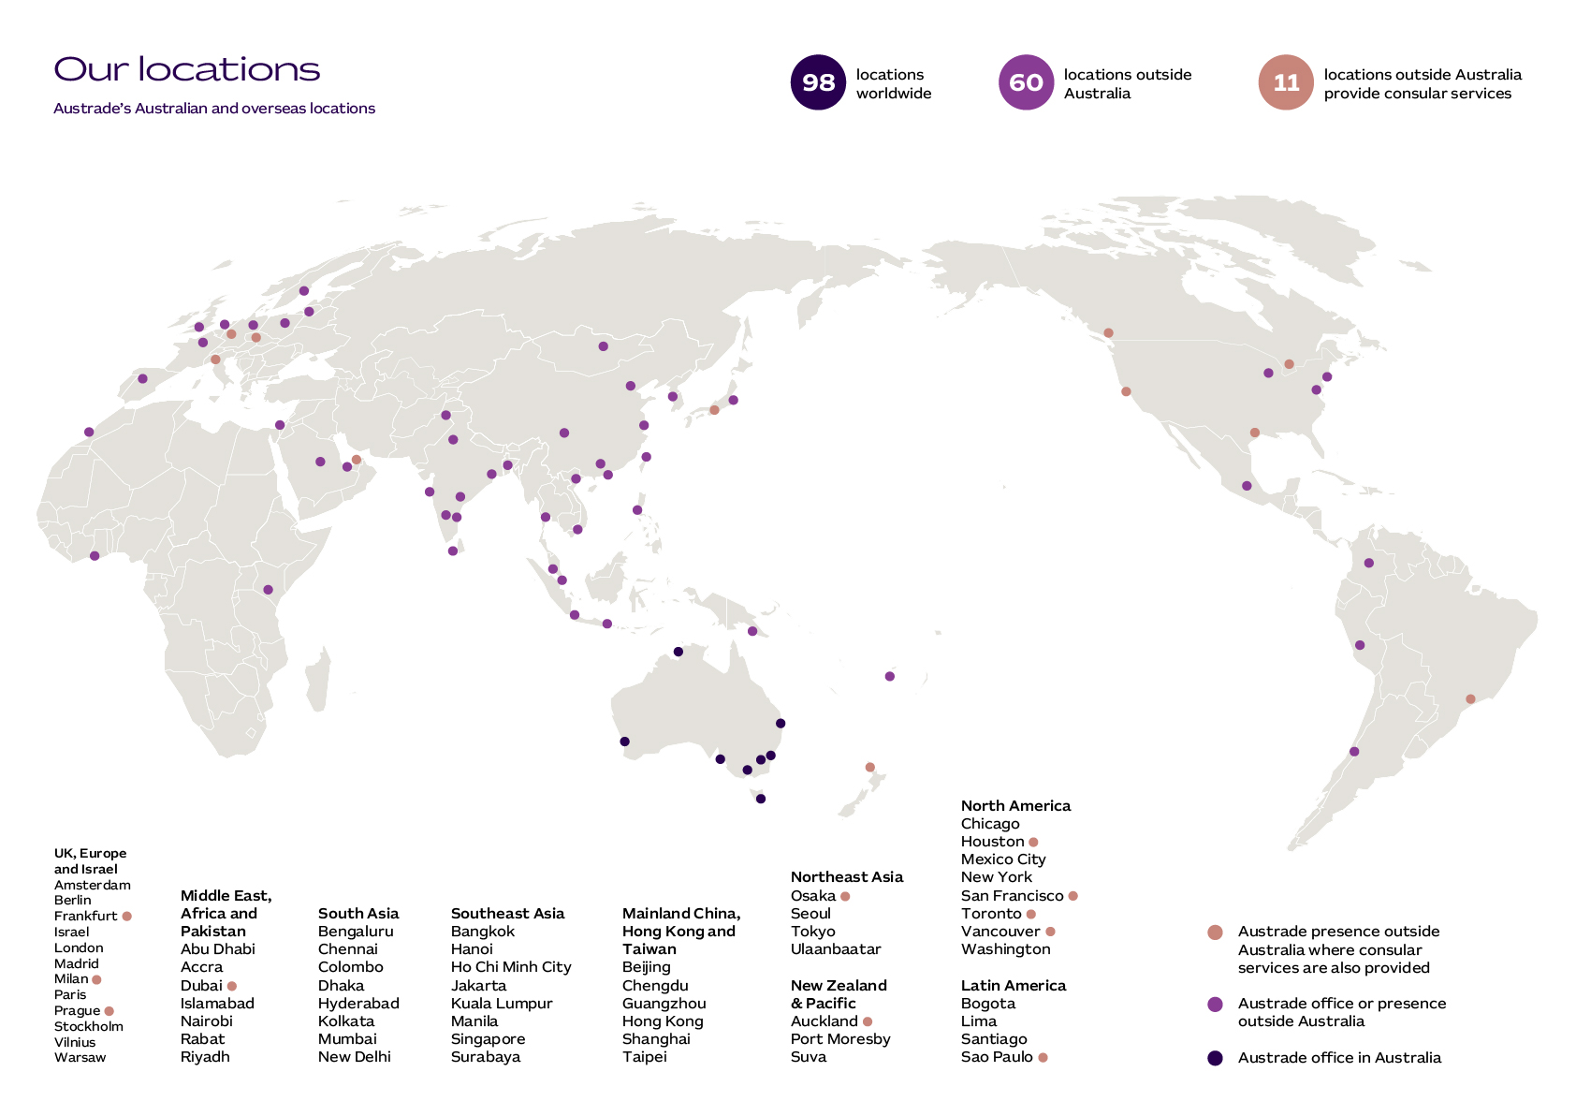

Austrade’s national network including TradeStart

8 Australian locations 30 TradeStart locations

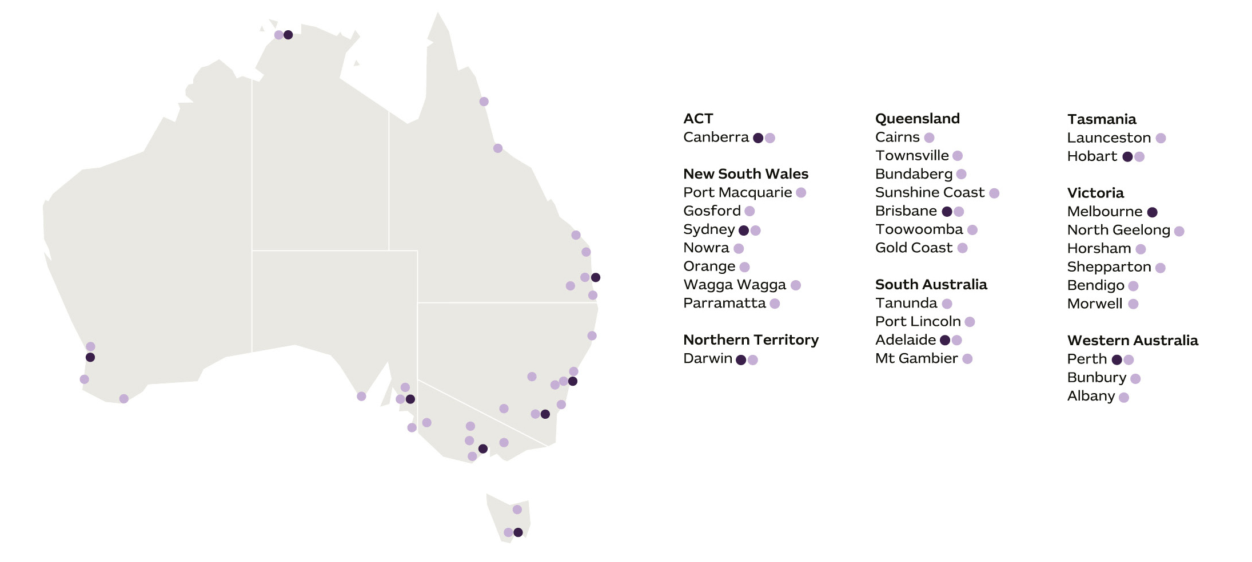

Our operating context
An increasingly complex geopolitical and economic environment is fundamentally reshaping the international trade, tourism and investment landscape. This has only further reinforced the critical role that Austrade plays to enable Australia’s trade capability, facilitate foreign investment, and advance our tourism and education sectors, helping to secure Australia’s economic security and prosperity.

Economic landscape and market outlook
The global economy enters 2026–27 in a period of heightened structural uncertainty, following a more resilient than expected 2025–26. The International Monetary Fund projects global output to expand by around 3.1 per cent in 2026, with public debt hovering near 95 per cent of GDP. Inflation has eased across most advanced economies, yet financing conditions remain materially tighter than the past decade, tempering investment appetite and constraining cross-border capital flows. In Australia, the domestic outlook remains uncertain, in large part driven by the conflict in the Middle East and resulting global oil shock.
Beneath these headline figures, the foundations of global trade and investment are being redrawn. We are seeing a fundamental reorientation of globalisation, with economic engagement increasingly influenced by geostrategic considerations. The conflict in the Middle East has increased volatility and is constraining economic activity, particularly in Asia, driven by a significant increase in energy costs. The conflict has highlighted how interdependent global systems have become, prompting governments and businesses to focus on strengthening resilience and adaptability across supply chains, trade routes and investment flows. Trade patterns are becoming increasingly regionalised, shaped by alliances and foreign policy. Governments are deploying industrial policy and targeted incentives to build domestic capability and fortify supply chains, particularly in critical minerals, clean energy, semiconductors and advanced manufacturing. At the same time, the supply of capital central to the net zero transformation is coming off historical highs, while competition for capital is intensifying in sectors such as critical technologies - including artificial intelligence.
Strong technology-driven investment is expected to support growth over the coming year, driven by the United States, while emerging Asian economies are maintaining robust growth, underpinned by urbanisation, digitalisation and a rising middle-class. With growth in emerging markets and developing economies projected to outpace the global average, Australia’s geographic proximity and trade and investment capabilities position it to capture expanding value from this shift in global growth dynamics.

Responding to changes in the operating environment
Austrade plays a critical role supporting Australian businesses to navigate a continuously shifting trade and investment landscape and positioning our economy to take advantage of high-value opportunities. Our approach will be targeted, guided by three priority objectives:
- Accelerating trade diversification: bolstering Australia’s international trade by expanding export reach in existing strategic markets while leveraging trade alliances and industry partners to diversify into new markets.
- Securing capital and capability: mobilising foreign investment to accelerate the net zero transition and safeguard Australia’s economic security, while leveraging trade agreements and Southeast Asia Investment Deal Teams to facilitate two-way international investment in the national interest.
- Creating a resilient, diversified tourism and visitor economy: implementing the THRIVE 2030 action plan, the government’s national visitor economy strategy, to enable the sustainable growth of tourism, Australia’s second largest services export.

Accelerating Trade diversification
Trade remains a core engine of Australia’s prosperity, underpinning one-third of total output and a quarter of jobs. Australian exporters also benefit from 19 free trade agreements (FTAs) covering 80% of two-way trade, which will rise to 88% as the new EU-FTA comes into effect. Australia’s reliability and high-quality exports make us a natural partner for nations seeking stable, diversified supply networks.
Austrade’s focus is building a resilient, diversified export base that can withstand external shocks while advancing the government’s broader economic goals. With countries increasingly eyeing the $4.5 trillion ASEAN marketplace, this focus will position us to take advantage of critical opportunities across the trading landscape. We are concentrating our efforts in three key areas:
- Empowering growth through trade diversification: As an enabler of our diversification agenda, the $55 million ANMI surge program amplifies our presence in existing and new markets. Through the new TDN, Austrade is working hand-in-hand with 40 peak industry bodies to provide extra in-market trade advisors, export intelligence and strategic events to help exporters capitalise on new, high-value growth opportunities.
- Utilising trade agreements: The Australia-India Economic Cooperation and Trade Agreement (ECTA) provides Australian businesses access to a market of more than 1.4 billion people, with tariffs removed on 85% of Australian goods and another 5% to be eliminated over the coming years. We are also deepening trade links with our second largest trading partner through the Australia-UK FTA, with 98% of Australian goods now tariff free. Once in force, the new FTA with the European Union (EU) will remove duties on 98% of the value of Australian exports entering the EU and expand access across 27 markets and 450 million consumers.

- Strengthening strategic regional ties: We are expanding our footprint in strategic markets across the Indo-Pacific through the Southeast and South Asia Business Exchanges, deploying a specialist Pacific Business Liaison to explore regional opportunities, and extending our Landing Pads program in Southeast Asia to embed tech scaleups in these fast-growing ecosystems. We are also helping Australian businesses leverage the CPTPP’s expanding network to access new markets, build commercial partnerships, and strengthen trade links across the Indo-Pacific.

Securing capital and capability
Austrade’s role is to promote, attract and facilitate foreign investment aligned with government priorities, focusing on accelerating the net zero transformation and bolstering Australia’s economic security in line with Future Made in Australia goals, to enhance sovereign capability. To achieve this, Austrade focuses on three core delivery areas:
- Targeting highly strategic foreign investment to strengthen capability in priority sectors that underpin national security and long-term economic prosperity.
- Utilising trade agreements and bilateral partnerships to diversify capital sources and strengthen the resilience of critical supply chains.
- Deepening relationships with global investors, federal, state and territory governments, and international chambers to secure sustained investment pipelines and unlock new opportunities.
These priorities are advanced through key programs that simplify the investment journey and highlight sector advantages. Australia’s Critical Minerals Strategy and Prospectus connect investors to world-leading reserves of lithium and rare earths, addressing global production shortfalls. Meanwhile, the Investor Front Door pilot has the potential to support nationally significant projects, offering regulatory navigation and identifying government financing to ensure Australia remains a leader in the race for future industries.
The global investment environment in 2026 will be challenging, with competition for capital intensifying as investment activity slows. Capital is also becoming more strategic – shifting from efficiency-seeking towards security-seeking capital allocation amid geopolitical and supply chain disruption. United Nations Conference on Trade and Investment (UNCTAD) data shows global foreign investment rose 14% to US$1.6 trillion in 2025, largely driven by financial centre flows rather than real investment activity, which remained fragile. Investor sentiment remained weak, with greenfield projects down 16%, despite elevated values due to a small number of mega-projects.
Despite these headwinds, Australia remains well positioned due to a predictable business environment, stable political and regulatory systems, and deep linkages with key partners. However, in an increasingly contested market for high-quality capital, Australia cannot rely on these advantages alone. Securing investment will require a targeted and coordinated approach with key partners that goes beyond traditional channels to tap into new sources of global capital.

Creating a resilient, diversified Tourism and Visitor Economy
Australia’s tourism industry and visitor economy made significant progress during the initial Recovery Phase (2022–2024) of THRIVE 2030, with national and regional visitor spend exceeding their targets. International visitation to Australia grew by 8% from 2024 to 2025 and growth in domestic trips reflect Australians’ continued desire to explore their country. Visitation from China grew, including through the Approved Destination Status (ADS) scheme, and China is comfortably Australia’s second largest visitor market after New Zealand.
With regional tourism contributing over 7% of regional jobs, facilitating greater visitor dispersal and promoting new experiences in the regions is critical. Australia’s Green and Gold runway of sporting events leading up to the Brisbane 2032 Olympics and Paralympics presents opportunities to encourage greater regional dispersal. Business events continue to attract a wide range of global visitors, delivering broader benefits to the tourism industry.
However, as skills shortages constrain growth and industry’s ability to meet demands, addressing workforce challenges is essential to building tourism businesses’ resilience and competitiveness. Significant opportunities exist in embedding sustainable tourism and accessible tourism, while promoting First Nations tourism can create unique experiences for visitors and increases economic opportunities for First Nations Australians.
The THRIVE 2030 Action Plan to 2030 will build on the strong foundation delivered in the Recovery Phase and embed sustainable growth. The Office of Tourism and the Visitor Economy’s (OTVE) role will leverage its convening power, extensive industry collaboration, and strong partnership with Tourism Australia to improve tourism outcomes. The embedding of Tourism Research Australia within OTVE delivers access to rich data, research and insights to support policy making and industry. By fostering growth in valuable visitor segments and improving the business operating environment, Austrade aims to ensure that Australia’s visitor economy achieves sustainable growth and remains a key driver of national prosperity.

Our key activities
To achieve our purpose, we will pursue two outcomes through four key activities. These activities are underpinned by whole-of-government strategic priorities and are shaped by emerging trends in our operating context.

Outcomes
Outcome 1:
To contribute to Australia’s economic prosperity by supporting Australian exporters to expand internationally, attracting productive international investment, and growing the visitor economy.
Outcome 2:
The protection and welfare of Australians abroad through timely and responsive consular and passport services in specific locations overseas.

Key activities
- Trade
- Investment
- Tourism and Visitor Economy
- Consular and Passport Services
Key activity 1: Trade
Supporting Australian businesses to establish, expand and diversify international markets through trade advice, connections, support and promotions; and leveraging industry partnerships and market insights to inform the strategic direction of trade.
Key initiatives:
1.1 Work with peak bodies through the Trade Diversification Network to help Australian exporters expand into new markets, navigate the global trade environment, and create new opportunities.
1.2 Strengthen Australia’s trade relationships while supporting exporters to expand into priority markets through the Southeast Asia Business Exchange (SEABX) and South Asia Business Exchange (SABX).
1.3 Help Australian businesses take advantage of the Australia-UAE Comprehensive Economic Partnership Agreement and prepare exporters to benefit from future agreements such as the Australia-EU Free Trade Agreement.
1.4 Provide practical guidance, tools, and live events through the expanded Go Global Toolkit, helping Australian businesses understand market opportunities and build the capability needed to enter and grow in international markets.
1.5 Deliver trade services aligned to the exporter journey, supporting businesses to explore opportunities, engage in priority markets, and grow and diversify their exports.
1.6 Deliver the Export Market Development Grants (EMDG) program to support Australian businesses and representative bodies to build export capability and promote their products and services internationally.
1.7 Leverage insights from businesses to inform government policy and broader stakeholder actions to support growth in export trade.
1.8 Drive exports through trade promotion, communication and marketing initiatives including targeted campaigns, events that harness Australia’s Nation Brand to promote Australia’s excellence in exporting, and recognition of Australian exporters through the Australian Export Awards.

Key activity 2: Investment
Proactively targeting and attracting inwards foreign investment, and outward investment, including via the Southeast Asia Investment Deal Teams.
Key initiatives:
2.1 Contribute to the government’s Future Made in Australia agenda by attracting foreign direct investment aligned with the Net Zero and Economic Security streams identified under the National Interest Framework, while leveraging trade agreements and bilateral and commercial relationships to broaden Australia’s sources of global capital.
2.2 Support the implementation of the Investor Front Door initiative through the attraction of nationally significant investment projects.
2.3 Connect Australian critical minerals companies with targeted international sources of investment and offtake to develop diversified and resilient supply chains, including investment in midstream processing that captures greater value onshore.
2.4 Facilitate strategic outbound investment in the national interest, including through the Southeast Asia Investment Deal Teams, part of the government’s Southeast Asia Economic Strategy to 2040, and across the Pacific in line with government objectives for the region.
2.5 Collaborate across governments, including with state and territory investment promotion agencies through the National Investment Forum to align strategic priorities, support state government investor pathways, and develop and deliver a pipeline of strategic investment projects.
2.6 Continue to promote inclusive and culturally aware engagement between foreign investors and First Nations groups.
2.7 Drive investment into Australia by informing investment-related government policy and delivering targeted marketing campaigns that build investor confidence.
Key activity 3: Tourism and Visitor Economy
Leading national visitor economy policy development and implementation, supported by the publication of official tourism statistics through Tourism Research Australia; market insights.

Key initiatives:
3.1 Lead Australia’s national visitor economy policy through leveraging our convening power and driving collaboration with key partners to implement THRIVE 2030, including delivery of the THRIVE 2030 Action Plan to 2030.
3.2 Provide advice to federal, state and territory government agencies and industry stakeholders to ensure policy, programs and strategies are designed to deliver maximum outcomes in the visitor economy.
3.3 Deliver visitor economy support programs, including administering grant programs that assist state and territory governments, tourism businesses and industry bodies.
3.4 Strengthen and publish leading-edge tourism statistics and analytics via Tourism Research Australia to inform decision-making via new data sources and innovative methodologies.
Key activity 4: Consular and Passport Services
Helping Australians overseas through the delivery of effective consular services, efficient passport services and practical contingency planning in designated locations, in accordance with DFAT’s Consular Services and Passports Client Services Charter.

Key initiatives:
4.1 Deliver responsive and appropriate consular services to Australian travellers and citizens living overseas, including notarial services, assistance with welfare issues, whereabouts enquiries, arrest or detention matters, deaths and medical emergencies.
4.2 Work collaboratively with DFAT to improve systems access and manage passport requests efficiently and accurately, including processing new passport applications, registering lost or stolen passports, issuing emergency passports and detecting passport fraud.

Our capabilities
Austrade will continue to build our capabilities and support our people to deliver for our clients and for Australia, ensuring disciplined decision-making and value for money.
All of Austrade’s core work is conducted in-house by Austrade employees. Any use of contractors or consultants by Austrade is consistent with Australian Public Service (APS) Strategic Commissioning Framework requirements.

Building our capability
Austrade’s strength lies in our people, their skills and knowledge, our global networks and footprint, and the systems that underpin our operations. In 2026–27, we will focus on the following capability areas to support delivery of commercial outcomes that grow Australia’s economy:
- Service Excellence – We will deliver quality, client-centric services and will continue to strive to maximise the impact of our work.
- Strategic partnerships and stewardship – We will leverage partnerships across government, industry and international stakeholders to amplify Austrade’s impact and support coordinated delivery of Australia’s trade and investment priorities.
- Governance, risk and compliance – We will maintain strong governance frameworks, risk management and assurance practices to support accountable decision-making, legislative compliance and the effective stewardship of public resources.
- Learning and development – We will continue to invest in our workforce capability and future skills to build a confident, agile and high-performing organisation that delivers tangible outcomes for Australian businesses.
- People and leadership – We will maintain support for our people and leadership team through an enhanced performance and capability development framework and recognise exemplary performance, service, and demonstration of Austrade values.
- Diversity, inclusion and wellbeing – We will continue to embed our Diversity and Inclusion Strategy, recognising diversity as an organisational strength that drives innovation, engagement and outcomes. We will strengthen our culture of belonging through increased First Nations representation and active delivery of Austrade’s Reconciliation Action Plan.
- Technology – We will strengthen corporate systems and processes and enhance data quality and accessibility. We will ensure consistent service delivery and governance by leveraging digital capability, including safe and responsible use of artificial intelligence, to support global connectivity.

Our partnerships and networks
Austrade maintains a focus on collaboration and information sharing with our portfolio partners, state and territory governments, industry networks and other government agencies.
Through ANMI, Austrade is working closely with national peak industry bodies to coordinate market priorities, support capability development, and facilitate targeted international engagement, including joint trade missions and major market facing events. This two-year surge program is a key mechanism to align Commonwealth and industry efforts to drive nationally coordinated trade diversification. Austrade is also partnering with industry groups to deliver live webinars and tailored content on our digital service platform, the Go Global Toolkit.
The Ministerial Council on Trade and Investment supports collaboration and information sharing across jurisdictions, while the Senior Official Trade and Investment Group (SOTIG), National Trade Forum (NTF) and National Investment Forum (NIF) act as mechanisms for engagement between Commonwealth and state and territory governments to drive a coordinated approach on the practical operations of delivering whole-of-government trade and investment priorities across Australia.
In 2026–27, the NTF will focus on digitalising export support, collaborating on key international events, and investigating avenues for co-servicing of clients. The NIF will focus on investment coordination including in areas relevant to Net Zero and First Nations, as well as driving improved capability and events collaboration.
The TradeStart model, jointly delivered with state and territory governments and industry organisations, forms part of Austrade’s onshore trade service architecture, providing export advisory services across regional Australia and capital cities.
Alongside federal, state and territory government partners, Austrade convenes several forums which support the delivery of the THRIVE 2030 strategy. These include the Tourism Ministers’ Meeting which promotes leadership and communication at a national level, and the Australian Standing Committee on Tourism (ASCOT) which promotes coordination of government policies and activities across state and territory governments and Tourism Australia. An ASCOT data sub-group, the Tourism Research Committee, ensures a proactive and collaborative approach to the collection and reporting of tourism data and insights.
Austrade also supports the Australian Government Visitor Economy Taskforce, which drives collaboration in implementation of THRIVE 2030 activities while Austrade’s Visitor Economy Industry Stakeholder Forum supports direct industry engagement.
1. Portfolio Partners and Other Government Agencies
- Department of Foreign Affairs and Trade;
- Tourism Australia; and
- Export Finance Australia.
2. State and Territory Governments
3. Industry Networks and Non-Government Organisations
4. Austrade Clients
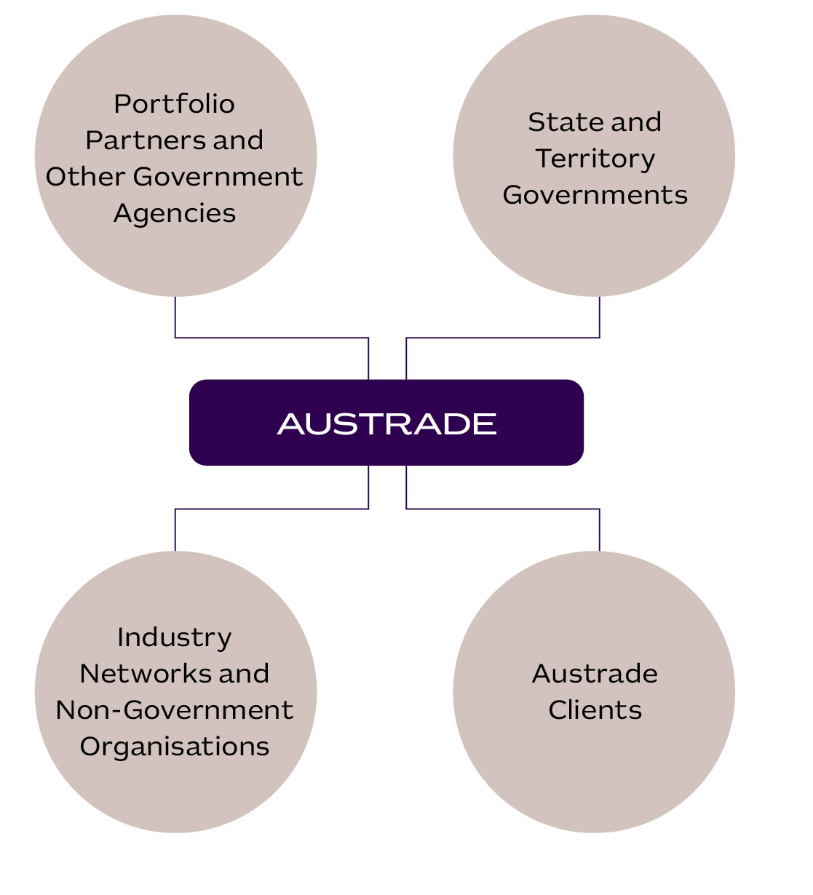

Performance
Austrade’s performance planning and targets enable us to monitor our impact over the four-year life of this plan.
Austrade’s performance planning process comprises the Portfolio Budget Statements and Corporate Plan, in accordance with the Austrade Act and the Public Governance, Performance and Accountability (PGPA) Act.
We have developed performance measures for our key activities, including a balance between quantitative and qualitative components. Our performance measures aim to ensure Austrade delivers on our outcomes. We report on our performance in the Annual Performance Statements, contained in the Austrade Annual Report.
Austrade’s international network is also key to our success and ability to deliver. We will continue to support our people overseas in our network of 60 offshore locations and promote alignment of our offshore footprint with sector priorities to continue our history of high performance.

Outcome 1: To contribute to Australia’s economic prosperity by supporting Australian exporters to expand internationally, attracting productive international investment, and growing the visitor economy.
Trade
The table below outlines Austrade’s three performance measures for trade and the associated targets, which are expected to remain constant from 2026–27 to 2029–30.
Performance measures | Targets |  |  |  | Source
Performance measures | 2026–27 | 2027–28 | 2028–29 | 2029–30 | Source
High level of satisfaction for Austrade’s clients with Austrade’s services | At least 85 per cent |  |  |  | Survey
Number of trade outcomes facilitated | At least 1,500 outcomes | At least 1,500 outcomes | At least 1,500 outcomes | At least 1,500 outcomes | Customer Relationship Management (CRM) system entry from client notification
EMDG recipients report that the receipt of a grant encouraged them to increase their export promotion activities | At least 70 per cent of EMDG recipients to report that receiving a grant encouraged them to increase their export promotion activities |  |  |  | Survey

Investment
The table below outlines Austrade’s investment performance measure and the associated target, which is expected to remain constant from 2026–27 to 2029–30.
Performance  measures | Targets |  |  |  | Source
Performance  measures | 2026–27 | 2027–28 | 2028–29 | 2029–30 | Source
Number of investment outcomes facilitated | At least  110 investment outcomes | At least 110 investment outcomes | At least 110 investment outcomes | At least 110 investment outcomes | CRM from investor notification

Policy
The table below outlines Austrade’s performance measure for the agency’s contribution to whole-of-government policy outcomes, including the three focus areas selected for 2026–27, with focus areas for 2027–28 to 2029–30 to be determined before the beginning of each financial year. This performance measure covers Trade, Investment, and Tourism and Visitor Economy key activities.
Performance  measures | Targets |  |  |  | Source
Performance  measures | 2026–27 | 2027–28 | 2028–29 | 2029–30 | Source
Effective contribution to whole-of-government policy outcomes, including using Austrade’s commercial insights | Focus Areas:  Trade Facilitation, Tourism Data,  Net Zero | Focus areas to be determined before the beginning of each year |  |  | Internal assessment and case studies where appropriate

Outcome 2: The protection and welfare of Australians abroad through timely and responsive consular and passport services in specific locations overseas.
Consular and passport services
The table below outlines Austrade’s consular and passport services performance measure, and the associated target that will remain constant from 2026–27 to 2029–30.
Performance  measures | Targets |  |  |  | Source
Performance  measures | 2026–27 | 2027–28 | 2028–29 | 2029–30 | Source
Effective delivery of consular and passport services to Australians overseas | At least 97 per cent of passport applications are processed without administrative errors |  |  |  | DFAT Passport and Consular Information System databases

This measure is used as a proxy measure for efficiency. Austrade has selected this measure as it relates to a standardised process undertaken by Austrade which includes relatively consistent resourcing across years to achieve the result.

Governance and key agency risks

Governance
Austrade’s governance arrangements are designed to foster effective leadership and collaboration to support the delivery of our strategic organisational and government priorities.
Austrade’s Governance Committee Structure, at 30 June 2026:
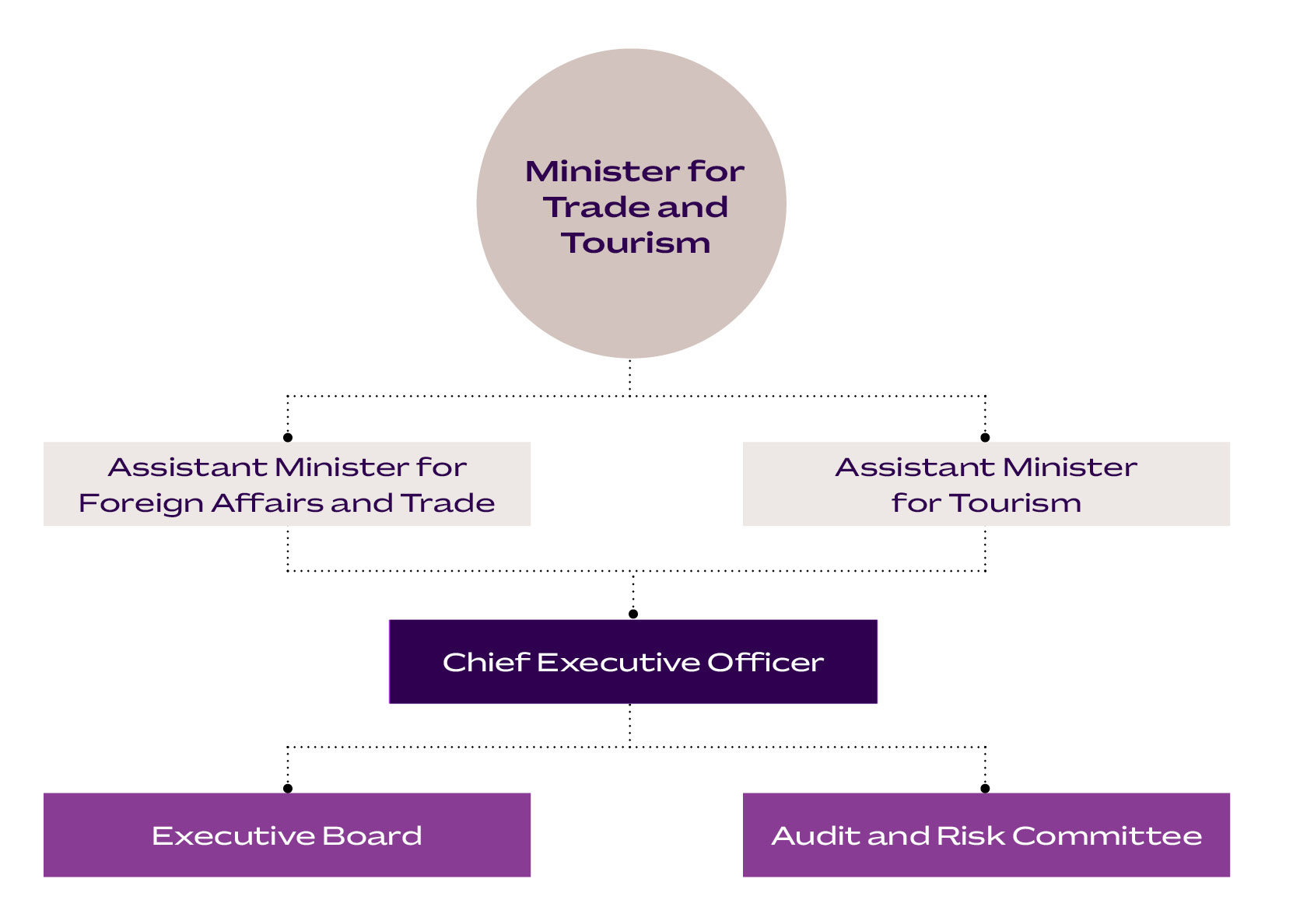

Enterprise risk framework
Section 16 of the Public Governance, Performance and Accountability Act 2013 requires Accountable Authorities to establish and maintain appropriate systems of risk oversight, management and internal control for the entity. Austrade’s risk management framework is guided by the Commonwealth Risk Management Policy.
At Austrade, risk management is led by the Chief Risk Officer, a role held by the Chief Operating Officer.
Our Audit and Risk Committee provides independent advice, support and oversight of our risk management function to the Accountable Authority through Executive Board.
Austrade operates a strong internal risk management framework and conducts risk management planning to support our agency’s objectives. Our risk management and reporting framework includes establishing risk context, undertaking risk assessments, setting risk tolerances and determining key enterprise risk focus areas.
We continue to focus on uplifting our risk management capability and culture to ensure we anticipate and respond effectively to changes in our environment, supporting risk-informed decision-making to pursue new opportunities.
In 2026, we will commence reporting of our exposure to climate risks and opportunities as required in the Commonwealth Climate Disclosure Policy. We will identify our climate risks, opportunities to contribute to reducing emissions and transitioning to cleaner energy, and the mitigations to minimise the impact these risks may have to our values and objectives.

Our key strategic risks and mitigations
Enterprise risks | Mitigation strategies
- Austrade does not deliver quality trade and investment services to businesses  - Austrade fails to provide quality policy advice to government to support the growth of Australia’s prosperity, including leading on national tourism policy.  - Austrade fails to administer Grant Programs efficiently and effectively on behalf of the government.  - Austrade fails to protect Australians in designated locations overseas through timely and responsive consular and passport services.  - Austrade’s system of internal control is ineffective.  - Austrade’s cyber security and information management controls are ineffective resulting in information and data being compromised.  - Austrade fails to meet its regulatory, legal, and ethical responsibilities  - Austrade fails to maintain a work environment and culture that supports employees’ health, safety, and wellbeing  - Austrade fails to adequately protect its employees and visitors from security threats at our work locations and whilst undertaking official duties. | - Close engagement with our clients and stakeholders to support the design and delivery of services  - Ongoing oversight by the CEO, Executive Board and second tier committees.  - Independent advice from the Audit and Risk Committee.  - Regular financial and performance reporting.  - Application of risk management, auditing, and reviews.  - Effective Governance, Security, Fraud Awareness, ICT, Work, Health and Safety, Capability and Leadership frameworks, with policies and procedures and training that support the delivery of operations and compliance with legislative and administrative requirements.  - Building a positive work culture through Australian Public Service Values, Code of Conduct and Austrade Values.  - Capability uplift with staff through education and training, improving the systems we use, and enhancing and streamlining risk management processes.

Acknowledgement of Country
In the spirit of reconciliation, Austrade acknowledges the Traditional Custodians of country throughout Australia and their connections to land, sea and community. We pay our respect to their Elders past and present and extend that respect to all Aboriginal and Torres Strait Islander peoples today.

Disclaimer
This document has been prepared by the Commonwealth of Australia represented by the Australian Trade and Investment Commission (Austrade). All dollar amounts included refer to Australian Dollars (AUD) unless otherwise stated.
Austrade has exercised due care and skill in preparing and compiling the information and data in this document. Austrade, its employees and advisers disclaim all liability, including liability for negligence and for any loss, damage, injury, expense or cost incurred by any person as a result of accessing, using or relying on any of the information or data in this document to the maximum extent permitted by law.
Austrade recommends the person exercise their own skill and care, including obtaining professional advice, in relation to their use of the information in this document for their purposes. The Australian Government does not endorse any company or activity referred to in the document and does not accept responsibility for any losses suffered in connection with any company or its activities.
Copyright © Commonwealth of Australia 2026
The material in this document is licensed under a Creative Commons Attribution – 4.0 International licence (CC BY licence), except for:
- any third-party material
- any material protected by a trademark
- any images and photographs.
More information on this CC BY licence is set out at the creative commons website: https://creativecommons.org/licenses/by/4.0/legalcode.

Attribution
Before reusing any part of this document, including reproduction, public display, public performance, distribution, dissemination, communication, or importation, you must comply with the Attribution requirements under the CC BY licence. Enquiries about this licence and any use of this document can be sent to: advisory@austrade.gov.au.

Using the Commonwealth Coat of Arms
The terms of use for the Coat of Arms are available from the It’s an Honour website (www.itsanhonour.gov.au).

Publication date: August 2026

International Monetary Fund: World Economic Outlook and Fiscal Monitor, April 2026
Lowy Institute Keynote Speech: Navigating Australia’s Trading Future, July 2025; Department of Foreign Affairs and Trade: A-EU FTA, Frequently Asked Questions, March 2026.
UN Trade and Development: Global Investment Growth, January 2026
Austrade’s trade outcome targets for 2026–27 have been increased to reflect Austrade’s strong performance of 2,000+ trade outcomes in prior years and increased trade activities resulting from additional Accessing New Markets Initiative (ANMI) funding.
Austrade will continue to monitor forward targets for 2027–28 onwards in the context of an uncertain global trade and investment landscape.

