Mongolian Mining Projects Report 2023

Introduction

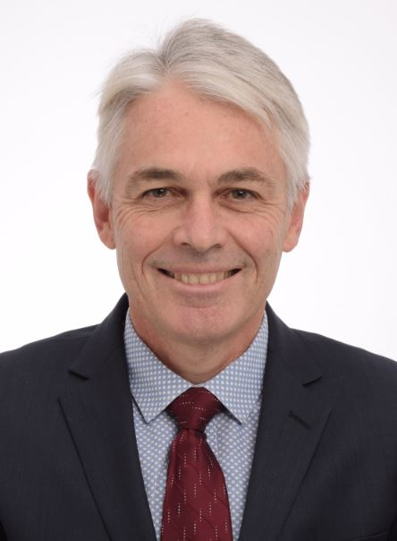
This report is a guide for Australian mining equipment, technology,
and services (METS) exporters considering doing business in Mongolia.
Mongolia has world-class deposits of copper, gold, coal, and iron ore,
and offers many present and future opportunities for Australian METS organisations involved in the mining value chain.
To assist Australian companies in accessing these opportunities the Australian Trade and Investment Commission (Austrade) has prepared this report. It examines market challenges, the mining landscape,
mining infrastructure issues, mining business and investment opportunities, and profiles some operating mines, planned mines and exploration projects.
We hope this publication will help you in undertaking your market
research into the Mongolian market. Should you need further information,
please contact Austrade on +976 70 133 001.
We wish you success in your business with Mongolia.
Regards
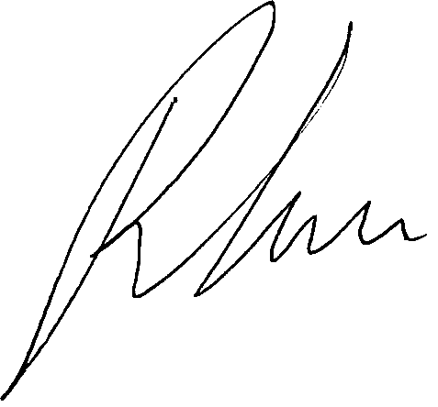

Ron Green
Trade Commissioner to Mongolia

Contents

About Mongolia 4
Mining landscape 20
Geological exploration work 33
Mining production 37
Mining business and investment opportunities 46
Mining industry production 48
Regulatory authorities 51
Operating mines 56
Planned mines 76
Major exploration projects 79
Links and resources 84
References 85
About Australian Trade and Investment Commission 86

Disclaimer
This document has been prepared by the Commonwealth of Australia represented by the Australian Trade and Investment Commission (Austrade). All dollar amounts included refer to Australian Dollars (AUD) unless otherwise stated. Austrade has exercised due care and skill in preparing and compiling the information and data in this document. Austrade, its employees and advisers disclaim all liability, including liability for negligence and for any loss, damage, injury, expense or cost incurred by any person as a result of accessing, using or relying on any of the information or data in this document to the maximum extent permitted by law.
Austrade recommends the person exercise their own skill and care, including obtaining professional advice, in relation to their use of the information in this document for their purposes.
The Australian Government does not endorse any company or activity referred to in the document and does not accept responsibility for any losses suffered in connection with any company or its activities.
Copyright © Commonwealth of Australia 2023
The material in this document is licensed under a Creative Commons Attribution – 4.0 International licence
(CC BY licence), except for:
- any third-party material
- any material protected by a trademark
- any images and photographs.
More information on this CC BY licence is set out at the creative commons website: https://creativecommons.org/licenses/by/4.0/legalcode.

Attribution
Before reusing any part of this document, including reproduction, public display, public performance, distribution, dissemination, communication, or importation, you must comply with the Attribution requirements under the CC BY licence.
Enquiries about this licence and any use of this document can be sent to: advisory@austrade.gov.au.
Using the Commonwealth Coat of Arms
The terms of use for the Coat of Arms are available from the It’s an Honour website (www.itsanhonour.gov.au).
Publication date: January 2023

About Mongolia

Location
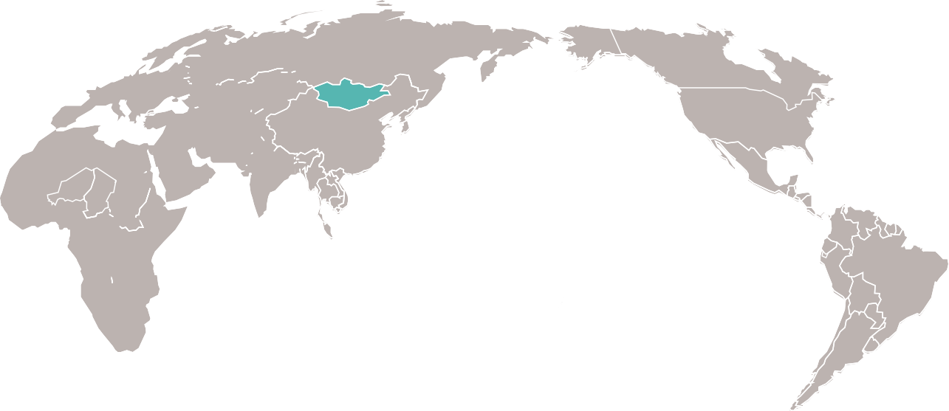
Mongolia is a land-locked country in the Northern-East Asia bordering with China with 4,673 km in the south and Russian Federation with 3,485 km in the north. It is located on average altitude of 1,580 meters above the sea level.

Territory
Territory of Mongolia is 1564.1 thousand square kilometres. In 2020, the population density was 2.1 persons per square kilometres at the national level and 339.8 persons per square kilometres in Ulaanbaatar city.
Mongolia is situated in the centre of Asia at 41 35’ – 52 08’ of the North altitude and at 87 44’ –119 55’ of the East longitude.
The total length of the Mongolian border is 8252.7 kilometres, of which 7351.6 kilometres is land border and 901.1 kilometres water border. Mongolia shares 3 543 kilometres border to the north with the Russian Federation of which 2 863 kilometres are land borders and 680 kilometres are water borders.
Mongolia shares 4709.7 kilometres border to the south with the People’s Republic of China, of which 4488.6 kilometres are land border and 221.1 kilometres are water border.
Mongolia has an average elevation of 1 580 meters above sea level. The highest point is Khuiten Mountain peak at 4 374 meters in the west and the lowest is Khukh Nuur Lake depression in the east, which lies at an altitude of 532 meters above sea level. The capital city Ulaanbaatar is 1 350 meters above sea level.
Population density is 2.1 people per km².

Landscape
The landscape has several distinct geographical features, including forest mountain ranges to the north, desert and low mountain areas to the south, high mountain ranges to the west and vast plains to the east. The climate is continental with hot summers and very cold winters.

History
Mongolia has had a significant impact on world history. The Hunnu empire (3rd century BC-4th century AD), Turkic kingdom and Mongol empire originated from this region, with the latter controlling most of Asia and parts of Europe in the 12th and 13th centuries.

Time
Time Zone: GMT +7 to +8 hours.

Climate
Mongolia’s climate can be described has highly continental dominated climate with warm summers and long, dry and very cold winters. Known as “the land of blue sky”, Mongolia is a very sunny country and has usually about 250 sunny days a year. The country has the world’s most typical continental climate with extreme diurnal and annual ranges of temperature. Average temperature in most of the country is below zero from November to March and close to it in April and October. Winter nights of -40°C are common most years (minimum recorded -55°C at the Uvs Lake). Summer extremes reach as high as+40°C in the Gobi Desert and +33°C in the capital Ulaanbaatar. Monthly temperature variations of +45°C and more are not uncommon in many regions of Mongolia.
Precipitation is scarce and is concentrated in summer, when the country is partly affected by the Asian monsoon; in winter, when a thermal high-pressure system dominates, the sky is often clear. Precipitation is more abundant in the north, where it exceeds 300 millimetres (12 inches) per year, while in the south, it drops below 200 mm (8 in) per year. During winter, snowfalls are frequent but usually light, in fact, they often create a thin white veil, which can be carried away by the wind.

Population
The total population of Mongolia in 2020 was 3, 357.5 thousand, of which 2, 316.5 thousand are urban population, and 1, 041.0 thousand are population in rural areas. In the same year the population of Ulaanbaatar was 1, 597.3 thousand. In 2020, the number of households reached 908.7 thousand, of which 67.3 % was living in an urban area and 32.7 % was residing in a rural area. The average household size was 3.6 persons. The sex ratio at birth was 105 boys per 100 girls in 2020. Life expectancy at birth is 70.71.

Ethnicity
Mongolia’s population is relatively homogenous in terms of ethnicity, language and religion. Its population is also relatively young with more than 63 % below the age of 35.
Mongolia is home to a wide range of Mongol ethnic groups. The 2020 Population and Housing Census highlights that 83.8% of the resident population of Mongolia were Khalkh, the dominant ethnic group of Mongolia. The Kazakh people, who are mainly concentrated in the northwest of the country in the western province of Bayan-Ulgii, made up 3.8% of the population.
Ethnic distinctions among the Mongol subgroups are relatively minor. There are also small groups of Turkic-speaking and other ethnic groups in the western and northern parts of Mongolia: Uyghurs, Uzbeks, Tuvans (or Tuvinians), Urianhais and Hotons. Their first language is Mongolian.

Language
The official language is Mongolian and is spoken by 95% of the population. In the west of country, Kazakh is also spoken by 5% pf the population.

Administrative setting
Mongolia is divided into 21 aimags (provinces) and the capital city, Ulaanbaatar. Aimags are divided into 330 soums (sub-provinces) which are further divided into 1,639 baghs (the smallest administrative unit under sub-provinces). The capital city, Ulaanbaatar, is divided into 9 districts which are comprised of 171 khoroos (sub-district).
At aimag level, government institutions mirror those at the national level. The central body at all levels of local Government is the Governor. The Governors are the representatives of the State and directly report to their respective higher-level Governors. The Governor of the aimag and the city is proposed by the respective hural and appointed by the Prime Minister.
Most of the country’s internal migrants over the past 30 years have moved from rural areas to the capital, Ulaanbaatar city, causing intensive urbanization and de-population of the countryside. Nearly half of the country’s population (47.8%) are now living in the capital, up from a little over a quarter (26.8%) in 1989.
Between 2010 and 2016 approximately 126,143 people arrived in Ulaanbaatar, bringing the total population to 1.4 million (2016).

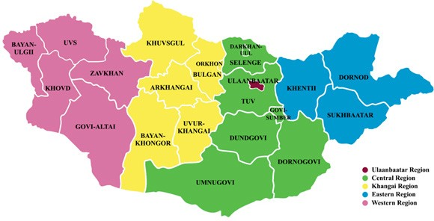
Figure 1: Mongolia Administrative Map (regions and aimags)

Political system
In 1990, with the collapse of the soviet bloc, Mongolia transitioned to a democracy and a free market economy. The new Constitution of Mongolia was adopted on January 13, 1992, and legalized the democratic form of government with a one-tier parliament and a presidential institution in Mongolia. The 1992 Constitution enshrines the concepts of democracy, freedom of speech, judicial independence and importantly, a market economy founded on a system of civil law.
Parliamentary elections are held once in four years and elect 76 Members of the Parliament. Furthermore, a local election is held every 4 years and the hurals of the citizens at the aimag, the capital, soum and district levels are established. The last Parliamentary Election were held in June 2020, where the Mongolian People’s Revolutionary Party (MPRP) won 62 seats in the 76-member parliament. The centre-right Democratic Party won 11 seats. The remaining two seats were secured by the Mongolian People’s Revolutionary Party (MPRP), by Right Party Electorate Coalition and by an independent candidate. Presidential election is held once every 6 years according to the Constitutional Amendment Law 2021 and the last election were held in June 2021.
There are 13 female Parliament members (in 2004, only 5 women were elected to the SGH). In 2020, 217 (19.6%) of the representatives elected to aimag, capital city and district representatives of citizens’ representative hural were women and 890 (80.4%) were men. The share of women in the representatives of citizens’ representative hural is 17.8% in the capital city, 29.9% in districts and 15.8% in aimags.
The President of Mongolia is a constitutional institution that plays a unique role in Mongolia’s political system and governance relations. The Constitutional Amendment Law states that the President is the head of state and the guarantor of the independence of the People’s Republic of Mongolia. The President of Mongolia is elected by the people through a free and democratic election held every 6 years. The President is the Commander-in-Chief and holds the power to veto legislation, although this can be overridden by a two-thirds majority in Parliament.
Executive power is exercised by the Government. The Judiciary is independent of the executive and the legislature. The Prime Minister is nominated by, and serves on behalf of, the majority party in the Parliament. The Cabinet is appointed by the Prime Minister. According to the Amendments to the 1992 Constitution, the Prime Minister have a sole authority to appoint Cabinet members without any approval by the Parliament.
There are 36 political parties officially registered by the Supreme Court, out of which two major political parties are the Mongolian People’s Party (MPP), which evolved from the communist single-party government, and the Democratic Party (DP), which grew out of Mongolia’s 1990 democracy movement.
Mongolia joined the United Nations on October 27, 1961. As of the end of 2020, Mongolia has diplomatic relations with 192 countries.

Economic overview
Mongolia’s extensive mineral deposits and growth in mining-sector activities have shifted Mongolia’s economy, which traditionally has been dependent on herding and agriculture. Mining, agriculture and service sectors are now the principal sectors in contributing to GDP. Growth has been spurred by the export of commodities such as gold, copper, and cashmere.
The economy is also highly dependent on trade with its neighbours. For example, Mongolia purchases 95% of its petroleum products and substantial amount of electric power from Russia, leaving it vulnerable to price increases. Trade with China represents more than half of Mongolia’s total external trade, with nearly 84% of Mongolia’s exports going to China.
Over the past decade, Mongolia has made important changes to its economic system, to become an open, dynamic market economy. Recent changes have also been introduced to its mining and investment legislation to generate stability for foreign investors.
Table 1: Selected key indicators, 2018-2020
Indicator | Unit | 2018-8 | 2019-8 | 2020-8
Economic Growth* | %age | 6.3 | 7.3 | -9.7
Balance of Payments** | Million.USD | -235.3 | -79.9 | -343.7
External trade balance | Million.USD | 869.2 | 1,295.8 | 1,025.6
Foreign exchange reserves** | Million.USD | 2,952.9 | 3,618.8 | 3,620.7
Inflation rate | %age | 7.2 | 8.1 | 3.4
Note: *First Half-year; **7 month Source: Ministry of Finance
Mongolia’s dependence on the mining sector has led to volatility, with recent GDP growth varying between 3 and 17 % in the last five years. The sector also contributes to 89 % of exports, one-third of the state budget, 22 % of GDP, and 70 % of FDI.
Table 2: Few selected indicators, 2020
 | Indicator | 2019 | 2020
 | GDP per capita | 4,450 USD | 4,125 USD
GDP | Total | 37,839.2 Bill MNT | 37,453.3 Bill MNT
 | Growth rate | 5.2% | -
 | Total | 26.8 billion USD | -
FDI
 | FDI | 2.9 billion USD
 | Trade balance | 1.5 billion USD | 2.2 billion USD
GDP | Export | 7.6 billion USD | 7.57 billion USD
 | Import | 6.1 billion USD | 5.29 billion USD
 | Inflation | 5.2% | 2.3%
Other Macroeconomic Figures
 | Policy interest rate | 11.0% | 7%
The Government of Mongolia therefore attaches great importance to diversifying its economy away from commodity exports. To this end it seeks to further develop its industrial (especially mining-related), agricultural and tourism sectors, as well as support sectors in banking and finance, and key infrastructure.

Figure 2: Mongolia’s GDP structure
Source: https://www.en.nso.mn
Foreign investment into Mongolia has increased significantly up until 2011 when it peaked its highest of USD 4.7 billion. According to statistics on foreign direct investment, since Mongolia adopted free market economy in 1990, a total of 14,200 foreign companies from 112 countries have been established and invested over USD 21.4 billion. However, FDI significantly decreased over the last couple of years both in terms of value and investors.
Figure 3: Foreign direct investments
Figure 4: FDI by country
Source: Mongol Bank, NSO, GASR
Mongolia improved in Doing Business 2020 and ranked 81 out of 190 economies.
Table 3. Ranks in Doing Business topics, 2020
Indicator | Ranking
Protecting investor | 25
Starting a business | 100
Registering property | 50
Getting credit | 25
Paying taxes | 71
Source: Doing business Mongolia, 2020, World Bank
Mongolia’s economic freedom score is 63.9, making its economy the 66th freest in the 2022 Index. Mongolia is ranked 12th among 39 countries in the Asia–Pacific region, and its overall score is above the regional and world averages.

Table 4. Economic Freedom Index
Indicator | Ranking
Business Freedom | 66.5
Trade Freedom | 74.4
Investment Freedom | 50.0
Source: 2022 Index of Economic Freedom
“Mongolia’s economy gathered steam in 2017 and 2018, slowed in 2019, and turned negative in 2020. Growth resumed in 2021. Economic freedom has improved during the past half- decade. Boosted by substantial score increases for fiscal health and judicial effectiveness, Mongolia has recorded an impressive 9.1-point overall gain of economic freedom since 2017 and has retained its position in the lower half of the “Moderately Free” category for two consecutive years.

Legal system
The Mongolian legal system is based on the Roman-German (continental) legal system. The principal legal act is the Constitution. The provisions of the Constitution, the laws corresponding to it, other regulatory acts, international treaties and other commitments of Mongolia, as well as regulatory resolutions of Constitutional Court and the Supreme Court, comprise the functioning law in Mongolia.
The Supreme Court is the highest judicial body and judges are nominated by the JGC, confirmed by the parliament and appointed by the President. The Supreme Court is constitutionally empowered to examine all lower court decisions, excluding specialized court rulings, upon appeal and provide official interpretations on all laws except the Constitution.
Specialized civil, criminal, and administrative courts exist at all levels and are not subject to Supreme Court supervision. At the apex of the judicial system is the Constitutional Court of Mongolia, the Tsets, whose jurisdiction extends solely over the interpretation of the Constitution.
Mongolia has specialized laws for contracts but no dedicated courts for commercial activities. Contractual disputes are usually adjudicated through the district court system. Disputants may appeal to the City Court of Ulaanbaatar and ultimately to the Supreme Court of Mongolia.
Mongolia has several specialized administrative courts adjudicating cases brought by citizens, foreign residents, and businesses against official administrative acts. Administrative Cases Courts deal with matters relating to public law but outside purely constitutional matters. The main function of the Administrative Cases Court is to review the constitutionality of the entire range of administrative action, particularly where it encroaches on basis rights. They deal with the area of law concerned with disputes between the public authorities and individuals arising from the exercise of public authority, including citizens and legal persons. This is regulated by the Law on Administrative Procedure. Any disputes which arise from an administrative act and which may affect a person’s rights, may be challenged before these courts. All areas of public life are covered: police, school regulations, roads, and the civil service.
Economic and business activities in Mongolia are regulated by a variety of laws, including the Civil Code (2002), Company Law (2007) and Law on Investment (2013).
Commercial Arbitration is based on Law of Mongolia on Arbitration, of which revision was enacted on 26 January 2017 by the Parliament of Mongolia with UNCITRAL Model Law on International Commercial Arbitration (1985). The Arbitration Law provides a clear set of rules and protections for Mongolia-based arbitration. Any
organization that satisfies the laws’ requirements can provide arbitral services.
The General Executive Agency for Court Decisions enforces judgments and orders.

Investment law
The Government of Mongolia has been taking an active policy to attract inward foreign direct investment since Mongolia has adopted a market economic system and has been persistently conducting a policy that stabilizes the legal environment of foreign investment and provides more favourable conditions for the investment procedures and regulations.
In 2013, the Government of Mongolia passed a new law on investment, which replaced both the old investment law of 1993 and the Law on Strategic sectors of 2012. The Investment Law eliminates the previous restrictions on private foreign investment, reduces governmental approval requirements for foreign state investment, introduces a simpler and more open investment process, establishes a new, dedicated agency to assist with the process and provides an array of investment incentives.
The 2013 Investment Law sets the general statutory and regulatory frame for all investors in Mongolia. Under the law, foreign investors may access the same investment opportunities as Mongolian citizens and receive the same protections as domestic investors. Investment domicile, not investor nationality, determines if an investment is foreign or domestic. The law provides for a more stable tax environment and offers tax and other incentives for investors; and authorizes a single point of registration, the State Registration Office (www.burtgel. gov.mn), for all investors. The Investment Law offers tax incentives in the form of transferable tax-stabilization certificates, giving qualifying projects favourable tax treatment for up to 27 years. Affected taxes may include the corporate- income tax, customs duties, value-added tax, and royalties.
Investors cite two primary national-treatment issues with respect to investment rules. First, foreign nationals and companies may not own real estate; only Mongolian adult citizens may own real estate. While foreign investors may obtain use rights for the underlying land, these rights expire after a set number of years with limited rights of renewal. Foreign investors also object to the regulatory requirement that each foreign investor in any given venture must invest a minimum of $100,000. Although the Investment Law has no such requirement, Mongolian regulators impose it on all foreign investors without requiring the same minimum from Mongolian investors.
The Mongolian National Development Agency’s One-Stop-Shop for investors provides services on investment data, visas, taxation, notarization, business registration, and government-business dispute resolution (http://nda.gov.mn/).
The law on investment provides incentives, such as tax exemptions, tax credits, longer terms to possess land, increased quota of foreign employees, simplified visa arrangements, and others. Only foreign state-owned entities (those with a minimum of 34% of ownership entities in the mining, media and communication, or financial sector) must obtain approval from an official government representative. The investment Law declares that a foreign state’s direct or indirect ownership exceeding 50% qualifies it as a foreign state-owned entity.

Investment types
- Joint Ventures, Consortium
- Mergers and Acquisition
- Concession (PPP), Product sharing, management contract
- Bond, Securities and other assets
- Financial leasing, Franchising
- Other Investment types
The Investment Law stipulates that a foreign entity must either be incorporated as a business entity with foreign investment (BEFI) or as a representative office in order to conduct any activity in Mongolia. A BEFI is defined as an entity that is incorporated in Mongolia and of which at least 25 % of the equity is held by a foreign investor(s) whose minimum contribution to the entity is US$100,000, per investor.
A representative office is defined as an entity that is established in Mongolia solely to operate as a representative office of a parent foreign entity.
Such an office does not have the power to earn revenue from business activities in Mongolia.
According to the Investment Law, “Stabilisation certificate” was introduced to create a more stable tax environment in Mongolia. Investors can stabilise applicable rates of the following taxes:
CIT, Customs duties, VAT and Mineral royalty tax. The holder of a stabilisation certificate will stabilise tax rates for period from five to eighteen years depending on amount of investment, industry of investment and geographic location of investment in Mongolia.
In addition, incentives in tax or non-tax forms are available to support foreign investors, as well as custom duty exemptions and VAT reductions for imported equipment and machinery during construction phase that met the following criteria:
- Construction of industry facilities/ plants for building materials production, oil, agricultural products processing plant and production facilities for exports products
- 2.nano, bio-technological production facilities
- 3. energy production and road construction.
Non-tax incentives include land leases of up to 60 years with possible one-time extension up to 40 years on a contract basis, preferential services (registration and checkpoints) to those investing in free trade zones or industrial and technological parks, exemption or ease of quotas on workforce and foreign specialists and employment permits and fees etc.
Mongolia ratified the Washington Convention and joined the International Centre for Settlement of Investment Disputes (ICSID) in 1991 and the New York Convention in 1994; and has accepted international arbitration in several disputes.

Taxation
Mongolia’s 2019 amendments to its General Law on Taxation, Corporate Income Tax, Value Added Tax, and Personal Income Tax laws entered into force on January 1, 2020. Businesses cite a decrease in the license-transfer tax for resource- use rights as especially significant. A 2017 change had imposed a tax of 30 % of the gross value of the transfer of rights involving land possession or usage, including exploration and mining licenses and rights for water, timber, pasturage, and land use in urban areas. While the new amendments lowered the fee to 10 % of the net rather than gross value, the tax continues to discourage investment in the resource sector.
The amendments also impose a tax of 5 % on the interest income of commercial Mongolian banks to be paid on loans and debt instruments obtained from local and foreign stock markets; decrease the withholding tax on income provided to non-residents to 15 %; lower from 20 % to 5 % the tax on dividends for foreign investors; and lower from 10 % to 5 % the tax on financing obtained through debt instruments from initial and secondary markets. They also simplify reporting procedures and provide relief for companies experiencing financial difficulties.
There are four principal tax laws affecting companies in the mining sector.
- General Law of Taxation – contains general provisions relating to tax but does not impose taxation. This also includes provisions regarding the administration of taxation, including
- the rights and duties of both taxpayers and administrators, and tax audit protocols.
- Mineral Law of Mongolia - contains provisions specific to the prospecting, exploration and mining of minerals, and also imposes royalties on mining licence holders.
- Corporate Income Tax Law - the provisions within this law apply to all companies; there is no separate corporate tax law for mining companies. CIT is levied only at the state level in Mongolia, no provincial or local corporate income taxes.
- VAT Law of Mongolia – an indirect tax relevant to all companies, with no separate section for miners.

Market challenges
There are some important market challenges in Mongolia that need to be considered in any market entry strategy.

Perception of foreign investment
Mongolians are more familiar with Russia and Eastern Europe than Western nations, as many have either lived or studied in these countries and are more likely to speak Russian than English. This is largely due to Mongolia having been a socialist republic and a command economy until 1990.
However, the educated younger generation is more favourable to the West, particularly among the increasing number of young Mongolians who have studied abroad.

Economic nationalism
Mongolians are more familiar with Russia and Eastern Europe than Western nations, as many have either lived or studied in these countries and are more likely to speak Russian than English. This is largely due to Mongolia having been a socialist republic and a command economy until 1990.
However, the educated younger generation is more favourable to the West, particularly among the increasing number of young Mongolians who have studied abroad.

Politicisation of process
From a mining perspective, it is often parliament rather than professional civil servants trained and qualified in specialised areas that determines what deposits are strategic. There are, however, a number of highly qualified and experienced advisers to the Prime Minister, President and Cabinet, covering areas such as foreign investment, mining legislation, royalties and taxation, and foreign affairs.

Bureaucracy
Mongolia inherited the Soviet system of bureaucracy that presided over a planned, command economy. During this era, the state bureaucracy managed the economy, and this legacy has largely continued despite the change to a free market economy. The degree of government intervention in the economy is high by Australian standards, and this is compounded by the overlapping of authorities and a lack of cooperation or coordination between departments in many areas. The bureaucratic process can be fluid, as government departments can unexpectedly change their requirements and procedures, for example, indefinitely calling a moratorium on all new exploration and mining licence applications.

Lack of skilled labour
There is a lack of skilled labour in Mongolia and exploration and mining companies often have difficulty finding labour to support their operations, including drilling, blasting, loading, haulage, processing, mine administration and IT support. Most companies invest in their own in-house training programs and infrastructure to support their operations, due to the limitations of vocational training and educational institutions in Mongolia. However, progress has been made in recent years, such as the Polytechnic College in South Gobi aimag, which has received support from Oyu Tolgoi. Oyu Tolgoi has also constructed a Mining School of Excellence in Nalaikh and upgraded and expanded Technical Vocational Education and Training (TVET) centres in Dalanzadgad, Choir and Darkhan city.

Technical skill shortage
Mongolia has a shortage of technical skills, especially in modern methods of mine management, mechanical engineering, process engineering, geology, hydrology and geophysics. The majority of available labour has tertiary qualifications based on the Russian curriculum and tends to have limited experience with equipment and processes outside Mongolia, Russia or Eastern Europe.

Environmental concerns
Although 40 % of Mongolians reside in the capital, the country is predominantly rural and there is still a strong connection to the land and concerns over mining companies’ intentions regarding the environment. Mining projects in the past have left some environmental damage and modern mining legislation and license conditions place considerable importance on environmental management.

Corruption
Corruption is a high risk for companies operating in Mongolia, stemming from political corruption and pervasive judicial corruption. Key anti- corruption legislation includes the Criminal Code and the Anti-Corruption Law, which prohibit active and passive bribery and the abuse of functions.
Facilitation payments are a grey area, and gifts are not expressly mentioned in the legislation but are likely to be considered bribery. The maximum punishment is up to ten years’ imprisonment and fines. Mongolia has ratified the United Nations Convention against Corruption.
Mongolia’s mining sector is perceived to be highly vulnerable to corruption. Most companies rate mining as among the sectors most vulnerable to corruption (Asia Foundation, Sep. 2015). Around 80 % of FDI has been directed towards
the mining industry; however, government involvement has disincentivized investors in recent years. Under the Minerals Law and the Nuclear Energy Law, the state is allowed to acquire equity stakes ranging from 34 % up to all of certain deposits deemed strategic for the nation, which often involves the mining sector (ICS 2015). Investors question the ability of the state to deal with the conflict of interest arising from being both a regulator and an owner-operator (ICS 2015). In 2013, a criminal court revoked 106 mining licenses that had been granted by an official found guilty of corruption (ICS 2015).
The Law on Regulating Public and Private Interests in Public Services and Preventing Conflicts of Interest requires officeholders and parliament members to declare their assets to the IAAC each year (BTI 2016). Despite some high-level prosecutions, there exist barriers to effective law enforcement. Mongolia is not a party to the OECD Convention on Combating Bribery but has ratified the United Nations Convention against Corruption.
The potential investor needs to be aware of complaints of corruption from foreign operators and investors in Mongolia. There have been claims of misconduct in mining licence applications and tender processes with foreign licence applicants often being informed that a local licence has already been granted for a property they are applying for, or an unexpected decision has been made to put the property out to tender.
Australian companies are advised to spend time investigating the market, obtain professional advice where appropriate and thoroughly investigate the issues to enter the market and establishing business relationships. Australian firms wishing to operate in Mongolia should commit to the highest level of corporate behaviour and familiarise themselves with Australia’s law and penalties pertaining to bribery of foreign officials.
Bribery of foreign public officials is a crime. Australian individuals and companies can be prosecuted in Australia for bribing foreign officials when overseas. For further information on the regulations governing bribery of foreign public officials, please visit: http://www.austrade.gov.au/ Export/About-Exporting/Legal-issues/Bribery-of- foreign-public-officials.
For further information on e-procurement, companies should visit the Government Procurement Agency of Mongolia website. Companies are strongly recommended to use a specialized due diligence tool on public procurement to mitigate risks associated with public procurement in Mongolia.
Mongolia is compliant with the Extractive Industry Transparency Initiative.

Setting up in Mongolia
Austrade looks forward to providing initial and ongoing support and advice; however, you will probably require a reputable third-party provider to accomplish the mechanics of setting up in Mongolia.
According to the Doing Business 2018 Rank by the World Bank, Mongolia stands at 59 in the ranking of 190 economies on the ease of starting a business8.The incorporation of a new business entity with foreign investment (BEFI) in Mongolia takes place at the General Authority for State
Registration and Intellectual Property of Mongolia. To register a new BEFI, the estimated time of preparing registration documents, obtaining a company name, opening a bank account and translation of documents is approximately 2-3 weeks⁹.
More information related to the registration of a company in Mongolia is provided on the website of the General Authority for State Registration and Intellectual Property in Mongolia, www.burtgel. gov.mn.

Education
Mongolia has a well-established education system, the literacy rate is high (98.4% in 2018), and 85% of the population has completed secondary school. The Human Development Index (HDI) is high, 0.74 at the national level in 2018. It is noteworthy that the HDI is higher for women than for men in Mongolia. The gross enrolment rate is 97.1 in basic education (1-9th grades) at the national level, which is similar for men and women.

Gender
Mongolia places 71st for Gender Inequality Index (GII) calculated by the UNDP for 162 countries on the basis of reproductive health, empowerment and labour market participation showings, and 92nd among 166 countries for the Gender Development Index (GDI) that measures gender inequalities in three basic dimensions of human development: health, education and command over economic resources.
The World Economic Forum’s (WEF) 2020 Global Gender Gap Report shows that the global average score for gender parity stands at 68.6% while Mongolia with its 70.6% indicator ranks 79th among 153 countries, and 7th among East Asia and Pacific region countries.
Mongolia is among 43 countries with low level of discrimination in social institutions. The improvement of Mongolia’s Gender Development Index (GDI) from 0.717 in 2005 to 1.046 in 2020 is largely explained by women’s average longevity and educational levels which are both higher than those of men. Despite this improvement, there are pressing issues in economic, social and environmental fields that demand urgent attention.

Economic participation and employment
Traditionally, employment of woman compared to man was high. The Mongolia ranks 53rd out of 159 countries in gender inequality globally and still most prime disadvantages of women employees is a social expectation, that women to do housework and child-caring.
By the end of 2017, 68.2% of men and 57% of women represented the entire Mongolian workforce. Women and girls dominate among graduates in universities, colleges and skills training and educational schools, but 16.3% of them remain unemployed. Women constituted 58.3% of unemployed, and men were dominant among graduates who became employed and paid regularly.
Labour force survey conducted in 2014 by the NSO revealed some gendered patterns and trends. These data affirm the conclusions made by World Bank, ADB studies that women prefer to work in secure paid employment in formal sector and they are more engaged in unpaid household work.

Wage gap
The 2015 Gender Gap Report reported it being 0.75. NSO data also shows a visible difference among professional groups and crafts workers.
Latest available data from 2019 shows that in Mongolia, the average worker earns MNT million month (Official exchange rate by Mongolbank: 1USD=2,848 MNT, as of October 2021) the highest paid economic sector is the mining and quarrying industry, where the average pay is MNT 2.3 million per month and the lowest paid economic sector is the service industry, where the average pay is MNT 0.6 million per month.
In 2019, the gender pay gap was reported to be minimal, however data reported at the lower administrative units show that the gender pay gap can be as high as 13%. Women continue to have a limited presence in higher-level managerial positions and in entrepreneurial work. Working women must also shoulder most of the household and care duties, unlike men.

Mining landscape

Resources
Mongolia is rich in mineral resources and has some of the world’s major mineral deposits including gold, copper, uranium and coal. Mongolia has substantial natural resources and minerals, which promise an unprecedented growth potential.
Mongolia is a one of the world’s leading mineral resources has over 8 thousand occurrences of 80 kinds of mineral deposits of 1,170 minefields. It includes 1619 gold, 227 thousand silver, 36.3 million copper, 660 million iron ore, 5.9 million zinc and 250 million tons of oil reserves. The biggest deposit is Erdenet copper mine, Oyu Tolgoi, Tsagaan Suvarga, Gatsuurt, Tavt, Asgat of gold, Bayangol, Tumurtei, Tumurtei Ovoo, Bargilt of iron ore. Mongolia accounts for 16.77% of the world’s reserves. On Jan 2019, the mining sector compounds 23.8% of GDP, 24.5% of national budget income, 71.8% of Gross Industrial output, 75.8% of FDI, 4.5% of workforce and 90.1% of export earnings.
The Mongolian mining industry consists of placer, sedimentary and hard rock, mineralised zones and ore bearing veins forms of mining. The types of mines that occur in Mongolia include open cut, underground, riverbank panning and washing.
Mongolia’s mineral wealth first began to be explored and exploited by the Russians after 1920, and later by Mongolians themselves.
Geological data gathered since the 1920s and exploration to date has proven vast mineral reserves, but only 30 per cent of Mongolia is covered by general exploration work and geological mapping is at a scale of 1:50,000.
Small-scale mining activities are usually placer with some hard rock operations. There are a number of illegal mining operations in this category that are largely unregulated by the central government, but usually have the sanction of the provincial governments (aimags). The majority of mines are medium-sized deposits. They are predominately legal operations that have obtained exploration and mining licences from the central government and have formal permits from the provincial authorities (aimags).

Table 5. Mineral reserves, 2019
Mongolia | Reserves
Gold (thousand ton) | 2.5
Zink (million ton) | 1.7
Iron ore (billion ton) | 1.2
Copper (million ton) | 57
Coal (billion ton) | 37.2
Uranium (thousand ton) | 197
Molybdenum (thousand ton) | 160
There are a small number of large-scale mines that are either Mongolian joint ventures with foreign companies or wholly foreign-owned. These mines have the relevant licences and permits and account for a large proportion of GDP, exports and employment in Mongolia. Some of these deposits have been designated as ‘strategic mineral reserves’ by the government of Mongolia and have special conditions attached to the licences.
Mining operations can operate in Mongolia by applying for and periodically renewing their exploration and mining licences with the Mineral Resources and Petroleum Authority of Mongolia.
Up until the 1970s, there was limited mining due to poor infrastructure, capital and technical capability. During the 1970s many significant mineral deposits were brought into production through joint ventures with Russian or eastern bloc countries. However, since 1990, the mining industry in Mongolia has expanded dramatically, particularly after the introduction of the Minerals Law of Mongolia of 1996, which saw an influx of foreign exploration companies.
The importance of the mining sector to the economy continues and contributes to higher proportion of the country’s GDP in the future.

Regulatory framework
The following main laws and regulations regulate mining and exploration related activities in Mongolia.
The relevant primary laws (as amended from time to time) are the:
- Minerals Law.
- Law of Mongolia on Prohibiting Mineral Exploration and Mining Operations at Headwaters of Rivers, Protected Zones of Water Reservoirs and Forested Areas of 16 July 2009.
- Law of Mongolia on Environmental Protection of 30 March 1995.
The relevant secondary laws are the:
- The Constitution of Mongolia of 13 January 1992.
- Law of Mongolia on Land of 7 June 2002.
- Law of Mongolia on Environmental Impact Assessment of 17 May 2012.
- Law of Mongolia on Commonly Distributed Minerals of 9 January 2014.
- Law of Mongolia on Nuclear Energy of 16 July 2009.
- Law of Mongolia on Protection of Cultural Heritage of 15 May 2014.
- Law of Mongolia on Subsoil of 29 November 1988.
- Law of Mongolia on Investment of 3 October 2013 (Investment Law).
- Law of Mongolia on Petroleum, 1 July 2014
- Law of Mongolia on Water (new amended version), 17 May 2012
- Law of Mongolia on Water Pollution Payment, 17 May 2012
- Law on Prohibition against Exploration and Mining in Headwater areas, Protected zones for Water Reserves and Forest Lands, 16 July 2009.
The Constitution of Mongolia was amended in 2019 in order to provide for equal access to the benefits of subsoil use for present and future generations, or the Principles of Sustainable Development. In accordance with the amendments to the Constitution, the Government of Mongolia has drafted the Law on the Wealth Fund, the Law on the Mining Exchange, and the Law on Mining-Based Heavy Industry and submitted them to the Parliament. The government has announced that it will revise the Minerals Law and submit it to parliament in 2022. The law is expected to support mining exploration, bring ESG and mine closure regulations up to international standards, and define policies on critical minerals.

Mineral Law
On July 1, 2014, the Mongolian Parliament passed the Law on the Amendments to the Mineral Law.
The Minerals Law (2006) regulates ownership of minerals, classification of mineral deposits, requirements of minerals license holders, state involvement and participation, licensing regulations, mining activities and their requirements, obligations of license holders including environmental, royalties and reporting, transfer and revocations of license, and dispute settlement.
The Minerals Law does not cover:
- Water.
- Petroleum and natural gas.
- Minerals with radioactivity.
- Commonly distributed minerals (such as sand, gravel and granite deposits that are commonly found and can be used for construction materials).
There are separate laws regulating the exploration and mining or production activities for these elements.

Other related laws
Relevant laws for the prospecting, exploration and mining of minerals in Mongolia include
- Law on protection of mineral resources
- General taxation law
- Law on Environmental Impact Assessment
- Law on Corporate Income Tax
- Law on customs tariff and customs duty.

Exploration and mining licences
There are two types of mineral related licences:
- An exploration licence, under which the licence holder can explore minerals in a designated area.
- A mining licence, under which the licence holder can mine and extract minerals, and keep the related benefits. Licences can only be held by legal entities that are registered in Mongolia.

Exploration licences
The moratorium on the issuance of new exploration licences has been repealed and the maximum period for an exploration licence has been extended from 9 to 12 years.
The Mongolian Parliament approved amendments to taxation and other relevant laws as part of 2018 Fiscal Budget, effective from January 2018. According to Corporate Income Tax Law, transfers of mineral licenses, including exploration or mining rights, are subject to 30% withholding tax on a gross basis. There is no restriction on the use of these licences as security for capital raising.
In February 2022, the government issued a new “exploration license” regulation to increase the number of new exploration licenses to be issued in Mongolia, which has declined over the past year. The regulation clarifies and simplifies the exploration licensing process, which will increase the number of licenses issued by about 100 per year by four to five times.

Mining licences
Mining licence holders are now obliged to:
- • supply products that have been mined, processed or semi-processed in preference to processing facilities operating in Mongolia at market price.
- • employ an employee to act as a liaison with the Mineral Resources and Petroleum Authority of Mongolia regarding environmental rehabilitation and mine closure.
The amendments specifically address the overlapping obligations of licence holders with obligations under the Petroleum Law with regard to coal bed methane. They are obliged to notify the Mineral Resources and Petroleum Authority of Mongolia if methane is discovered during coal mining and are permitted to produce coal bed methane in accordance with the Petroleum Law.

Licence terms
Exploration licences are granted for an initial three-year term and can be extended up to three times for additional three-year periods. The maximum period that an exploration licence can be held by a holder is 12 years from the date of initial issuance. Exploration licence holders must apply for an extension at least one month before the licence term is due to expire.
Mining licences are granted for an initial term of 30 years and can be extended twice for additional 20-year periods. MRPAM can decide whether to grant an extension depending on the minerals reserve. Licences for minerals with radioactivity are subject to a different regime. Mining licence holders must apply for their licence extension not less than two years prior to expiry.

Fees
Exploration licence holders must pay annual fees for each hectare of the licenced area, as follows:
- In the first year, the fee is MNT145 per hectare.
- In the second year, the fee is MNT290 per hectare.
- In the third year, the fee is MNT435 per hectare.
- In the fourth to sixth year, the annual fee is MNT1,450 per hectare.
- In the seventh to ninth year, the annual fee is MNT2,175 per hectare.
- In the tenth to 12th year, the annual fee is MNT7,250 per hectare.
Mining licence holders must annually pay MNT21,750 per hectare of the licenced area. The annual licence fee per hectare for deposits of limestone, coal and minerals designated for domestic production is MNT7,250. These fees must be paid in advance each year.

Liability and fees
Exploration licence holders must conduct exploration within the territory of the licences and their annual expenditure for each hectare must not be less than a specified amount depending on the term of the licence. The Minerals Law provides for the amounts in USD but payments of the fees must be made in MNT. The minimum expenditure is set out below:
- Second to third year, USD0.5.
- Fourth to sixth year, USD1.0.
- Seventh to ninth year, USD1.5.
- Tenth to 12th year, USD10.
(Article 33.1, Minerals Law.) The expenditure is verified by MRPAM who can conduct on-site inspections.
Both exploration and mining licence holders must enter into a community development agreement with the local administrative body. The purpose of this agreement is to:
- Protect the environment.
- Develop local infrastructure.
- Increase local employment.

Restrictions on transfer
Mining license holders and their contractors are encouraged to hire Mongolian citizens, and a quota for foreign staff is currently capped at 10% of the total number of employees.
Licence holders must also reimburse local citizens directly in full if they cause damage to local facilities or historical and cultural heritage during exploration and mining operations.
Licences on their own are generally not transferable by law. If a licence holder sells the associated exploration documents and reports to a third party (and pays the relevant tax), the MRPAM may register a change of the licence holder and register the licence in the name of the new holder. The same procedure applies to mining licences, but the licence holder must also sell mining assets to the buyer (in addition to the documents and reports). Licences can also be transferred through acquisition of shares in a company holding a licence, subject to the recent tax amendments or a corporate reorganisation under the Company Law of 2011 (such as a merger or separation).
The Minerals Law authorises the Mongolian Parliament to determine mineral deposits of “strategic importance”. If the deposit is or has been explored and developed using state funds, the government may hold up to 50% of the shares of an entity that is holding a licence over a deposit designated as being of strategic importance. If the deposit has been explored and developed by private entities, the state may hold up to 34% of the shares. Licence holders of a strategically important deposit must also publicly trade at least 10% of their shares on the Mongolian Stock Exchange.

Revocation of licences
Where a licence is revoked it must be reissued by tender except where the revocation is because the licence holder has failed to pay licence fees on time (or spend the minimum expenditure).

Preference for suppliers and customers
Mining licence holders must preferentially
- procure goods and services and hire subcontractors from business entities which are registered, and paying taxes, in Mongolia
- supply products that have been semi-developed, concentrated or mined from the mining licence site to processing facilities operating in Mongolia at prevailing market prices (Minter Ellison LLP, 2014).
In 2019 there were 6.1 million hectares of land licensed for exploration and mining as shown in Figure 3. Of this 6.1 million hectares, mining licences covered 3.6 million hectares and exploration licences covered 2.5 million hectares.
As of 31 December 2018, exploration and mining licences granted for 6.8 per cent of the whole territory, of which Figure 4 shows that 2565 valid licences for mineral resources had been registered in Mongolia, composed of 1,666 mining licences and 899 exploration licences (As of February 2022). Most mining licences in Mongolia have been issued for gold, various construction materials and coal (see Figure 5).
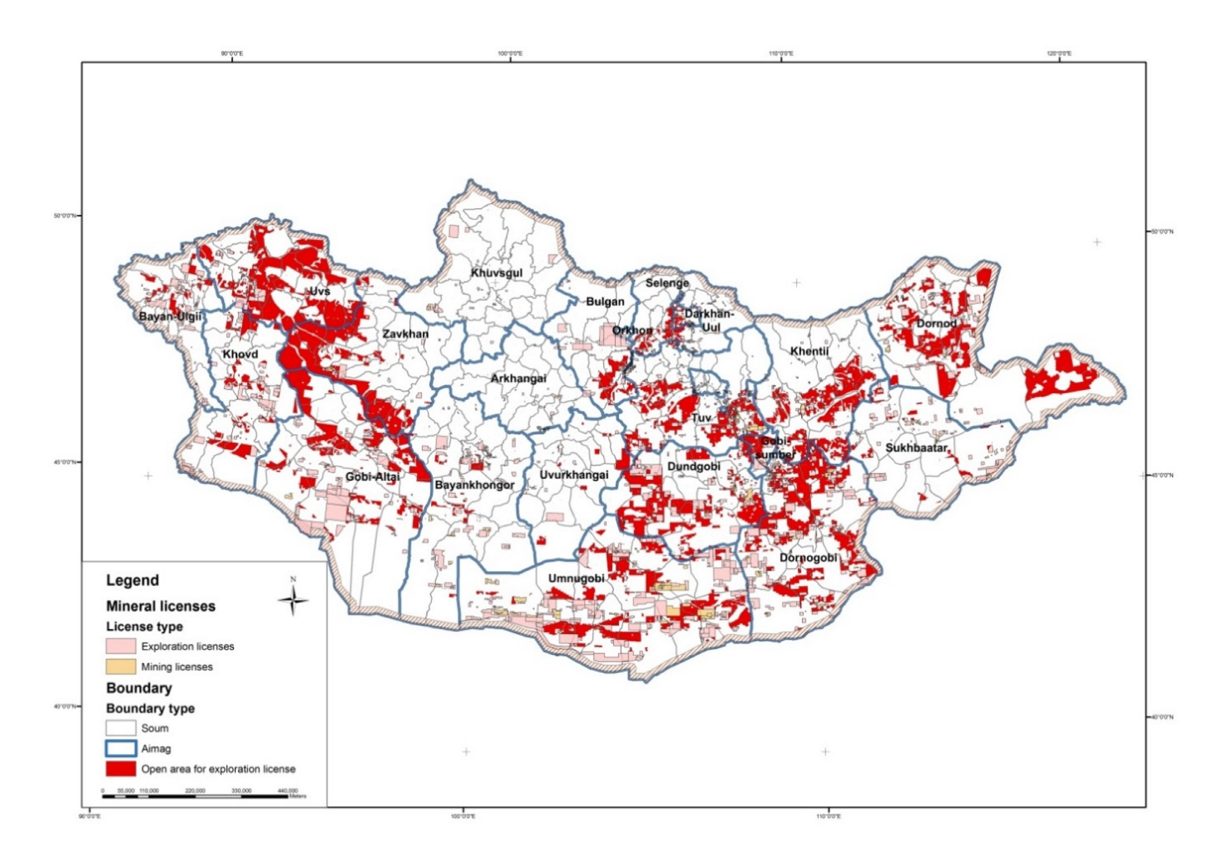
Figure 5: Granted licences in Mongolia
Source: MRAM Information Circular 2015, MRA
In 2019 there were 6.1 million hectares of land licensed for exploration and mining as shown in Figure 3. Of this 6.1 million hectares, mining licences covered 3.6 million hectares and exploration licences covered 2.5 million hectares.
As of 31 December 2018, exploration and mining licenses granted for 6.8 per cent of the whole territory, of which Figure 4 shows that 2565 valid licenses for mineral resources had been registered in Mongolia, composed of 1,666 mining licences and 899 exploration licences (As of February 2022). Most mining licences in Mongolia have been issued for gold, various construction materials and coal (see Figure 5).
Figure 6: Area of valid licences in million hectares from 2006 to 2018
Source: Monthly mining industry statistics, Feb 2019, MRPAM
Figure 7: Number of valid licences, 2008-2022 Q2
Source: Monthly mining industry statistics, Feb 2022, MRPAM
Figure 8: The structure of mining licences by types of minerals as of 04 January 2018
Source: Monthly mining industry statistics, Feb 2019, MRPAM
Table 6. Number of mining licence holders (100% foreign invested companies by countries)
 | Owner | License | Area/squire
 | Number | Number | HA | %
Total | 240 | 382 | 1,317,687.9 | 100%
China | 130 | 159 | 336,133.3 | 25.51%
Virgin Islands | 27 | 49 | 90,663.1 | 6.88%
Hong Kong | 15 | 30 | 88,754.9 | 6.74%
Singapore | 13 | 54 | 332,587.3 | 25.21%
Canada | 12 | 23 | 249,686.9 | 18.95%
South Korea | 9 | 11 | 15,762.9 | 1.20%
Australia | 4 | 4 | 22,097.0 | 1.68%
Russia | 4 | 5 | 2,490.4 | 0.19%
Great Britain | 3 | 4 | 6,038.7 | 0.46%
Netherland | 3 | 12 | 105,975.5 | 8.04%
Germany | 2 | 2 | 603.9 | 0.05%
Bermuda | 2 | 3 | 7,314.3 | 0.56%
USA | 2 | 4 | 2,442.3 | 0.19%
Japan | 2 | 3 | 3,015.1 | 0.23%
Luxemburg | 2 | 6 | 13,528.2 | 1.03%
Seashells | 1 | 1 | 375.2 | 0.03%
Russia & S.Korea | 1 | 1 | 118.2 | 0.01%
Virgin Islands & Singapore | 1 | 1 | 1,934.0 | 0.15%
Russia & China | 1 | 1 | 47.5 | 0.004%
Barbados | 1 | 3 | 9,183.0 | 0.7%
Great Britain and China | 1 | 1 | 54.2 | 0.004%
Thailand | 1 | 1 | 3,027.9 | 0.23%
Switzerland | 1 | 1 | 19,736.7 | 1.50%
Malaysia | 1 | 2 | 2,416.5 | 0.18%
Bulgaria | 1 | 1 | 3,700.9 | 0.28%
Source: MRPAM
Table 7. Number of mining license holders (Joint Venture companies by countries)
 | Owner | License | Area/squire
 | Number | Number | HA | %
Total | 88 | 131 | 248,183.9 | 100%
Mongolia-China | 41 | 58 | 94,903.3 | 38.2%
Mongolia-S.Korea | 9 | 13 | 24,174.0 | 9.7%
Mongolia-Russia | 8 | 12 | 3,929.1 | 1.6%
Mongolia-Virgin Islands | 5 | 7 | 24,174.0 | 10.0%
Mongolia-Japan | 4 | 7 | 13,338.9 | 5.4%
Mongolia-Germany | 3 | 4 | 5,911.9 | 2.4%
Mongolia-Singapore | 2 | 3 | 4,060.1 | 1.6%
Mongolia-Hong Kong | 2 | 7 | 23,454.2 | 9.5%
Mongolia-Czech Republic | 2 | 4 | 17,911.4 | 7.2%
Mongolia-Singapore-Hong Kong | 1 | 1 | 1,469.5 | 0.6%
Mongolia-Kazakhstan | 1 | 1 | 1,789.4 | 0.7%
Mongolia-USA-Virgin  Islands-S.Korea | 1 | 1 | 3,766.7 | 1.5%
Mongolia-Bulgaria | 1 | 3 | 1,083.7 | 0.4%
Mongolia-Great Britain | 1 | 1 | 1,472.0 | 0.6%
Mongolia-Canada | 1 | 1 | 3,957.7 | 1.6%
Mongolia-Canada-China | 1 | 1 | 6,352.8 | 2.6%
Mongolia-Luxemburg | 1 | 2 | 10,011.2 | 4.03%
Mongolia-Russia-Ukraine | 1 | 1 | 46.9 | 0.0%
Mongolia-Poland | 1 | 1 | 4,561.3 | 0.6%
Mongolia-Hungary | 1 | 1 | 87.4 | 0.04%
Mongolia-Hong Kong-Japan | 1 | 2 | 4,115.0 | 1.7%
Source: MRPAM
Looking at the nature of business ownership as of July 2018, 1,933 businesses owned the 2,736 licenses referred to in Figure 2. The dynamics of the ownership, licence holders and areas are shown in Table 7.
Table 8. Ownership of valid licences by investments as of Feb 2022
Owner | Owner | License | Area/squire
 | Number | Number | HA | %
Total | 1,646 | 2,565 | 6,221,599.2 | 100
Local | 1,317 | 2,052 | 4,655,727.3 | 74.8
100% foreign invested companies | 240 | 382 | 1,317,387.9 | 21.2
Joint venture companies | 88 | 131 | 248,183.9 | 4
Source: Computerised mining cadastre system, 2022, MRPAM
Figure 9: Number of licence holders as of February 2022
Source: Monthly mining industry statistics, Feb 2022, MRPAM

Geological exploration work

Geology
Within Mongolia, there are formations and sediments belonging to all different ages with Archean to Quaternary being identified. The area is structurally divided into Precambrian microcontinent massifs, Palaeozoic (Hercynian and Caledonian) fold belts that developed in the oceanic stage and structural basins, which were formed in the continental stage.

Geological mapping and general exploration work
Concerning geological mapping as of 2016, 33.7 per cent of Mongolia was covered via the 1:50 000 scale. As it stands with regards to the 1:200 000 scale, having fully incorporated all types of relevant geological and mining information into an integrated digital system, the state’s geological complex map covers 99 per cent or 1,548,301 square km of Mongolia.
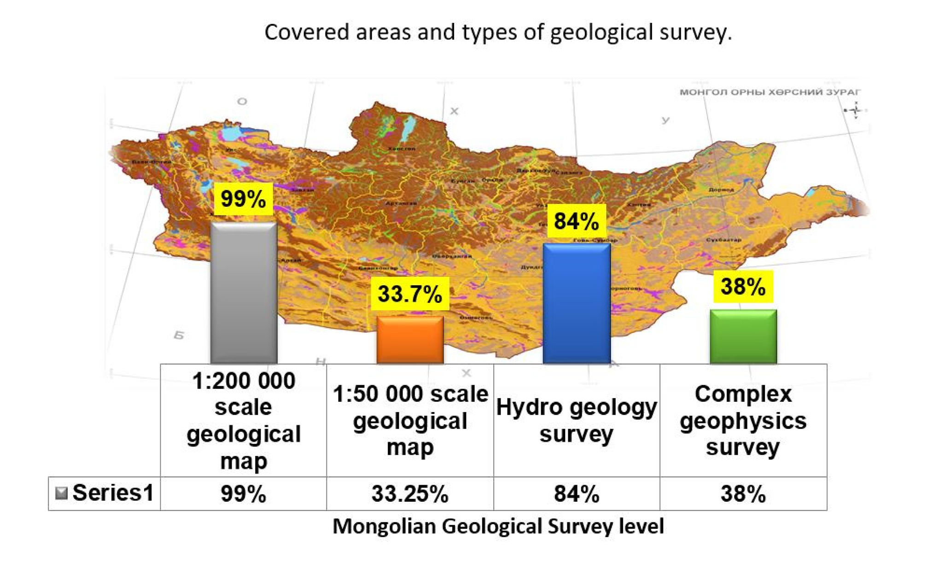
Figure 10: Covered areas and types of geological survey
Concerning geological and exploration activities undertaken by exploration licence holders, in 2020 120.2 billion MNT (approx. A$54.5 million) was spent by private organisations on geological exploration work which resumed to almost similar level of 2017 which was 130.5 billion MNT (approx. A$59.1 million) as shown in Figure 8.
Figure 11: Private investments in exploration works
Source: Monthly mining industry statistics, Jan 2020, MRPAM

Mineral resources reserves
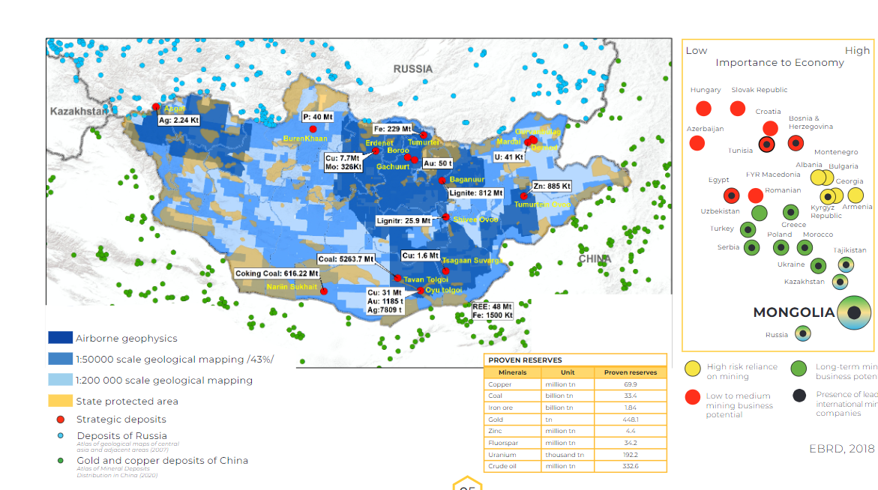
Mongolia has abundant mineral resources with unprecedented growth potential. As of 2018 there were 1,170 mineral deposits and over 8000 mineral occurrences with 80 different commodities discovered and recorded in Mongolia. The four largest types, and mentioned here in greater detail, are gold, copper, iron ore and coal.
Figure 12: Mineral potentials of Mongolia
Source: EBRD 2018

Gold
There are ten major gold bearing areas in Mongolia, with the main recoverable reserves being mineralised zones and placer deposits. As of 2014, there are 117 primary and 664 gold placer deposits with proven reserves, and 1763 occurrences had been identified. The deposits contain 3.29 thousand tonnes of reserves in categories A, B and C.

Copper
Mongolia is rich in porphyry copper deposits. Copper-molybdenum (Cu-Mo) mineralisation mainly occurs in three types, including copper (Cu) porphyries deposits; copper-nickel (Cu-Ni) magmatic segregations; and strata bound (Cu) deposits. There are 57 copper deposits and around 1180 copper occurrences and holds 60.7 million tonnes of reserves in categories A, B and C.
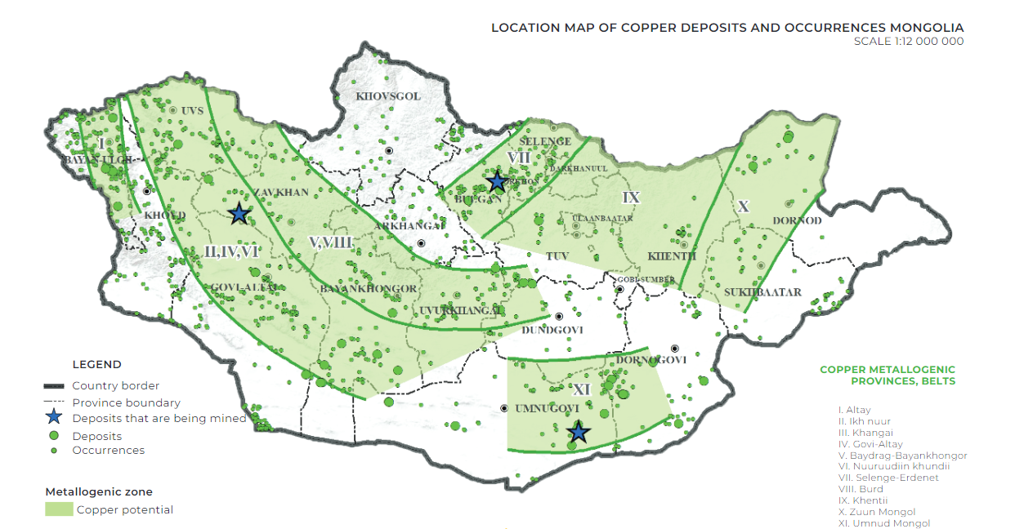
Figure 13: Copper deposits occurrences in Mongolia
Source: National Geological Survey of Mongolia 2022

Iron ore and industrial metals
71 iron ore deposits with proven reserves and 500 occurrences have been defined countrywide. The proven iron ore reserves of Mongolia are calculated to be 1.65 billion tonnes.
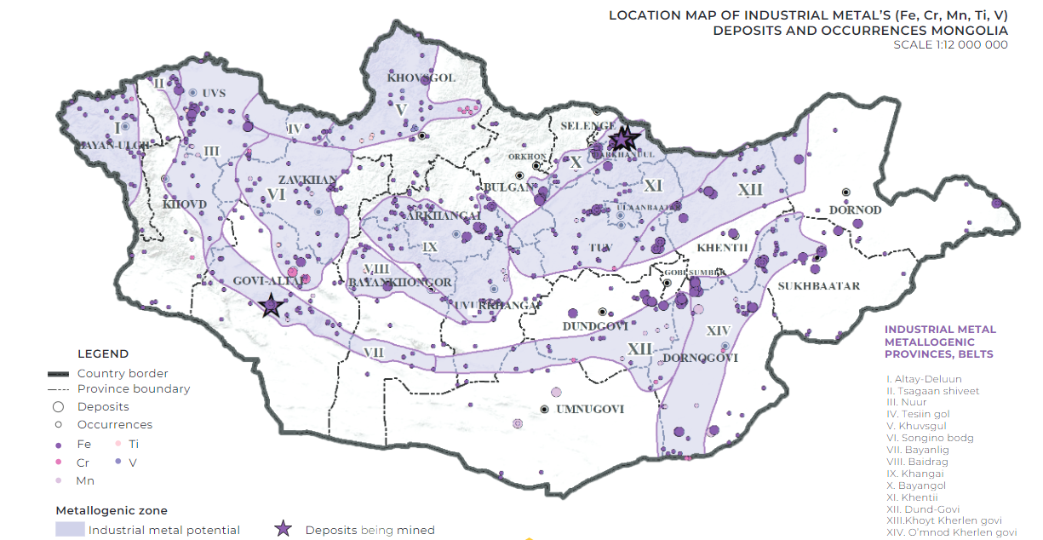
Figure 14: Industrial metals deposits occurrences in Mongolia
Source: National Geological Survey of Mongolia 2022

Coal
Coal occurs within units of intercalated sandstone, siltstone, and conglomerates. There are 160 coal deposits and 270 occurrences over 15 coal basins and 3 coalfields in Mongolia. As of the first half of 2013, the geological estimation of coal reserves had reached 173.3 billion tonnes (category P) and the reserves determined through more detailed exploration accounted for 26.8 billon tonnes (categories A, B and C). This places Mongolia in the top 10 countries for coal reserves.
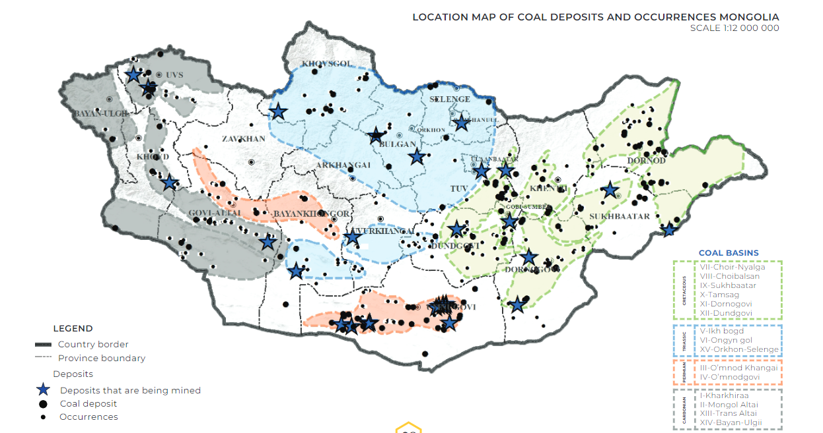
Figure 15: Coal deposits occurrences in Mongolia
Source: National Geological Survey of Mongolia 2022

Mining production

Production
In 2021, total production of the mining sector reached 10,448.0 billion MNT (approx. A$4.7 billion), which as shown in Table 8 represented a 19.8 per cent increase from 2020, and a 49 per cent increase from 2017. The sector’s contribution to the overall economy is illustrated in Figure 14. In 2018, the mining sector generated 21 per cent of GDP and 71 per cent of total industrial output.
Table 9. Production of the mining and extractive industry, in billion MNT, 2021
Mongolia | 2011 | 2012 | 2013 | 2014 | 2015 | 2016 | 2017 | 2018 | 2019 | 2020 | 2021
Gross Domestic Product | 13,174 | 16,688 | 19,174 | 22,227 | 22,895 | 23,931 | 28,011 | 32,583 | 37,839 | 37,453 | 43,019
Mining  sector | 2,536 | 2,743 | 2,849 | 3,661 | 4,150 | 4,823 | 7,008 | 8,371 | 9,590 | 8,722 | 10,448
Extractive sector production | 931 | 1,249 | 1,672 | 1,951 | 1,606 | 1,596 | 1,932 | 2,298 | 2,675 | 2,905 | 3,268
Industrial Production | 8,777 | 9,821 | 10,444 | 14,403 | 15,176 | 15,961 | 21,673 | 27,373 | 31,357 | 31,648
Source: Mining statistics by MRPAM, 2019
Figure 16: Share of the mining sector in the GDP and total industrial production,
2011-2018
Source: Mining statistics by MRPAM, 2020
In 2021, total production of the mining sector reached 10,448.0 billion MNT (approx. A$4.7 billion), which as shown in Table 8 represented a 19.8 per cent increase from 2020, and a 49 per cent increase from 2017. The sector’s contribution to the overall economy is illustrated in Figure 14. In 2018, the mining sector generated 21 per cent of GDP and 71 per cent of total industrial output.
Table 10. Production of main commodities of mining and extractive industry,
2016-2020
Mongolia | Unit | 2016 | 2017 | 2018 | 2019 | 2020*
Copper, with concentrate | x 1000 ton | 1,445.1 | 1,317.6 | 1,310.8 | 1,262.4 | 1,276.0
Molybdenum, with concentrate | ton | 5,174.4 | 5,759.6 | 5,486.1 | 5,302.8 | 6,147.7
Gold | ton | 18.4 | 19.8 | 20.7 | 16.2 | 20.2
Flour spar | x 1000 ton | 167.7 | 108.9 | 101.2 | 156.1 | 127.3
Iron ore | x 1000 ton | 4,936.2 | 7,694.7 | 6,225.4 | 8,572.2 | 9,224.4
Zinc concentrate | x 1000 ton | 100.2 | 82.7 | 87.9 | 83.1 | 76.3
Coal | x 1000 ton | 35,522.3 | 48,145.1 | 51,401.3 | 55,799.4 | 43,844.8
Source: Mongolian Statistical Yearbook 2020. NSO.

Processing and concentration
One hundred and eight plants operate throughout Mongolia processing minerals other than coal. Of those plants:
- 11 are involved in primary gold mines.
- 38 processing plants are involved in iron ore and over 10 of them are processing in a wet environment. The remaining plants process iron ore through the dry magnetic separation method.
- 20 mixed metal plants operate in Mongolia. Six of these plants are for lead-zinc, 4 are for copper-molybdenum, 5 are for copper-gold and 5 are for other commodities.
- 19 fluorspar plants.
- One silver, one zinc and one molybdenum processing plant are in operation.
- There are 4 tungsten and tin processing plants. (Mineral Resources and Petroleum Authority of Mongolia, June 2014)

Coal mining and processing
Coal is currently Mongolia’s most important commodity and Tavan Tolgoi has the one of the largest untapped coal reserves in the world. In 2018, 186 business entities own 319 special licences for coal mining. In 41 coalfields, 82 open pit mines are being used, which are made up of one state-owned, two majority state owned, three local government owned and the rest are private owned coal mines. (Mineral Resources Authority of Mongolia, 2015).
Figure 17: Coal mining and exports statistics, 2015-2022.II
Source: Monthly mining industry statistics, MRPAM, Feb 2022

Mining infrastructure issues
There are a range of infrastructure issues to be considered before investing in mining in Mongolia.

Climate
The extreme climate of Mongolia impacts the quality of road, rail and air transport in the mining sector. Mongolia is effectively frozen for six months of the year (October - March), with temperatures regularly descending below - 40өC. At the other end of the spectrum (April - September), summer temperatures in the Gobi Desert can reach over 50өC. The summer is also a relatively wet season and can bring sudden river flooding and impassable roads. This makes for a challenging operational environment, where some areas frequently cannot be accessed for long periods of time and a lack of preparation can have serious consequences. The most reliable form of transport for heavy haulage is rail, although this is not without its challenges.

Transport hubs and shipping
Mongolia is a landlocked country and there are issues getting people and freight in and out of the country. There are essentially three main transport hubs: Chinggis Khaan International Airport in Ulaanbaatar, Sukhbaatar Railway Station at the Mongolian-Russian border, and Zamyn Uud Railway Station on the Mongolian-Chinese border. Sea freight to Mongolia passes through either Tianjin in China (1,344 km from Ulaanbaatar) or Nakhodka (4,037 km from Ulaanbaatar), both of which have a bonded warehouse for Mongolian freight. From these ports the bulk of the freight is sent by rail, the remainder by road.
The New Ulaanbaatar International Airport in Khushig Valley in Sergelen soum of Tuv Aimag is an international airport built with the ODA loans and technical assistance by JICA. The new airport replaces existing Chinggis Khaan International Airport in Buyant Ukhaa, Ulaanbaatar. Initially scheduled to open in 2016 but repeatedly postponed, the airport commenced operation in on 4 July 2021.
Operation of the new airport has been entrusted to a private enterprise for the first time in Mongolian airport business. The New Ulaanbaatar International Airport LCC which received capital from a group of Japanese companies (Mitsubishi Corporation, Narita International Airport Corporation, Japan Airport Terminal Co., Ltd, JALUX Inc.) and a Mongolian state-owned enterprise, has concluded a concession contract with the Mongolian government. It is expected that the new airport will be operated in a safe and reliable manner based on the technical cooperation it has received. It is anticipated that the new airport will act as a gateway for the people and goods of Mongolia and that it will fulfil an important role in developing its economy. JICA will continue cooperation by providing Mongolia with high quality infrastructure to assist growth and to promote Mongolia’s sustainable economic development and stable social progress.

Roads
Total length of the road network 111 942.4 km in 2020, of which 11 963.8 km are improved roads while the remaining 99 978.6 km are dirt roads.
Mongolia is connected to the Asian Highway Network through three routes - the AH-3 (Altanbulag-Ulaanbaatar-Zamiin Uud), AH-4 (Yarant-Khovd-Ulgii-Ulaanbaishint) and AH-32 (Sumber-Undurkhaan-Ulaanbaatar-Tsetserleg-Uliastai-Khovd-Ulgii-Ulaanbaishint). The AH-3, of which the Project is a part, connects Russia-Mongolia-China and is a vital part of the “Economic Corridor” of the three countries. The AH-3 route runs for 1,029.6 km within Mongolian, and passes through the major economic region of Mongolia, including industrial, agricultural and livestock farming regions. One of the main aims of upgrading the AH-3 road is to improve its ability to accommodate freight transportation through the vertical axis Altanbulag-Ulaanbaatar-Zamin Uud.
The most of the provincial centers are connected by paved road, but not the districts (soums). Total length of state road is 15,231 kilometres long, of which paved road is 6,234 kilometres. However, this limited connectivity of road network often makes travel within the country lengthy and hazardous. The roads are subject to major surface damage due to the severe seasonal changes which include flooding, snow drifts and ice and these poor road conditions effect driving ability, which are often compounded by a disregard for road rules. New mineral roads are planned or under construction in the mining-intensive Umnugovi Aimag.
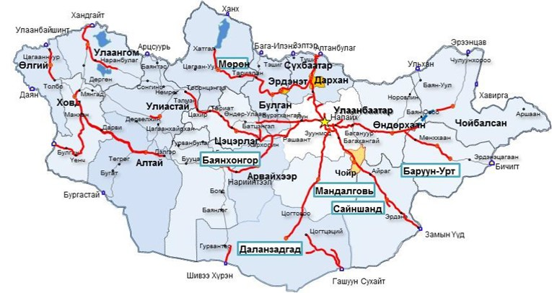
Figure 18: Mongolia’s road network

Railways
The Mongolian rail network comprises 1,815km of broad-gauge track, of which 1,110km is the Trans-Mongolian line that runs north-south and links Russia to China. Another 239km represents a separate Eastern Mongolian network that connects with the Russian network. The balance of 477km consists of spur lines of these two main lines, one of which connects the Erdenet Mine to the Trans-Mongolian line.
The railroad and rolling stock are owned and operated by a Mongolian-Russian joint venture. The diesel locomotives and rolling stock are Russian and are generally reliable. A considerable amount of freight runs through Mongolia from Russia to China and vice versa, including timber, oil, coal, copper–molybdenum, iron ore, manufactured goods and consumer products.
Rail projects in Mongolia have been heavily influenced by geo-politics. The Mongolian rail track gauge is the same as Russian broad gauge, whilst China uses narrow gauge. Consequently, all rail stock requires a change of gauge at the Chinese border, causing freight delays.
By its resolution #121, dated 3 November 2012, the Government of Mongolia provided rights to “Mongoliin Tumur Zam” state owned company to implement 2 -tage new railway project program (projects). Total of 1800km length new railway is planned for southern and eastern parts of Mongolia requiring 6-9 billion USD investment. It is expected that current transportation costs will decrease 4 times and capacity would increase up to 30 million tons annually in each line.
The 1st stage of the program is planned for implementation in 2018-2024, and test commissioning is expected in June 2022 at Tavan Tolgoi-Gashuunsukhait and Tavan Tolgoi -Zuun Bayan lines.
- Tavan Tolgoi – Gashuunsukhait 250 km (concession) Capacity: 30 million tons
- Tavan Tolgoi – Zuun Bayan 415 km (concession) Capacity: 30 million tons
- Zuun Bayan-Khangi (Concession) Capacity: 30 million tons

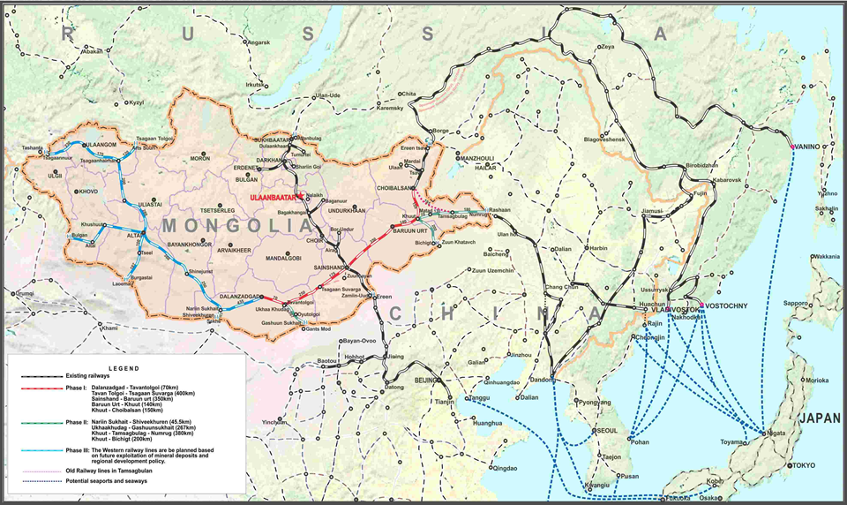
Figure 19: Rail network
Source: Mongolian railway company www.mtz.mn/content/show/id/1015

Aviation
All airports in Mongolia experience frequent closures due to extreme weather conditions, including strong winds, sand or snow storms, or visibility problems caused by excessive air pollution. Air charter services using turboprop aircraft are available out of Ulaanbaatar to service exploration and mining projects, and the quality of the planes and pilots is good with most having Russian training and qualifications.
Airfreight to Mongolia is expensive and costs can be as high as US$30 per kilogram depending on the route and carrier. The main carriers are Mongolian Airlines (MIAT), Aero Mongolia, Hunnu Air, Easiness Air China, Aeroflot, Turkish Airlines, and Korean Air, Air Busan, Angara Airlines, Asiana Airlines. All have wide-bodied aircrafts. These carriers have regular services to Beijing, Seoul, Osaka, Hong Kong, Tokyo, Irkutsk, Moscow, Berlin and Frankfurt. From 03 June 2019 Kazakhstan’s SCAT Airlines starts direct flights between Ulaanbaatar and Nur-Sultan, a previously known as Astana. According to the Ministry of Roads and Transportation, over the past five years, foreign airlines have accounted for more than 40 percent of all international passenger traffic.
As for the local market, “MIAT” JSC, “Aero Mongolia” LLC, “Hunnu Air” LLC operated scheduled and unscheduled flights, and “Mongolian Airways” LLC operated charter flights. Of the total local passengers, 19 percent are scheduled passengers and 81 percent are chartered or mining passengers.

Communications
The telecommunications network covers all 21 provincial centres (aimags) and most of the districts (soums) of Mongolia. Domestic and International calls can be made from anywhere in these areas via fixed land lines. There are four mobile operators providing services using GSM, CDMA and 4G technologies. These mobile networks cover all aimag and soum centres. Calling outside of mobile and fixed line networks is possible using satellite telephones. Broadband Internet is available in all aimags and some soum centres, but it can be a challenge to access the Internet in remote parts of Mongolia.
According to the NSO, there are 6294.6 thousand mobile cellular telephone registered users, and 3 907.2 thousand permanent internet users.

Power
In 2018 Mongolia’s total installed capacity of electricity power generation was 1,122 megawatts (MW) with the majority (90%) of the electricity being generated from coal fired thermal plants, followed by renewables (mainly wind) (6%). The remainder is supplied by diesel and hydropower stations, which each account 2% of the total electricity generation in Mongolia. Renewable energy sources, including hydroelectric dams, wind and solar, share in the total electricity generation has increased over the last few years, from just 1% in 2013 to about 4% in 2016 and almost 7% by 2018.
Mongolia is a net exporter of energy mostly through coal export, but it is a net importer of electricity. There has been an increase in the electricity demand in the country following economic development over the last decade.
The Unified Power System of Mongolia consists of four independent systems, shown in Figure 18:
- Western Energy System covering Bayan Ulgii, Uvs and Khovd aimags;
- Altai-Uliastai Energy System for Zavkhan and Govi Altai aimags;
- Eastern Energy System Dornod and Sukhbaatar aimags; and
- CES covering all other aimags – where the Project is located.
The CES, where the Project is located, is the largest system in the country covering key population and industrial areas, covering electricity supply to 80% of the total territory of the country and 72% of the total population. Around 20% of its demand is supplied from imports from neighboring countries (15% from China and 5% from Russia). It is run by NPGT.
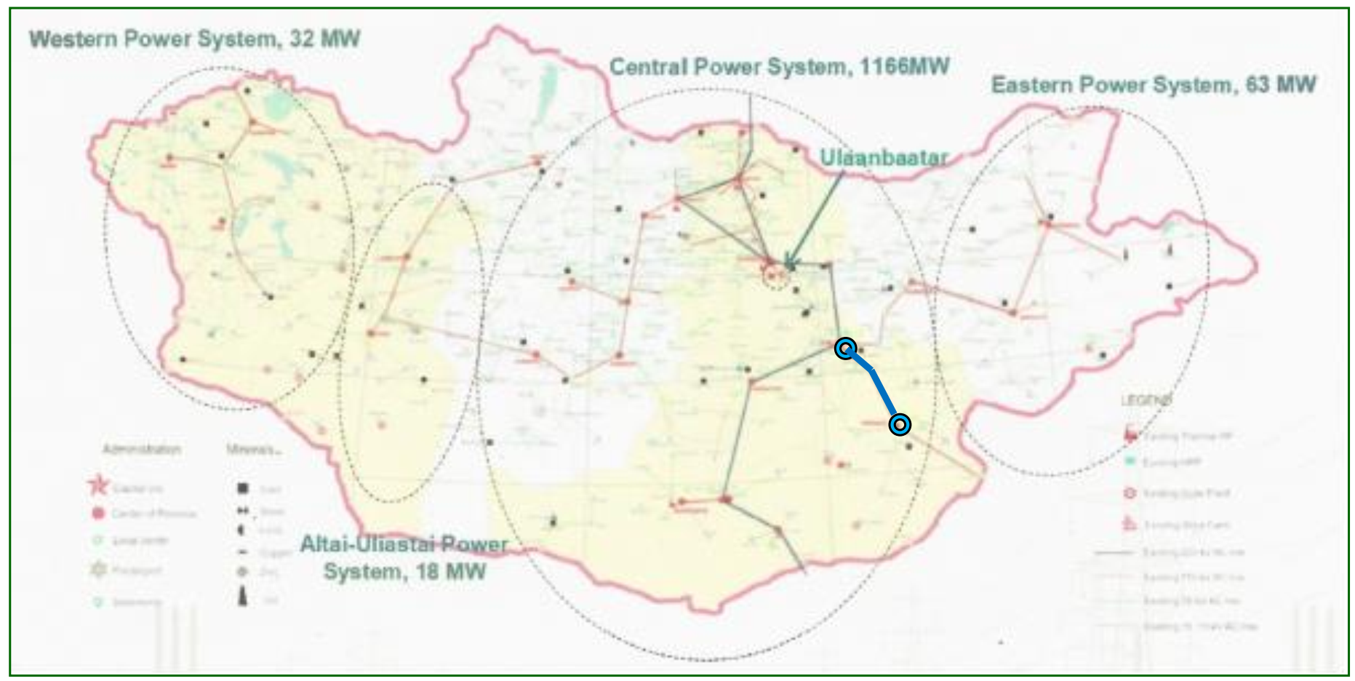
Figure 20: Electricity generation and transmission systems in Mongolia

Water
Mongolia is an arid country; the northern and western regions may enjoy 250-400mm of annual rainfall and surface flows occur, but mean annual rainfall in the southern Gobi Desert is limited to 70mm. Under these conditions groundwater presents the best, and in some instances only, water source.
Several projects and mines under development have established water security from groundwater sources, following significant investment and time in exploration and testing, as is demanded under local regulations and to meet international standards. Some sources lie more than 50km from the project centre.
Within the framework of the “New Rehabilitation Policy”, the “Blue Horse” national program will be initiated, and work will be carried out to irrigate pastures, supply water to the Gobi region, recycle gray water, create lakes and ponds, and rehabilitate dried rivers, streams, springs and streams.

Mining business and investment opportunities
There are a number of opportunities for Australian companies in the Mongolian mining sector. Australian goods and services have a good reputation in the Mongolian market, and there is strong brand awareness across all segments of the market.

Equipment and consumables supply
Opportunities exist for Australian suppliers to supply larger Mongolian, foreign-owned and joint-ventured projects at the higher end of the market, as these companies have higher operational standards and are quality conscious. Small, mid-sized local operators tend to be more price sensitive and purchase a greater volume of their equipment and consumables from China, although there is a growing appreciation for quality versus cost in this segment of the market. To take full advantage of these opportunities it is critical to establish a market presence.

Technical services
There are opportunities for technical services in the Mongolian mining sector, particularly in the fields of engineering, geology, hydrology, geophysics, mine software, technical training and environmental management. Foreign miners currently employ the majority of these services, but there are successful examples of Australian companies working with Mongolian miners and the Government.

Vocational training
With regards to large scale mining projects and the agreements between mining companies and the government, a ratio of Mongolian worker to foreigners has been stipulated, which has created demand for skilled workers. Mongolia’s vocational training sector is adapting to meet the needs of modern mining, but the present system still is based on theoretical based learning. Opportunities exist for the provision of education for trades, followed by mine safety and operations. Opportunity also exist to partner with local TVET institutions, government and mining companies who require skilled labour. Key areas that require development are: curriculum development, teacher training and development, and management of facilities, staff and students.

Higher education
Opportunities exist for foreign universities with a strong mining focus to partner with local institutions to help raise the standard of learning and better equip graduates to meet the needs of a modern mining sector. A common remark from foreign mining companies is that Mongolian graduates would benefit from a bridging year at institutions in countries such as Australia, to raise them to the standards acceptable to modern mining companies.

Direct investment
Mongolia has some of the most significant mineral deposits in the world. Only 30 per cent of the country has been fully geologically surveyed, and of this more than 6,000 significant deposits of 80 different minerals have been discovered. This situation alone makes Mongolia one of the more attractive countries for green field exploration and mining.

Non-mining opportunities
As the mining sector lifts the wealth and development of Mongolia, increasing demands will be placed on other sectors to meet the needs of these projects and an advancing economy. Large mine sites in the South Gobi region and the equally prospective reserves in the northern region, require a vast range of supporting infrastructure and services. Examples include mine-to-market rail design, construction and operations, urban planning, and health and medical infrastructure and services.

Mining industry production
Table 11. Production of Mining Industry, (2020-2022.II)
Main commodities | Unit | 2012 |  | 2014 |  | 2016
 |  | Plan | Report | Plan | Report | Plan | Report
Gold (Total) | kg | 15,888.90 | 14,481.60 | 46,146.60 | - | 11,875.40 | -
Gold | kg | 4,809.80 | 6,142.30 | 34,975.90 | - | 4,900.60 | -
(by product at concentrate) | kg | 11,079.10 | 8,339.30 | 11,170.60 | - | 6,974.80 | -
Gold (Total of placer g.m and r.m) | kg | 4,678.10 | 3,036.00 | 4,793.50 | - | 4,747.60 | -
Construction material
Clay | x1000 tonne | 246.60 | 48.10 | 125.70 | - | 560.00 | -
Clay rock | x1000 tonne | 1,187.70 | 308.00 | 1,360.70 | - | 1,269.80 | -
Clinker | x1000 tonne | 814.00 | - | 26.60 | - | - | -
Cement | x1000 tonne | 869.20 | 1,557.00 | 1,950.00 | - | 1,890.30 | -
Crystal | x1000 tonne | 61.80 | - | 6.10 | - | - | -
Marble | x1000 tonne | 252.90 | 2.60 | 256.80 | - | - | -
Gypsum | x1000 tonne | 166.60 | 97.90 | 173.50 | - | 117.40 | -
Tungsten | tonne | 621.70 | - | 1,628.90 | - | 602.90 | -
Copper | x1000 tonne | 1,275.20 | 1,267.60 | 1,420.20 | - | 1,170.30 | -
Manganese | x1000 tonne | 129.10 | - | 208.70 | - | 75.60 | -
Molybdenum | x1000 tonne | 4.70 | 6.00 | 5.00 | - | 5.00 | -
Silver | kg | 12,761.90 | 2,946.00 | 9,890.70 | - | 10,898.30 | -
Silver concentrate | x1000 tonne | 194.60 | 201.50 | 7.80 | - | 6.90 | -
Silver (by product with other products) | kg | 65,000.10 | 27,478.30 | 73,329.30 | - | 63,080.00 | -
Iron | x1000 tonne | 15220.5 | 9947.6 | 15166.9 | - | 8377.1
Iron ore  (coarse concentrate) | x1000 tonne | 5,087.50 | 2,943.60 | 5,162.50 | - | 3,603.50 | -
Iron ore (fine concentrate) | x1000 tonne | 6,769.20 | 2,435.60 | 7,308.40 | - | 4,773.60 | -
Iron ore (coarse ore) | x1000 tonne | 3,260.90 | 2,900.50 | 1,002.00 | - | - | -
Iron ore (fine ore) | x1000 tonne | 103.00 | 1,668.00 | 1,694.00 | - | - | -
Uranium | tonne | 22.30 | 1.30 | 29.80 | - | 8.30
Fluorspar | x1000 tonne | 2,207.40 | 490.10 | 2,200.70 | - | 547.20
Lead | x1000 tonne | 16.40 | 26.00 | 17.20 | - | 16.60 | -
Tin | tonne | - | - | 26.80 | - | - | -
Zink | x1000 tonne | 129.60 | 126.10 | 112.90 | - | 91.80 | -
Zeolite | x1000 tonne | 105.20 | - | - | - | - | -
Coal | x1000 tonne | 91,710.50 | 43,355.00 | 100,571.0 | - | 91,646.00 | -
Source: MRPAM Monthly report Feb.2022

Regulatory authorities
The Ministry of Mining and Heavy Industry is in charge of implementing mining-related government policies and laws, and can approve regulations on mineral resources exploration and mining.
MRPAM grants mining and exploration licences and monitors the operations of licence holders. The registration of licences and licenced areas is maintained by MRPAM. Security over the licences is registered with the MRPAM and it may terminate licences based on grounds specified by law.
The Ministry of Environment and Tourism approves environmental protection plans for mining and exploration licence holders. Without approval, the licence may be subject to termination or suspension.

Ministry of Mining and Heavy Industry
The Ministry of Mining and Heavy Industry develops and implements mining sector related legislation, policy and strategy, as well as providing information, recommendations and supports to the Minister and Government in all relevant matters. Furthermore, the Ministry provides oversight and analysis on sector policy, planning, coordination and policy implementation. It also conducts outcome assessments and ensures effective use of budget and investments as well as coordination within the sector.
Figure 21: Organizational chart of Ministry of Mining and Heavy Industry:

Minister
Deputy Minister

Division of Geological policy |  |  | Division of Mining policy |  |  | Division of Petroleum policy |  |  | Division of heavy industry policy |  |  | Division of study and investment policy |  |  | Division of monitoring, assessment and internal auditing
Department of geological study and planning |  |  | Department of technology and technical issue |  |  | Department of regulation of petrolium policy implementation |  |  | Department of infrastructure |  |  | Department of study and statistics |  |  | Department of digitilization policy and information technology
Division of Administration

Department of legal issue |  |  | Division of Finance |  |  | Department of Forreign cooperation

Mineral Resources and Petroleum Authority of Mongolia
The Mineral Resources and Petroleum Authority of Mongolia (MRPAM) is an implementing agency of the Government of Mongolia. Its purpose is to support the administration of the mineral resources in formulating development of policy, to provide required information and create a favourable environment to increase investment in the mining sector. MRPAM also provides services related to exploration and mining licenses in order to implement the governing Minerals Law.
The Mineral Resources and Petroleum Authority works in concert with other government agencies on environmental matters related to mining.
Figure 22: Organizational chart of MRPAM
Coal research Division
Mining and technology Division

Chairman

Board of Chairman

Vice Chairman

Vice Chairman

Legal Division
Minerals Information and Technology Division
Monitoring, evalutation and Stats Division
Public Administration and Management Division
Petroleum Extraction Division
Petroleum Products Division
Heavy Industry and Technology Division
Central Lab for Minerals and Petroleum
Geology Division
Mining and technology Division
Coal research Division
Cadastre Division

Address: Government Building 12, Barilgachdyn Talbai 3, Chingeltei District, Ulaanbaatar
Phone: +976 51 263926
Fax: +976 11 310370
Website: www.mrpam.gov.mn
E-mail: info@mrpam.gov.mn

National Geological Office
The National Geological Office have functions to discover mineral resources by conduct in thorough research of subsoil minerals regardless of mineral types with geology, geochemistry, and geophysical methods. Moreover, the office manages registration of at the state database, carry out state-funded geological research, make mineral analysis, build national geology and mineral database, enhance it, and serve interested people with information except for classified documents.
Figure 23: Organization Chart of National Geological Office

National Geological Office

Minister of Minin and Heavy Industry

Head

Science, technological committee
(with 11 members)

Management Committe
(with 7 members)

Deputy Head (Chief Geologist)

State geological institional review team
(with 22 members)

Stratigraphical commission
(with 20 members)

Department of State  Administration Management |  |  | Department of study planning, economics for resources |  |  | Department of Geological research |  |  | Center of Information |  |  | Central Archive of Geological Document
Source: (https://ngs.gov.mn)

Some formatted documents/drawing/information can be obtained from the central archive/information centre.
Table 12. Service tariffs
Mongolia | Layers of maps | Digital  (*.shp format)  Cost. avr (AUD) | Digital  (*.shp format)  Cost. avr (AUD) | Printing  Cost avr  (AUD)
A map of Geophysical methods | 1: 5 000 000 Magnetic surveys | 23.00 $ | 7.00 $ | 7.00 $
 | 1: 5 000 000 Gravity surveys | 23.00 $ | 7.00 $ | 7.00 $
 | 1:5 000 000 Accretion and collision | 46.00 $ | 9.00 $ | 9.00 $
 | 1:3 200 000 Magnetic surveys | 92.00 $ | 9.00 $ | 9.00 $
 | 1:3 200 000 Gravity surveys | 92.00 $ | 9.00 $ | 9.00 $
A map of Geology | 1: 1 000 000 Geological map  (with note/explanation), year of 2000 | 115.00 $ | 9.00 $ | 69.00 $
 | 1: 1 000 000 A map of tectonic  (with note/explanation) year of 2004 | 91.00 $ | 9.00 $ | 69.00 $
 | 1: 1 000 000 A map of tectonic Mesozoic Cenozoic | 137.00 $ | 45.00 $ | 91.00 $
 | 1: 1 000 000 Mesozoic Cenozoic for minerals | 137.00 $ | 45.00 $ | 91.00 $
 | 1: 1 000 000 A map of geomorphology | 137.00 $ | 45.00 $ | 91.00 $
A map of minerals | 1: 1 000 000 A map of minerals (Construction material, salt, metals, metallurgical coal, thermal coal etc., any of kind) | 137.00 $ | 46.00 $ | 113.00 $
 | 1: 500 000 A map of geology | 450.00 $ | 92.00 $ | 113.00 $
A map of Geological mapping, general exploration | 1: 200 000 State geological complex map (geological, distribution, predictable, mineral resources | 450.00 $ | 68.00 $ | 9.00 $
 | 1:50 000 State geological complex map (geological, distribution, predictable, mineral resources, sampling, geomorphological, factual, Mop graphical | 318.00 $ | 68.00 $ | 9.00 $
A map of ASTER Satellite Imagery | 1: 50 000 (package, 3D with spectral bands) | 364.00 $ | 27.00 $ | 23.00 $
 | 1: 200 000 A map of Landstat | 68.00 $ | 34.00 $ | 18.00 $
 | 1: 50 000 A map of Centinel | 32.00 $ | 34.00 $ | 18.00 $

Operating mines
The Ministry of Mining and Heavy Industry is in charge of implementing mining-related government policies and laws, and can approve regulations on mineral resources exploration and mining.
MRPAM grants mining and exploration licences and monitors the operations of licence holders. The registration of licences and licenced areas is maintained by MRPAM. Security over the licences is registered with the MRPAM and it may terminate licences based on grounds specified by law.
The Ministry of Environment and Tourism approves environmental protection plans for mining and exploration licence holders. Without approval, the licence may be subject to termination or suspension.

Copper
01. Erdenet Mine Copper and Molybdenum
02. Oyu Tolgoi Mine Copper and Gold

Coal
03. Baganuur Mine Thermal Coal
04. Khushuut Mine Coking and Thermal Coal
05. Naryn Sukhait Mine Coking Coal
06. Ovoot Tolgoi Mine Coking Coal
07. Shivee Ovoo Mine Thermal Coalz
08. Tavan Tolgoi Mine Coking Coal
09. Ukhaa Khudag Mine Coking Coal

Iron Ore
10. Bargilt Mine Iron Ore
11. Bayangol Mine Iron Ore
12. Tumurtei Mine Iron Ore

Gold
13. Bayan Airag Mine Gold and Silver

Flourspar
14. Bor-Undur Mine Flourspar Zinc
15. Tumurtiin Ovoo Mine Zinc
Operating Mine # 1
Name of mine | Erdenet Mine
Mineral mined | Copper (Cu) and Molybdenum (Mo)
Location | Bayan-Undur Soum, Orkhon Aimag, 400km northwest of Ulaanbaatar.
Ownership | Erdenet Mining Corporation is 100 per cent owned by the Mongolian Government
Operator of mine | Erdenet Mining Corporation LLC (EMC)
Web address | www.erdenetmc.mn
Production commenced | Operations started in 1978
Mining operation  (mining equipment) | Conventional shovel-truck open pit mining.  Excavators: LIEBHERR-994B, EKG-10, EKG-15,  Haulage: Belaz-75130, BelAZ-75473 and BelAZ-7648  Loaders: Komatsu WA800 and WA-600, LIEBHERR L-581  Drills: SBSH250-32  Grader: CAT -16H  Dozer: Komatsu D-275A; 824G, WD-500
Production | Production commenced
Mineral reserves and ore grade | Estimated reserves: 1.5 billion tonnes  Grade: Cu 0.526; Mo 0.0188
Production capacity | Mining: 32 mln tonnes of ore per year (extension project going under construction and capacity will increase up to 35 mln tons of ore per year)
 | Processing: Over 569 thousand tonnes of copper concentrate and 3,000 tonnes of molybdenum concentrate per year. The mine has a Solvent Extraction Electro Winning Plant which is capable of producing 3,000 tonnes Cu cathode annually.
Total number of employees | Approximately 6,000
Infrastructure | Erdenet is connected by railway to the East-Siberian railway network and to the Chinese railway network. It is also connected by a paved road to Bulgan aimag and Darkhan and Ulaanbaatar cities. The infrastructure surrounding Erdenet is well developed.
Production for 2020 | 26 mln tonnes of ore; 530,000 tonnes of copper concentrate;
Contact | Name: Mr. G. Ganbat  Position: General Manager, Development Department  Address: Administrative Building II, Nairamdal Square, Bayan-Undur soum, Orkhon Aimag, Mongolia  Email: ganbat@erdenetmc.mn  Telephone: + 976 1-352-73726

Operating Mine # 2
Name of mine | Oyu Tolgoi Mine (open pit and shifts to underground)
Mineral mined | Copper (Cu) and Gold (Au)
Location | Khanbogd Soum of Umnugovi Aimag, approximately 550 km south of Ulaanbaatar, 80 km north of the Mongolia-China border
Ownership | 34 per cent of OT LLC is owned by the Government of Mongolia, while the other 66 per cent is held by Turquoise Hill Resources, 51 per cent of which is owned by Rio Tinto.
Operator of mine | Oyu Tolgoi LLC
Web address | www.ot.mn
Production commenced | 2013
Mining operation (mining equipment) | Conventional shovel-truck open pit mining.  Excavators: Bucyrus 495HR and Bucyrus 340  Haulage: Komatsu 930E  Loaders: Komatsu WA 1200  Drills: Atlas Copco PV351 and Sandvik DR580  Grader: CAT 16M  Dozer: Komatsu DT375 and Komatsu DT475
Mineral reserves and ore grade | Measured and indicated at CuEq 0.37 per cent, Cu 14,616,714klbs; Au-7,674koz; Measured and indicated at CuEq 0.22 per cent, Cu 772,148klbs; Au-821koz
Production capacity | Concentrates produced 722,500 tonnes; Concentrate sold: 724,300 tonnes  (in year 2017)
Total number of employees | 12,364 as of Q4’2020
Infrastructure | There is limited public infrastructure. All major infrastructure for operation was developed in the construction phase (2010-2013). This includes: paved roads from the mine to the Chinese border, water pipelines, power lines to the Chinese grid, a central heating plant and an international standard airport. OT and Government of Mongolia signed Power source framework agreement on Dec 31, 2018 to build power plant based on Tavan Tolgoi coalfields.
Production for 2021 | Production of copper in “749,600 tonnes” concentrates: 163,000 tonnes of copper; gold in concentrates: 468,000 ounces; silver in concentrates: 977,000 ounces
Contact | Name: Mr Otgonbayar  Position: GM Business Development  Address: Monnis Tower, Chinggis Avenue 15, Ulaanbaatar  Email: procurement@ot.mn  Telephone: +976-11-331880  Fax: +976-11-331890

Operating Mine # 3
Name of mine | Baganuur Mine
Mineral mined | Thermal coal
Location | Baganuur District, which is 130 km east of Ulaanbaatar.
Ownership | Mongolian Government owns 75 per cent and 25 per cent is privately owned.  75.00 % owned by Erdenes Mongol LLC  21.06 % owned by Mongolian Coal Corporation LLC  3.94 % owned by other minor shareholders
Operator of mine | Baganuur JSC
Web address | www.baganuurmine.mn
Production commenced | Operations started in 1978
Mining operation  (mining equipment) | Excavators: ESH20/90, ESH15/90,ESH10/70, ESH13/50, EKG10, EKG8  Dump trucks: BelAZ-7555, CAT 777, CAT773, KOMATSU-HD405  Drills: Sandvik D45KS, Russian SBR A-160
Mineral reserves and ore grade | 800 mln tonnes of B type brown coal
Production capacity | Mining: 4 mln tonnes of coal per year
 | Processing:N/A
Total number of employees | 1128 as of 31 Dec 2020
Infrastructure | Connected by paved road and railroad to Ulaanbaatar. Fully supplied with electric power, water and heating.
Production for 2020 | 4.051 mln tonnes of thermal coal  Overburden: 17,838 thous bcm  Rate: 4.7  Caloric value: 3,508 kCal/kg
Contact | Name: Mr. Enkhbat  Position: Head of Department  Address: Baganuur LLC, Baganuur District, Ulaanbaatar 12150  Telephone: + 976 70210114  Fax: + 976 70213130

Operating Mine # 4
Name of mine | Khushuut Mine
Mineral mined | Coking coal and thermal coal
Location | Darvi soum of Khovd Aimag, 1500 km west-southwest of Ulaanbaatar and 310 km northeast of the Bulgan border crossing between Mongolia and China.
Ownership | Mongolia Energy Corporation Limited, (HK Stock Exchange listed)
Operator of mine | MoEnCo LLC, Mongolia
Web address | www.moenco.mn  MEC (mongolia-energy.com)
Production commenced | From 1971 as a government owned mine, from 2007 operated by MoEnCo LLC
Mining operation (mining equipment) | Open cut mine with conventional shovel and truck fleet operated by mine-contractors: Monnis Mining Equipment LLC (Mongolia), Altain Zam LLC (Mongolia) and Shin Jiang Lu Di Van LLC (China).
Mineral reserves and ore grade | 87.9 million tonnes of coal

Operating Mine # 5
Name of mine | Naryn Sukhait Mine
Mineral mined | Coking and thermal coal
Location | Gurvan Tes Soum of Umnugovi Aimag, 849 km southwest of Ulaanbaatar and 56 km north of the Mongolia-China border.
Ownership | Mongolyn Alt (MAK) Corporation
Operator of mine | Mongolyn Alt LLC
Web address | www.mak.mn
Production commenced | Operations started in 2007
Mining operation  (mining equipment) | Excavators:  Bucyrus RH 170 and Bucyrus RH 120  Komatsu 2600  Haulage: BelAZ -75306 and BelAZ 75131  Drills: Sandvik D75KS  Sandvik D45KS  Atlas Copco DML E
Mineral reserves and ore grade | 229 mln tonnes of semi soft metallurgical coal resources
Production capacity | Mining: 8 mln tonnes of coal per year
 | Processing: 1 mln tonnes of coal per year
Total number of employees | 750 employees
Infrastructure | 96km of power transmission line was completed between Ceke and the Mongolia-China border in 2007. 55km of paved road was also commissioned between the Shivee Khuren border point to Naryn Sukhait property in 2010.
Contact | Name: Mr.Khaliun.P  Position: General Manager  Address: Peace Avenue -14, Ulaanbaatar, Mongolia  Email: alterdene@mak.mn  Telephone: + 976 75759700  Cell Phone: + 976 88072885  Fax: + 976 70107481

Operating Mine # 6
Name of mine | Ovoot Tolgoi Mine
Mineral mined | Coal
Location | Within the administrative units of Gurvantes and Noyon Soums in Umnugobi Aimag. The mine is located approximately 40km from the Shivee Khuren-Ceke border point, crossing at the Mongolia-China border.
Ownership | SouthGobi Resources Ltd (the largest shareholders are China Cinda Asset Management Corporation Limited and China Investment Corporation, both of them are state-owned financial institutions in China)
Operator of mine | SouthGobi Sands LLC
Web address | www.southgobi.com
Production commenced | April 2008
Mining operation  (mining equipment) | Conventional open cut mine with two Liebherr 996 (33m3 & 36m3) hydraulic excavators, three Liebherr R9250 (15m3) hydraulic excavators, 22 MT4400AC (218 tonne capacity) haul trucks and two Terex TR100 (91 tonne capacity) haul trucks, together with various pieces of ancillary equipment.
Mineral reserves and ore grade | Measured and Indicated: 302.2 Mt coal as of 31 December 2016
Production capacity | Mining: 9 mln tonnes of coal per year
 | Processing: Coal wash plant commenced in 2018
Total number of employees | 444 employees as of 31 December 2018
Infrastructure | Connected to China by paved highway
Exports for 2021  (2nd half) | 0.1 mln tonnes of coal for exports (due to COVID-19)
Contact | Name: Munkhbat Chuluun  Position: Vice President of Public Relations  Address: 8th Floor, Monnis Building, Orgil Stadium 22, Great Mongolian State Street, 15th khoroo, Khan-Uul District, Ulaanbaatar 17011 Mongolia  Phone: +976 70070710  Fax: +976 70070720

Operating Mine # 7
Name of mine | Shivee Ovoo Mine
Mineral mined | Thermal coal
Location | Gobi Soum, Gobisumber Aimag, 260 km south east of Ulaanbaatar
Ownership | 90 per cent owned by the Government of Mongolia and 10 per cent owned by other shareholders
Operator of mine | Shivee - Ovoo JSC
Web address | www.shivee-ovoo.mn
Production commenced | Operations started in 1990
Mining operation (mining equipment) | Excavators: ESH25/90, ESH 11/70, EKG5A  Dump trucks: 16 units BelAZ-7555, CAT 777, KOMATSU-HD405  Drill: 2 units Sandvik D45KS, Russian SBR A-160  Other: Dozers, graders etc.
Mineral reserves and ore grade | 646.5 M tonnes of B-2 type brown coal
Production capacity | Mining: 2 mln tonnes of coal per year
 | Processing: N/A
Total number of employees | 510
Infrastructure | Connected by paved road and railroad with Ulaanbaatar. Fully supplied with electric power, water and heating.
Contact | Name: Mr Erdenebayar B  Position: General Technologist  Address: Shivee Ovoo soum, Gobisumber Aimag, Mongolia  Telephone: +976 99028695; +976 70546464; Fax: +976 70546464  Email: b.erdenebayar@shivee.ovoo.mn  Email: info@shivee-ovoo.mn

Operating Mine # 8
Name of mine | Tavan Tolgoi Mine
Mineral mined | Coking coal
Location | Tsogttsetsii Soum, Umnugovi Aimag, 540 km south of Ulaanbaatar, and 270 km north of the Mongolia-China border
Ownership | Erdenes Tavan Tolgoi LLC - 100 per cent owned by Mongolian Government through Erdenes Mongolia LLC
Operator of mine | A package -Mongol mining and exploration LLC  B package – Khishig Arvin Industrial LLC  C package – MMQ LLC  Blast and drilling service – Special mining services LLC
Web address | www.erdenestt.mn  https://ett.mn
Production commenced | East Tsankhi section started in 2011  West Tsankhi section started in 2013
Mining operation  (mining equipment) | Conventional shovel-truck operation  Excavators: Liebherr R 9350  Haulage: Terex MT4400
Mineral reserves and ore grade | A reserve of 6 billion tonnes coal of which 1.4 billion is coking coal and 4.6 billion is thermal coal.
Production capacity | Mining: The scale of production will reach full capacity in 2022 with production of 109 mln bcm.
 | Processing: a technical and economic feasibility study for the coal enrichment plant with capacity of 10 mln tonnes was approved by the Ministry of Mining, Mongolia. EPC tender released and going final evaluation.
Total number of employees | Erdenes Tavan Tolgoi JSC employs 129 people at the head office in Ulaanbaatar and 439 at the mine site.
Infrastructure | Water supply project: Zagiin Us project (40l/s) is under construction, located 40km north-east from Tavan Tolgoi.  Power supply project: Tavan Tolgoi area connected with central grid by 220kV line and substation in 2020. This power over head line links OT as well. 450MW coal fired combined heat and power plant project will commence in 2022.  Road: coal is transported to customers by paved road.  Railway project: 245 km railway project Tavan Tolgoi mine to Mongolian-China border is under construction and test run will commence July, 2022.  New road project: 2 concession contracts secured and commenced construction work since end of 2021.
Production for 2020 | West tsankhi section - 6 mil ton  East tsankhi section - 7 mil ton  Total 13 mil ton
Contact | Name: Mr.Dorjsuren.L  Position: Head of Department of Operation and Technical policy  Address: Finance Center, Jigjidjav Street 8, Chingiltei District, Ulaanbaatar, Mongolia  Email: dorjsuren.l@erdenestt.mn, info@erdenestt.mn  Telephone: + 976 7505-5555  Cell: + 976 99002690

Operating Mine # 9
Name of mine | Ukhaa Khudag (“UHG”) mine
Mineral mined | Coal
Location | Tsogttsetsii Soum, Umnugovi Aimag, 560 km south of Ulaanbaatar, and 240 km north of the Mongolia-China border
Ownership | Mongolian
Operator of mine | Energy Resources
Web address | www.energyresources.mn, www.mmc.mn
Production commenced | Operations started in 2009
Mining operation  (mining equipment) | Excavators: Liebherr 996, Liebherr 9250, Hitachi 3600, Hitachi 1200  Dump trucks: CAT 793, CAT 785, CAT 777  Drills: Sandvik D45KS, Atlas Copco DP, Cat MD6290
Mineral reserves and ore grade | Coal reserve estimate, as at 1 Jan 2021 (Notes):  - Coking coal: 292 mln tonnes  - Thermal coal: 13 mln tonnes  Total: 305 mln tonnes
Production capacity | Mining: 15 mln tonnes per annum
 | Processing: 15 mln tonnes of coal per annum
Total number of employees | 1,900 as of 1 March 2022
Infrastructure | UHG has the most advanced operations in the coal industry of Mongolia and currently is the only coal producer with an integrated coal mining, processing, transportation and marketing operations.  At UHG mine the Company has all necessary infrastructures and facilities including 18 MW power plant, 15 mln tonnes Coal handling and processing plant, a water supply system. Also social infrastructure facilities for the mine employees and local residences are in place such as an apartment complex, school and kindergarten and a modern miners’ camp with various in-house service facilities.
Production of mine in 2020 | ROM Coal Production – 7.7 Mt  Overburden – 39.4 bcm  Stripping ratio- 5.6 bcm per ROM tonne
Coal processing in 2020 | Processing throughput – 7.4 Mt  Washed coking coal 48% yield l- 3.5 Mt  Washed thermal coal 16% yield-1.2 Mt
Contact | Name: Mr Baasandorj Tsogoo  Position: Vice President and COO  Address: 16th floor, Central Tower, Sukhbaatar District, Ulaanbaatar 14200, Mongolia  Email: contact@mmc.mn  Telephone: + 976 70122279  Fax: + 976 11 322279

Operating Mine # 10
Name of mine | Bargilt Mine
Mineral mined | Iron ore
Location | Bor Undur Soum, Khentii Aimag, 320km southeast of Ulaanbaatar
Ownership | Mongolrostsvetmet LLC is owned by Mongolian Government.
Operator of mine | Bor Undur Mine (MonRos)
Web Address | www.mongolros.mn
Production commenced | 2011
Mining operation (mining equipment) | Open pit mining  Excavator: Hyundai Robex 500 LC-7A, HITACHI Zaxis 870H-3, LIEBHERR, EKG 5A  Haulage: Kamaz, BelAZ, HOWO-ZZ3257  Drill: SbSh -250  Dozer: Caterpillar, SHANTIU SD32
Mineral reserves and ore grade | Proved reserves: 13.4 mln tonnes, Inferred resources: 45 mln.tonnes
Production capacity | Mining: 2 mln tonnes per year
 | Processing: Wet and dry magnetic separation, 450,000 tonnes of iron ore concentrate
Total number of employees | 170 employees
Infrastructure | The Bor Undur mine has all transport, railway, administration and maintenance infrastructure.
Production for 2021 | 2,287,520 DMT iron ore, including  228,816 DMT iron ore concentrate (Fe 65%)  249,564 DMT iron ore lump (Fe 52%)
Contact | Name: Mr. D.Mendbayar  Position: Head of Export and Procurement Department  Address: Mongolrostsvetmet, Bayanzurkh District, Ulaanbaatar, Mongolia, ZIP 13341  Email: mailbox@monros.mn  Telephone: + 976 11 458072  Cell Phone: + 976 99114343  Fax: + 976 11 458380

Operating Mine # 11
Name of mine | Bayangol Mine
Mineral mined | Iron Ore
Location | Yeruu Soum, Selenge Aimag, which is 340 km north of Ulaanbaatar
Ownership | Mongolian Dornyn Gobi Iron Ore Company Limited
Operator of mine | Boldtumur Eruu Gol Co., Ltd
Web address | www.bteg.mn
Production commenced | 2008
Mining operation  (mining equipment) | Open pit mining  Excavators: WK-12, KOMATSU-PC3000, CAT-385C and VOLVO-EC700B  Dump trucks: TEREX-100, TEREX-50 and KOMATSU-HD785  Loader: VOLVO-L350F  Drills: CDM-30, ROC-L8, SWDE-200, SWDB-200, SWDB-250  Dozer: SHANTUI-SD22, SD32 and KOMATSU-D275A
Mineral reserves  and ore grade | A total definite reserve is 120 mln tonnes of iron ore but potential to reach 150 mln tonnes.  Grade: 43% - 45% Fe
Production capacity | Mining: 6 mln tonnes per year
 | Processing: dry and wet magnetic separation
Total number of employees | 1300 as of 31 Oct 2018
Infrastructure | The mine site is provided with improved road access, high voltage power lines and a railway spur.
Production for 2018 | 3 mln tonnes of iron ore
Contact | Name: Mr. Chuluunkhuu.P  Position: Executive Director  Address: Baruun Selbe-20, Chingeltei District, Ulaanbaatar, Mongolia  Email: info@bteg.mn  Telephone: + 976 11 329360  Cell Phone: + 976 99085784  Fax: + 976 11 318088

Operating Mine # 12
Name of mine | Tumurtei Mine
Mineral mined | Iron ore
Location | Khuder soum of Selenge Aimag, 130 km north-east from Darkhan-Uul Aimag, approximately 560 km north of Ulaanbaatar
Ownership | The state-owned Darkhan Metallurgical Plant Co.Ltd
Operator of mine | Darkhan Metallurgical Plant Co.Ltd
Web address | www.dmp.mn
Production commenced | 2011
Mining operation (mining equipment) | Excavators: Hitachi EX-2600B, EX-1200  Loaders: Luigong  Haulage: BelAZ-75131, Howo-A60 trucks  Drills: Sandvik D550, Sunward SWD-165  Grader: CAT16M  Dozers: CATD10 and CATD9R
Mineral reserves and ore grade | Indicated Resource: 57 mln tonnes  Inferred Resource: 100.6 mln tonnes  Probable Reserve: 71.6 mln tonnes  Total: 229.2 mln tonnes
Production capacity | Mining: up to 3 mln tonnes per year
 | Processing: 3 mln tonnes of iron ore per year
Total number of employees | 600
Infrastructure | Currently, 34.5 km of railway from Khandgait station of BTEG LLC to Tumurtei mine is commissioned in 2016. A 16 MW substation was built at the Eruu soum and connected a 49.7 km of 110/6 KV power transmission line from the Eruu substation to the Tumurtei mine. There is also a terminal for loading iron concentrate at the Khandgait station which was built in 2014.
Production for 2021 | Mined 5.8 million tonnes of iron ore
Contact | Name: Mr. Ganbayar  Position: Head of Department, research and development  Address: Darkhan Metallurgical Plant, Industrial Area, Darkhan City, Mongolia Email: ganbayar.j@dmp.mn  Telephone: + 976 7037 4203  Cell Phone: + 976 9910 7411

Operating Mine # 13
Name of mine | Bayan Airag
Mineral mined | Gold
Location | Durvuljin soum of Zavkhan Aimag, in the North-Western part of Mongolia, approximately 1,200 km to the west of Ulaanbaatar
Ownership | Bayan Airag Exploration LLC
Operator of mine | Bayan Airag Exploration LLC
Web address | www.bayanairag.com
Production commenced | 2014
Mining operation  (mining equipment) | Conventional shovel-truck open pit mining.  Excavators: CAT-390D; CAT-320D; CAT-345D  Haulage: -773E  Drills: Atlas Copco RockT-35  Grader: CAT160K  Dozer: CAT-D8R and CAT-D8N
Mineral reserves and ore grade | Estimated reserves: 5 mln tonnes of ore  Grade: 2.2 grams of Au per tonne
Production capacity | 980,000 tonnes of ore for around 50,000 ounces per year
Total number of employees | 458 employees as of 01 Feb 2019
Infrastructure | Processing plant  Heap leach pad  12km Bore field/water supply system  3.6MW Diesel station and overhead power line  Reagent storage, liquor tank, ponds, workshop, laboratory  Camp with capacity for 400 people
Production for 2018 | Mining: 550,000 tonnes of ore
Contact | Name: Peter Robert Thompson  Position: CEO  Name: Enkhtuvshin Yura  Position: Managing Director  E-mail: enkhtuvshin.yu@bayanairag.com  Address: 7th Floor, Central Tower, Great Chinggis Khaan’s Square 2, Sukhbaatar District, Ulaanbaatar 14210, Mongolia  Telephone: + 976 7711 6100

Operating Mine # 14
Name of mine | Bor Undur Mine
Mineral mined | Fluorspar (CaF2)
Location | Bor Undur Soum, Khentii Aimag, 320km southeast of Ulaanbaatar
Ownership | Mongolrostsvetmet Mining Corporation LLC owned by the Mongolian Government
Operator of mine | Bor Undur Mine (MonRos)
Web address | www.mongolros.mn
Production commenced | Operations started in 1982
Mining operation (mining equipment) | Underground mining by shrinkage stopping  Excavator: HUYNDAI 2900LC, Dozer: T-170  Underground loaders: JCC-2 HD, Underground haling dump: JKQ-10
Mineral reserves and ore grade | Reserves: 16.5 mln tonnes – fluorspar for the company’s 13 licensed areas Grade: average 31 per cent CaF2
Production capacity | Mining: 500,000 -600,000 tonnes of CaF2 ore per year
 | Processing: 120,000 -140,000 tonnes of CaF2 acid grade concentrate
Total number of employees | 1,179
Infrastructure | Bor Undur mine has all transport, railway, administration and maintenance infrastructure.
Production for 2021 | 87,901 tonnes of flourspare ore
Contact | Name: Mr. Munkhbat.B  Position: CEO  Address: Mongolrostsvetmet, Bayanzurkh District, Ulaanbaatar, Mongolia, ZIP 13341  Email: munkhbat@monros.mn;  Telephone: + 976 11 458072  Fax: + 976 11 458380

Operating Mine # 15
Name of mine | Tumurtiin Ovoo zinc mine
Mineral mined | Zinc
Location | Within the administrative units of Gurvantes and Noyon Soums in the Umnugobi Aimag. The mine is located approximately 40km from the Shivee Khuren-Ceke border point, crossing at the Mongolia-China border.
Ownership | Tsairt Mineral LLC (Mongolian-Chinese Joint Venture)
Operator of mine | Tsairt Mineral LLC
Web address | www.tsairt.mn
Production commenced | 2005.08.28 (commissioned)
Mining operation  (mining equipment) | Conventional open cut mine
Mineral reserves and ore grade | Measured and Indicated: 7.6 Mt zinc
Production capacity | Mining: 420 thou tonnes of zinc ore per year
 | Processing: 100 thou tonnes of concentrate
Total number of employees | Approximately 600 employees
Infrastructure | Connected to China by paved highway
Production for 2018 | 100 thou tonnes of concentrate per year
Contact | Name of contact: Ms.Oyuntuya, Director of Representative Office in Ulaanbaatar  Address: 203 G&D Center, Student street 16/3, Sukhbaatar District,  Ulaanbaatar-48, Mongolia  Phone: +976 11325342  Fax: +976 11326900

Operating Mine # 16
Name of mine | Altan Tsagaan Ovoo, “ATO Project”
Mineral mined | Gold Mine
Location | Tsagaan Ovoo soum, Dornod Aimag, Mongolia
Ownership | Steppe Gold LLC
Operator of mine | Khishig Arvin LLC
Web address | www.steppegold.com
Production commenced | November, 2019
Mining operation  (mining equipment) | Open Pit Mining, Mining Fleet 1x CAT330D excavator, 50tn 3xDump truck, Dozer CAT D8, Grader CAT140H
Mineral reserves and ore grade | 5.23Mton Oxide ore, Grade 1.25g/t Au, 10g/t Ag, (From NI43-101)
Production capacity | Feb, 2021 Updated: Increased resources from 1.22M Oz Au eq to 2.45M Oz Au eq 1.2Million ton
Total number of employees | 142
Infrastructure | Electricity by own generator, Camp 200 people capacity  - Camp sewerage construction has been completed.  - Boilerhouse has been completed and operating.  - Stage II crasher is ongoing  - Chemical storage expansion construction has commenced  - Explosive magazine has been completed
Production for 2020 | FY 2020 - Company has commenced 50,000 to 60,000 ounce of gold from its Phase I Heap Leach Operation at the ATO Gold Mine annually.  923,928 tonnes total mined for 2021.  ROM pad balance as at 31st December was 552,594 tonnes at an average grade of 1.2 g/t.  Jan, 2022- Company has recently completed a feasibility Study into the Phase II expansion of the ATO Gold Mine to produce ~ 100,000 of gold ounces equivalent per annum.
Contact | Matthew Wood  Executive Charman  mwood@steppegold.com  Bataa Tumur-Ochir  President and CEO  bataa@steppegold.com  Shangri-La office, Suite 1201, Olympic street 19A,  Sukhbaatar District 1, Ulaanbaatar 14241, Mongolia  Tel: +976 7732 1914

Planned mines
01. Ovoot Mine Coking Coal
02. Oyu Tolgoi Underground Mine Copper and Gold
03. Tsagaan Suvarga Mine Copper
04. Altan Tsagaan Ovoo Mine Gold and Silver
05. Zuuvch Ovoo Uranium

Planned Mine # 1
Name of mine | Ovoot Mine
Mineral | Coking Coal
Location | Located in north-western Mongolia
Ownership | Aspire Mining Limited
Web address | www.aspiremininglimited.com
Comment | Aspire is the owner of the Ovoot Coking Coal Project which is the second largest coking coal project by reserves in Mongolia. Ovoot has reported reserves as of July 2013 of 255Mt by JORC (2012) standards. Plans for the mine consist of initially producing 5 Mtpa increasing to produce up to 10 Mtpa of high quality coking coal over a 21-year life of mine. Aspire was granted a mining license in August 2012 and received approval for its Mongolian Feasibility Study by MRAM in 2013.  In August 2015 a resolution was passed by the Cabinet of the Government of Mongolia authorizing the Government’s Investment Agency to execute a concession agreement with Aspire’s subsidiary Northern Railway LLC to build and operate the Erdenet to Ovoot railway. The concession is for an operational period of 30 years with 100 per cent of the railway to be transferred to the Mongolian Government after 30 years. This concession presents Ovoot with a path to markets including China and Russia by rail.  Northern Railways LLC (Northern Railways) is a Mongolian registered company, a special purpose investment vehicle established by Aspire Mining, which is responsible for the oversight of all aspects of pre-development, construction, and operation of the Erdenet to Ovoot railway.  Northern Railways is currently owned 80% by Aspire Mining Limited and 20% by the Noble Group. In October 2017 Northern Railways and Aspire entered into a binding Memorandum of Understanding with China Gezhouba Group Corporation (CGGC) a large Chinese state owned enterprise and one of the world’s largest construction companies. In the MOU CGGC agreed to complete a Definitive Feasibility Study for the Erdenet to Ovoot Railway by 31 March 2018. There was also agreement on a path for CGGC to acquire a 51% interest in Northern Railways through further investment in order for Northern Railways to complete conditions precedent relating to the Rail Concession Agreement.
Contact | Name: Matt Crompton  Position: Infrastructure Manager  Email: matt@aspiremininglimited.com  Address: Altai Tower, 3rd Floor, Room 302, Chinggis Ave-8, 1st Khoroo, Sukhbaatar District, Ulaanbaatar Mongolia  Telephone: +976 7011 6828

Planned Mine # 2
Name of mine | Oyu Tolgoi Underground Mine
Mineral | Copper and gold
Location | Khanbogd Soum of Umnugovi Aimag, approximately 550 km south of Ulaanbaatar city and 80 km north of the Mongolian-Chinese border.
Ownership | 34 per cent of OT LLC is owned by the Government of Mongolia, while the other 66 per cent is held by Turquoise Hill Resources, 51 per cent of which is owned by Rio Tinto.
Operator of mine | Oyu Tolgoi LLC
Web address | www.ot.mn
Comment | Oyu Tolgoi was discovered in 2001 and consists of a series of deposits containing copper, gold, silver and molybdenum. The Oyu Tolgoi deposits stretch over 12km and contain an estimated measured and indicated mineral resource of 46.8 bn pounds of contained copper and 25.3 mln ounces of contained gold, and an estimated inferred mineral resource of 51.5 bn pounds of contained copper and 36 mln ounces of contained gold.  The project involves sinking a total of 6.1 km across five shafts and mining 203 km of tunnel at a depth of 1.3 km underground, with construction of associated crushing and materials handling infrastructure and surface facilities.  Key facts about Oyu Tolgoi underground mine:  - 80 per cent of Oyu Tolgoi’s value lies beneath the surface  - Mining method: Block caving  - Operations: The mine will work 365 days a year with two 12-hour shifts.  - At the peak of construction, the underground workforce is expected to be  - over 3,000 – and majority Mongolian.  - The total conveyor length (10 km) is as long as the distance from the Chinggis  - Square to Tolgoit station.  - The deepest shaft is the equivalent of 12 Blue Sky Towers in depth.  - Total length of tunnels over the life of Hugo North Lift 1 - 203 km (mostly with a height of 5.5m and a width of 5m)  The UG project officially commenced in May 2016 after receiving formal notice to proceed from the board and shareholders of OT LLC following the signing of the  Underground Mine Development and Financing Plan. The total forecast capital spend for the UG project is US$5.3 bln.  Throughout 2018, construction of the underground project continued with the successful completion of several critical path assets, from fully commissioning of the ventilation shaft 5 to completing the sinking of Shaft 2, one of the largest shafts on the planet. The detailed engineering design work is near to be completed and overall construction reached the mark of 46% of progress (currently 54% as of end of May 2019). However, more detailed geotechnical information and difficult ground conditions have required a review of the mine design. This, combined with the technically complex fit-out and commissioning work on the main production and service shaft, is ultimately expected to result in a further revised ramp-up schedule and delayed sustainable production date beyond the nine months indicated in October 2018. Detailed estimates are being calculated to assess financial impact and amended schedule.  Underground Development Update  Technical progress  - The project is technically and operationally ready for undercut commencement, despite continued COVID-19 constraints. Site accommodation and staffing levels improved in the quarter to between 60%-70% of planned requirements. The impact on project costs of the additional restrictions related to COVID-19 to end of December 2021 is estimated to be $175 million. The project has achieved the conveyor to surface decline breakthrough and completed construction of Materials Handling System 1 with commissioning expected to be completed in the coming weeks.  - Shaft 4 sinking activities recommenced in October, with advancement now at 148 metres below ground level. Shaft 3 readiness works continue, with sinking commencement expected by the end of the first quarter of 2022, despite some disruptions following an unplanned failure on one of the sinking brake systems. The delay to the commissioning of shafts 3 and 4 is still expected to be approximately nine months per prior guidance based on known COVID-19 impacts to date. Panel 1 and 2 studies will be ongoing throughout 2022.

Major exploration projects
01. Cogegobi (Orano): Cogegobi uranium projects
02. Kincora Copper: Bronze Fox copper-gold project
03. Xanadu Mines: Kharmagtai Porphyry copper-gold project
04. Erdene Resource Development: Bayankhundii, Altannar gold projects

Exploration Project # 1
Company | Orano (former AREVA) via its exploration subsidiary Cogegobi
Website | www.orano.group
Exploration projects | Cogegobi is carrying out geological and exploration works in Dornogobi and Sukhbaatar aimags, in south-eastern Mongolia. The most advanced projects are the discovery of the Zuuvch Ovoo and Dulaan Uul deposits. The Zuuvch Ovoo uranium deposit has become one of the 10 biggest uranium deposits discovered in the world during the past 20 years.
Comments | Orano’s exploration activities are conducted by Cogegobi, which holds 3 exploration licenses covering the sedimentary basin of the Gobi Desert. There are:  - 2 licenses in Dornogobi aimag  - 1 license in Sukhbaatar aimag  Cogegobi first discovered the Dulaan Uul uranium deposit with 6,260 tonnes of resources in 2011, and then the Zuuvch Ovoo deposit with an estimated 54,540 tonnes of resources. It was officially registered in 2013 as a strategic deposit by the Mineral Resources Professional Council of Mongolia and the feasibility studies of Dulaan Uul and Zuuvch Ovoo were approved by the present Council in February 2015.
Contact | Name: Byambadolgor Luvsanjamts  Position: Secretary  Address: International Commercial Center, Jamyan gunii Street 9, Sukhbaatar district, 1r khoroo, Ulaanbaatar City, Mongolia  Telephone: + 976 7011 0475 - ext 103  E-mail address: byambadolgor.luvsanjamts@orano.group

Exploration Project # 2
Company | Kincora Copper Limited is an exploration company, based in Ulaanbaatar with a corporate office in Vancouver. Kincora is TSX Venture Exchange listed.
Web address | www.kincoracopper.com
Project name | Bronze Fox, East Tsagaan Suvarga and Southern Gobi district scale exploration
Location | Kincora holds the dominant landholding between and on strike from the Oyu Tolgoi copper-gold mine and the Tsagaan Suvarga development project. The Company’s Bronze Fox copper-gold deposit is located 200 kilometres from the Chinese border, approximately 140 kilometres northeast of the Oyu Tolgoi project. The Company’s East Tsagaan Suvarga, is a brownfield target 10 kilometres east of Tsagaan Suvarga.
Comments | In 4Q’15, the Bronze Fox project was again unimparied and in 4Q’16 Kincora completed a transformational transaction with IBEX, a private entity indirectly controlled by Robert Friedland (via HPX) to consolidate the dominant position in the Southern Gobi copper belt.  This supported Kincora rebuilding an industry leading technical team, credited with the discovery of multiple tier 1 copper projects, who are looking to undertake the first modern systematic district scale exploration program in Mongolia.  After completing one of the largest capital raisings globally in 2017 for comparable stage regional exploration activities, Kincora’s board and shareholder register has been restructured with three recognized institutional shareholders backing our dual exploration and expansion strategy.  Exploration is focused on two large-scale drill ready exploration targets.  Bronze Fox is one of the largest in-situ copper systems in Mongolia, with only modest drilling and new high grade drill targets. Successful drilling would likely confirm the large scale independently defined exploration target (1.3-1.5Mt CuEq contained metal) and the first significant copper discovery globally since 2014. Drilling is focused on testing the western section of the system across a key regional fault where 3 of only 4 holes previously drilled by Kincora intersected over 1% copper (including Hole F62: 13m @ 1.4% CuEq within 390m @ 0.49% CuEq).  Kincora’s wholly owned East Tsagaan Suvarga project is a confirmed “brownfield”, Tier 1 scale conceptual series of 4 prospects (12 km from >US$1billion construction open pit project).
Contact | Address: Khasvuu” Building 3rd Floor Suite 301, Transporters Street,  Peace Avenue, Sukhbaatar District, Ulaanbaatar 14210, Mongolia  Tel: +976 7010 0095  Fax: +976 7010 0097  Email: altantuya@kincoracopper.com  Email: enquiries@kincoracopper.com

Exploration Project # 3
Company | Xanadu Mines Ltd is an ASX and TSX-listed company and maintains an active exploration and business development programs in Mongolia
Web address | www.xanadumines.com
Flagship Project | Kharmagtai porphyry copper-gold exploration project
Location | Kharmagtai is located in Umnugovi Aimag, approximately 420km southeast of Ulaanbaatar
Comments | LCM ASX Announcement Template (investi.com.au)  Kharmagtai is within the South Gobi porphyry copper province which hosts most of the known porphyry deposits in the South Gobi region of Mongolia, including the Oyu Tolgoi copper-gold operations (120km south), the Tsagaan Suvarga porphyry copper-molybdenum development (170km east) and Xanadu’s Red Mountain porphyry copper-gold exploration project (260km northeast).  Kharmagtai consists of multiple co-genetic gold-rich porphyry copper centers and tourmaline breccia pipes occurring within the Lower Carboniferous Kharmagtai Igneous Complex. Extensive exploration has to-date, identified significant shallow high-grade porphyry copper-gold mineralization within the Stockwork Hill, White Hill and Copper Hill deposits, which are located within a 2km radius of each other.  A majority of the strongly mineralized porphyry complex lies under unexplored shallow post-mineral sediments. Porphyry mineralization at Kharmagtai is associated with widespread magnetite alteration and all the main prospects are associated with broad magnetic highs. A regional magnetic survey outlined numerous distinct circular magnetic anomalies in the vicinity of the Stockwork Hill, White Hill and Copper Hill prospects.  In 2021, Xanadu report a major increase in Kharmagtai open-cut resource to 1.9Mt Cu and 4.3Moz Au.
Contact | Name: Andrew Stewart  Position: Managing Director and Chief Executive Officer  Address: Suite 23, Building 9B, Olympic Street, Sukhbaatar District Ulaanbaatar 14240, Mongolia  Telephone: + 976 7012 0211  Facsimile: + 976 7013 0211  Email: andrew.stewart@xanadumines.com
Exploration Project # 4
Company | Erdene Resource Development Corp.
Web address | www.erdene.com  t: @ErdeneRes  f: @ErdeneResource  epr_en.pdf (erdene.com)
Planned projects | Khundii Gold District
Comments | Erdene’s deposits are located in the Edren Terrane, within the Central Asian Orogenic Belt, host to some of the world’s largest gold and copper-gold deposits.  The Khundii Gold District is comprised of multiple high- grade gold and base metal prospects, two of which are being considered for development: Bayan Khundii and Altan Nar in Bayankhongor Aimag of Mongolia. In addition, the company discovered and defined a large molybdenum-copper resource on the 100% owned, Zuun Mod project, 40 kilometres to the east.  Over the past years, drilling at the Altan Nar and Bayan Khundii projects (16 km apart and collectively referred to as the Khundii Gold Project) has revealed very high gold grades, including intercepts up to 2,200 g/t gold over 1 metre within 14 metres of 158 g/t gold at Bayan Khundii, and intercepts up to 101 g/t gold over 1 metre within 20 metres of 10.3 g/t gold at Altan Nar.  The company plans to commence preparatory site works in the coming months, with full construction ramping up in mid-2022.  Bayan Khundii Gold Project -100% Erdene  - Detailed design- 90% completion  - Long lead equipment’s’ contract secured (inc SAG and Ball mill)  - Starts HR recruitment  Exploration  - Completed 2021 exploration program, drilling 19,706 metres over 154 holes at the Dark Horse Mane prospect and Ulaan Southeast discovery, adjacent Bayan Khundii
Contact | Peter C. Akerley, President and CEO, or Robert Jenkins, CFO  Address: Monrud LLC Building, 2nd floor, United Nations Street 6/6, Chingiltei District, Ulaanbaatar, Mongolia  Tel: +976 11 319758  Email: uboffice@erdene.com

Links and resources

Government ministries
Ministry of Mining and Heavy Industry www.mmhi.gov.mn
Ministry of Environment and Tourism www.mne.mn
Ministry of Foreign Affairs www.mfa.gov.mn
Ministry of Defence www.mod.gov.mn
Ministry of Finance www.mof.gov.mn
Ministry of Justice www.moj.gov.mn
Ministry of Energy www.energy.gov.mn
Ministry of Construction and Urban Development www.mcud.gov.mn
Ministry of Education, Culture and Science www.meds.gov.mn
Ministry of Road and Transportation www.mrt.gov.mn
Ministry of Food and Agriculture www.mofa.gov.mn
Ministry of Health www.moh.mn

Government agencies and authorities
Embassy of Mongolia in Australia www.mongolianembassy.org.au
National Development Agency www.nda.gov.mn
Customs General Administration www.ecustoms.mn
Financial Regulatory Commission www.frc.mn
General Authority for State Registration www.burtgel.gov.mn
General Department of Taxation www.mta.mn
Mongolian Immigration Agency www.immigration.gov.mn

Industry associations
AustCham - Australia Mongolia Chamber of Commerce www.austchammongolia.com Business Council of Mongolia www.bcmongolia.org
Mongolian National Chamber of Commerce and Industry www.mongolchamber.mn Mongolian National Mining Association www.miningmongolia.mn

News and media
AustCham - Australia Mongolia Chamber of Commerce www.austchammongolia.com
Business Council of Mongolia www.bcmongolia.org
Mongolian National Chamber of Commerce and Industry www.mongolchamber.mn Mongolian National Mining Association www.miningmongolia.mn

Please note: this list of websites and resources is not definitive. Inclusion in this list does not imply endorsement by Austrade. The information provided is a guide only.

References
(2019, 6 12). Retrieved from Wikipedia: https://en.wikipedia.org/wiki/New_Ulaanbaatar_International_Airport
Centre for Aviation . (2019, 6 12). Retrieved from CAPA:
https://centreforaviation.com/data/profiles/newairports/new-ulaanbaatar-international-airport
Mineral Resources and Petroleum Authority of Mongolia. (2011). Industrial minerals and selected rare metals in Mongolia. Ulaanbaatar: Mineral Resources and Petroleum Authority of Mongolia.
Mineral Resources and Petroleum Authority of Mongolia. (2018). Monthly Mining Industry Statistics. Ulaanbaatar: Mineral Resources and Petroleum Authority of Mongolia.
Mineral Resources and Petroleum Authority of Mongolia. (June 2014). Geology and Mining Booklet. Ulaanbaatar.
Mineral Resources Authority of Mongolia. (2022). MRAM Information Circular. Ulaanbaatar.
Minter Ellison LLP. (2014). High Level Overview of the Amendments to the Minerals Law. Ulaanbaatar.
National Development Agency. (2019). Investment Guide 2019. Ulaanbaatar, Mongolia: National Development Agency.
Office, N. S. (2019). Monthly Statistics Bulletin. Ulaanbaatar, Mongolia: National Statistics Office.
Bertelsmann Foundation: Bertelsmann Transformation Index 2016.
World Bank: Doing Business 2016.
World Economic Forum: Global Competitiveness Report 2015-2016.
US Department of State: Investment Climate Statement 2015.
OECD: Anti-Corruption Reforms in Mongolia, October 2015.
Freedom House: Freedom of the Press 2015.
Freedom House: Freedom in the World 2015.
Asia Foundation: Study of Private Perceptions of Corruption (STOPP), 18 November 2015.
Asia Foundation: Survey on Perceptions and Knowledge of Corruption (SPEAK), 23 June 2015.
US Department of State: Country Report on Human Rights Practices for 2014.
World Economic Forum: The Global Enabling Trade Report 2014.
Forbes: “Mongolia Under UN Human Rights Investigation For Executive Detention”, 24 November 2014.
World Bank: Enterprise Surveys 2015.
In addition to the above, interviews with Mongolian mining authorities and a number of the mining project developers as well as extensive desk research was undertaken.

About Australian Trade and Investment Commission
The Australian Trade and Investment Commission – Austrade – contributes to Australia’s economic prosperity by helping Australian businesses, education institutions, tourism operators, governments, and citizens as they:
- develop international markets
- win productive foreign direct investment
- promote international education
- strengthen Australia’s tourism industry
- seek consular and passport services.
Austrade provides information and advice that can help Australian companies reduce the time, cost, and risk of exporting. We also provide a range of services to Australian exporters looking to expand their business in growth and emerging markets, including:
- information and advice on doing business in international markets
- help with overseas market selection
- identification of relevant overseas contacts
- assistance with market entry and expansion
- identification and follow-up of specific international business opportunities.
We also administer the Export Market Development Grant (EMDG) scheme – the Australian Government’s financial assistance program for aspiring and current exporters.
For more information, please contact:
Australian Trade and Investment Commission
Level 20, Property Offices, Shangri-La Centre 19A Olympic Street, Sukhbaatar District-1 Ulaanbaatar 14241 Mongolia
Tel: +976 7013 3001
Fax: +976 7013 3014
Email: Mongolia@austrade.gov.au

NSO. Population and Housing Survey, 2020.
www.1212.mn
https://www.1212.mn/stat.aspx?LIST_ID=976_L01
http://zasag.mn.
Hural – local self-governing body.
Mongolia: Internal migration study. 2018. National University of Mongolia/International Organization for Migration (IOM)/ the Swiss Agency for Development and Cooperation (SDC)
Mongolia adopted its first constitution on November 26, 1924, the second on June 30, 1940, the third on July 6, 1960, and the fourth on January 13, 1992.
According to the Amendments to the 1992 Constitution in November 2019.
Economic Freedom Index Mongolia 2022, Heritage Foundation.
Economic Freedom Index Mongolia 2022, Heritage Foundation.
2018 human development statistics.
The Global Gender Gap Index benchmarks national gender gaps on economic, political, education and health criteria. Source: World Economic Forum, the Global Gender Gap Report 2016.
Social Institutions and Gender Index. 2019. https://www.genderindex.org/country/mongolia/.
Schmillen, A., & Weimann-Sandig, N. (2017). Perceptions of precariousness: Gender Disparities in Mongolia’s Labor Market. Technical report, World Bank Group.
National Statistics Office of Mongolia, 2017.
The population, labor and social protection sector gender responsive policy of Mongolia (2018-2024).
WEF. The Global Gender Gap Report 2015. 10th Anniversary Edition.
NSO. 2019. Entity Worker’s Monthly Average Salary Survey.
ibidem.
International Labor Organization. 2019. Accelerating the 2030 Sustainable Development Goals through decent work – Mongolia.
Mineral Resources and Petroleum Authority of Mongolia, June 2014.
Mineral Resources and Petroleum Authority of Mongolia, 2011.
MJICA press release. July 15, 2021.
Double counted figures. A cell phone user may receive services from more than one cell phone service provider.
OECD 2019, Sustainable Infrastructure Development for a Low-Carbon Transition in Central Asia and the Caucasus: Mapping of Potentially High-impact Infrastructure Projects and Needs Assessment.

