Accessible tourism resources

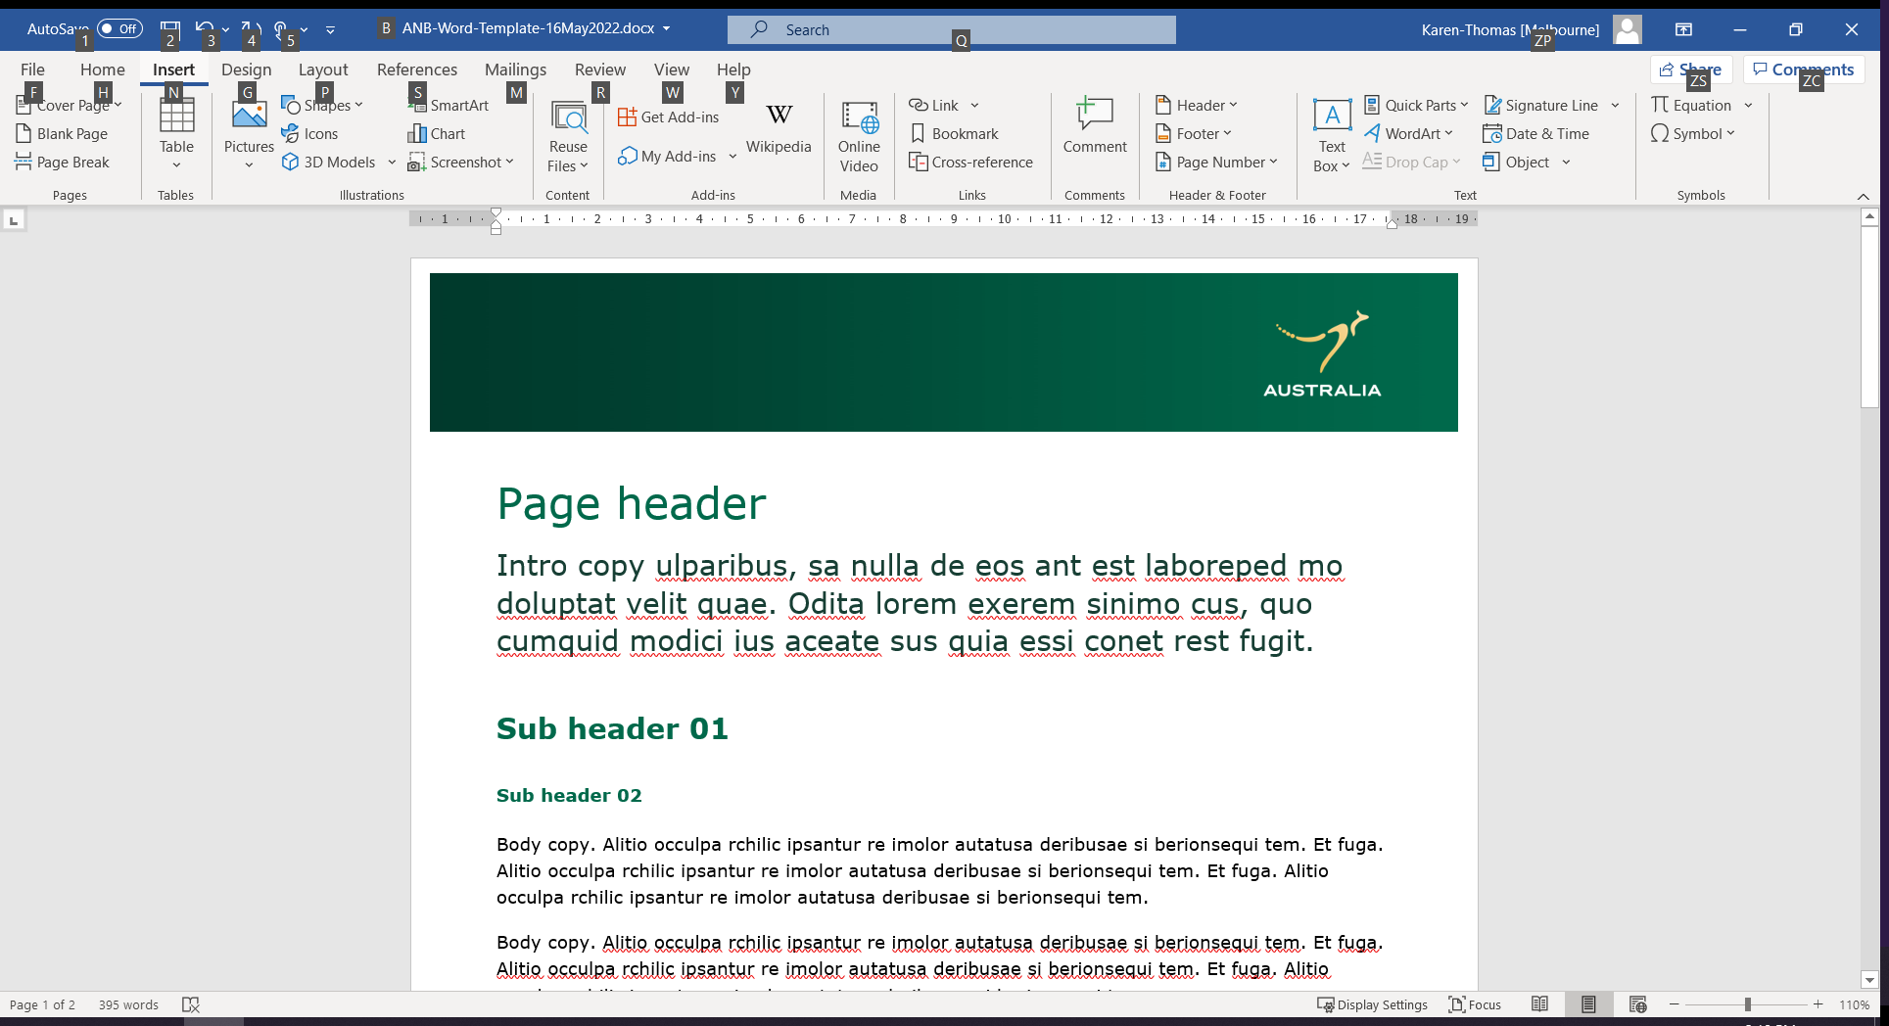

Our list of websites, resources and specialists to help tourism businesses become more accessible and inclusive.

Resources include links to:

accessible tourism specialists and industry resources, including not-for-profit organisations

Australian government resources and information.

The resources below are listed in alphabetical order and do not represent an endorsement of any particular product.

Accessibility specialists and industry resources for tourism

| Organisation | Detail |
| --- | --- |
| **The Access Agency** | [The Access Agency](https://theaccessagency.com.au/)  The Access Agency’s tourism specialists deliver a wide range of services across Australia – from accessibility audits and appraisals to strategy and training. It works with governments, destinations and tourism businesses. |
| **Accessible Australia** | [Accessible Australia](https://www.accessibleaustralia.com.au/)  Spinal life Australia have created Accessible Australia, a free resource with an interactive online map with reviews focussed on accessibility. Listings are completed by users and includes hotels, restaurants, cafés, bars, shopping centres, public bathrooms, beaches, parks and more. |
| **Accessible Accommodation** | [Accessible Accommodation](https://www.accessibleaccommodation.com/)  The Accessible Group’s accommodation platform and consultancy provides help on making premises accessible, with tailored reports recommending changes and improvements. They have a three-tiered ‘Accessible Qualified’ rating system and a listing attribute on ATDW. |
| **Australian Disability Network** | [Australian Disability Network](https://australiandisabilitynetwork.org.au/)  This not-for-profit organisation established in 2000, and with more than 350 member organisations, helps businesses to support customers and clients with disability and employ people with disability. They have online and in person training, membership services, an access and inclusion index and a wide range of programs and research. |
| **Australian Tourism Data Warehouse (ATDW)** | [Australian Tourism Data Warehouse](https://www.atdw.com.au/)  This national platform for digital tourism marketing helps businesses increase their online exposure by listing their accessible tourism features. Listed businesses may be featured on ATDW partner websites across Australia. Free one-on-one optimisation sessions are available to help tourism operators improve the marketing of their business. |
| **Australian Tourism Export Council (ATEC)** | [[Australian Tourism Export Council](https://traininghub.atec.net.au/courses/atec-s-accessible-host)](https://traininghub.atec.net.au/courses/atec-s-accessible-host)  ATEC’s Accessible and Inclusive Host program is a diversity-focused business development program with practical learning resources to help upskill and prepare tourism business to successfully welcome guests from all life stages, backgrounds and abilities. The three-module program helps operators understand the needs of, and cater to, the accessible tourism community. |
| **Australian Tourism Industry Council (ATIC)** | [Accessible Tourism Industry Council](https://www.qualitytourismaustralia.com/home/accessible-tourism/)  ATIC’s Accessible Tourism program, part of the Quality Tourism Framework supported by the Australian Government, provides businesses with a comprehensive online accessibility assessment and an Accessibility Information guide for visitors. Businesses meeting essential criteria are recognised across support areas of cognitive/autism; limited mobility; low hearing; low vision; wheelchairs and scooters. |
| **Centre for Accessibility Australia** | [Centre for Accessibility Australia](https://www.accessibility.org.au/guides/what-is-the-wcag-standard/)  The Centre for Accessibility Australia is a not-for-profit organisation that promotes accessibility through advocacy, research, training services, auditing services and celebrations such as the Australian Access Awards. Its focus is the incorporation of digital accessibility. |
| **Cerge** | [Cerge](https://cerge.app/)  Cerge is an accessibility app to support tourism operators and travellers. The Cérge Companion App is a free assistive technology for individuals with disability, support worker, carers, and parents to notify a participating destination/venue of specific service preferences ahead of time. |
| **Diversity Council Australia** | [Diversity Council Australia](https://www.dca.org.au/)  Diversity Council Australia (DCA) is the independent not-for-profit peak body leading diversity and inclusion in the workplace. Members receive access to research, events and programs, curated resources and expert advice across all diversity dimensions to improve workforce diversity. |
| **Flare Access** | [Flare Access](https://flareaccess.com.au/)  Flare Access have a background in occupational therapy and have significant experience in providing accessibility consulting to the tourism sector. They have worked with local councils as well as with small business. |
| **Getaboutable** | [[GetAboutAble](https://getaboutable.com/businesses/)](https://getaboutable.com/businesses/)  Getaboutable helps businesses increase their accessibility, including with site assessments, disability action and inclusion plans, online accessibility information and staff training in accessibility and inclusion. Getaboutable also hosts the annual Accessible & Inclusive Tourism Conference. |
| **Get Skilled Access** | [Get Skilled Access](https://getskilledaccess.com.au/)  Get Skilled Access is an Australian-owned disability enterprise founded by Australian of the Year Dylan Alcott OA. Get Skilled Access provides a range of services to improve disability inclusion and accessibility, including consulting, access audits, training and action plans. |
| Hidden Disabilities Sunflower | [Hidden Disabilities Sunflower](https://hdsunflower.com/au/)  The Hidden Disabilities Sunflower started at Gatwick Airport to identify passengers with hidden disabilities who may need additional help and support. The program was launched in Australia in 2020, in partnership with Bayley House. Their Australian website contains information on over 900 non-visible disabilities, conditions or chronic illnesses that Sunflower wearers use to identify their hidden disability. |
| **Inclusive Tourism** | [Inclusive Tourism](https://inclusivetourism.com.au/)  Inclusive Tourism performs access audits and mentors businesses in developing their accessibility in addition to offering staff training and marketing advice. Inclusive Tourism has worked with government, local councils, universities, hotels as well as tourism providers to make destinations more accessible. |
| **Push Adventures** | [Push Adventures](https://pushadventures.com.au/)  Push Adventures is an inclusive tourism consultancy that offers practical advice to support tourism operators to create meaningful experiences that are accessible for a whole range of guests. |
| **Sparrowly Group** | [Sparrowly Group](https://www.sparrowly.com/accessible-tourism)  Sparrowly Group provide a range of resources and is available to assist tourism operators to build their accessibility. |
| **Travability** | [Travability](https://travability.travel/)  Travability offer a range of services including training, marketing and accessibility audits as well as a travel booking service. |
| Vacayit | [Vacayit](https://www.vacayit.com/)  Vacayit is an app that provides travel guides that captures senses and emotions, ensuring that everyone, can fully engage and enjoy their travel adventures. The app also allows businesses to create stories. |
| World Wide Web Consortium (W3C) | [World Wide Web Consortium](https://www.w3.org/WAI/fundamentals/)  The World Wide Web Consortium (W3C), an international non-profit organisation, develops standards and guidelines to help build a web based on the principles of accessibility, internationalization, privacy and security. The organisation produces the Web Content Accessibility Guidelines, and offers resources to assist in implementing them. |

Government resources and information

| Organisation | Detail | |
| --- | --- | --- |
| **Australian Government Style Manual** | [[Australian Government Style Manual](https://www.stylemanual.gov.au/accessible-and-inclusive-content/inclusive-language/people-disability)](https://www.stylemanual.gov.au/accessible-and-inclusive-content/inclusive-language/people-disability)  Tips on using inclusive language that respects diversity, covering a wide range of people with different disabilities. Helpful for writing websites and tourism signage. |
| **Australian Human Rights Commission** | [[Australian Human Rights Commission](https://humanrights.gov.au/our-work/employers/access-all-improving-accessibility-consumers-disability)](https://humanrights.gov.au/our-work/employers/access-all-improving-accessibility-consumers-disability)  Practical tips for businesses on improving access to goods, services, facilities, premises and information for consumers with disability, including information on access requirement for assistance animals. |
| **Disability Gateway** | [Disability Gateway](https://www.disabilitygateway.gov.au/leisure/holidays)  The Disability Gateway has information and services to help people with disability, their family, friends and carers, to find the support they need. It includes a ‘Holidays and going out’ section in which you can search in your Australian state or territory for accessible tourism information, including government resources. |
| **Australia’s Disability Strategy** | [Australia’s Disability Strategy](https://www.disabilitygateway.gov.au/ads)  Australia’s Disability Strategy 2021-2031 is Australia’s national disability policy framework and was developed by all levels of government alongside people with disability, their families, carers and representatives. The Strategy sets out a plan to improve the lives of people with disability in Australia over the next 10 years. |
| Job Access | [Job Access](https://www.atdw.com.au/)  JobAccess has a dedicated employers page to provide support and answer question about employing people with disability. Funded by the Australian Government, the hub provides free and expert support to help remove barriers to employing people with disability. It also includes a link to the Employment Assistance Fund that can pay for supports for eligible employees and employers. |

Have we missed a provider? Email [VisitorEconomy@austrade.gov.au](mailto:VisitorEconomy@austrade.gov.au?subject=Accessible%20tourism%20resources%20list) to let us know.