Australian METS Opportunities in the Middle East, North Africa and Türkiye
  - Saudi Arabia | United Arab Emirates | Morocco | Egypt | Türkiye





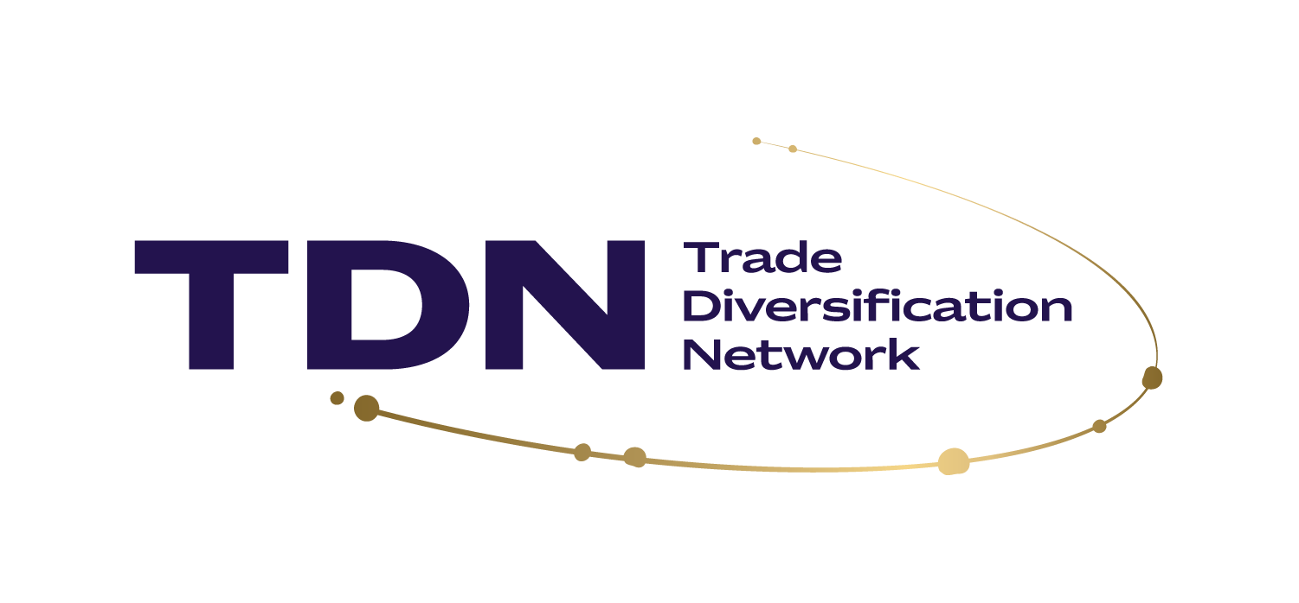

About this report
This report has been prepared by Austmine, with support from the Australian Trade and Investment Commission, to assist Australian Mining Equipment, Technology and Services (METS) companies to assess emerging opportunities in the Kingdom of Saudi Arabia, the United Arab Emirates (UAE), Morocco, Egypt and Türkiye.
The report examines the development of the mining and minerals sectors in each country, the operational needs of priority customers, areas of alignment with Australian METS capabilities, and commercial considerations that may influence market access and solution delivery.
It forms part of a broader trade diversification program designed to help Australian METS companies identify, prepare for, connect with and advance opportunities in international markets.
This report does not assess the current regional security situation. It notes company-reported disruptions where they affect an operating account or its procurement outlook. Companies should use current Australian Government advice and their own risk assessment when deciding when and how to engage.

The report is supported by the Accessing New Markets Initiative (ANMI). ANMI is a $55 million program helping Australian businesses diversify and grow their exports, designed and jointly delivered by Austrade and industry. As a Trade Diversification Network (TDN) member, Austmine is working collectively with Austrade to develop new global markets and accelerate international growth for Australian METS companies.

About Austmine
Austmine is the leading industry association for Australia’s METS sector. It connects Australian solution providers with mining companies, government and international markets through industry intelligence, export development programs, events and commercial networks.

About Austrade
The Australian Trade and Investment Commission (Austrade) is the Australian Government agency responsible for promoting Australian trade, investment and education interests. It helps Australian businesses develop international markets through market insights, connections and practical export support.

Disclaimer: This publication provides general market intelligence for Australian METS companies. It does not constitute legal, tax, customs, procurement, financial, investment, sanctions or other professional advice.
Market conditions, legislation, procurement requirements and business practices may change and may differ according to the buyer, tender, product, service and proposed commercial structure.
Companies should undertake their own due diligence and obtain appropriately qualified legal, customs, tax, financial and commercial advice before entering a tender, appointing an agent or distributor, shipping equipment, establishing a local entity or entering into any contractual arrangement.
While reasonable care has been taken in the preparation of this report, Austmine and the Australian Government do not guarantee that the information is complete, current or suitable for a particular business or transaction.
Participation in the research, or inclusion of a company or project in this report, does not constitute endorsement by Austmine, Austrade or the Australian Government.

Acknowledgement of country
In the spirit of reconciliation, we acknowledge the Traditional Custodians of country throughout Australia and their connections to land, sea and community. We pay our respect to their elders past and present and extend that respect to all Aboriginal and Torres Strait Islander peoples today.
Copyright © Commonwealth of Australia 2026
The material in this document is licensed under a Creative Commons Attribution – 4.0 International licence, with the exception of:
- the Commonwealth Coat of Arms
- the Australian Trade and Investment Commission’s logo
- any third party material any material protected by a trade mark
- any images and photographs.
More information on this CC BY licence is set out at the creative commons website: https://creativecommons.org/licenses/by/4.0/legalcode.

Attribution
Before reusing any part of this document, including reproduction, public display, public performance, distribution, dissemination, communication, or importation, you must comply with the Attribution requirements under the CC BY licence. Enquiries about this licence and any use of this document can be sent to: advisory@austrade.gov.au.

Using the Commonwealth Coat of Arms
The terms under which the Coat of Arms can be used are detailed on the Department of the Prime Minister and Cabinet website at pmc.gov.au/government/commonwealth-coat-arms.

“Trade diversification is becoming a strategic imperative for Australian METS exporters. The Middle East, North Africa and Türkiye are investing heavily in mining development and economic transformation, creating new opportunities for Australian companies to supply world-leading mining technologies, services and operational expertise.”

- Susan Kahwati, Head of Resources, Energy, Infrastructure and the Green Economy, Austrade

Executive summary
Five distinct markets offering growth opportunities for Australian METS
Saudi Arabia, the United Arab Emirates (UAE), Morocco, Türkiye and Egypt are evolving markets for Australian METS businesses. Mineral resources, economic diversification and changes to supply chains are supporting investment in exploration, mining projects and downstream processing.
However, the five markets differ substantially in mining characteristics, technological maturity, investment activity and commercial accessibility, and should be approached as a portfolio of five distinct opportunities rather than with a single regional strategy.
This report considers current mining activity and the development outlook over the next five to ten years. Mineral endowment and announced investments analysed in this report signal market potential, but METS companies need to distinguish between funded and operating projects, which represent immediate commercial prospects, and projects still awaiting studies, approvals or financing.
Saudi Arabia offers the broadest combination of operating demand, exploration and proposed development in the region. Maaden has outlined a US$110 billion investment ambition across gold, phosphate, aluminium and other activities, and the government's Vision 2030 strategy has created frameworks to unlock an estimated US$2.5 trillion in mineral resources.^{[1][2]} Capturing this opportunity increasingly requires an in-Kingdom presence rather than a regional footprint alone, to align with procurement qualification, local content requirements and service expectations.
The United Arab Emirates features industrial customers in aluminium, steel and quarrying, but primarily serves as a regional hub for logistics, trade and investment. Major ports support bulk materials handling, warehousing and re-export to customers across the Middle East, Africa and South Asia. The case for a UAE base depends on where procurement authority sits and whether repeat work supports local stock, staff and service. Establishing a presence in the UAE improves connectivity and oversight but carries significant setup and operating costs, and may not remove the need for local partners, content and delivery arrangements in operating countries. ^{[3][4][5]}
Morocco presents an emerging opportunity anchored by OCP Group's US$13 billion 2023–2027 investment program, which is reshaping the country's phosphate and fertiliser industry.^{[6][7]} Government-led diversification strategies are making a tangible impact on base and precious metals investment with increased activity from Managem, Aya Gold & Silver, and several Canadian-listed juniors. Routes to market are often linked to OCP's business units or its established contractor network, and suppliers should expect a highly competitive, European-facing business culture that values established relationships.
Egypt is developing its mining sector through regulatory changes, incentives and a national airborne mineral survey.^{[13]} The Sukari gold mine and funded exploration programs provide current opportunities for Australian METS. The test for prospects is whether licences and announced projects convert into financed work programs and development decisions.^{[8][9]}
Türkiye is an established and competitive mining and industrial market, supported by a mature domestic supplier base spanning its boron industry, gold and other metals.^{[9][10][11]} Opportunities are increasingly focused on upgrading and sustaining ageing infrastructure and maximising value from existing assets. METS companies must demonstrate a clear technical or commercial advantage to compete effectively against Turkish, Chinese and European providers.
These country-level findings are reinforced by Austmine's member survey of 29 companies pursuing opportunities in the region. Saudi Arabia was the most frequently cited priority market for the next one to three years (37.9%), followed by Türkiye (24.1%) and the UAE (20.7%).
However, offering a relevant, technically superior solution is not enough to capture success across the region. The barriers to entry and complexities are significant, and the survey identifies that while 79% of respondents are already exporting internationally, finding the right customer or decision-maker (66%) and local partner requirements (59%) are limitations for Australian METS.
For companies considering these markets, the first step is to identify requirements that match their capability, establish who specifies and purchases these solutions, and assess what local supply and service capability the opportunity demands. Site discussions, relevant operating references and trials can then help test demand before committing to staff, inventory or a local entity.
Austmine and Austrade can support Australian METS companies in establishing demand for their solution through market intelligence, trade programs and coordinated engagement before a significant investment decision is made on pursuing new markets.

Market Snapshot for METS
Market | Opportunity profile | Commercial opportunity | Capability Alignment | Commercial considerations
Saudi Arabia | Primary mining and exploration growth market over immediate and long-term. | Maaden operations and expansion portfolio across mining, processing and downstream industries.  Exploration activity driven by Maaden and increasing foreign investment. | Exploration technology, drilling services, data acquisition and analysis.  Engineering & construction, mine design, process modelling, water and waste.  Skills transfer, training and automation. | Increasing local content, capability and service requirements.  Access to Maaden procurement pathways, contractors and business units.
United Arab Emirates | Domestic industrial minerals, metals processing and potential regional service base. | Aluminium, steel, quarrying and select downstream refining and smelting.  Strategic access to logistics and servicing capability. | Process optimisation, maintenance, materials handling and technical support. Energy efficiency and emissions reduction. | Buyer-specific qualification for in-country value-add.  Cost, operating model and practicalities of a regional presence.
Morocco | Significant phosphate and select metals projects alongside exploration activity. | OCP-led phosphate operations and expansion.  Managem, Aya Gold & Silver and funded metals exploration or development programs. | Water treatment and recycling, minerals processing, materials handling and reliability.  Energy management and renewables integration.  Exploration & geological services. | Concentrated buyers and incumbent relationships.  European-facing commercial market and French-language capability.  Local delivery and servicing model.
Egypt | Market amidst significant mining and investment reforms with selective current demand. | Technologies and services linked to funded exploration and airborne survey.  Short-term prospects with Sukari gold mine and industrial minerals. | Mineral surveying, drilling, geological modelling and studies.  Water, minerals recovery, maintenance and specialist site services. | Monitoring of project funding and contracting. Customer-specific procurement, import arrangements, payment considerations and technical support.
Türkiye | Mature, competitive mining market with demand for specialised technical solutions. | Optimisation and upgrades of operational mines and process plants across boron, gold and other metals. | Mineral processing, optimisation and water management.  Fleet maintenance and reliability.  Underground systems, safety and training. | High domestic and global competition with local support and servicing requirement.  Currency fluctuations and commercial risk.

Introduction

Report objective and market focus
This report is designed to assist Australian METS companies to assess and prioritise opportunities across Saudi Arabia, Morocco, Egypt, Türkiye and the United Arab Emirates.
It provides practical, evidence-based market intelligence to identify where Australian mining capability may be most relevant, which opportunities present the strongest medium- to long-term prospects, and where further market research, customer engagement or business development activity may be warranted.

Why these markets, why now
The markets examined in this report form a growing mining and minerals processing corridor, characterised by significant capital investment, development ambitions and increasing demand for international expertise. Together, they present a significant diversification opportunity for Australian METS, provided market engagement is tailored to the distinct operating conditions, procurement practices and local requirements of each market.

Saudi Arabia
Economic Profile: Large, high-income economy; GDP US$1.28tn in 2025.
Economic Structure: Oil-dominated, but diversifying into manufacturing, infrastructure and mining.
Mining Profile: Large mineral endowment: gold, copper, phosphate, bauxite and critical minerals.
Mining investment: Strong exploration growth.^{[1]}

The UAE
Economic Profile: Large, high-income economy; GDP US$552bn in 2025.
Economic Structure: Oil plus trade, finance, construction, manufacturing, logistics and real estate.^{[2]}
Mining Profile: Limited domestic mining; significant metals processing and industrial activity.
Mining investment: Growing critical minerals and international mining investment.

Morocco
Economic Profile: Diversified, middle-income economy; GDP US$182bn in 2025.
Economic Structure: Manufacturing, agriculture, tourism, phosphates, automotive, aerospace and renewables.
Mining Profile: Leading phosphate producer with growing metals activity.^{[3]}
Mining investment: Diversification beyond phosphate, including copper and cobalt.

Egypt
Economic Profile: Large, diversified economy; GDP US$365bn in 2025.
Economic Structure: Diversified across services, manufacturing, construction, energy, tourism and agriculture.
Mining Profile: Developing relative to geological potential; gold is the main current opportunity.^{[4]}
Mining investment: Egypt’s target of increasing mining’s contribution to GDP to 5–6% is a policy ambition, rather than its current contribution.^{[4]}

Türkiye
Economic Profile: Large, industrialised economy; GDP US$1.60tn in 2025.
Economic Structure: Diversified across manufacturing, construction, trade, services and energy.
Mining Profile: Mature mining sector; major boron and natural-stone industries, plus gold, chromite and copper.^{[5]}
Mining investment: Ongoing exploration.

Economic profile gross domestic product (GDP) figures use the latest World Bank current price GDP data available in September 2026: Saudi Arabia ^{[2]}, Türkiye ^{[3]}, Morocco ^{[4]}, Egypt ^{[5]} and the UAE ^{[6]}. Egypt's 5–6% mining contribution is a policy target, not current output.^{[1]}

Research methodology and acknowledgements
This report draws on desktop research that prioritises published information from government agencies, mining and industrial operators, and official procurement or trade systems. Sources are listed at the end of the report and were accessed up to September 2026 unless otherwise noted.
Austmine supplemented this research with interviews involving mining companies, METS businesses and other industry stakeholders across the region. These interviews provided practical insights into customer requirements, procurement processes, operating conditions and common market entry challenges.
The research was also informed by a survey of 29 Australian METS companies, including businesses already active in the region and those considering future market entry. The survey helped identify current levels of engagement, markets of interest and the principal entry barriers experienced or anticipated by Australian suppliers.
Findings were tested by Austrade regional offices, whose in-market knowledge provided additional context and helped validate the practical relevance of the analysis. The Saudi Arabia and United Arab Emirates sections were also reviewed by Altios consultants, who provided feedback on market conditions and commercial considerations. Capability requirements and market entry pathways in Türkiye were informed by research from the Australian Turkish Chamber of Commerce.
Austmine gratefully acknowledges the organisations and individuals who contributed their time and experience to the research. Their input informed the report; however, the analysis, assessments and conclusions remain those of Austmine and should not be interpreted as formal endorsement by any contributing organisation.

How to use this report
The priority markets examined in this report differ significantly in their mining maturity, customer base, procurement systems and market entry requirements. They should not be treated as a single, uniform regional opportunity.
- The analysis of each market therefore considers:
- the role of the market within the regional mining and minerals ecosystem
- major operators, industrial customers and project development activity
- operational needs and alignment with Australian METS capability
- customer, procurement and commercial pathways
- localisation, delivery and servicing expectations
- issues that require buyer-specific or professional validation.

The market assessments are intended to help companies identify potential opportunity alignment and to support initial market investigation. They are not a substitute for detailed opportunity, partner, legal, tax or transaction-level due diligence. Opportunity assessments should be considered alongside current security conditions, transport reliability and counterparty requirements. These factors may affect the timing and cost of visits, mobilisation and delivery

Market analysis and opportunity assessment

Saudi Arabia
Building a world-leading mining and minerals ecosystem
Among the markets assessed in this report, the Kingdom of Saudi Arabia offers the broadest combination of operating demand, exploration activity and funded mining and processing development.
Saudi Arabia’s Vision 2030 strategy has set the course for a substantial program of mining activity and investment. Central to this agenda is the ambition to establish mining as the third pillar of the economy to unlock an estimated US$2.5 trillion in untapped mineral wealth.^{[1]}
The scale and pace of Saudi Arabia’s economic diversification is creating the foundations needed to realise this potential. Legal and regulatory reforms, investment incentives, international partnerships, and the adoption of advanced technologies and processes for geological data collection are working in parallel to accelerate exploration, development and capital across the Kingdom’s mining industry.
Maaden, the Middle East’s largest multi-commodity mining and metals company, is at the centre of Saudi Arabia’s mining expansion, and has outlined a US$110 billion ten-year investment program to triple its phosphate and gold production and double aluminium output.^{[23][2]} Current development priorities include the Ar Rjum gold mine, the Phosphate 3 expansion and the planned rare-earth refining joint venture with MP Materials, backed by the US Department of War.^{[13][21][24]}

“We see this as a once-in-a-generation opportunity in the region. There's support from the highest levels to develop the minerals sector and the investments are there.”

- Steve Ledger, Regional Vice President, Strategic Partnerships, Fleet Space Technologies
The scale of the mining opportunity in Saudi Arabia is demonstrated by the extensive exploration campaign underway across the Kingdom, with spending reaching an estimated US$346 million in 2025 from approximately US$50 million in 2020.^{[3]}
Maaden remains the exploration leader in Saudi Arabia, including work around existing operations. On 18 August 2026, Maaden and Aramco signed a shareholders’ agreement for a proposed exploration and hard-rock mining venture covering approximately 182,000 km² in Zone-4 of the Arabian Platform. The agreement taking effect and the venture being incorporated remain subject to approvals and other conditions; procurement arrangements should be confirmed before suppliers treat the announcement as an opportunity to bid.^{[4]}.^{[4]} Saudi Arabia has also attracted investment or exploration commitments from Ivanhoe Electric, Barrick, Hancock Prospecting, Vedanta, McEwen Mining and Zijin Mining.^{[5][6][7]}
The Australian METS sector holds a strong position within the Saudi Arabian mining industry, with Australia’s expertise, innovation and reputation highly respected in the Kingdom. METS businesses active in Saudi Arabia are primarily supporting exploration campaigns, geological surveys, resource and feasibility studies, and mine and processing plant design. However, with Saudi Arabia’s mineral endowment transitioning from potential to projects, Australian METS companies need to position their business to capture opportunities across the mining value chain.

Market at a glance
Saudi Arabia snapshot
Market outlook | Long-term mining and processing regional hub
Principal activity | Gold, copper, zinc, phosphate, bauxite, aluminium, industrial minerals and select critical minerals and rare earths
Strongest METS alignment | Current: Exploration, geoscience, engineering and design, infrastructure development, water management, safety and training.  Emerging: Digitisation and automation, advanced minerals processing, waste management, maintenance and asset reliability, contract mining services, maximising recovery.
Priority customers | Maaden – immediate opportunities across project portfolio and expansions.  Al Masane Al Kobra Mining Co. (AMAK) – operating copper, zinc, gold and silver producer.  EPCMs and delivery partners – Worley and JESA (Phosphate 3, Phase 1), Bechtel (Ar Rjum) and Hatch (Maaden strategic delivery partner).  Mining contractors – Contractors undertake a significant proportion of mining services, such as Byrnecut supporting underground development and production at Maaden’s Jabal Sayid copper project.  Exploration ecosystem – Saudi Geological Survey, exploration licence holders.
Typical access pathway | Engage Maaden, the appointed EPCM or the mine contractor according to who specifies and purchases the solution.
Key commercial considerations | Increasing local content, employment and service requirements. Access to Maaden procurement pathways, contractors and business units.  Confirm Saudi delivery, partner or presence requirements for work, together with payment terms and after-sales support.

Saudi Arabia Mining and Processing Operations
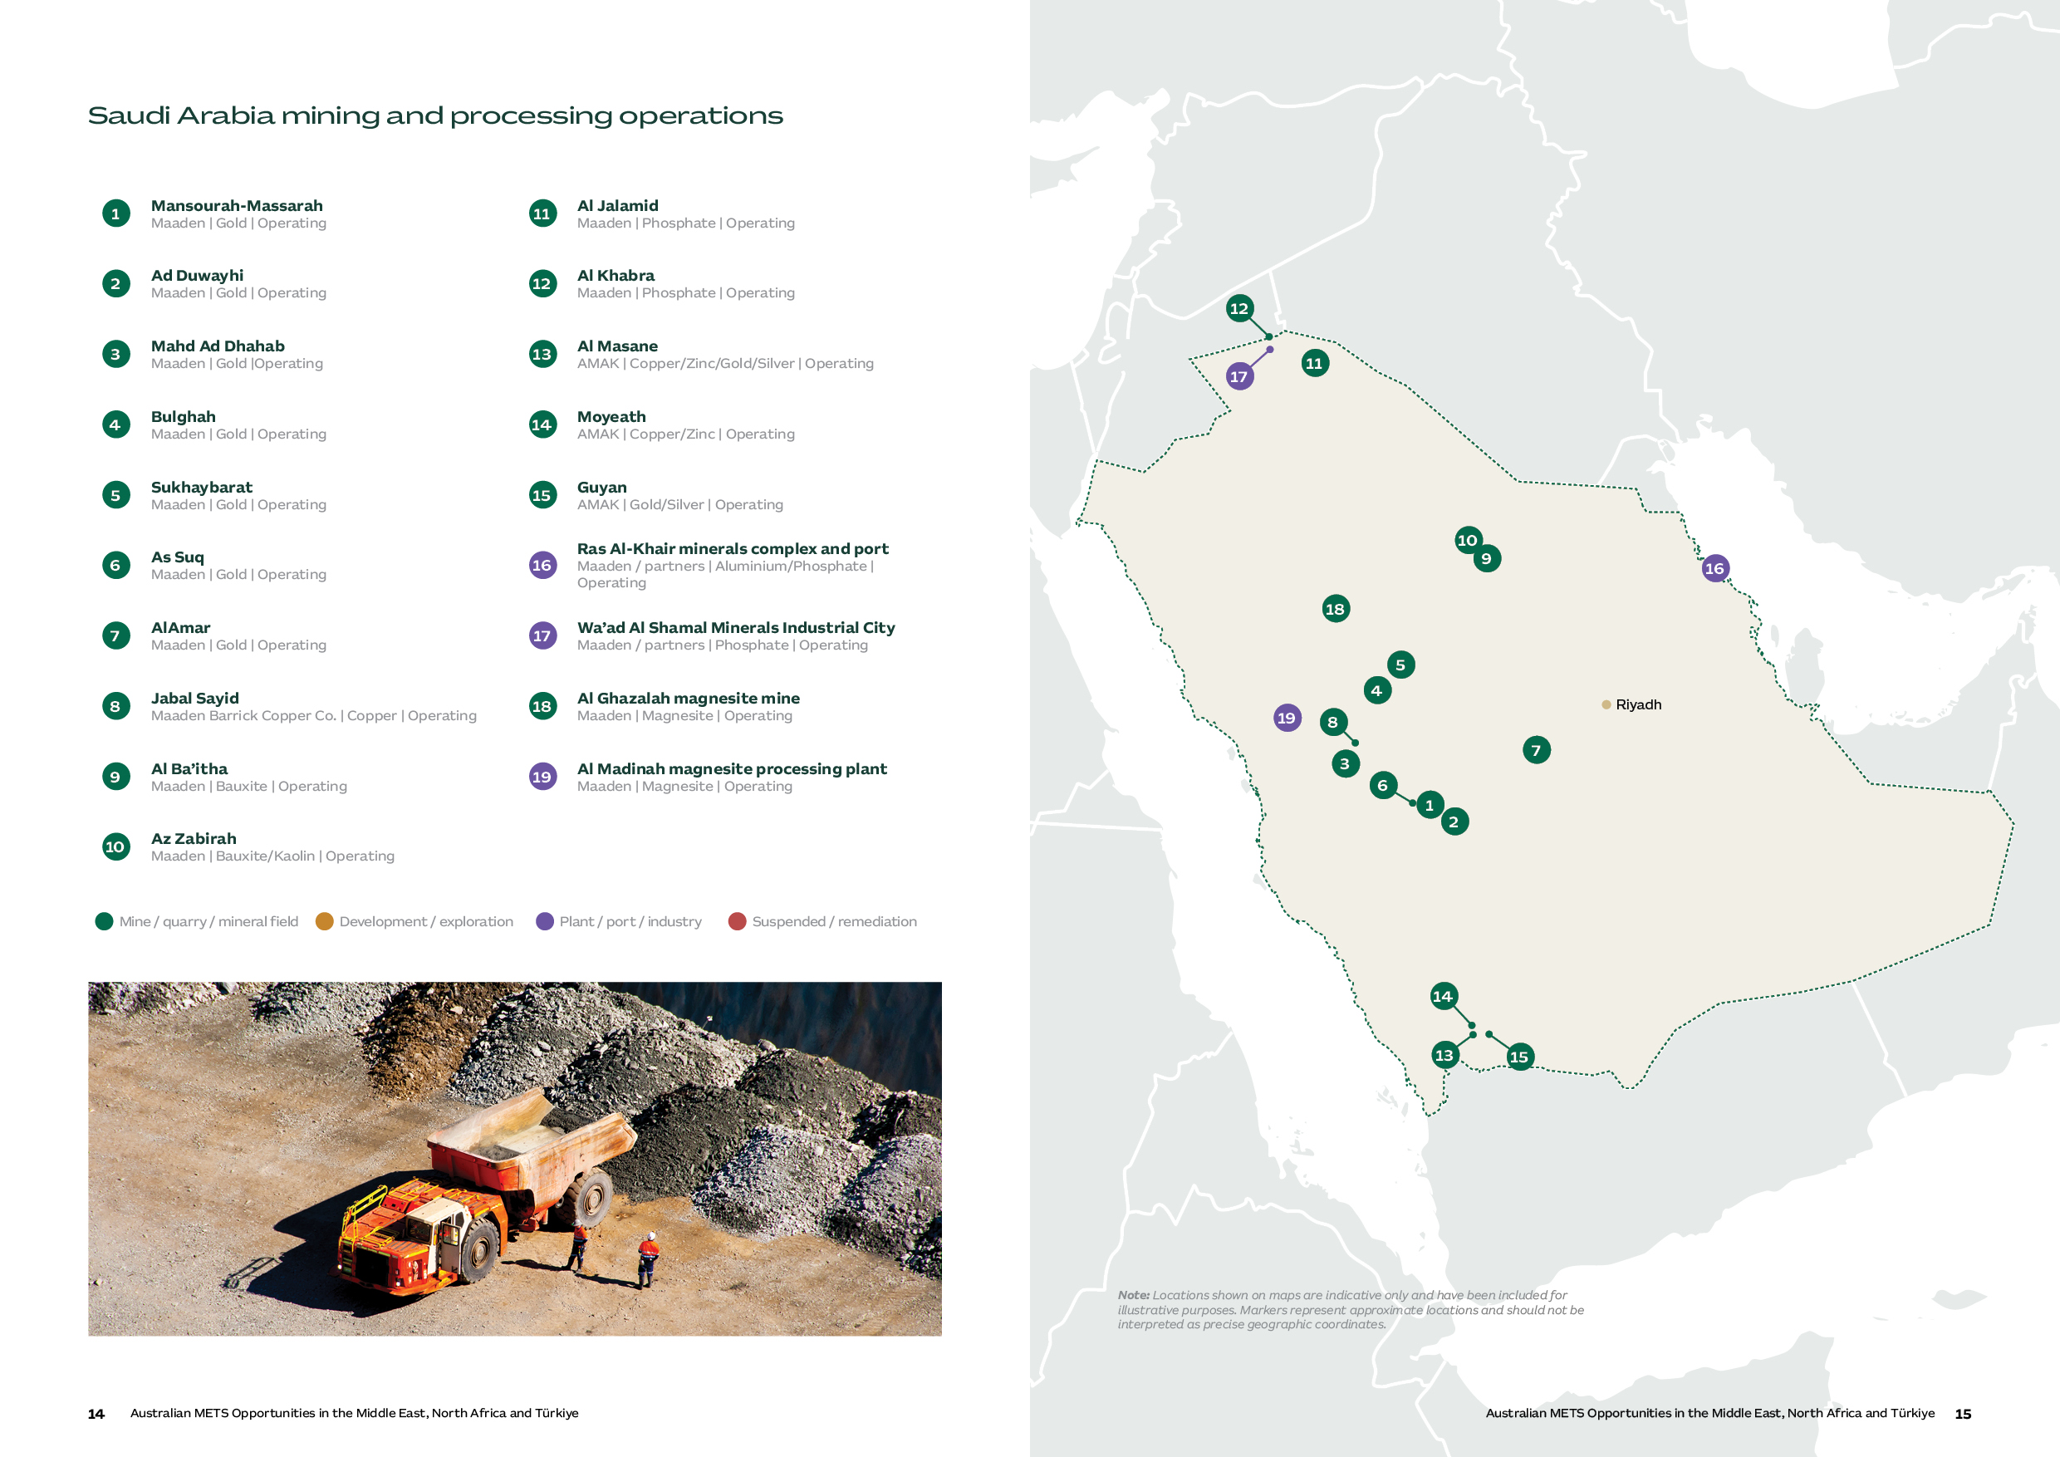

Mining Activity and Implications for Australian METS
While Saudi Arabia’s mining industry is transforming rapidly, there is a diverse portfolio of operating assets providing immediate opportunities for Australian METS.
Gold, copper and most exploration activities are concentrated principally within the Arabian Shield in the west and centre of the Kingdom. Phosphate assets are concentrated in the north and connect to the Wa'ad Al Shamal complex, while bauxite and industrial mineral operations feed downstream processing and export infrastructure at Ras Al-Khair and other eastern industrial locations.^{[8]}

Opportunity | Status | Australian METS alignment
Arabian Shield gold portfolio | Strongest mining cluster of operating mines and significant exploration campaigns. | Exploration solutions and services, studies, ore characterisation and process design for growth projects.  Asset reliability, water management, digitisation, safety and training for operating mines.
Copper and polymetallic operations | Maaden/Barrick Jabal Sayid and AMAK operating and growing base metals portfolio. | Underground productivity, ventilation, process control, reliability, geotechnical monitoring, safety and workforce capability.
Northern phosphate system | Maaden’s Al Jalamid and Al Khabra mines connect to Wa’ad Al Shamal processing and industrial infrastructure. Phosphate 3 Phase 1 is an expansion moving towards commissioning. | Materials handling, beneficiation, process optimisation, water, energy efficiency, maintenance and environmental systems.
Bauxite mining and aluminium processing | Al Ba'itha and related mineral assets feed the integrated Ras Al-Khair processing and export system. | Bulk handling, refining and smelting support, reliability, waste management (red mud), emissions reduction, asset integrity and port-linked logistics.
Exploration and licensing pipeline | Licence releases providing significant Maaden and foreign investment activity across prospective Arabian Shield areas. | Geophysics, geochemistry, drilling, sampling, laboratories, data platforms and field systems.

“Maaden is aiming to cut its groundwater use by 65% by 2040, and it's already moving in that direction, a 9% cut in withdrawal and a 45% increase in treated water use in 2024 alone. That's a real, near-term market for the water-efficient processing and recycling technology Australian METS companies specialise in.”

- Aalia Hamadeh, Project manager, ALTIOS MIDDLE EAST

Market expansion and exploration activity
Saudi Arabia is a rapidly expanding mining investment market, driven through a structured program aligned to the Kingdom’s Vision 2030 objectives to increase mining's GDP contribution to SR240 billion (US$63 billion) by 2030, create 200,000 direct and indirect jobs, and attract US$27 billion in new investment. ^{[1]}
To capture value from an estimated US$2.5 trillion in mineral resources across 48 identified minerals, the Kingdom has introduced a range of initiatives to build a dynamic mining investment and exploration ecosystem. These include legal and regulatory reforms, licensing and digitisation initiatives, exploration incentives and financing mechanisms, geological data programs, infrastructure investment, and international partnerships.
Maaden leads Saudi Arabia’s exploration portfolio, with much of its activity targeting areas near existing operations. On 18 August 2026, Aramco and Maaden signed a shareholders’ agreement for a proposed venture owned 51% by Maaden and 49% by Aramco. The exploration programme covers approximately 182,000 km² in Zone-4 of the Arabian Platform ^{[32]}. The agreement taking effect and the venture being incorporated remain subject to approvals and other conditions. Suppliers should therefore confirm procurement arrangements before treating the announcement as an opportunity to bid.^{[31]} Maaden has also outlined a US$110 billion investment ambition over the next decade, including plans to expand gold, phosphate and aluminium production.^{[2][21][22][24]} Saudi Arabia has established mining partnerships and joint ventures at different stages with companies including Ivanhoe Electric, Barrick, Hancock Prospecting, Vedanta, McEwen Mining and Zijin Mining. The arrangements span existing operations, exploration commitments and proposed downstream investments.^{[5][6][7][25]}
Central to attracting investors has been digitisation and data capture, including a large-scale national geological survey program led by the Saudi Geological Survey and the development of the Ta’adeen platform as a gateway for licensing, investment incentives, prequalification and competitive auctions. The Ta’adeen platform is operated by ESNAD (Saudi Mining Services Company) under the Ministry of Industry and Mineral Resources.^{[9]}

Key Projects
Project | Overview | METS opportunity
Jabal Sayid Copper Mine – Maaden Barrick Copper Company (50-50 JV) | Saudi Arabia’s largest underground base metals mine producing 64kt of copper in 2025, with gold and silver as by-products. Australian mining contractor, Byrnecut Group, has a long-standing partnership and undertakes underground development, production drilling, blasting, haulage, paste-fill and fleet maintenance. | Byrnecut provides an interface into the market and has introduced several Australian technologies, such as the LiveMine paperless data management system and the Transcale truck load scanner, weighbridge and truck analysis system. Current priorities for Jabal Sayid are to maintain production efficiencies and continue exploration activities to extend the life of mine.^{[10]} Potential METS fit includes underground productivity, fleet reliability, ventilation, processing performance and funded exploration work; suppliers should confirm a specific operating need and purchasing route.
Mansourah-Massarah Gold Mine – Maaden | Mansourah-Massarah is Maaden’s flagship gold project, which is expected to produce 250,000 ounces of gold per year over its mine life. The site includes open-pit mines, a greenfield mineral concentrator and gold processing plant. | Immediate opportunities align to operational efficiencies across maintenance, fleet management, materials handling and processing optimisation. Maaden continues to explore multiple high-grade deposits south of its existing mine which indicates potential for expanded operations in the area. ^{[11]}
Phosphate Phase 3 – Maaden | Phosphate 3 aims to increase Maaden’s phosphate production to 9Mt annually across their two key industrial cities of Wa'ad Al Shamal (WAS) and Ras Al-Khair (RAK). Commissioning of Phase 1 infrastructure is on track to begin at the end of 2026. | Worley and JESA International are leading the design and construction of Phase 1, with support of specialist equipment and technology providers such as FLSmidth.^{[12]} Operational, maintenance and optimisation support opportunities set to follow from 2027 ramp up.
Ar Rjum Gold Mine - Maaden | Ar Rjum is Maaden's newest gold mine with an expected first production in late 2028. It is an open pit mine with a processing facility that is expected to produce 3.6 million ounces of gold over a 12-year life of mine.[27, 32] | Saudi Arabian Bechtel Company and Bechtel Australia Pty Ltd are the parties to Maaden’s EPCM agreement for the Ar Rjum mine and processing facilities. The involvement of Bechtel Australia is relevant to Australian suppliers, but companies should confirm the responsible purchasing entity, supplier qualification requirements and availability of specific work packages before pursuing supply opportunities ^{[32]}.
Rare Earth Refinery – Maaden – MP Materials / US Department of War JV | A binding term sheet announced in November 2025 set out a proposed joint venture for rare earth refining and separation; the facility has not yet reached construction. The planned facility would process rare earth feedstock sourced from both Saudi Arabia and other global regions, producing substantial volumes of separated light and heavy rare earth oxides.^{[13]} | This project remains at an early stage rather than a fully financed project under construction. However, it represents a longer-term vision of Saudi Arabia as a downstream industrial hub with supply chain opportunities including engineering and construction, specialised processing and refining technology and digital architecture.

Market Approach for Australian METS

“Australian companies enter Saudi Arabia with a genuine advantage: Australian mining expertise is well regarded and there are strong existing people-to-people links between the two countries.”

- Daniel Jamsheedi, Partnership Director, Australian Saudi Business Council and Forum

Category | Capabilities Required | Demand Drivers
Exploration solutions | Airborne and satellite geophysics, geochemical surveys, drilling services, core logging, AI-driven mineral prospectivity mapping. | This represents a more immediate opportunity, as demonstrated by the Fleet Space Technologies case study below.  The Saudi Arabia mineral exploration equipment market size reached over US$2.05bn in 2025 and is expected to grow to US$3.7bn by 2034.^{[14]}
Engineering and construction | Turnkey plant design and build, civil works, remote infrastructure (roads, power, water, accommodation), project management. | Market activity is shifting from specific plant builds to a multi-decade pipeline of greenfield plant and infrastructure builds.  Worley’s work on Phosphate 3 and Bechtel’s Ar Rjum EPCM contract provide routes for suppliers to investigate defined work packages. Companies should confirm the relevant package, contractor and procurement stage.^{[21][28]}
Mineral Processing and Metallurgy | Full flow sheet design and equipment supply across new projects, re-processing and conversion of waste streams to value. | Maaden’s expansion and exploration portfolio will lead to demand for the full suite of capabilities to design, engineer, construct and operate processing infrastructure. Other immediate opportunities relate to finding value streams from phosphate and bauxite waste, such as converting phosphogypsum into cement or re-processing red mud rich in elements such as rare earths.
Mine Automation, Digital and AI Systems | Fleet automation, remote operations, IoT/telemetry, satellite monitoring, data analytics platforms, communications infrastructure. | Saudi Arabia is seeking to expand and develop projects leveraging the latest advancements in digital systems and connectivity. This is evidenced by Maaden and Hexagon partnering to launch the Middle East's first "digital mine" at Mansourah-Massarah, including mine-to-mill digital twins, material flow intelligence, and an MoU to modernise mining curricula. ^{[15]}
Skills, Training and Workforce Development | Technical and vocational training, competency frameworks, localisation programs, leadership development, and digitisation and automation capacities. | Vision 2030 targets the creation of 200,000 direct and indirect mining jobs. However, a 2026 TASC Report finds that Saudi Arabia faces a projected shortage of 663,000 skilled workers by 2030, and 93% of organisations report active talent gaps. While this is not unique to mining, it illustrates the wider competition for labour as Vision 2030 projects expand across multiple sectors. ^{[16][19]}

“What really resonates very well with private and public sector is knowledge transfer, because this is a country that's building capability and capacity.”

Abed Hakmi, Director of Energy and Mineral Resources, Infrastructure and Defence, Australian Trade and Investment Commission (Austrade), Riyadh

Procurement and supplier preparation
Any long-term growth strategy in Saudi Arabia requires strong relationships across Maaden and its wider supply chain. Registration through Maaden’s Supplier Portal is the formal starting point for establishing a business relationship with Maaden and its affiliates. Foreign companies must provide documentation including business licences, certificates of incorporation, evidence of authority to operate internationally, detailed financial statements, and relevant regulatory and compliance certifications.
Registration is simply a prerequisite for engaging with Maaden. Companies must build relationships with relevant business units, identify operational needs and forthcoming opportunities, and establish a visible presence through major industry events and direct engagement. In many cases, a partnership, joint venture or representative arrangement with a well-connected Saudi entity can provide a more effective pathway into Maaden and its supply chain.
Maaden’s dedicated Technology and Innovation team may offer a particularly relevant entry point for Australian METS companies. The team identifies, evaluates and develops solutions to priority operational challenges, creating potential pathways for technology partnerships, trials and pilot projects involving specialist SMEs.
Companies should nevertheless recognise that Maaden’s local content program, Tharwah, is designed to strengthen the participation of Saudi suppliers and SMEs. This can influence procurement decisions and the competitiveness of foreign bidders, particularly for larger engineering, processing and service packages. Australian companies should therefore consider how local partnerships, in-country capability and knowledge transfer can strengthen their market proposition ^{[18]}.

Fleet Space Technologies: from pilots to a long-term Saudi exploration partnership
Fleet Space Technologies delivers mineral systems intelligence to mining companies worldwide. Its ExoSphere platform combines ground-based seismic sensors, satellite connectivity and machine learning to generate 3D subsurface models, giving exploration and mine development teams the data they need to de-risk and accelerate capital decisions.
Fleet entered Saudi Arabia in 2023, identifying a clear opportunity linked to the Kingdom’s rapid exploration expansion and need to cover large, historically underexplored areas. Fleet mapped the key people at Maaden and built relationships at industry conferences ahead of formal engagements.
Fleet delivered its first two pilot projects with Maaden from Australia, a deliberate strategy to prove the technology and build trust, before committing to a market Fleet did not yet know would generate real demand. The relationship subsequently progressed to a four-year strategic partnership signed in 2025 to explore more than 12,000 km² of the company’s priority projects across the Arabian Shield.
After demand had been demonstrated, Fleet formed a joint venture with Tahreez, a subsidiary of Alturki Holding, to establish an in-market presence and improve client engagement, credibility, contracting and its ability to deliver turnkey programs. This has developed into a genuine in-country operation, including geoscience teams, and field delivery teams supported by geophysical equipment.
That footprint is now being leveraged beyond the original client relationship. Fleet has extended into other major and junior exploration companies operating in Saudi Arabia and is positioning its in-country team and equipment to support mineral exploration in other Gulf states.
The practical lesson is staged commitment: prove value before making a major establishment decision and invest in credible local delivery once market fit is clear. This avoids potential risks with procurement and contracting moving slower than expectations.

Market entry and delivery expectations
Success in Saudi Arabia is driven by a long-term approach that prioritises local partnerships, networks, and sustained support. While the opportunities are significant, it is a complex market that requires considerable time and resource commitment to build and maintain relationships, support clients, and develop local workforces.
“Once there is market fit and demand, finding a credible in-country partner will accelerate everything else.”

- Steve Ledger, Regional Vice President, Strategic Partnerships, Fleet Space Technologies
Saudi local content and service requirements may affect the delivery model, and METS companies should assess whether direct service, a distributor, contractor, partner or local operation can meet the specific requirement.^{[17][18]}

Saudization
Saudization, implemented through the broader Nitaqat framework and occupation-specific requirements, is becoming an increasingly important consideration. The Saudization requirement for engineering professions increased from 20% to 25% in July 2024 and rose to 30% from 30 June 2026. The current requirement applies to private sector establishments employing five or more people across 46 designated engineering professions.^{[16]}
Saudization requirements do not prevent companies from employing expatriate specialists, but they reduce the flexibility of relying predominantly on expatriate recruitment to fill skilled roles. Foreign companies must plan for the recruitment, development and retention of Saudi professionals as part of their operating model. This reinforces the importance of local partnerships, workforce development and knowledge transfer when entering the market.

Importation
Products entering Saudi Arabia may be subject to product conformity and customs requirements. Importers are typically required to register on the SABER Portal, an online verification system used to issue conformity certificates before goods can enter the market. Requirements vary by product classification and intended use, making product-specific confirmation an important step when assessing the commercial and delivery requirements of any opportunity.
Competition
Competition in Saudi Arabia is high and growing. The world’s major OEMs, engineering houses and technology providers have established a presence in the Kingdom, while Chinese industrial and mining companies are increasingly active. More than 750 Chinese companies now operate in Saudi Arabia across sectors including construction, manufacturing and natural resources. Chinese investment in the Kingdom reached US$8.26 billion in 2024, an increase of 29% year-on-year, while bilateral trade reached US$107.5 billion.^{[20]}
This growing international presence reinforces the need for Australian METS companies to focus on segments and applications where their expertise, technology and capabilities are clearly differentiated, while also seeking to leverage relationships with Australian businesses already active in the Kingdom, such as Worley, Ausenco and Byrnecut.

METS Networks
For Australian METS companies seeking to understand the Saudi market in greater depth, the Future Minerals Forum (FMF), held in Riyadh each January, is the leading platform. Led by Austrade and supported by Austmine, Australia maintains a coordinated presence at FMF to engage with over 18,000 attendees, offering a valuable opportunity to network with current and prospective mining industry customers. Networks such as the Australian Saudi Business Council can further support the development of high-level relationships aimed at understanding, pursuing, and capturing growth opportunities in the Kingdom.
“….what the country is looking for is partners who can help solve real problems that cannot be addressed locally – partners who will work with them, rather than simply try to sell to them. .”

Daniel Jamsheedi, Partnership Director, Australian Saudi Business Council and Forum

United Arab Emirates
A regional industrial, logistics and investment platform
The UAE is not a large conventional mining jurisdiction. For Australian METS, it combines domestic customers in metals processing and quarrying with regional engineering and service functions and resources investors with overseas portfolios.
Domestic METS demand spans quarrying and bulk materials in Ras Al Khaimah, Emirates Global Aluminium (EGA) operations and EMSTEEL’s steel and building materials businesses.^{[4][7][12][16]} Abu Dhabi hosts resources investors such as International Resources Holding (IRH)^{[10]}, while Dubai provides a commercial and logistics base. Access to an investor’s overseas portfolio still depends on the operating company’s procurement and delivery requirements.^{[11][15]}
Oil and gas remain important to the UAE economy despite diversification. The Australian Department of Foreign Affairs and Trade (DFAT) identifies their continuing role in exports and government revenue alongside growth in trade, transport, manufacturing and services. For METS suppliers, demand should be assessed through named quarrying and industrial accounts rather than inferred from the economy’s oil and gas share.^{[11]}
The Australia–UAE Comprehensive Economic Partnership Agreement (CEPA) entered into force on 1 October 2025. DFAT states that it will eliminate tariffs on more than 99% of Australian goods exports to the UAE by value when fully implemented in 2029. Eligibility depends on the product and rules of origin and does not automatically extend to goods re-exported to another market.^{[1][2][3]}
The UAE’s ports and international transport links support regional trade and service delivery. Jebel Ali is an established logistics node, while DFAT identifies Dubai’s role in re-export, finance and business services.^{[11][19]} Connectivity can support regional operations, but suppliers should check current routes, costs and delivery reliability. Ownership, licensing, tax and employment requirements remain separate considerations when choosing a UAE base.^{[21][25]}
For Australian suppliers, the strongest alignment in the UAE’s domestic industry is with technologies and services that improve reliability, productivity and environmental performance. A regional presence can support repeat business across several markets where the customer base and service requirements justify the investment. METS companies should weigh the UAE's regional accessibility and logistics advantages against the real cost of establishing a local presence, and should generally only consider this once sufficient scale has been established in the region.

Market at a glance
United Arab Emirates snapshot
Market role | Industrial processing, quarrying, regional engineering & service hub and resources-investment decision centre
Principal activity | Aluminium, steel, building materials, mining investment, logistics and regional service delivery
Strongest METS alignment | Regional delivery and service into mining markets in Africa, the Middle East and South Asia.  Domestic industrial optimisation, maintenance, digitisation, energy efficiency, and emissions reduction.
Typical access pathway | Direct engagement with industrial buyers, investors, project contractors or regional distribution and service partners.
Key commercial considerations | Buyer-specific qualification and in-country value requirements. The cost and practicalities of local service, stockholding or a regional presence. A UAE base does not replace operating-country requirements or local delivery expectations.

UAE Industrial Operations & Infrastructure
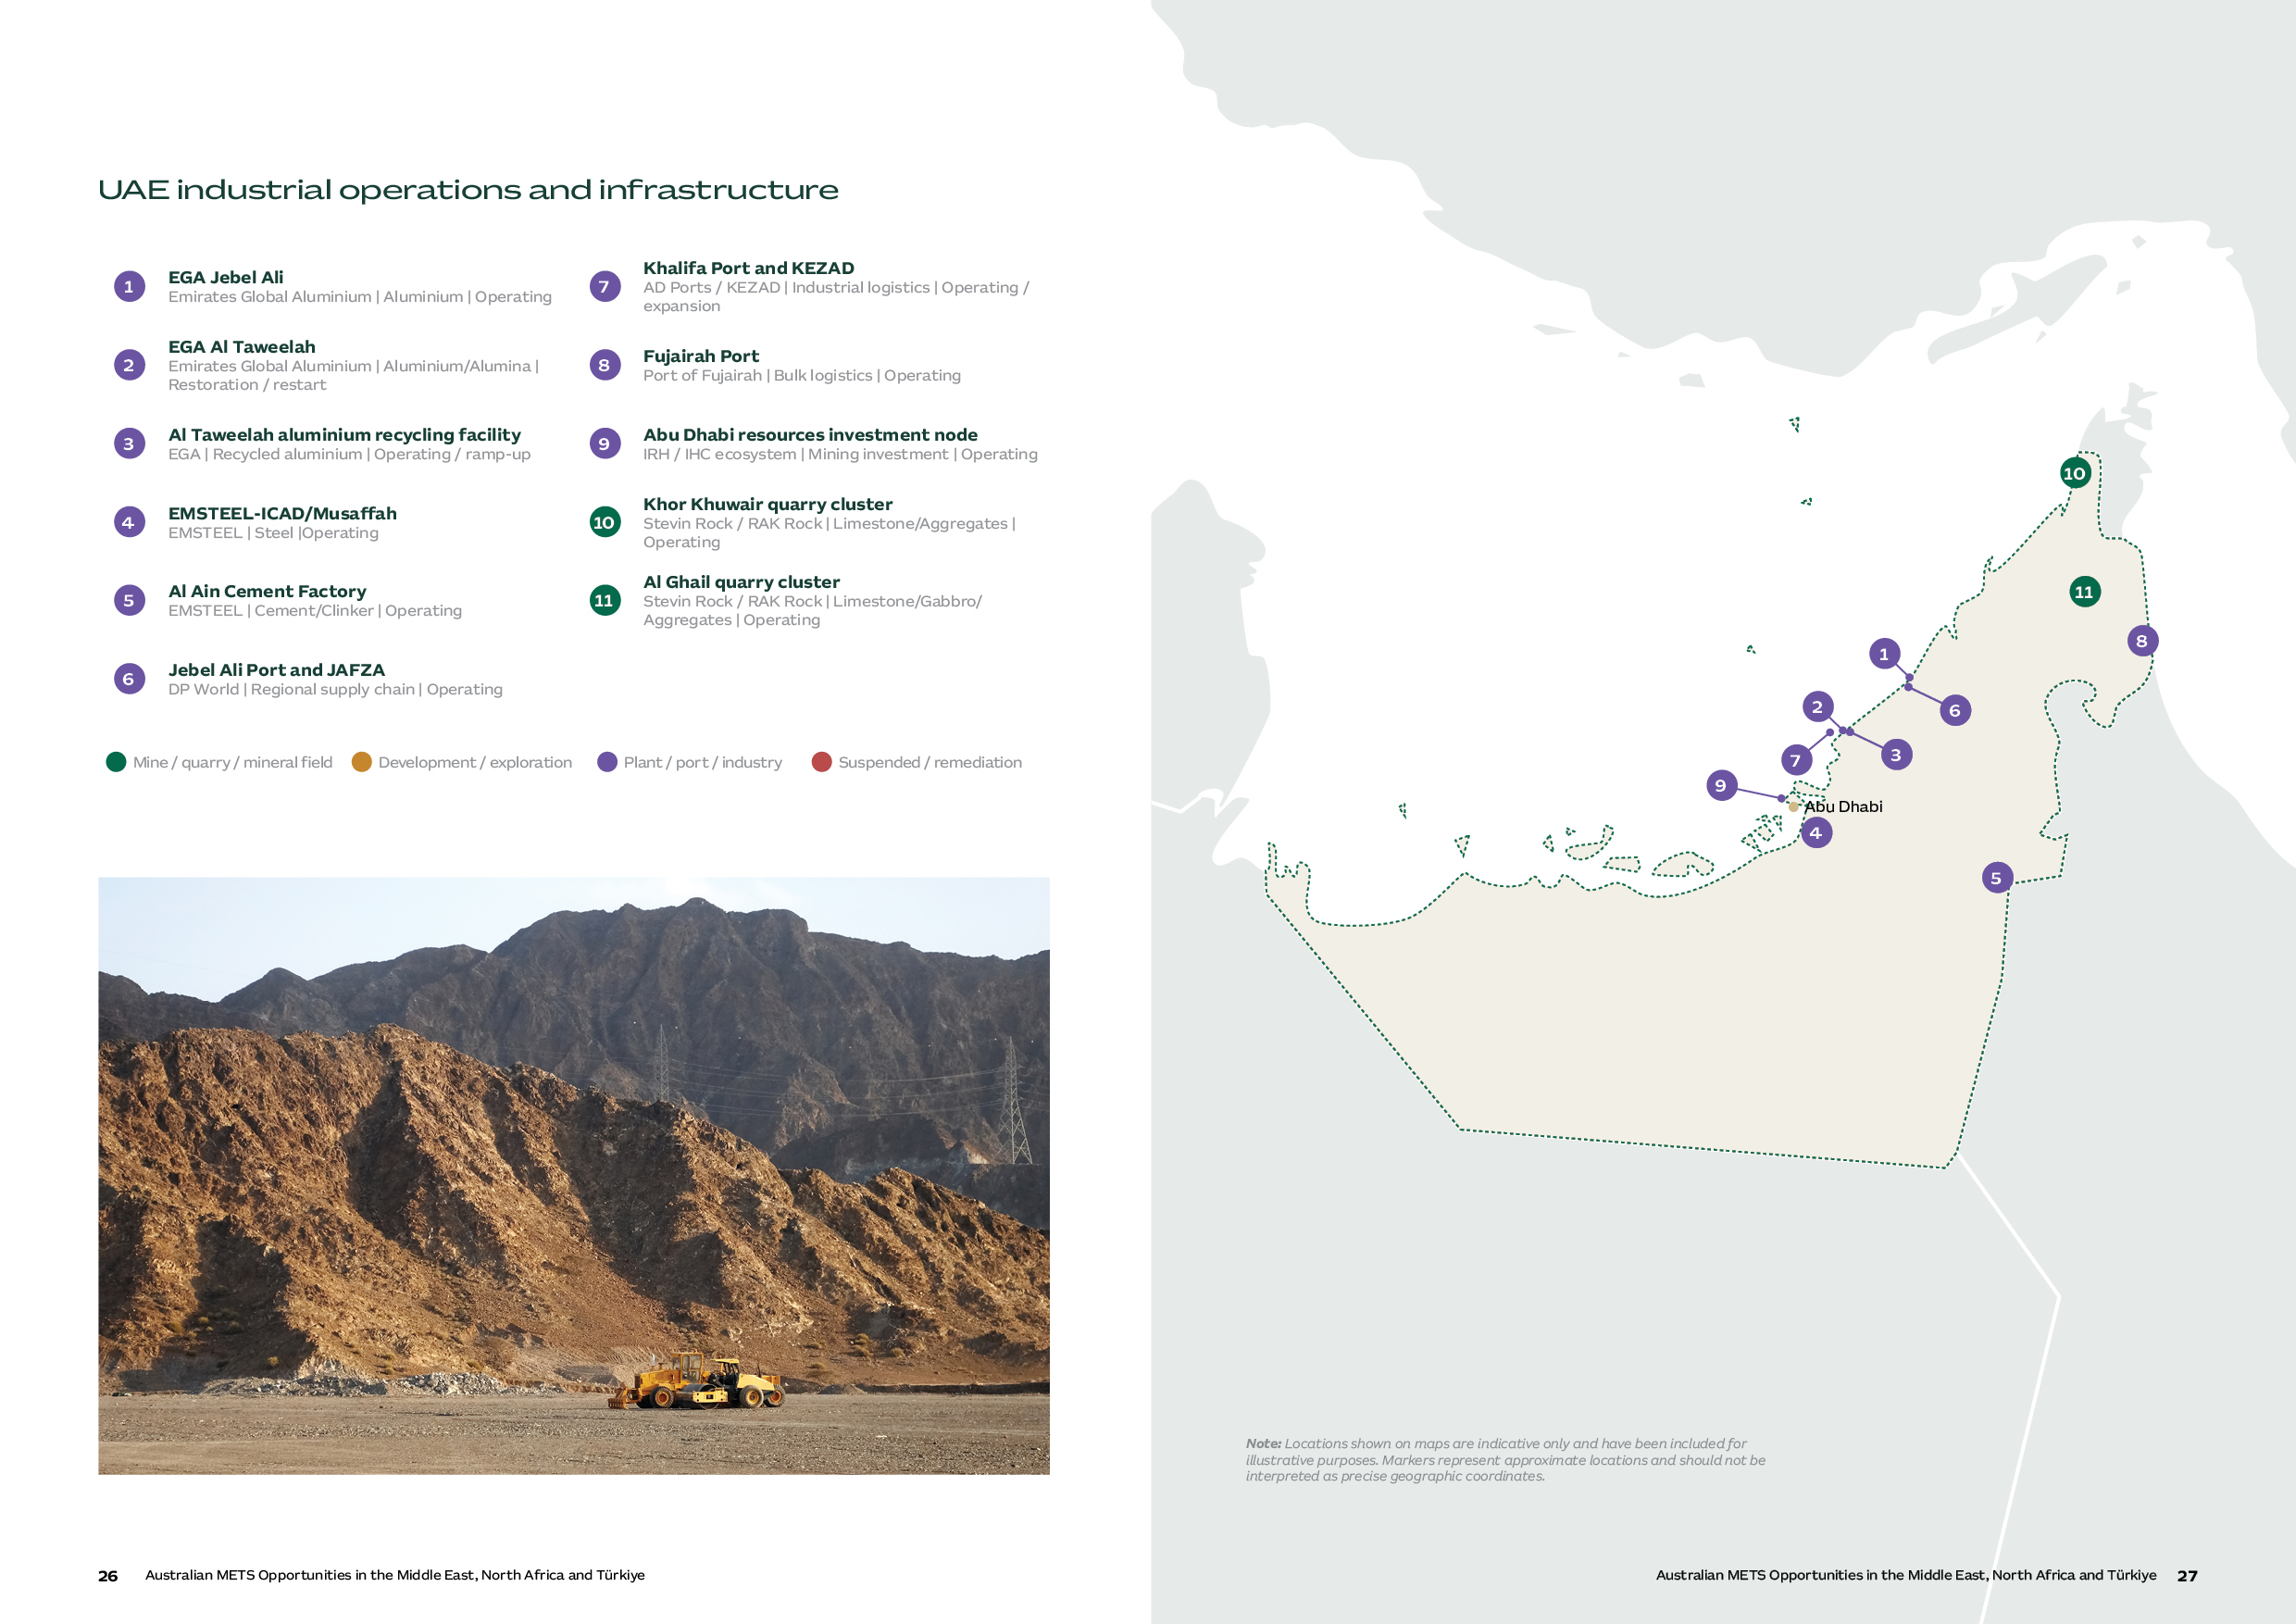

Mining Activity and Implications for Australian METS
The UAE’s operating assets create selective opportunities for Australian METS that fall outside of the typical mining and metals portfolio.
Aluminium and steel complexes are concentrated around Jebel Ali, Al Taweelah and Musaffah/Industrial City of Abu Dhabi (ICAD). Ras Al Khaimah contains major quarrying operations. Ports and freight infrastructure connect these activities with domestic and export customers.^{[7][12][16][19]}
Near-term demand centres on plant reliability, processing performance, quarry productivity, maintenance and environmental systems. Foreign resources investment in neighbouring markets, regional procurement and service functions extend METS opportunities beyond the UAE, but access depends on the relevant asset owner, project and operating country requirements.
Opportunity | Status | Australian METS alignment
EGA: Jebel Ali and Al Taweelah | Integrated smelting, refining and recycling assets form the principal large-scale industrial cluster. Al Taweelah is in restoration and ramp-up. | Reliability, process control, energy efficiency, digital optimisation, emissions, recycling, asset integrity and major-hazard safety.
EMSTEEL and Musaffah/ICAD | Steel and building materials production provides a major industrial customer pathway. | Maintenance, condition monitoring, materials handling, process control, energy, emissions and workforce capability.
Ras Al Khaimah quarry clusters | Khor Khuwair and Al Ghail represent the clearest domestic extractive minerals activity. | Crushing and screening, wear, maintenance, dust suppression, fleet productivity, conveyors, environmental monitoring and safety.
Ports and industrial logistics | Jebel Ali, Khalifa Port and Fujairah support bulk materials, warehousing, re-export and regional service delivery. | Bulk handling, inventory visibility, condition monitoring, spares, logistics technology and regional technical support.
UAE-based resources investors | Abu Dhabi-based investors and technology functions may influence mining assets outside the UAE. | Technical due diligence, major contracting, operational improvements and portfolio-level technology deployment.

Market expansion and industrial investment
EGA's restoration of its Al Taweelah facility, following the March 2026 shutdown, has generated plant restart requirements estimated at approximately US$400 million in capital expenditure. The bulk of this work falls in 2026, with the remainder carrying into 2027. ^{[12][13]}
The longer-term industrial pipeline is broader than one restoration program. EGA and Sunstone are planning a US$300 million, 300,000 tonnes-per-annum anode plant, with construction from 2026 and first production expected as early as 2028. EMSTEEL is in the midst of an Asset Enhancement Program providing opportunities to support plant performance, materials handling, energy, emissions and decarbonisation. A proposed gallium plant at Al Taweelah remains at feasibility stage and should be treated as a watchlist opportunity.^{[7][13][14][17]}
Ras Al Khaimah's quarrying industry provides a substantial domestic market for extractive equipment and services. Its largest operator, Stevin Rock, runs three sites with a combined annual capacity of approximately 80 million tonnes, according to the Ras Al Khaimah Investment and Development Office (IDO).^{[16]} The business is pursuing improved materials recovery and is investing in new wash plants to recover saleable sand and aggregate from waste material.
In July 2026, CFlo announced that a wet-processing plant for limestone scalpings and mine rejects had been dispatched to Stevin Rock, with commissioning still ahead.^{[33]} The investment illustrates demand for improved materials recovery.
The UAE also matters as an outbound resources-investment centre. For example, Abu Dhabi-based International Resources Holding (IRH) is the majority owner of Zambia’s Mopani Copper Mines following a 51% acquisition in 2024. For Australian METS firms, portfolio and technical engagement may begin in Abu Dhabi, while vendor qualification, delivery and local-value commitments occur in Zambia.^{[15]}

Key Projects
Project | Overview | METS opportunity
EGA Al Taweelah restoration and recycling ramp-up | Restoration of the smelter is progressing towards production target of the first quarter of 2027. On 26 August 2026, EGA reported that 315 of 1,262 reduction cells had restarted. The recycling plant is also ramping up, with full production expected in late the fourth quarter of 2026.^{[12][13]} | Asset integrity, controls, safe commissioning, reliability, scrap preparation, process optimisation and emissions management. Potential suppliers need to establish which ramp-up requirements remain available and register on the EGA Supplier Collaboration Portal.
EGA–Sunstone anode plant | A US$300 million joint venture to establish a 300,000 tpa pre-baked anode manufacturing facility in Abu Dhabi's Khalifa Industrial Zone Abu Dhabi (KIZAD), with construction commencing in 2026 and first production targeted for 2028.^{[14]} | Materials handling, process and environmental controls, utilities, inspection, commissioning and maintenance. Sunstone will build for the joint venture.
Stevin Rock quarry processing upgrade – Ras Al Khaimah | Two major contracts have been awarded to support greater recovery. CFlo reported dispatch of a wet-processing plant for limestone scalpings and mine rejects on 15 July 2026, with commissioning still ahead.^{[33]} CDE has announced a contract to design and manufacture a 1,000tph and a 250tph sand and aggregates wash plant to be located at the Al Ghail facility.^{[35]} | Potential complementary work in wear, water recovery, plant reliability and maintenance.
IRH / Mopani transformation, Zambia | IRH reports investment of more than US$1.1 billion since 2024 and a target to increase copper production to 300,000 tonnes per year by 2029.^{[10]} | Geophysics, digital mine systems, grade control, predictive maintenance, underground connectivity and safety. IRH reports strong Zambian procurement localisation.

Market Approach for Australian METS
Category | Capabilities required | Demand drivers
Maintenance and asset reliability | Asset integrity, non-destructive testing, electrical systems, controls, safe commissioning, condition monitoring and critical spares. | EGA restoration and ramp-up, together with continuing maintenance and reliability needs across metals, cement and quarry operations.
Processing and productivity | Advanced process control, materials handling, wear management, digital twins, analytics and predictive maintenance. | Operating plants and quarry fleets provide opportunities to improve throughput, availability and lifecycle cost.
Water, energy and environmental performance | Energy efficiency, water balance and reuse, dust and emissions monitoring, recycling technologies and supply chain resilience. | Recycling, industrial decarbonisation and operational resilience support demand for measurable improvements in resource use and environmental performance.
Engineering and regional technical support | Engineering, technical studies, project controls, training, remote operations, spares and field service. | UAE industrial projects and a defined multi-market customer base may support regional delivery and after-sales capability.

Australia–UAE Comprehensive Economic Partnership Agreement (CEPA)
The Australia–UAE Comprehensive Economic Partnership Agreement (CEPA) entered into force on 1 October 2025. DFAT states that tariffs will be eliminated on more than 99% of Australian goods exports to the UAE by value when fully implemented in 2029.^{[1]}
CEPA may improve the landed cost of eligible Australian goods, but it does not automatically waive UAE product standards, testing, import approvals or buyer qualification. Confirm the product-specific requirements before pricing or dispatch.^{[1][3][38]}
Preferential treatment is applied per product line via the good's HS classification; exporters can identify the applicable tariff and staging schedule for a specific good through DFAT's FTA Portal.^{[1][3]}

Procurement and supplier preparation
The UAE Ministry of Finance's Federal Supplier Register is the mandatory entry point for selling to UAE federal government entities, requiring annual renewal to remain eligible for tenders. Industrial buyers and contractors maintain their own separate registration and approved-vendor systems. The National In-Country Value (ICV) Program, administered separately by the Ministry of Industry and Advanced Technology (MoIAT), scores suppliers on local procurement, in-country investment and national employment. Where adopted, this score is factored directly into bid evaluation, and a missing or low score can weaken an otherwise competitive bid. Its relevance and weighting vary by buyer, however; it is not a universal procurement quota.^{[8][9]} EGA and EMSTEEL use their own supplier and site processes; Stevin Rock or its contractors buy for quarry operations. For overseas assets held by UAE investors, confirm whether the operating company purchases in the host country.
EGA reports that it procured more than US$2 billion of goods and services locally in 2025, equal to 42% of its total procurement spend, and that it prioritises local suppliers when they are commercially competitive. This creates a practical incentive for international suppliers to add UAE-based service, stockholding or manufacturing capability.^{[6]}

“A local partner needs practical support from the Australian supplier. This includes product training, joint customer meetings and a clear explanation of the problem the technology solves”

- Kassem Younes PSM, Queensland Trade and Investment Commissioner to the Middle East and Africa

Market entry and delivery expectations
The value of a UAE-based presence depends on the target buyer and the volume of repeat business. A distributor or technical service partner can be sufficient where deal flow is occasional. Recurring or multi-market demand tends to justify regional staff, inventory or account management, as service depth and the ICV benefit become more material to bid outcomes.
In evaluating a partner, technical staff, import capability, field service reach and existing access to target accounts typically matter more than geographic coverage alone. Stockholding, repair, calibration, training or assembly capability become more relevant once repeat demand is established.^{[6][9]}
Commercial agency, establishment, import and re-export arrangements can have legal, tax and operational implications and should be considered in the context of the specific customer and commercial model.^{[1][3]}
Interviews undertaken for this report illustrate that the case for a local UAE presence strengthens as engagement in the region matures. Capital Limited, a mining services provider with a significant footprint across the Middle East and North Africa, opened its Dubai office to support business development, travel logistics and management functions. Jord, an engineering and process equipment supplier, operates from Dubai to serve the region's oil and gas sector, where it has extensive experience. Austin Engineering, a global equipment manufacturer with recent UAE interests, plans to service local customers from Australia, with regional support under consideration as activity develops.

“The regulatory environment in the UAE and Saudi Arabia evolves constantly, licensing requirements, local content rules and market entry pathways shift regularly in both jurisdictions. Choosing the right structure and staying compliant isn't something companies can work out from the outside. A missed filing deadline, an incorrect tax treatment or an overlooked local requirement can be costly to fix later, which is why working with an experienced service provider from the start often makes the difference between a smooth market entry and a difficult one.”

- Flavie Paquay, Middle East Director, ALTIOS MIDDLE EAST

What a UAE base can, and cannot, support
Dubai and Abu Dhabi function as established regional hubs, with international air connectivity and a concentration of regional headquarters, distributors and professional services providers. The UAE is also a member of the Gulf Cooperation Council (GCC), alongside Saudi Arabia, Qatar, Kuwait, Bahrain and Oman. The GCC Customs Union applies a common external tariff to many imports, but the treatment of goods moving between member states depends on the product, origin and customs documentation. Services, procurement, value-added tax (VAT) and local content requirements still require a country-specific assessment. A UAE base therefore supports regional travel, logistics and relationship management, but each GCC market still requires separate assessment of its customs, procurement and local content rules.^{[19][11][20]}

Market | How a UAE base can help | Limitations and operating implication
UAE domestic market | Provides direct proximity to EGA, EMSTEEL, quarrying operators, engineering, procurement and construction (EPC) contractors and regional offices. A mainland company can trade directly across the UAE and pursue government work. | A free-zone licence does not, by itself, authorise direct mainland activity. The sales and import route must match the licence, customer and activity.^{[21]}
Oman, Qatar, Bahrain and Kuwait | Can support account management, travel, re-export and selected stock or service functions where there is a genuine multi-market customer base. | Each market retains its own customs, standards, registration, tender and local delivery requirements. GCC integration does not create a single procurement or licensing market.^{[19][20]}
Saudi Arabia | Useful for regional oversight, travel and relationships with companies that maintain regional offices. | Increasing Saudi requirements for business registration, importation, workforce localisation and site support may mean a base in UAE is insufficient for market growth. (see Saudi Arabia references ^{[17]} and ^{[18]})
Wider Middle East, Africa and South Asia | Dubai can provide logistics, professional services and access to UAE-based investors, traders and engineering groups with overseas portfolios. | Value depends on where procurement authority sits. Delivery, permits, taxation, local content and after sales support remain country and project specific.^{[18]}

“The UAE remains a strong regional hub for connectivity, but companies targeting Saudi Arabia, the largest economy in the region, increasingly need to treat the Kingdom as a distinct market with dedicated in-country engagement.”

- Kassem Younes PSM, Queensland Trade and Investment Commissioner to the Middle East and Africa

Choosing the operating model
Both mainland and free zone structures allow 100% foreign ownership for most activities. A mainland company can trade directly across the UAE and is generally the clearer route for repeat UAE sales, site services and government work. A free zone company can suit regional management, international consulting, trading or re-export, but its licence does not by itself authorise direct activity on the UAE mainland. Depending on the activity, mainland access may require a distributor, branch, separate licence or an applicable permit.^{[21]} Dubai Multi Commodities Centre (DMCC) advertises remote company setup and publishes indicative licence costs; banking, visas and operational service capability need separate planning.^{[23][24]}
An Emirati equity partner is therefore not generally required for most activities. A technically capable distributor may still be commercially important for import, field service and account access, but a registered commercial agency carries different legal obligations to an ordinary distribution agreement and should be assessed accordingly.^{[24]}

Warehousing and service capability
For equipment suppliers, the establishment decision concerns stock and service capability as much as office space. Free zones offer warehousing and light manufacturing alongside port and transport access, which can support regional spare-parts inventory, equipment consolidation or light assembly where licensed activity and customer demand justify the investment. Zone selection should follow customer geography and site access rather than brand recognition alone.^{[36]}

Free zone | Supports | Key benefit for METS
Jebel Ali Free Zone Authority (JAFZA) – Dubai | Distribution, warehousing, spare parts and light assembly. | Major port and logistics hub; strong platform for regional distribution and re-export.
Khalifa Economic Zones Abu Dhabi (KEZAD) – Abu Dhabi | Manufacturing, assembly, workshops and warehousing. | Industrial ecosystem and proximity to Abu Dhabi's energy, metals and manufacturing customers, including EGA and EMSTEEL.
Ras Al Khaimah Economic Zone (RAKEZ) – Ras Al Khaimah | Workshops, servicing, light manufacturing and warehousing. | Cost-effective industrial base with proximity to Stevin Rock and Ras Al Khaimah's quarrying and aggregates sector.
Fujairah Free Zone – Fujairah | Aggregates, bulk materials, processing and logistics. | Proximity to quarrying activity and Fujairah Port for export-oriented operations.
Dubai Multi Commodities Centre (DMCC) – Dubai | Regional headquarters, trading, consulting, engineering and professional services. | Established commodities trading ecosystem and access to international mining and trading networks.

Free zone status does not automatically exempt a business from corporate tax, VAT or compliance obligations. Tax and customs advice should cover the actual movement of contracts, goods and personnel, including sales into the UAE mainland and re-exports.^{[25][26]}
Where the target buyer applies the National ICV Program, the commercial case for local staff, procurement, stockholding, repair or assembly should be weighed against that buyer’s scoring and tender requirements. A UAE address alone should not be assumed to deliver a meaningful procurement benefit.^{[27]}

“With more than 46 jurisdictions across the UAE, including mainland and themed free zones, each offering different regulatory frameworks, licensing activities, ownership structures, and operational considerations, choosing the right jurisdiction can be challenging. The key is to ensure that your chosen jurisdiction is fit for purpose today and aligned with your business objectives for the future.”

- Maria Libunao, Head of corporate services, ALTIOS MIDDLE EAST

Developing the right relationships
The Mining Show is the most directly relevant event for mining equipment and supply, typically taking place each November in Dubai. It is useful for testing regional demand, meeting distributors and engaging mining companies, contractors and government representatives.^{[28]}
Australian companies should also leverage the presence of Austrade’s Dubai and Abu Dhabi offices, the Australian Business Council Dubai and the Australia–UAE Business Council to build market understanding and identify credible contacts. ^{[11][29][30][31]}

Morocco
A phosphate mining giant diversifying for long-term growth
Morocco occupies a highly strategic position in the global food security landscape, holding an estimated 70% of the world's known phosphate reserves, the essential building block for fertiliser production to feed a growing planet. Morocco ranks second in global phosphate rock production behind China, with an output of 36 million tonnes in 2025.^{[1]}
The state-owned OCP Group has led the development of phosphate reserves since 1920 and has driven substantial investment in downstream industries, producing 12 million tonnes of fertiliser in 2024 with an expansion target of 20 million tonnes annually by 2027. With global demand for fertiliser expected to grow steadily over the next decade, Morocco’s scale and longevity of reserves position the country as critical to food security and global agricultural supply chains for decades to come.^{[2][3]}
However, Morocco’s mining ambitions extend beyond phosphate. The Ministry of Energy Transition and Sustainable Development is implementing the Morocco Mining Plan 2021–2030 to diversify mineral production, increase non-phosphate exploration and support sustainable economic development. In May 2026, the Ministry launched a public competition covering 361 exploration blocks across approximately 13,000 km², supported by a digital mining cadastre to attract further mineral exploration investment.^{[14]}
Morocco is also seeking to leverage mineral endowment for downstream processing industries. This is evidenced by the African Development Bank Group recent approval of a €100 million loan to Gotion Power Morocco to finance the development of an integrated cathode-to-cell lithium iron phosphate battery gigafactory in the Rabat-Salé-Kénitra Free Trade Zone.^{[5]}
While the bulk of immediate METS opportunities for base and precious metals centres on supporting exploration, geological surveying studies and front-end engineering design, a small number of strategic mining and industrial accounts are operating across copper, cobalt, gold and silver. This is led by Managem, Morocco's main diversified mining organisation with several operating units across the country, and growing activity from Aya Gold & Silver.
Australian METS companies can access a broad range of opportunities through targeted engagement across the phosphate, metals and exploration sectors. OCP has ambitious plans to expand mining and processing infrastructure while reducing the water and energy intensity of operations. Established and developing metals mines are demonstrating a growing appetite for productivity-enhancing technologies, while significant investment from Canadian-listed mining companies is bringing international best practices and technologies to the market.

Market at a glance
Morocco snapshot
Market role | Established phosphate and select metals operations with further project development.
Principal activity | Phosphate, copper, silver, gold, cobalt, zinc and selected industrial minerals
Strongest METS alignment | Current: Water management, desalination, specialised processing, energy infrastructure and efficiency, maintenance, materials handling, waste management, environmental performance.  Emerging: Exploration, geoscience, drilling, mine design and development, metallurgy and mineralogy, feasibility studies, process flow modelling.
Typical access pathway | Direct engagement with the OCP or private operator business unit, or through project and engineering partners such as Worley/JESA.
Key commercial considerations | Purchasing is concentrated in a small number of major accounts, often with established suppliers and engineering partners. Identify the responsible business unit, French-language requirements, expected service response and suitable local support. Allow for extended negotiations and consider payment, currency, tax and import arrangements.

Morocco Mines and Processing Operations
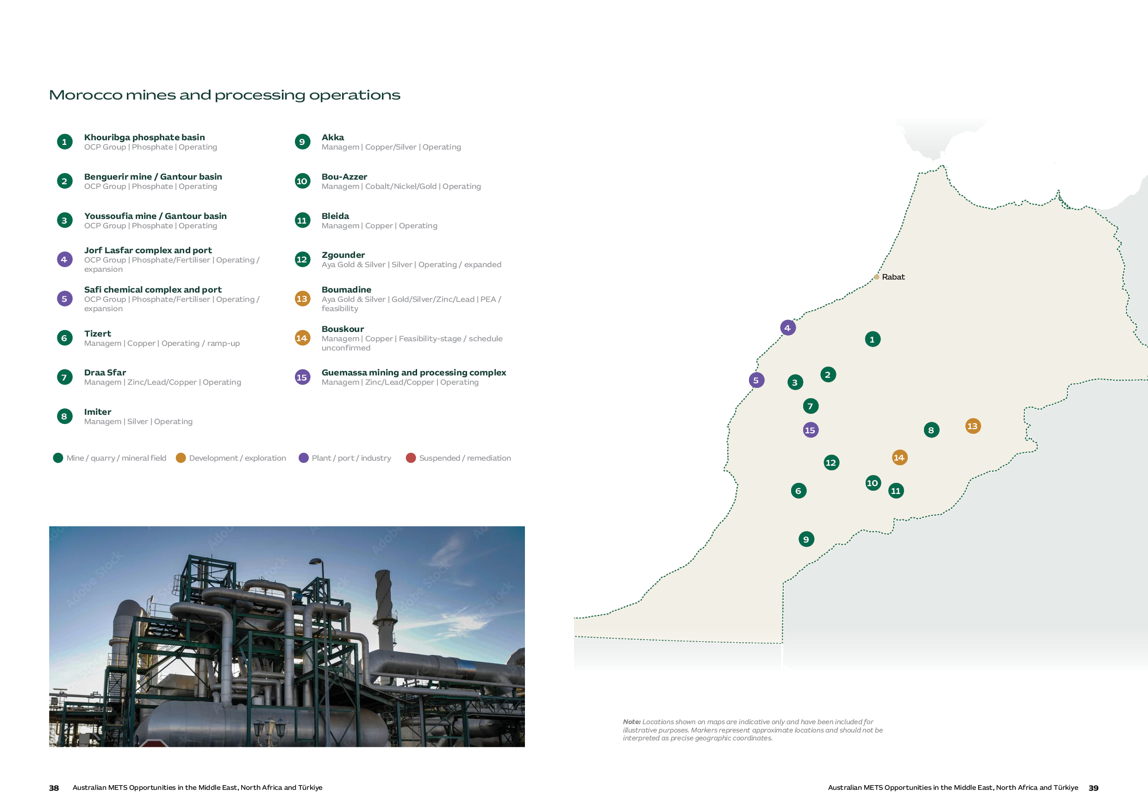

Mining Activity and Implications for Australian METS
Morocco has two distinct opportunity systems.
OCP’s phosphate value chain is concentrated around the Khouribga and Gantour mining basins and links to the processing and export complexes at Jorf Lasfar and Safi, with industrial activities spanning mining, beneficiation, chemical processing, fertiliser production, water and logistics.^{[6]}
Metals activity is more dispersed, with copper, cobalt, silver and polymetallic assets extending through the Atlas and Anti-Atlas regions and selected central and eastern districts. Managem provides the primary opportunity in metals and is continuing to expand its footprint across the region, achieving record profits and production in 2025. Canadian-listed Aya Gold and Silver operates the Zgounder silver mine and is developing the Boumadine polymetallic project.^{[7]}
For Australian METS companies, the strongest pathway is not broad market coverage but disciplined account selection aligned with development needs or operational priorities requiring specialised technical expertise or technologies.

Opportunity | Status | Australian METS alignment
OCP phosphate mining basins | Khouribga and Gantour are the core mining units feeding an integrated national phosphate system. | Mine planning, beneficiation, materials handling, water, energy, maintenance, automation and environmental performance.
OCP Jorf Lasfar and Safi processing complexes | OCP’s two primary chemical hubs to process raw phosphate rock into phosphoric acid and downstream fertilizer products, including significant water and export infrastructure. | Desalination and water systems, process optimisation, energy efficiency, emissions, asset integrity, waste management, maintenance and logistics.
Managem copper and polymetallic system | Tizert, Akka, Bou-Azzer, Bleida and Guemassa offer a geographically dispersed operating and growth portfolio. | Copper and polymetallic processing, project services, reliability, environmental, social and governance (ESG) systems, mine planning and technical studies.
Aya Gold and Silver Zgounder operation and Boumadine development | An expanded operating silver mine sits alongside a separate advanced polymetallic growth project. | Plant optimisation, water, digital systems, reliability, resource definition, test work and project studies.
Exploration licence holders | Licence releases and exploration activity may generate work before projects reach development. | Geophysics, drilling, sampling, laboratories, geological modelling and studies.

Market development and Exploration Activity
Morocco’s strong investment environment is reflected in the Fraser Institute’s 2025 Investment Attractiveness Index, where it ranked 15th of 68 jurisdictions, up from 18th of 82 in 2024. Based on survey responses from 256 global mining companies, Morocco ranked second in Africa behind Botswana, which ranked 7th globally. ^{[8]}
Exploration in Morocco is largely focused on base and precious metals. It has attracted considerable foreign investment from companies listed on the Toronto Stock Exchange, such as Morocco Strategic Minerals, Stellar AfricaGold and Trigon Metals. Aya Gold & Silver's total exploration and development expenditure across its Moroccan projects reached approximately US$41 million in 2025, with a focus on its development of the Boumadine project.^{[9]}

Key Projects
Project | Overview | METS opportunity
Khouribga Mining Complex and Jorf Lasfar Phosphate-Fertiliser Hub – OCP Group | Khouribga is OCP's primary mine site, producing around 70% of the Group's total output through large-scale open-pit operations. Mining involves continuous overburden removal and ore washing to produce merchant-grade phosphate rock, which is then processed through washing and beneficiation plants on site, before transport via a 235km slurry pipeline to the Jorf Lasfar processing complex. | Khouribga and Jorf Lasfar form OCP's Northern Axis. OCP Group reported in July 2025 that it had achieved complete autonomy from conventional water across its industrial and mining sites, two years ahead of its original 2027 target. Current priorities include continued desalination and transfer infrastructure, renewable energy and processing efficiency.^{[14]}
Bou-Azzer Cobalt Mine and Cobalt Sulfate Plant – Managem | Bou-Azzer is Morocco's founding cobalt operation and Managem's flagship cobalt asset. Mining is conducted via underground methods with historical annual output of around 1,500–2,400 tonnes of contained cobalt used for cobalt cathode. | Market sources report that Managem is commissioning a project to switch from cobalt metal to sulfate production. The plant would have a capacity of 6,000 tonnes of sulfate per year, equivalent to about 1,200 tonnes of contained cobalt. This requires new technical capabilities and presents potential opportunities.^{[10]}
Tizert Copper Mine – Managem | Tizert is a greenfield copper operation that commenced production in 2025, and plans to be the largest underground mining operation in the region. Its development and ramp-up add operating and technical service demand alongside Morocco’s established metals assets. | As a greenfields site, Managem worked with Epiroc to embed digitisation technologies such as real-time personnel and vehicle tracking and safety systems.^{[11]} METS applications include plant reliability, maintenance, operating optimisation and workforce capability as copper concentrate production ramps up, along with efficiency-enhancing systems leveraging the mine’s digital architecture.
Boumadine Polymetallic Project - Aya Gold and Silver | Boumadine is a development-stage polymetallic growth project. Aya published an updated preliminary economic assessment on 9 September 2026 outlining a combined open-pit and underground plan with a 14-year mine life. A feasibility study and environmental and social impact assessment (ESIA) are underway, supported by a 400,000-metre drilling program across 2026–2027.^{[15]} | Near-term METS opportunities relate to engineering, metallurgical testwork, water and infrastructure design, resource-definition and drilling. Future procurement packages remain prospective until the feasibility study, approvals and funding are further advanced.^{[17]}

Market Approach for Australian METS

“A local presence, either directly or through a qualified local partner or distributor, is a key success factor for large-scale projects. OCP typically seeks strategic partners capable of creating long-term value, rather than transactional supplier relationships.”

- Driss Sekkat, Investment Director, Austrade

Australian METS Capability Alignment
Category | Capabilities Required | Demand Drivers
Water & desalination technology | Seawater desalination plant design and construction; non-conventional water treatment and reuse systems; water-efficient beneficiation and processing technology; water recycling and tailings water recovery. | Water scarcity makes desalination, transfer and reuse central to OCP’s operations. OCP reported autonomy from conventional water across its industrial and mining sites in July 2025 and continues to develop water infrastructure at Jorf Lasfar and Safi.^{[6][13]} Water availability also affects project planning in inland exploration areas.
Renewable energy & decarbonisation | Solar and wind power integration for mine sites; green hydrogen/ammonia production expertise; grid connection and hybrid power system design; carbon capture/reduction technology. | OCP targets 100% renewable energy by 2027 and carbon neutrality (Scopes 1 and 2 by 2030, Scope 3 by 2040), backed by a US$13 billion 2023–2027 investment program.^{[12]}
Mining equipment & processing technology | Slurry pumps, hydrocyclones and separation equipment; crushing, grinding, and beneficiation plant technology; energy-efficient processing systems; equipment suited to open-pit and underground hard-rock operations. | OCP's ongoing Khouribga/Benguerir/Louta expansions and Managem's new mines (Tizert, Bou-Azzer sulfate plant) require modern, efficient processing equipment as production scales and OCP pursues its 20 Mt/year 2027 fertiliser target.^{[13]}
Mine automation & digitalisation | Real-time personnel/vehicle tracking systems; remote and autonomous drilling/haulage technology; digital mine planning and orebody modelling software; data management and IoT sensor systems. | Managem's "digitalised greenfield" approach at Tizert signals appetite for automation from project inception. OCP's existing sensor-based slurry pipeline monitoring shows precedent for data-driven operations.
Exploration & geological services | Diamond and reverse-circulation (RC) drilling contract services; geophysical surveying; assay and metallurgical test work laboratories; resource estimation and reporting under Canada's National Instrument 43-101 and the Australasian Code for Reporting of Exploration Results, Mineral Resources and Ore Reserves (JORC Code). | Rapid growth in junior explorer activity (Aya, Morocco Strategic Minerals, Stellar AfricaGold, Steadright, Trigon, CMR) with limited major international drilling contractor presence currently established in-country.
Environmental, safety & sustainability consulting | ESG compliance and reporting aligned with European Union (EU) standards; mine rehabilitation and closure planning; quality, health, safety and environment (QHSE) systems and auditing; community development program design. | Morocco's green mining agenda is explicitly aligned with EU sustainability standards to support its export relationship with Europe. OCP and Managem both publicise strong sustainability and community commitments, and EU-linked trade requires demonstrable compliance.

Procurement and supplier preparation
Morocco has historically had no mandatory local content requirements in place. However, a draft mining code reform is set to examine the transfer and leasing of exploitation permits, regulate subcontracting, and prioritise local employment and training through a new professional mining card.^{[16]}
Customs duties and any zone-based incentives depend on the product, location and activity. Suppliers should confirm the applicable treatment before pricing equipment or choosing an import route.^{[17]}
OCP is the central account, and access differs according to the scale and nature of the requirement. Selected components and equipment may move through formal supplier and online procurement processes, while larger projects are more likely to involve sustained local engagement, engineering partners and a partnership-based delivery model. This reinforces the need to identify the relevant project and technical pathway rather than treating OCP as a single procurement channel. ^{[18]}
A potential avenue for Australian METS companies to development and engineering opportunities may be through JESA, the joint venture between OCP and Worley. They provide significant project management and delivery capabilities across OCP’s major industrial and mining units, along with access to opportunities in other markets, such as Maaden’s 3 Phosphate Phase 1 expansion in Saudi Arabia.
“In Morocco, a strong local agent is essential to securing projects. Occasional proposals submitted remotely are unlikely to succeed without an established local presence and relationships”.”

- Shane Freeman, Senior Sales Manager, JORD International

Market entry and delivery expectations
Morocco should be approached as a distinct, European-facing commercial market, as business practices, customer expectations, and route-to-market considerations differ materially from the Gulf region or Africa. Commercial and technical engagements are often carried out in French language, and this shapes practical requirements for market access.
Jord’s experience points to the value of a credible local representative and continuing customer support. Australian METS companies should assess whether an agent, partner or local service model can meet the buyer’s language, installation, training and after-sales requirements, and allow time to establish the relationship.
Australia's relative geographic distance and limited existing investment in Morocco's mining industry present a potential competitiveness challenge. Morocco's integration with European markets, along with significant investment from Canadian junior miners and explorers, has brought supply chains and technical solutions from those regions. Morocco's mining sector is explicitly aligning its sustainability standards with the EU, and suppliers should expect scrutiny on carbon footprint, health and safety certification, and ESG standards.
For Australian METS investigating the market, the annual International Mining Congress (IMC) in Rabat offers the key platform to connect with industry and establish relationships with major mining houses, explorers and potential in-market partners. Companies can engage with Austrade’s office in Paris to receive advice, connections and support for the Moroccan market.

“It is important to approach Morocco as a distinct market rather than grouping it with the Gulf countries. The business mindset and decision-making processes are shaped by a different context, with many practices being familiar to European companies.”

- Driss Sekkat, Investment Director, Austrade

METS Case Study

Jord: entering Morocco through relationships, references and an in-market representative
Jord is an Australian METS company specialising in minerals processing technology and modular plant solutions. Building on its Middle Eastern operations, Jord is constantly expanding its presence into North Africa.
Jord is pursuing an opportunity to improve plant operating systems for a major Moroccan phosphate producer. Its approach has focused on collaboration with engineering houses, EPC contractors and end users to develop opportunities and maintain strong local relationships.
Building trust and identifying suitable local representation have been important in understanding customer expectations and establishing credibility. The customer's openness to local and international operating references has enabled Jord to demonstrate its technical capabilities whilst building long term relationships in the region.
Morocco is a competitive industrial market with established international suppliers. Jord's experience reinforces the importance of proven technology, relevant test work and demonstrable operational benefits, supported by strong customer interaction and ongoing technical support.
Commercial ongoing negotiations have required consideration of contractual, financial and regulatory matters, including exchange rates and withholding taxes, highlighting the value of local expertise and appropriate professional advice.
Jord's experience demonstrates that successful market development relies on technical credibility, flexibility, effective communication and sustained local engagement. Combining international expertise with trusted local partnerships provides a strong foundation for long-term growth in Morocco.

Egypt
A market amidst significant reform and transformation
Egypt’s mining industry is undergoing significant regulatory and institutional change linked to the government’s objective to raise mining’s contribution from around 1% of GDP to 5–6% over the coming years.^{[1]}
To deliver this target, the Mineral Resources and Mining Industries Authority (MRMIA) has an expanded mandate covering mining, downstream industries, and value creation. It has launched a comprehensive reform platform to attract investment into the sector, including modernising the industry’s legal framework to align with international best practices, creating competitive fiscal terms and stability clauses, delivering a suite of investment incentives, and driving a digital transformation agenda to increase efficiencies, transparency and governance.^{[8]}
To support future mining activity, Egypt has launched its first nationwide airborne mineral survey in 42 years. Led by the Ministry of Petroleum and Mineral Resources and MRMIA with Xcalibur Smart Mapping, the program covers six strategic regions and uses advanced airborne geophysics, artificial intelligence and multi-source geospatial data integration to generate higher-resolution geological information and reduce exploration risk.^{[2]}
The early signs of these reforms have been promising, with initial results indicating increased international interest, new exploration commitments and companies returning to Egypt. However, Egypt has a long path to navigate to develop its minerals sector, and the conversion of exploration licences into funded exploration programs and new mine development decisions across the next 12–24 months will be the real test.

“I've never seen a country and a government so proactive in turning things around and making it open to external investment and people coming into the industry."

- Colin Rawbone, Managing Director, SRK Exploration
For Australian METS companies, the strongest established mining account is the Sukari Gold Mine, owned 50% by AngloGold Ashanti and 50% by the Egyptian government.^{[3]} Since commencing production in 2009, Sukari has transformed into Egypt’s largest and most important mining operation, producing 500,000 ounces of gold in 2025{14]. Sukari is the strongest proof-of-concept for Egypt's modern gold mining industry, demonstrating that a large-scale international mining operation can be developed and operated in partnership with a major foreign investor, utilising international expertise and technical best practices.^{[3]}
Egypt’s longer-term prospects depend on implementation of the reforms and sustained investment. The announced changes and new exploration activity signal potential, but their practical effect on METS opportunities will be clearer as licence holders undertake funded work, secure finance and progress projects to development and construction.

Market at a glance
Egypt snapshot
Market role | Market amidst significant mining and investment reforms with selective current demand
Principal activity | Gold, phosphate, copper, mineral sands, iron ore and rare earths
Strongest METS alignment | Mine recovery and reliability; geoscience, surveying, drilling, water and specialist technical services
Typical access pathway | Direct engagement with AngloGold Ashanti business units, MRMIA or government-owned mining operators
Key commercial considerations | Current purchasing is concentrated around established operations and funded exploration. Observe project funding and timing, identify purchasing unit, agree commercial terms, confirm partner capability required, and allow for equipment importation and mobilisation.

Egypt’s exploration opening and the execution test
SRK Exploration has worked with Egypt for almost a decade and is in an unparalleled position to understand the transformational change underway in the market. According to their Managing Director, Colin Rawbone, a shift from a closed, high-risk, first-mover play to a more credible destination for international participation is rapidly developing, driven by national geoscience studies, a more accessible cadastre and a broader multi-commodity exploration focus.
These significant reforms have brought a maturing base of exploration companies and service providers, including drilling companies, laboratories and technical experts, demonstrating the development towards a vibrant mining ecosystem. SRK believes these international players are bringing in modern and expatriate skill sets to supplement a strongly academic domestic technical base and well-established infrastructure.
While the transformation is real and rapid, the mining industry development will take time, effort and investment. SRK notes that while signs are positive, Egypt must sustain the momentum, and potential investors will want to see outcomes from initial explorers.

“It's just about timing in the market and having that stability... I think that's the real litmus test for Egypt now.”

- Colin Rawbone, Managing Director, SRK Exploration

Egypt Mines and Processing Operations
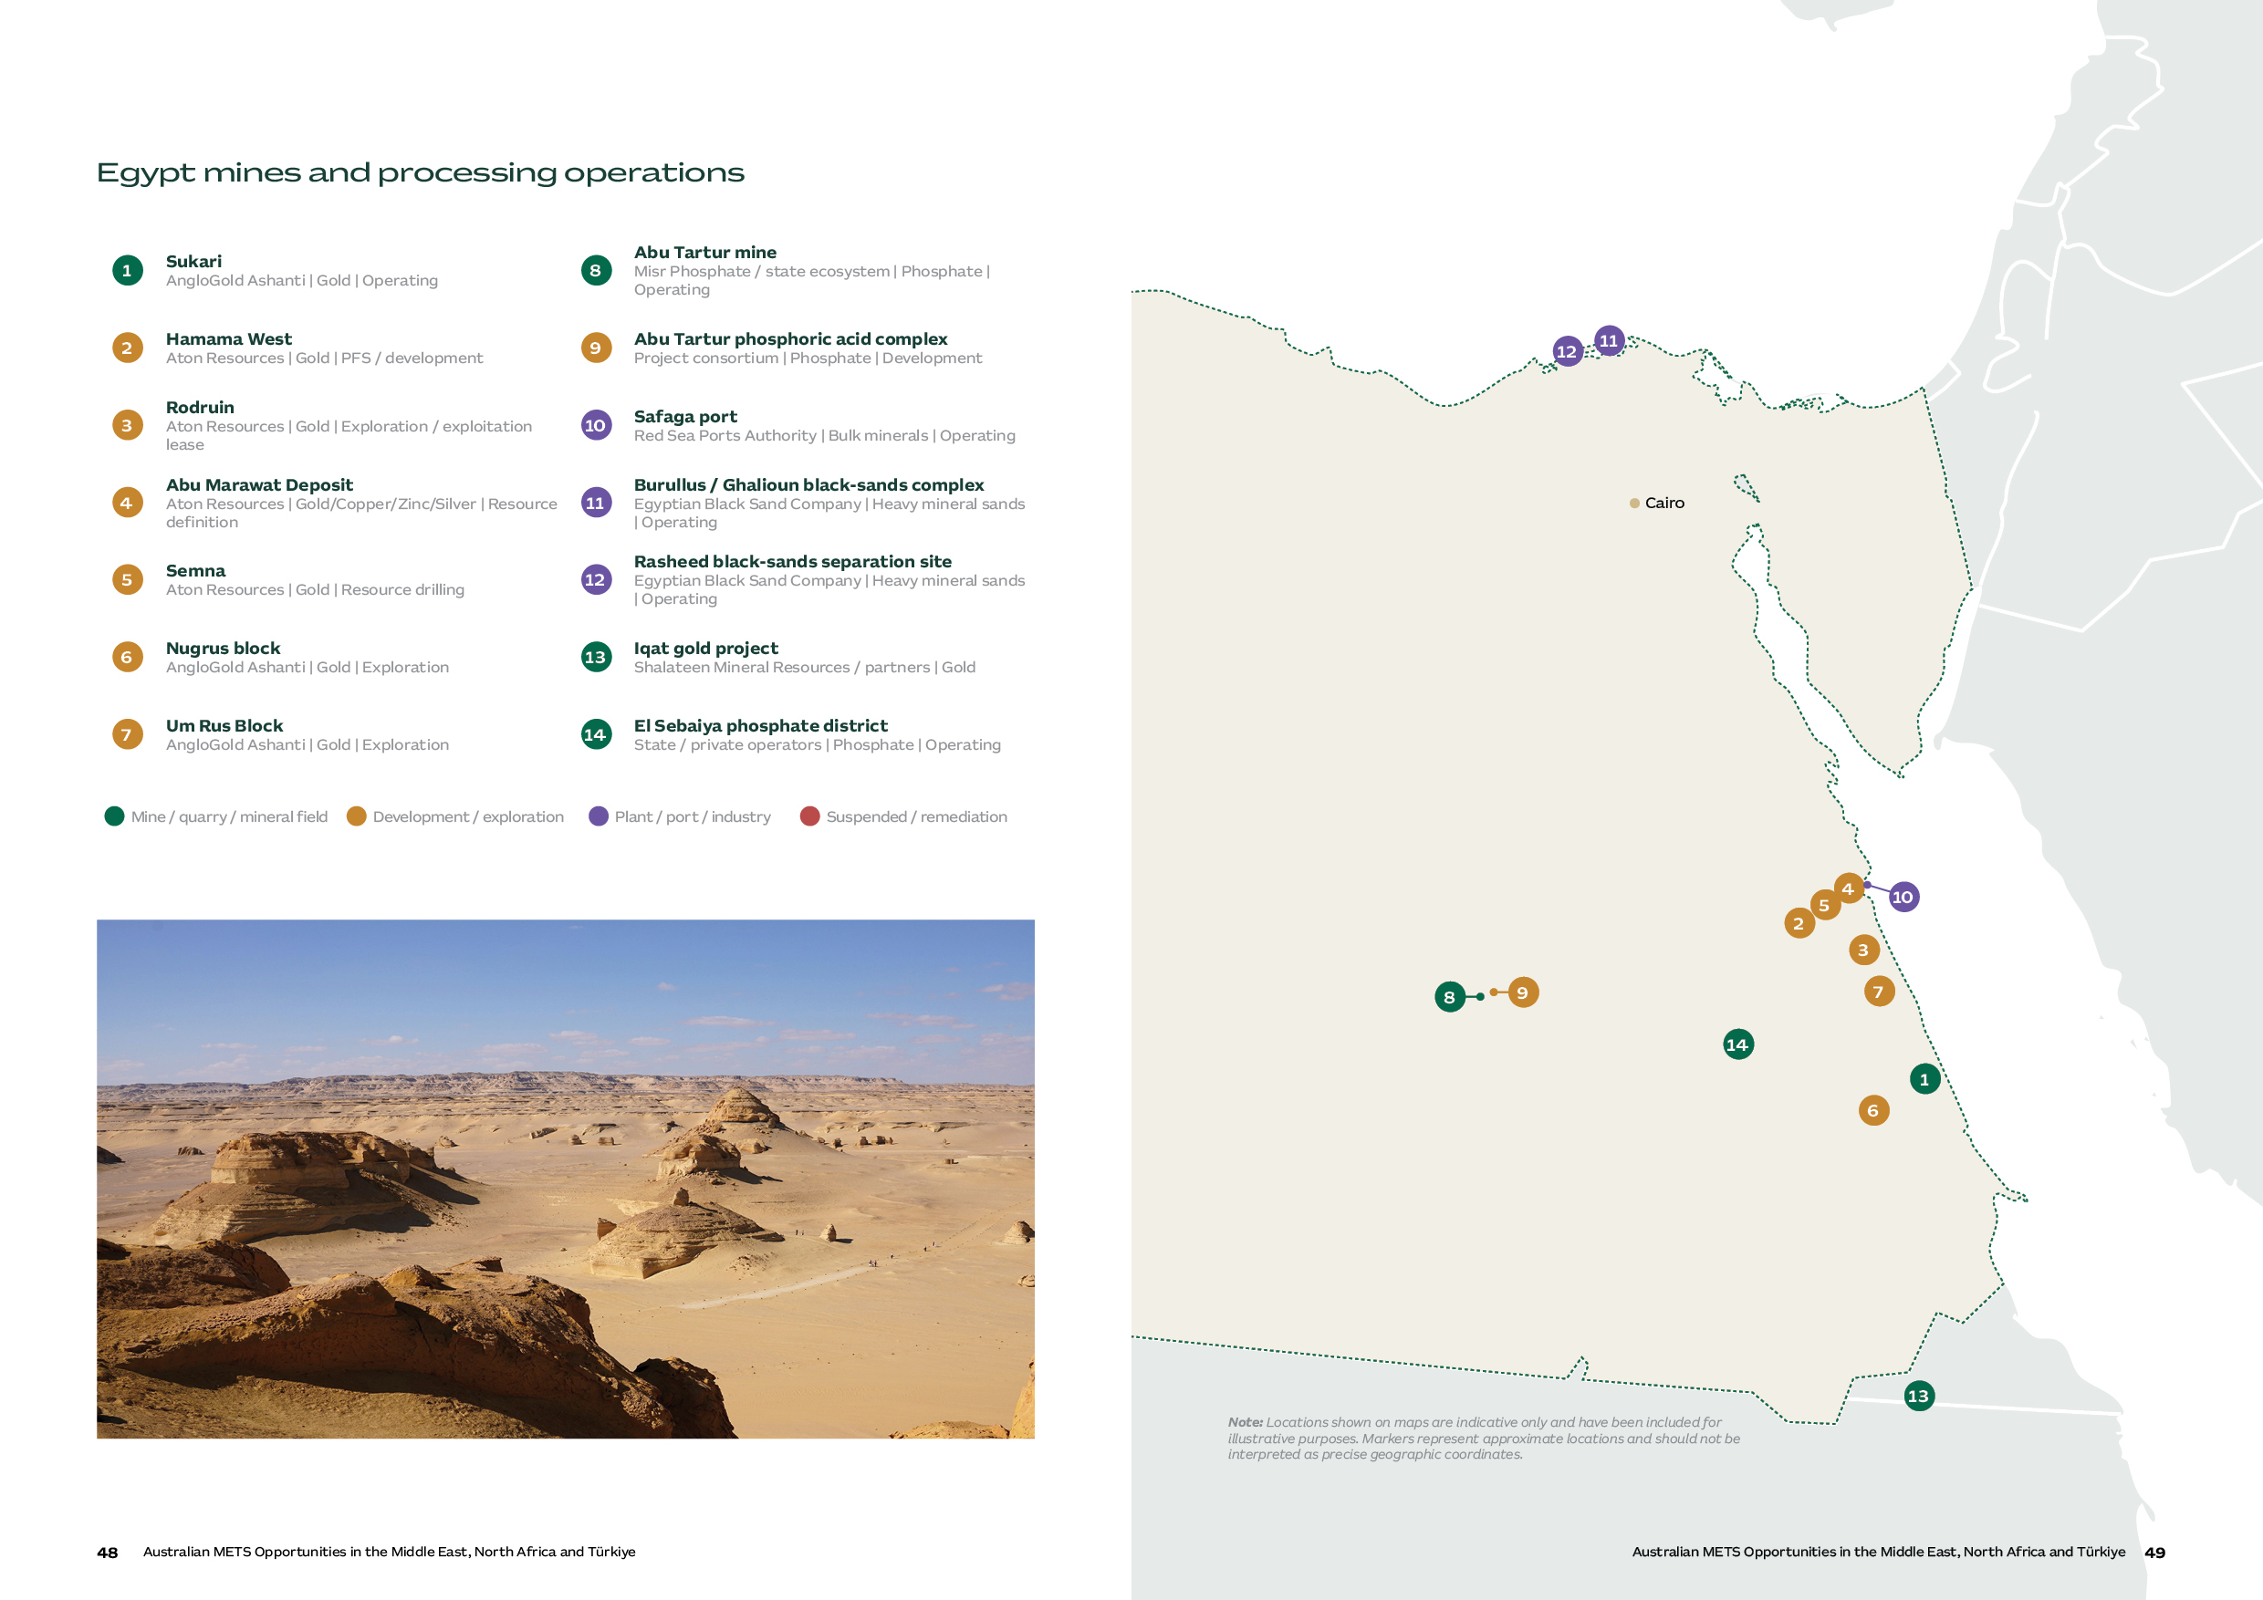

Mining Activity and Implications for Australian METS
While gold is the main mining opportunity in Egypt, potential exists across a broad array of minerals and metals, with each commodity at a different level of maturity. The flagship Sukari operation is in the Eastern Desert within the Arabian-Nubian Shield, where much of Egypt’s gold exploration is concentrated. Red Sea ports provide important logistics hubs for current and potential gold projects. Phosphate activity is centred further west and south, while black sands processing, involving heavy minerals including ilmenite, zircon, magnetite, rutile, garnet and monazite, is located along the Nile Delta and Mediterranean coast.
For Australian METS companies, the timing of market entry to Egypt should follow project maturity rather than the size of the geological opportunity alone. Companies should track committed exploration spend, project finance and procurement timing rather than treating reform announcements alone as a signal of near-term purchasing.

Opportunity | Status | Australian METS alignment
Sukari gold mine – AngloGold Ashanti and MRMIA | A large-scale open-pit and underground gold operation providing Egypt's strongest established mining account. | Processing and recovery, comminution, maintenance, water, tailings, digital systems, safety and environmental performance.
Eastern Desert exploration | A cluster of licences and exploration activity is driving resource definition and development around the Arabian-Nubian Shield. | Geophysics, remote sensing, drilling, core and sample tracking, laboratories, field data and logistics.
Phosphate districts and Abu Tartur | Western Desert and Upper Egypt phosphate assets create a separate mining and downstream development opportunity. Most yet to be developed with small historical production from Abu Tartur project. | Exploration, mining systems, beneficiation, bulk handling, water, process engineering, infrastructure and environmental management.
Black sands systems | Largely operated by the government-owned Egyptian Black Sand Company (EBSC), this complex involves integrated dredging and processing/separation operations. | Mineral separation, magnetic, process control, maintenance, product quality and environmental monitoring.

Market development and Exploration Activity
Egypt's mining sector is at an early but increasingly active stage of development. While current production is concentrated in a small number of established operations, the government's 2025–26 reforms are expanding Egypt's exploration pipeline.
Recent licensing activity provides an indication of sector activity. In the fourth quarter of 2025, MRMIA approved 53 decisions: 11 new exploration licences, 15 new exploitation licences, 26 exploitation-licence renewals and one land-licence request. The decisions covered minerals including feldspar, calcite, vermiculite, magnetite, iron oxide, talc, fluorspar, phosphate and glass sand. International companies are also recommitting capital, including Cyprus-based FMC, which announced plans to resume gold and mineral exploration in the Eastern Desert with around US$20 million of investment.^{[4][5]}
“What they've managed to achieve in 11 months is unheard of anywhere."

- Doug Horak, CEO, Australia-Africa Minerals and Energy Group (AAMEG)

Key Projects
Project | Overview | METS opportunity
Sukari - AngloGold Ashanti (50%) and MRMIA (50%) Joint Venture | Sukari is Egypt’s largest modern gold mine. The operation produced 500,000 ounces of gold in 2025 and combines open-pit and underground mining with a large processing plant.^{[3]} | In August 2026, AngloGold Ashanti announced various initiatives to increase the mine's long-term value, including upgrading the mining fleet, accelerating waste stripping, and improving the processing plant to enhance gold recovery. They also noted ongoing exploration on the Little Sukari project to expand mineral resources.^{[6]}
Hamama West – Aton Resources | Aton targets first production in 2027 from its proposed Hamama West heap-leach project. Aton agreed a facility of up to US$30 million in September 2026 for further exploration and development at Hamama and general corporate expenses.^{[13]} | Technical studies, test work, metallurgy, project systems, infrastructure planning and future process design. Xinhai subscribed for CAD$4 million of Aton shares and signed a non-binding memorandum to discuss potential cooperation; this does not establish an EPC award or committed plant supply. ^{[7][11]}
Eastern Desert Regional Exploration – AngloGold Ashanti | AngloGold Ashanti’s greenfield exploration portfolio in Egypt includes the Nugrus and Najd blocks in the Eastern Desert.^{[11]}[ 6][12} | Potential METS applications include drilling, geophysics, geochemistry, data systems and resource modelling. Suppliers should confirm the current exploration programme, budget and procurement requirements before pursuing work. ^{[11]}.^{[6][12]}
National Geophysical Airborne Survey – MRMIA | Egypt has launched its first nationwide airborne mineral survey in 42 years. Xcalibur Smart Mapping is the principal international contractor, using advanced airborne geophysics, AI and multi-source geospatial data integration across six regions.^{[2]} | The principal survey contract has already been awarded. Suppliers should establish whether Xcalibur or MRMIA has a defined follow-on need for data interpretation, integration or related services.

Market Approach for Australian METS
Category | Capabilities Required | Demand Drivers
Mineral exploration and geological services | Geological modelling; exploration targeting; resource estimation; JORC-compliant reporting; field geology; geochemical interpretation. | Expansion of exploration following mining sector reforms and the 2026 Open Blocks system covering gold, phosphate, talc and kaolin. Egypt is seeking to attract international exploration companies and improve resource definition.
Geophysical surveying and remote sensing | Airborne geophysics; ground geophysics; hyperspectral imaging; remote sensing; 3D geological modelling; drone/UAV surveying. | Large, underexplored areas of the Eastern Desert and Arabian-Nubian Shield create demand for efficient exploration technologies. Sukari and surrounding exploration areas already use geochemical, geological, drilling and airborne geophysical techniques.
Exploration drilling and drilling technology | RC and diamond drilling; directional drilling; automated drilling; downhole instrumentation; drill optimisation; geological logging. | New exploration licences and increasing gold exploration will require significant drilling capacity. International companies are actively returning to or expanding exploration activity in the Eastern Desert.
Gold mining and mine optimisation | Mine planning; grade control; fleet optimisation; blasting; orebody modelling; production optimisation; automation. | Sukari and other gold mines coming on board with both open-pit and underground mining creates opportunities for productivity, cost and recovery improvements. Other projects depend on funding and development decisions.
Water management and treatment | Mine water treatment; desalination; water recycling; filtration; dewatering; tailings-water recovery; process-water optimisation | Water scarcity and the location of many mineral deposits in arid areas make water efficiency increasingly important. Processing expansion also increases demand for water recycling and treatment technologies.
Mining safety and workforce capability | Safety systems; fatigue management; proximity detection; mine rescue; training; competency systems; operational risk management | Expansion of mining activity will require development of technical and operational capability. Australian expertise in mine safety, training and operational systems is highly transferable to Egypt's developing modern mining industry.
Mine environmental management and closure | Environmental monitoring; rehabilitation; biodiversity management; closure planning; ESG reporting; impact assessment. | Egypt's mining reforms are accompanied by a stronger focus on internationally aligned environmental practices. New exploration and mining developments will require environmental assessment, permitting and closure planning.
Phosphate mining and processing | Beneficiation; phosphate processing; materials handling; process engineering; water management; downstream chemical processing. | The government is pursuing phosphate growth, evidenced by a July 2026 memorandum of understanding between MRMIA and Genesis Mining Egypt for a proposed US$930 million integrated phosphate project in the New Valley. Studies, finance and procurement decisions remain ahead.^{[14]}
Mineral sands / black sands processing | Mineral separation; magnetic/electrostatic separation; gravity concentration; wet processing; tailings management; process automation. | Egypt is seeking to monetise its mineral sands resources and develop downstream processing. This is a particularly relevant niche for Australian companies with mineral sands processing and separation expertise.

Procurement and supplier preparation
Current procurement opportunities are concentrated around established operations and funded exploration activity. Suppliers should identify specific purchasing requirements rather than assume that announced reforms or licence awards will generate immediate tenders.
A key factor is to determine whether the ultimate customer is a state-linked mining company or a multinational organisation, EPCM or private Egyptian operator. While government procurement generally gives preference to Egyptian-origin products, local content is not yet codified in mining-specific legislation. In practice, local content expectations at operating mines are driven by operator-level ESG and community commitments rather than statute.
For major projects that may be developed in the coming years, getting specified into the technical design is a more effective route to market than competing solely at the final tender stage. Therefore, METS companies should build relationships with these counterparts before procurement opportunities arise.

Market entry and delivery expectations
As the mining sector is still developing in Egypt, a staged approach to market entry is recommended that reduces upfront capital costs and allows a local presence. This includes initial market validation and customer mapping, establishing an Egyptian partner, and undertaking targeted business visits.
A local partner is highly valuable in Egypt, and a purely Australia-to-Egypt remote sales model is likely to be less effective for technical mining equipment and services. Key elements to look for in partners include existing relationships with mine operators, government entities and EPC contractors, and the ability to provide installation, commissioning, maintenance and Arabic-language support. The local Egyptian workforce has a high level of education and provides a strong resource to support in-market follow-up and technical requirements.
Commercial agency, distribution and importation have different registration requirements. Companies should check importer eligibility under the current GOEIC rules, including the foreign-ownership exceptions introduced by Law 173/2023 and subsequent amendments and regulations. Before contracting or shipping, confirm with GOEIC and qualified Egyptian advisers who will act as importer of record, how long the registration is valid and which conditions apply ^{[15]}.
For equipment and parts shipped to Egypt, agree with the importer or an experienced customs broker who will arrange clearance, duties, insurance and inland transport under the chosen Incoterm. Egypt’s Advance Cargo Information (ACI) process requires advance shipment data and an ACID number. Exporters should check the current Nafeza instructions and document requirements before dispatch, including for samples and temporary imports. Confirm any claimed customs or tax incentive for the specific licence, item and transaction rather than assuming a general exemption.^{[9]}
For Australian METS companies looking at the market, consider starting with the Egyptian Mining Forum, taking place annually in Cairo. This is an increasingly popular event to meet the key players, with the first major Australian delegation delivered by AAMEG in 2026.

Case Study

Capital Limited: Building an Egyptian operating base and regional workforce
Capital Limited has maintained a long-standing presence in Egypt for nearly two decades, with operations at the Sukari Gold Mine commencing in 2005. Initially supporting exploration drilling, Capital’s role at Sukari has expanded over time into production drilling and broader mining services.
The company now employs over 600 people in Egypt. This long-term presence has been sustained by a strong focus on local employment, training and skills development across drilling, engineering, maintenance and other specialist functions. Egyptian employees now hold senior management roles across the business in Egypt and globally within Capital Limited. These roles include, but are not limited to, Senior Finance and Country Manager positions, as well as roles across Procurement, IT, Supply Chain and Maintenance, and Training.
Capital has also expanded its service offering through MSALABS, establishing the first internationally certified assay laboratory in Egypt, based in Marsa Alam. The laboratory provides sample preparation and assay services, with additional multi-element analysis supported by MSALABS’ Vancouver laboratory. MSALABS has also continued to expand its activities in Egypt and Saudi Arabia.
Capital’s experience in Egypt demonstrates how long-term investment in local capability, workforce development and an expanding mining services offering can support customers as the country’s mining sector develops from exploration through to production.
“Since commencing operations in Egypt in 2005, Capital has grown alongside the country’s mining sector, investing in local talent, developing technical capability and expanding the services we provide to our customers.”

- Damien Valente, General Manager Business Development, Capital Limited

Türkiye
An established, competitive mining and minerals processing market
Türkiye offers Australian METS companies an established operating mining and minerals processing base, with opportunities concentrated in specialist technologies and services that deliver measurable performance improvements.
Türkiye spans Europe and Asia, with an estimated population of 85.8 million in 2025. Ankara is the capital and Istanbul is the principal commercial, transport and advanced manufacturing hub. Mining and minerals processing are geographically dispersed, so account selection and local service coverage matter more than proximity to one national mining centre.^{[11][12]}
Türkiye combines a diverse resource base with established mining, minerals processing and machinery capability. The Presidency of the Republic of Türkiye Investment Office’s sector profile reports that the country holds 73 per cent of identified global boron reserves and hosts 649 international mining companies.^{[13]}
Boron is a defining part of the industry. Eti Maden operates under the state framework for boron mining and processing. Its mining and processing network creates opportunities across extraction, beneficiation, product quality, materials handling, plant reliability, energy and emissions performance.^{[1][2][16][17][18][19]}
Gold and polymetallic operations provide the clearest near- and medium-term project pipeline across surface mining, underground production and minerals processing. Eldorado Gold is investing in heap-leach, agglomeration, water, pit and underground development at Kışladağ and Efemçukuru. ACG Metals produced first copper concentrate from the Gediktepe sulphide expansion in August 2026 and has moved into ramp-up phases. Centerra is progressing a life-of-mine optimisation study at Öksüt, expected to be completed in early 2027. These are predominantly operating, brownfield or staged opportunities where optimisation, expansion and local service are more relevant than broad greenfield equipment supply.^{[17][18][19][20]}
Australian capability is most relevant where suppliers can demonstrate an advantage in recovery, safety, water management, underground productivity, fleet performance, digitalisation or lifecycle cost. Türkiye’s strong domestic machinery and engineering base, alongside European and Chinese competition, makes technical differentiation and responsive service central to the opportunity.^{[14]}

Market at a glance
Türkiye snapshot
Market role | Established operating mines, processing plants and strong domestic engineering and machinery competition
Principal activity | Boron, gold, copper-zinc and other polymetallic ores; industrial minerals and natural stone
Strongest METS alignment | Minerals processing, recovery, automation, underground safety, ventilation, tailings, monitoring and selected technologies with protected intellectual property (IP)
Priority customers | Eti Maden, Eldorado Gold, TÜMAD, private operators, contractors and specialised distributors
Typical access pathway | Direct engagement with operators and industrial customers, supported where appropriate by technically capable local service or distribution partners.
Key commercial consideration | Competition from Turkish and international suppliers requires a demonstrable technical or lifecycle benefit. Turkish-language documentation, timely commissioning and after-sales support may affect selection.

Türkiye mines and processing operations
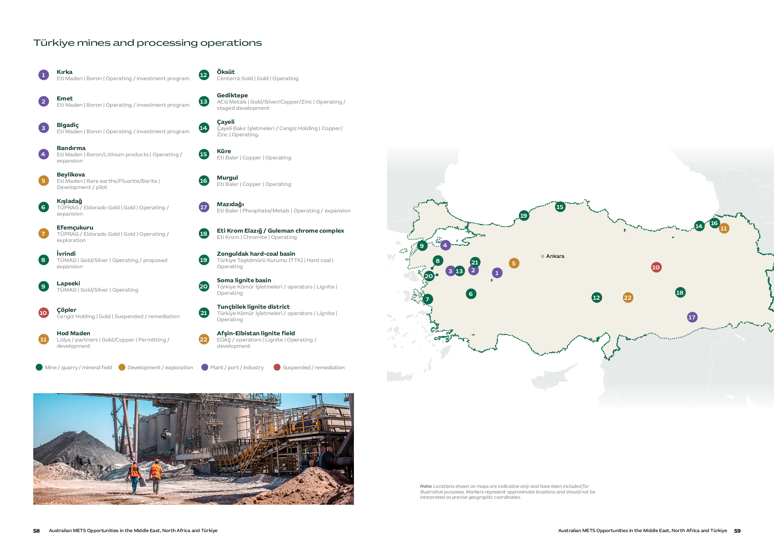

Mining Activity and Implications for Australian METS
Türkiye’s mining and minerals industry is geographically distributed. Western Türkiye contains the principal boron complexes and several major gold operations; copper and base-metals assets extend through northern and eastern belts; and central Türkiye contains Öksüt and the Beylikova rare-earth pilot and proposed industrial development.
Operating mines and processing complexes provide the clearest near-term opportunities. Demand aligns with recovery and throughput improvements, underground productivity, water management, fleet performance and plant reliability. Reference sites, lifecycle value and commissioning, training and after-sales support help specialist suppliers compete within this established market. Coal-related opportunities require separate consideration of the customer, funding, policy and emissions context.

Opportunity | Status | Australian METS alignment
Eti Maden boron system | Kırka, Emet, Bigadiç and Bandırma form a linked mining, processing and downstream system.^{[3]} | Beneficiation, process control, automation, energy, maintenance, materials handling and downstream technology.^{[4]}
Eldorado Gold Kışladağ and Efemçukuru | Operating mines with funded heap-leach, water, pit and underground work in 2026. | Recovery, water, geometallurgy, fleet, underground safety, communications, workforce capability, maintenance and process optimisation.
Gediktepe / western gold cluster | Gediktepe produced first copper concentrate on 31 August 2026 and is ramping up the sulphide circuit; İvrindi and Lapseki are established Turkish-operated assets.^{[19]} | Ramp-up optimisation, flotation, concentrate handling, wear, maintenance, fleet, water and environmental systems.
Centerra Gold Inc. - Öksüt | Operating heap-leach mine with life-of-mine optimisation study expected in early 2027. | Residual recovery, solution management, low-grade ore, water, closure and monitoring.
Cengiz Holding - Çayeli | Operating underground copper-zinc mine with recent South Orebody work reported to extend mine life to 2036.^{[21][27]} | Underground systems, processing, asset transition, reliability, water and mine-life support.
Beylikova rare earths | Pilot plant operating; government states an intention to scale toward an industrial refining facility.^{[24]} | Testwork, separation, process control, water, residues, laboratories and commissioning.
Coal and industrial minerals | Large operating districts remain part of the mining system but differ in policy, emissions and capital context. | Safety, ventilation, conveyors, rehabilitation, water, dust and emissions monitoring.

Market expansion and exploration activity
Investment includes expansion and optimisation at existing operations, alongside exploration. Kışladağ’s heap-leach improvements and Efemçukuru’s underground development differ from Gediktepe’s sulphide ramp-up and Öksüt’s life-of-mine study.^{[18][19][20]} Eldorado’s 2026 guidance also includes resource-growth and discovery programs in Türkiye, supporting potential demand for exploration services.^{[18]}
Law No. 7554, adopted in July 2025, amended the Mining Law and related environmental legislation. It introduced decision periods for specified permissions, a rehabilitation-fee account and an investment guarantee for licence applications. The changes affect project timing and licence-holder obligations.^{[15]}
Beylikova remains a pilot operation, with industrial scale-up awaiting funding, design and procurement clarity. Hod Maden is now with Lidya Mines after SSR Mining’s July 2026 sale; confirm its financing and buying route. Çöpler remains suspended and was sold to Cengiz Holding in June 2026; it is not a current operating procurement account. Çayeli’s ownership change calls for a fresh supplier-qualification check. ^{[21][22][23][24][27][28]}

Key Projects
Project | Overview | METS opportunity
Kışladağ - Tüprag Metal Madencilik, a subsidiary of Eldorado Gold Corporation | Kışladağ is a large, low-grade porphyry gold deposit with mining via open-pit methods and processing using crushing and heap leaching. It produced 168,701 ounces of gold in 2025 and reports a 13-year reserve life to 2038.^{[17][18][5]} | Eldorado has committed approximately US$35 million to whole-ore agglomeration intended to improve heap permeability, leach kinetics and cycle times. A secondary crusher expansion is also underway.
Efemçukuru - Tüprag Metal Madencilik, a subsidiary of Eldorado Gold Corporation | Efemçukuru is an established high-grade underground gold operation that commenced commercial production in 2011. The operation produced 72,482 ounces of gold in 2025 and currently has an eight-year reserve life.^{[17][18][6]} | Efemçukuru is currently progressing underground growth and development at the Kokarpinar and Bati vein systems, providing opportunities in development equipment, drilling and ground support, underground mobile equipment, ventilation, pumping, mine services, communications and mine planning/optimisation.
Gediktepe – ACG Metals | Gediktepe is transitioning from oxide-gold production to processing sulphide ore for copper and zinc concentrates. First copper concentrate was produced in August 2026, marking the start of ramp-up toward the operator’s year-end production target.^{[19]} | The ramp-up provides near-term opportunities associated with mineral processing optimisation, comminution, flotation, materials handling, process control and automation, plant maintenance, water management and operational reliability.
Öksüt – Centerra Gold Inc. | Large-scale open pit mine with ore processed through a heap-leach operation. A life-of-mine optimisation study is expected to be complete early 2027, evaluating residual leaching, low-grade oxide and solution management.^{[20]} | Residual recovery, solution management, low-grade ore, water, closure/reclamation planning and monitoring.

Market Approach for Australian METS
Category | Capabilities required | Demand drivers
Mineral processing and metallurgy | Recovery, throughput and energy/reagent efficiency, metallurgical test work, process control, flotation and leach optimisation, supported by test work or operating data. | Boron processing, operating gold mines, Gediktepe ramp-up and study-led optimisation. Technical value needs to be demonstrated against incumbent supply.
Underground systems and safety | Ventilation, communications, tracking, ground support, geotechnical monitoring and mobile-equipment productivity. | Underground development and operating mine safety, productivity and reliability requirements.
Water and environmental performance | Water balance, solution management, tailings, monitoring, closure and rehabilitation systems. | Operating requirements, mine planning and environmental obligations.
Fleet performance and reliability | Truck bodies, wear materials, condition monitoring, rebuilds, OEM-independent troubleshooting and technician training. | Payload, uptime and lifecycle improvement at operating sites, supported by spares and responsive technical service.
Geoscience and digital systems | Exploration, geochemistry, assay, mine planning, automation, telemetry and operational analytics. | Targeted technical needs across resource evaluation, operational improvement and predictive maintenance.

“There are areas where the in-country solution simply isn't available, and operators are open to working with specialist companies from outside Türkiye.”

- Maintenance Manager at major operational gold mining company

Procurement and supplier preparation
Most priority purchases are made through owner/operator or EPC processes rather than a single national channel. Eti Maden publishes tenders through its own system, while private operators use corporate prequalification, technical evaluation and commercial negotiation. For public tenders within scope, foreign suppliers should check whether Electronic Public Procurement Platform (EKAP) registration is required.^{[7]} Turkish-language technical documentation, responsive commissioning and after-sales support can be decisive.^{[16]}

Buyer / player | Role / active assets | How to engage
Eti Maden | State-owned boron mining, processing and product facilities. | Monitor the Eti Maden tender system and exact technical specifications.^{[1][16]}
Eldorado Gold / TÜPRAG | Kışladağ open-pit heap leach and Efemçukuru underground/flotation. | Target site engineering and supply chain; distinguish sustaining from growth packages.^{[17][18]}
ACG Metals / Gediktepe operator | Copper-concentrate ramp-up following the sulphide expansion. | Major sulphide equipment is delivered; focus on ramp-up, performance optimisation and next-phase scope.^{[19]}
Centerra / Öksüt | Operating heap-leach mine and life-of-mine optimisation study. | Qualify further opportunity after study scope, budget and revised plan are published.^{[20]}
TÜMAD | Operating İvrindi and Lapseki gold and silver mines. | Engage the relevant operator’s technical and procurement teams. Confirm current expansion plans, purchasing requirements and supplier qualification for the proposed work.^{[8][9][10]}
Cengiz / Çayeli Bakır | Current owner/operator pathway for an operating copper-zinc mine following transfer to Cengiz Holding on 30 April 2026.^{[27]} | Confirm current supplier qualification, responsible procurement entity and approved-vendor pathway.^{[21][27]}
Turkish EPCs / distributors | Project delivery, fabrication, import, service and buyer access. | Choose partners with mining references and technical service.

METS Case Study

Austin Engineering: supporting improved productivity in Türkiye for a global gold leader
A common route to emerging markets for Australian METS companies is engagement with multinational or global mining companies that have the experience, bandwidth and capital to leverage the latest technological advancements in mining. This was the case for Austin Engineering and its expansion into Türkiye.
During the COVID period, Eldorado Gold’s Turkish operation, Tüprag, contacted Austin Engineering seeking to improve haulage payload and address a production constraint. Austin engaged in technical discussions with Tüprag remotely, presenting materials, proposals and reference cases to a site committee that assessed their proposed lightweight truck body design.
Following these engagements, Austin received the first order of 11 units for trial. These were tested, validated and accepted in Turkish operating conditions, and two additional orders soon followed.
Austin reports that while it was challenged with pricing due to distance of delivery, the client was willing to invest in the long-term cost and efficiency benefits of adopting a specialist solution, backed by international references, technical experience and quantified payload benefit.
Delivery combined remote technical support with site visits, welding procedures, inspections, training tools and Austin’s AustIQ condition monitoring platform. While Austin has yet to establish a Turkish entity, their delivery and follow-up support enabled Tüprag’s operational team to inspect, maintain and maximise the equipment.
During this process, Austin undertook careful risk assessment and best practice procedures from potential challenges of doing business in Türkiye, such as transacting in multiple currencies, contractual milestone payments, and collaborating with their partners on logistics.
Austin’s experience demonstrates that Australian METS businesses should identify the strategic accounts that are seeking to raise technical standards through exposure to international solution providers. While the broader Turkish market may be more price sensitive, this case study highlights the successful application of Australian technology in local operating conditions.

“It wasn’t about being local. It was about us partnering with them and providing the tools to train their people.”

- Brad Higgins, Austin Engineering

Market entry and delivery expectations
Türkiye’s investment framework provides equal treatment for international and domestic investors. This does not mean every procurement is commercially neutral, and it does not remove tax, customs, work-permit, certification or contracting requirements.^{[25]}
For machinery within the relevant scope, the Ministry of Trade’s Product Rules Database identifies CE marking and conformity-assessment requirements. Requirements differ by product and use, so suppliers should confirm the applicable Turkish regulation, declaration, standards, importer responsibility and Turkish-language documentation before shipment.^{[26]}
Currency movements and bid-validity periods can affect the competitiveness of imported equipment and services, particularly for longer procurement processes. The relevance of these factors will depend on the customer, contract structure and transaction currency.
Commercial arrangements need to address currency, bid validity, indexation, tax and duty, warranty, acceptance and payment terms. For partner-supported delivery, service levels, territory, customer ownership and anti-bribery responsibilities also matter. Open-ended Turkish-lira exposure and unclear commissioning-acceptance criteria can weaken an otherwise sound commercial proposition. Inventory, repair or engineering investment is most relevant where recurring demand and response-time requirements justify the cost.
The Mining Türkiye expo held every two years in Istanbul serves as a strong starting point for market intelligence and customer and partner engagement. This event brings together around 800 international companies, industry representatives, and engineering solution providers. The Australian Turkish Chamber of Commerce is also well positioned to help companies understand operating complexities, key networks and market entry pathways.
“For Australian companies, they definitely need very good, reliable local partners.”

- Fevzi Durunesil, General Manager, FESA

Gekko Systems: Entering Türkiye with Specialised Solutions and Local Partnerships
Gekko Systems, an Australian leader in gold processing and low-energy mining solutions, were first approached by FESA, an industrial engineering and equipment company based in Ankara, to support projects in Ghana and Liberia with their highly specialised processing technologies. Following three years of building a strong track record in the region, Gekko signed an agency agreement with FESA in 2024.
Fevzi Durunesil, General Manager, FESA describes Türkiye as an increasingly price sensitive market, especially for government procurement opportunities in the mining industry. For many suppliers, this has reduced competitiveness, especially with a growing presence of Chinese manufacturers often offering lower prices, faster delivery and more flexible payment terms.
FESA saw an opportunity for Gekko’s specialist equipment and technical knowledge in applications where local alternatives did not meet the same need. It also valued Gekko’s willingness to adapt to local regulatory and commercial requirements.
With increasing activity in the gold mining sector and operators starting to look at highly complex processing applications, such as re-processing tailings, Fevzi believes that Gekko has strong future potential in the region.
Despite this, Fevzi cautions that Australian companies must conduct significant due diligence to find that right local partner that offers reliable, wide coverage without many competing product lines. This will support in developing the market, screening potential customers, managing language and time zone risk, and taking care of importation and payments.
This case study demonstrates the value of a well-researched local partner in accessing the Turkish market, along with neighbouring mining jurisdictions.

Comparative outlook for Australian METS
Balancing opportunity scale, capability alignment and commercial accessibility
The table below compares current opportunities, commercial constraints and practical engagement routes across the five markets.

Market | Current opportunity | Main commercial consideration | Practical engagement approach
Saudi Arabia | The broadest combination of investment, exploration, mine development, operating assets and downstream processing demand. | Access to Maaden procurement of technical units, increasing localisation commitments and in-country service expectations. | Engage now where there is a defined customer need. Build technical sponsorship and determine the required Saudi partner or presence before scaling investment.
United Arab Emirates | Targeted demand in aluminium, steel, quarrying and industrial services, together with access to regional logistics and resources investors. | Domestic industrial sales and the case for a regional base are separate decisions. A UAE office does not replace country-specific customer and delivery arrangements. | Target identifiable industrial accounts first. Consider a regional service base only when repeat demand across more than one market justifies it.
Morocco | Concentrated opportunities in phosphate and fertiliser processing, operating metals assets and selected new developments. | Access is centred on a small number of major operators and project partners. Relationships, French-language capability and continuing service matter. | Use a strategic-account approach focused on OCP Group, Managem and selected project owners. Invest in local relationships and service arrangements over time.
Egypt | Current demand around Sukari, exploration, geological information and selected developments, with broader potential if reform produces funded activity. | The development pipeline remains less proven. Funding, importation, mobilisation and customer-specific procurement affect the timing of work. | Pursue specific operating or exploration opportunities selectively while monitoring whether licences convert into funded programs and development decisions.
Türkiye | An established market for specialist equipment and services across boron, gold and other mining and industrial operations. | Strong domestic, European and Chinese competition places a premium on differentiation, Turkish-language support and responsive technical service. | Engage selectively now where the solution offers measurable technical or lifecycle value that local and international competitors do not provide.

The longer-term outlook
Across the five-to-ten-year outlook, existing operations remain the firmest starting point. Saudi Arabia combines operating mines with the broadest announced expansion agenda, but each project needs its own funding and package check. The UAE offers industrial accounts and a regional service base where a defined customer portfolio supports the cost. Morocco’s phosphate and metals operations provide current demand alongside further development. Egypt’s wider prospects depend on exploration commitments, finance and project decisions beyond Sukari. Türkiye offers an established, competitive market for replacement equipment, recovery improvements and technical services.
Regardless of how immediate the opportunity, Australian METS companies should begin engaging in markets with aligned capability requirements now rather than waiting for projects to reach a bankable stage. Relationships, local registrations and in-country credibility typically take years to establish, and companies that only arrive once a package is tendered are competing against suppliers who have already built the trust and local presence the customer expects.

Australian METS Views: Priority Markets
Austmine's survey of 29 Australian METS companies found that Saudi Arabia was the most frequently selected priority market for the next one to three years, at 37.9%, followed by Türkiye at 24.1% and the UAE at 20.7%.
Longer-term choices were less settled, with 24.1% unsure of their priority and 6.9% selecting no market at that stage, an understandable outlook in such a rapidly changing region. Türkiye retained the same share over five to ten years. Interest in the UAE fell over the longer period, while Morocco attracted 6.9% of longer-term selections. No respondent selected Egypt as its highest-priority market in either timeframe. However, this does not indicate there are no export opportunities as reforms proceed.
One highest-priority market selected by each respondent (n=29)*
Market or response | Next 1–3 years | Next 5–10 years
Saudi Arabia | 37.9% | 27.6%
Türkiye | 24.1% | 24.1%
United Arab Emirates | 20.7% | 10.3%
Morocco | 0.0% | 6.9%
Egypt | 0.0% | 0.0%
Unsure | 13.8% | 24.1%
None at this stage | 3.4% | 6.9%
* The survey received 29 responses between 9 June and 23 July 2026. It is a snapshot, not a representative sector estimate. Each respondent selected one highest-priority market, so zero selections do not imply no other interest or demand.

Australian METS Views: Customer access
Respondents provided their feedback on the greatest challenges to growth in the region, with finding the right customer or decision-maker selected by 66% of respondents. Similarly, 72.4% identified introductions to customers, operators and project owners as a valuable form of support. Promotion to international customers and participation in trade events or missions were also prominent, at 51.7% and 44.8% respectively.

Support respondents considered valuable for international growth (n=29)

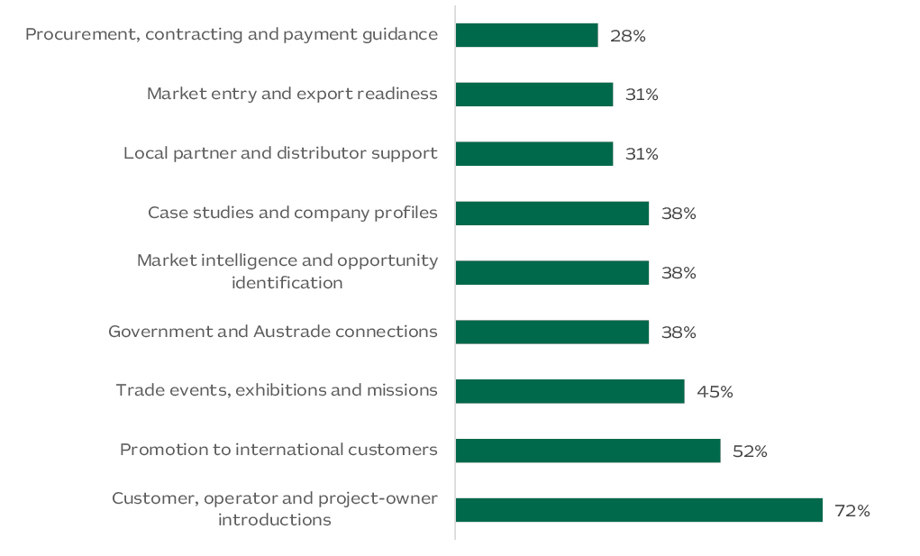
Australian METS companies should prioritise industry events and outreach targeted to technical decision-makers who understand operational requirements and will better engage around specialised solutions. Supplier registration may be a pre-requisite to work, but it is not a substitute for developing relationships with users of the technology.
Abed Hakmi of Austrade Riyadh emphasises the need to understand solution demand and alignment with the relevant technical department.

“Before committing to the supplier approval process, speak with the technical team and understand what they need. You need to know whether your product solves a problem they are willing to pay to fix. Then work through the purchasing requirements and how you will support the customer locally?”

- Abed Hakmi, Director of Energy and Mineral Resources, Infrastructure and Defence, Australian Trade and Investment Commission (Austrade), Riyadh
Customer access is only one element of commercial considerations, and Australian METS companies provided their perspectives of other critical barriers. Local partner requirements were selected by 58.6% of respondents, limited market intelligence by 44.8%, contract risk by 41.4% and local content expectations by 37.9%. These responses indicate that companies recognise the complexity of the operating environment across the region and the need to invest in local relationships and value-add.

Delivery and support
For Australian METS companies with limited scale and resources, one of the most common challenges can be the ability to install, maintain and support a solution following the contract award.
The companies interviewed for this report each utilised different approaches that reflect the unique requirements of their customer and level of engagement in the region. Austin Engineering engaged remotely during negotiations with their Turkish customer and then supported their product through site visits, documented procedures, remote tools and customer training. Gekko and Fleet Space established partnerships with local representatives only once significant customer demand was identified. The experience of Capital Limited in Egypt and JORD in Morocco shows that providing on-site services and maintaining equipment may eventually require a larger regional or local presence.
“Customers expect ongoing equipment support and long-term relationships, making an established regional presence essential for effective after-sales service and sustainable growth.”

- Shane Freeman, Senior Sales Manager, JORD International
Finding the right partner does not automatically equal success either. Appointing a representative will have limited value if that business cannot explain the technology or obtain timely technical input from the Australian supplier. Expert interviews carried out for this report emphasised that building product knowledge and undertaking joint customer engagement is critical in markets with mining sectors that are still in development.

Implications for Australian engagement
The report findings favour focused market development, with Australian capability matched to specific customers and purchasing requirements. For Austmine and Austrade, this means keeping market intelligence close to operating needs and project progress. This requirement is not uniform across the markets. In Morocco this calls for sustained engagement with a small number of strategic accounts; in Egypt it requires close attention to exploration commitments and project approvals.
The survey also provides a basis for tailoring assistance. Twenty-three of the 29 respondents, or 79.3%, were already exporting internationally. Their needs may include assessing an unfamiliar partner, understanding a buyer’s qualification process or establishing a workable service arrangement. This supports building on existing export experience, while recognising that experience elsewhere does not establish readiness for every market covered here.
Industry events and missions can help establish the relationships needed for this work. Fleet Space’s experience shows the value of identifying target customers before an event and continuing the technical discussion afterwards. Follow-up should establish who will assess the solution, what references are needed and the next commercial step. Progress can be judged through substantive customer discussions, requests for technical information, trials, supplier qualification and subsequent work.
Continuity matters because project development and customer qualification can extend beyond a single mission or program. Australian engagement should retain a longer-term view while helping companies make proportionate commitments. A supplier with current operating customers may be able to support a regional presence; another may be better served through direct technical support or a capable partner. Assistance with these decisions, including training and after-sales arrangements, deserves attention alongside promotion.

Conclusion
A differentiated opportunity for Australian METS
The Middle East, North Africa and Türkiye provide a credible diversification opportunity for Australian METS companies. The five markets provide different pathways with substantial differences in customer demand, market maturity and commercial accessibility. Saudi Arabia has the broadest combination of operating demand, exploration and announced development activity. Türkiye provides established demand where suppliers can demonstrate a technical and service advantage. Opportunities in the UAE, Morocco and Egypt are more concentrated around particular customers, assets and funded programs.
The Australian METS survey points to practical difficulties in reaching decision-makers, assessing partners and obtaining market intelligence, including among companies already exporting. The interviews conducted add practical evidence about proving technical value and maintaining support after a sale. Together, they indicate where assistance can be useful, without establishing that market entry will be straightforward or that the same approach will suit every company.

Where to start
Companies with limited resources should begin with the market and customer where their capability addresses a recognised need and where they can support the solution after sale. For many suppliers, Saudi Arabia will warrant the earliest investigation because of the breadth of operating and development activity. Türkiye may provide nearer-term opportunities for specialist suppliers able to demonstrate an advantage over established competitors. The UAE should be separated into two decisions: pursuing domestic industrial customers and establishing a regional base. Morocco requires sustained strategic-account development, while activity in Egypt should remain tied to specific customers, funded exploration and confirmed project progress.

What to watch
Over the next 12 to 24 months, the following milestones may indicate where more defined demand is emerging:
- Saudi Arabia: procurement and construction progress at Maaden projects, including Phosphate 3 commissioning and Ar Rjum development.
- United Arab Emirates: restoration and recycling activity at EGA, and funded procurement by other industrial and quarrying accounts.
- Morocco: OCP Group’s operating and investment program, and further study, funding and procurement decisions at Aya Gold & Silver’s Boumadine project.
- Egypt: exploration licences converting into funded field programs, and project decisions beyond Sukari.
- Türkiye: Öksüt study results, Çayeli’s purchasing arrangements following the ownership change, Hod Maden financing and any formal decision on Çöpler’s restart.
Over the next five to ten years, new investment could broaden the customer base available to Australian METS. Existing mines and industrial plants provide a foundation for engagement while that pipeline develops. Companies should use the country chapters to identify customers whose requirements match their capability, confirm the purchasing and service arrangements, and assess the resources needed to pursue the work. Companies considering the opportunities in this report are encouraged to contact their Austmine or Austrade representative to discuss the most appropriate next step.

Taking the next step
Using the report to investigate a specific opportunity
The country chapters identify areas where Australian capability may be relevant. They are intended to support further investigation rather than provide a general recommendation to enter a market. For most suppliers, the useful starting point will be a specific customer, operating requirement or funded project rather than the market in isolation.

Information that can strengthen an opportunity assessment

Area to establish | Questions for further investigation | Useful evidence
Customer requirement | What operating, project or service requirement is the customer seeking to address, and who is responsible for it? | Site or project discussion, published operating priority, technical brief or defined work package.
Purchasing pathway | Does the operator, project owner, EPC or distributor specify and purchase the solution? Is supplier qualification required? | Named technical contact, procurement owner, qualification requirements and indicative timing.
Technical case | What will the customer need to assess performance and risk? | Comparable operating reference, quantified benefit, test work, pilot results or an agreed trial pathway.
Delivery and support | What installation, commissioning, training, maintenance, language and response capability will be expected? | Defined responsibilities, service model, partner capability and support costs.
Commercial basis | Are the likely order value, sales cycle and ongoing service requirements proportionate to the resources needed to pursue the work? | Indicative scope, budget status, payment and acceptance terms, import responsibility and internal resourcing decision.

Accessing current support and information
Contacts and services for Australian METS companies
Market conditions, project timing and office coverage may change after publication. The channels below provide current information on Austrade and Austmine services, international offices, events and market activity.

Austmine
Austmine’s international programs connect Australian METS companies with market intelligence, major events, missions and technical decision-makers. Companies can use the current international and events pages to identify relevant activity and contact the International Business team.
International programs: current market activity and team contacts. View current details
Events and webinars: current Austmine events and registration details. View current details

Austrade
Austrade provides eligible Australian businesses with market information, advice and connections through its Australian and international network. The level and form of assistance will depend on the company, market and opportunity. Current office and service pages should be used because staff and regional coverage can change.
METS enquiries: METSmanager@austrade.gov.au. View current details
Saudi Arabia: Austrade Riyadh office and current contact details. View current details
United Arab Emirates: Austrade Dubai and Abu Dhabi offices and current contact details. View current details
Other markets: use Austrade’s international office directory or exporter enquiry service to confirm the post currently responsible for Morocco, Egypt and Türkiye. View current details
Exporter services: information on market assessment, export strategy and overseas contacts. View current details
TradeStart: local export advice for Australian small and medium-sized businesses. View current details
Austrade events: current webinars, trade shows and international events. View current details

Information that can assist an initial discussion
A brief description of the solution, the operating problem it addresses, relevant customer references and the target account or project will help Austmine or Austrade direct an enquiry. Where a company is considering a partner or local presence, it is also useful to identify the service, import, language or customer-access requirement that the arrangement is intended to address.
Austmine and Austrade can assist companies to interpret current market conditions and identify appropriate avenues for further engagement. Commercial, legal, tax, customs and partner decisions remain the responsibility of the company and should be supported by transaction-specific advice.

References

Executive Summary
1. Saudi Ministry of Industry and Mineral Resources, Saudi Ministry Qualifies 24 Local and International Bidders for Round 10 Exploration Licenses, 9 June 2026. Source link
2. Maaden, Maaden Adds More Than 7 Million Ounces of New Gold Resources Through Discovery and Resource Development, 12 January 2026. Source link
3. Australian Department of Foreign Affairs and Trade, Australia–UAE Comprehensive Economic Partnership Agreement, updated 2026. Source link
4. Emirates Global Aluminium, EGA Delivers Strong Underlying Financial Performance and Record Sales in 2025, 25 February 2026. Source link
5. EMSTEEL, Annual Report 2025, 2026. Source link
6. OCP Group, Investment Plan 2023–2027, undated. Source link
7. OCP Group, Sustainability Report 2024, 2025. Source link
8. Egyptian Ministry of Petroleum and Mineral Resources, Issuance of 53 Mining Licences, 11 January 2026. Source link
9. AngloGold Ashanti, Sukari, Egypt, updated 2026. Source link
10. Eti Maden, Boron in Türkiye, undated. Source link
11. Eldorado Gold, Kışladağ, updated 2026. Source link
12. Eldorado Gold, Efemçukuru, updated 2026. Source link
13. Egyptian Ministry of Petroleum and Mineral Resources, Presentation at Australia-Africa Minerals & Energy Group (AAMEG) event. Perth, 22 July 2026.

Regional Market Context
1. Saudi Ministry of Industry and Mineral Resources, Saudi Ministry Qualifies 24 Local and International Bidders for Round 10 Exploration Licenses, 9 June 2026. Source link
2. Australian Department of Foreign Affairs and Trade, Australia–UAE Comprehensive Economic Partnership Agreement, updated 2026. Source link
3. OCP Group, Investment Plan 2023–2027, undated. Source link
4. Egyptian Ministry of Petroleum and Mineral Resources, Egypt Mining Forum Inauguration: Mining-Sector Reform Pillars, 18 July 2023. Source link
5. Eti Maden, Boron in Türkiye, undated. Source link
6. World Bank, Saudi Arabia | Data, updated 2026. Source link
7. World Bank, Türkiye | Data, updated 2026. Source link
8. World Bank, Morocco | Data, updated 2026. Source link
9. World Bank, Egypt, Arab Rep. | Data, updated 2026. Source link
10. World Bank, United Arab Emirates | Data, updated 2026. Source link

Saudi Arabia
1. Saudi Vision 2030, Strategy for the Mining Sector, undated. Source link
2. Semafor, Saudi mining giant Maaden outlines $110 billion investment plan, 15 January 2026. Source link
3. Mines and Money, New Discoveries Reinforce Scale of Saudi Mining Vision, 2 August 2026. Source link
4. Aramco, Aramco and Maaden sign shareholders’ agreement to form joint venture to unlock new frontier for mineral exploration and hard-rock mining in Saudi Arabia, 18 August 2026. Source link
5. Ivanhoe Electric Inc., Maaden and Ivanhoe Electric to Establish a 50/50 Joint Venture to Explore for Copper, Gold, Silver and Electric Metals in Saudi Arabia, 11 January 2023. Source link
6. Mining Weekly / Bloomberg, Saudi Arabia awards exploration leases to some major miners, 20 March 2025. Source link
7. Bloomberg, Vedanta Plans Saudi Spending Boost in Push for Copper, Gold, 19 November 2025. Source link
8. Maaden, Core Business Units, undated. Source link
9. Taaden, About Taaden, undated. Source link
10. Byrnecut Group, Jabal Sayid Project in Saudi Arabia, August 2022. Source link
11. Gulf News, Saudi mining company Maaden finds new gold deposits, 28 December 2023. Source link
12. FLSmidth, FLSmidth to Deliver Key Beneficiation Equipment to a Saudi Arabian Phosphate Mine, 7 August 2023. Source link
13. Maaden, Maaden Furthers Commitment with MP Materials to Establish Rare Earth Refinery Joint Venture in the Kingdom, 19 November 2025. Source link
14. IMARC Group, Saudi Arabia Mineral Exploration Equipment Market Size, Share, Trends and Forecast by Equipment Type, Mineral Type, End User, and Region, 2026-2034, 2025. Source link
15. Maaden, Maaden and Hexagon Partner to Launch Region’s First Digital Mine, 16 January 2024. Source link
16. Saudi Ministry of Human Resources and Social Development, The Ministry Issues Two Decisions to Raise Localization Rates in Engineering and Procurement Professions, 31 December 2025. Source link
17. Altios, Saudisation in KSA: What International Companies Must Get Right in 2026, 29 December 2025. Source link
18. Maaden, Tharwah Local Content Program, undated. Source link
19. TASC, The Human Infrastructure Behind Vision 2030: A Strategic Guide to Workforce Readiness in Saudi Arabia, 2026. Source link
20. Saudi Press Agency, Saudi Arabia Strengthens Industrial Ties with China in Industry and Mining, undated. Source link
21. Maaden, Maaden’s Ar Rjum Gold Mine Moves Forward with Award of First Development Contract, 23 October 2025. Source link
22. Maaden, Why Feeding the World Is the Kingdom’s Next Growth Story, 16 October 2025. Source link
23. Maaden, About Maaden, undated. Source link
24. Maaden, Maaden Releases Second Quarter 2026 Results, 9 August 2026. Source link
25. Barrick Mining Corporation, 2025 Full Year Results, 5 March 2026. Source link
26. Maaden, Sustainability at Maaden: Reducing Groundwater Usage, undated. Source link
27. ZAWYA Projects, Saudi’s Maaden awards $104mln EPCM contract for Ar Rjum goldmine, undated. Source link
28. Maaden, Supplier Portal, undated. Source link
29. SABER, Saudi Product Safety Program Platform, undated. Source link
30. Zakat, Tax and Customs Authority, Import Instructions, undated. Source link
31. Aramco, Aramco and Maaden sign shareholders’ agreement to form joint venture to unlock new frontier for mineral exploration and hard-rock mining in Saudi Arabia, 18 August 2026. Source link
32. Maaden / Saudi Exchange, Announcement Details Saudi Arabian Mining Company (Maaden) Announces the completion of the signing of the EPCM Contract with Saudi Arabian Bechtel Company (SABCO) and Bechtel Australia PTY LTD, 23 October 2025. Source link

United Arab Emirates
1. Australian Department of Foreign Affairs and Trade, Australia–UAE Comprehensive Economic Partnership Agreement, updated 2026. Source link
2. Australian Department of Foreign Affairs and Trade, Australia–UAE CEPA: Outcomes at a Glance, undated. Source link
3. Australian Department of Foreign Affairs and Trade, Using UAE CEPA to Do Business with the United Arab Emirates, undated. Source link
4. Emirates Global Aluminium, EGA Delivers Strong Underlying Financial Performance and Record Sales in 2025, 25 February 2026. Source link
5. Emirates Global Aluminium, Sustainability Reports, 2026. Source link
6. Emirates Global Aluminium, Our Commercial Success and Local Procurement, undated. Source link
7. EMSTEEL, Annual Report 2025, 2026. Source link
8. UAE Ministry of Finance, Federal Supplier Register, undated. Source link
9. UAE Ministry of Industry and Advanced Technology, National In-Country Value Program, undated. Source link
10. International Resources Holding, About IRH, undated. Source link
11. Australian Department of Foreign Affairs and Trade, United Arab Emirates Country Brief, updated 2026. Source link
12. Emirates Global Aluminium, Al Taweelah Smelter Restoration Reaches 25% Completion Milestone, 26 August 2026. Source link
13. Emirates Global Aluminium, EGA Delivers Resilient H1 2026 Performance, Maintaining Operational and Supply Chain Continuity amid Regional Disruption, 12 August 2026. Source link
14. Emirates Global Aluminium, EGA and Sunstone to Begin Construction of Anode Manufacturing Plant in UAE in 2026, 16 December 2025. Source link
15. International Resources Holding, UAE-Backed IRH Investment Drives Revival of Zambia’s Mopani Copper Mines, 21 July 2025. Source link
16. Ras Al Khaimah Investment and Development Office, Stevin Rock Portfolio Profile, undated. Source link
17. Emirates Global Aluminium, Tawazun Council, RTX and EGA Sign MOU to Explore Gallium Production in Abu Dhabi, 16 May 2025. Source link
18. Worley, Worley in the United Arab Emirates, undated. Source link
19. DP World, Jebel Ali Port, undated. Source link
20. Gulf Cooperation Council Secretariat, Finalising Customs Union and Common Market Requirements Remains a Top Priority, 11 February 2025. Source link
21. Dubai Multi Commodities Centre, The Differences Between Mainland and Free Zone Companies in Dubai, 25 August 2026. Source link
22. United Arab Emirates Government, Federal Law No. 3 of 2022 Regulating Commercial Agencies, undated. Source link
23. Dubai Multi Commodities Centre, How to Set Up a Business in Dubai Remotely with DMCC, undated. Source link
24. Dubai Multi Commodities Centre, How Much Does It Cost to Set Up a Company in Dubai?, 12 February 2026. Source link
25. United Arab Emirates Ministry of Finance, Corporate Tax, undated. Source link
26. United Arab Emirates Federal Tax Authority, Registration for VAT, updated 6 April 2026. Source link
27. United Arab Emirates Ministry of Industry and Advanced Technology, National In-Country Value Program, undated. Source link
28. Dubai World Trade Centre, The Mining Show 2026, undated. Source link
29. Dubai Chambers, Services and Business Hub, undated. Source link
30. Australian Business Council Dubai, Australian Business Council Dubai, undated. Source link
31. Australia–UAE Business Council, Australia–UAE Business Council, undated. Source link
32. Altios, personal communication and in-market guidance provided to Austmine by the Head of Corporate Services, September 2026.
33. CFlo, CFlo Secures Major Order from Stevin Rock in Ras Al Khaimah, 15 July 2026. Source link
34. Jebel Ali Free Zone, Warehouses to Suit Your Storage Needs, undated. Source link
35. CDE, Stevin Rock Selects CDE Wash Plant for World’s Largest Limestone Quarry, 14 September 2026. Source link
36. Australian Department of Foreign Affairs and Trade, Australia–UAE CEPA Chapter 8 Technical Barriers to Trade, official text, 2024. Source link

Morocco
1. U.S. Geological Survey, Mineral Commodity Summaries: Phosphate Rock, February 2026. Source link
2. OCP Group, Our Strategy and Strategic Priorities, undated. Source link
3. McKinsey and Company, The 2040 fertilizer industry: How could industry trends affect demand?, 17 December 2024. Source link
4. Austrade, Morocco’s mining transformation unearths METS opportunities, 13 June 2025. Source link
5. African Development Bank, African Development Bank Approves €100 Million to Gotion Power Morocco to Develop Africa’s First Lithium Ion Phosphate Battery Gigafactory, 24 July 2026. Source link
6. OCP Group, Industrial Operations, undated. Source link
7. Morocco World News, Managem Reports MAD 13.694 Billion Revenue in 2025, as Q4 Surges 170%, 27 February 2026. Source link
8. Fraser Institute, Annual Survey of Mining Companies 2025, February 2026. Source link
9. Aya Gold and Silver, Aya Gold and Silver Provides 2026 Outlook and Strategic Priorities, 27 January 2026. Source link
10. Fastmarkets, Miner Managem to Switch to Cobalt Sulfate Production Instead of Metal, 8 January 2026. Source link
11. Epiroc, Epiroc partners with Managem for digitalization of Tizert project in Morocco, 26 November 2024. Source link
12. OCP Group, Investment Plan, undated. Source link
13. OCP Group, A decisive step by OCP Green Water toward the water autonomy of the Group, 14 July 2025. Source link
14. Kingdom of Morocco, Ministry of Energy Transition and Sustainable Development, Morocco Strengthens the Attractiveness of Its Mining Sector through the Tafilalet–Figuig Public Competition, 6 May 2026. Source link
15. Aya Gold and Silver, Aya Gold and Silver Announces Updated PEA for Boumadine: After-Tax NPV Doubles to $3.5B with 93% IRR, 9 September 2026. Source link
16. Bird & Bird, Mining in Morocco: An Overview of the Mining Regulatory Framework and Ongoing Reforms, 4 June 2026. Source link
17. WTO, Morocco: Trade Policy Review, 18 March 2025. Source link
18. OCP Group, Contact OCP and e-Supply Access, undated. Source link

Egypt
1. Egyptian Ministry of Petroleum and Mineral Resources, Minister of Petroleum and Mineral Resources Discusses with World Bank Strengthening Cooperation in the Mining Sector, 14 January 2026. Source link
2. Xcalibur Smart Mapping, Egypt Launches First Nationwide Airborne Mineral Survey in 42 Years with Xcalibur Smart Mapping, 29 April 2026. Source link
3. AngloGold Ashanti, Sukari, Egypt, updated 2026. Source link
4. Egyptian Ministry of Petroleum and Mineral Resources, The Mineral Resources and Mining Industries Authority: Issuance and Renewal of 53 Licenses for Mineral Exploration and Exploitation, 11 January 2026.
5. Ministry of Petroleum and Mineral Resources, Minister of Petroleum and Mineral Resources Discusses with Cyprus's FMC Resuming Its Gold and Mineral Exploration Activities and Pumping $20-million Investments, 16 June 2026. Source link
6. Egypt Oil and Gas Group, AngloGold Expands Gold Exploration in Egypt’s Eastern Desert, 6 August 2026. Source link
7. Aton Resources Inc., Aton closes CAD$4 million private placement, 12 August 2026. Source link
8. Egyptian Ministry of Petroleum and Mineral Resources, Minister of Petroleum and Mineral Resources Reviews Mining Reforms and Investor Incentives at Mining Indaba 2026, 9 February 2026. Source link
9. Nafeza, Advance Cargo Information System, undated. Source link
10. Aton Resources, Aton Announces Strategic Cooperation Relationship and Board Nominee, 29 July 2026. Source link
11. AngloGold Ashanti, Greenfield Exploration, Egypt, undated. Source link
12. Aton Resources, Aton Announces US$30 Million Credit Facility with OU Moonrider, 1 September 2026. Source link
13. Egypt Oil & Gas Group, MRMIA, Genesis Mining Egypt Sign Phosphate Project MoU, 23 July 2026. Source link
14. AngloGold Ashanti, Sukari, Egypt, undated. Sukari, Egypt - AngloGold Ashanti
15. General Organization for Export and Import Control (GOEIC), Registration and re-registration in the importers register; laws directory; implementing-decisions directory, undated

Türkiye
1. Eti Maden, Boron in Türkiye, undated. Source link
2. Eti Maden, Eti Maden, undated. Source link
3. Eti Maden, Projects, undated. Source link
4. Eti Maden, Sustainability Report 2024, 2025. Source link
5. Eldorado Gold, Kışladağ, updated 2026. Source link
6. Eldorado Gold, Efemçukuru, updated 2026. Source link
7. Public Procurement Authority of Türkiye, EKAP Registration for Foreign Natural and Legal Persons, undated. Source link
8. TÜMAD Mining, About TÜMAD Mining, undated. Source link
9. TÜMAD Mining, İvrindi Gold and Silver Operation, undated. Source link
10. TÜMAD Mining, Lapseki Gold and Silver Operation, undated. Source link
11. Australian Department of Foreign Affairs and Trade, Türkiye Country Brief, updated 2026. Source link
12. Australian Department of Foreign Affairs and Trade, Türkiye Country/Economy Fact Sheet, 2026. Source link
13. Invest in Türkiye, Mining and Metals, updated 2026; data years stated. Source link
14. Invest in Türkiye, Machinery, updated 2026; data years stated. Source link
15. Republic of Türkiye Official Gazette, Law No. 7554 Amending Certain Laws, 24 July 2025. Source link
16. Eti Maden, Tender Announcements, undated. Source link
17. Eldorado Gold, Updated Mineral Reserve and Mineral Resource Statement, 26 November 2025. Source link
18. Eldorado Gold, 2026 Guidance and Three-Year Outlook, 19 February 2026. Source link
19. ACG Metals, First Copper Concentrate Production at Gediktepe, 1 September 2026. Source link
20. Centerra Gold, Second Quarter 2026 Results and Increased Öksüt Production Guidance, 28 July 2026. Source link
21. First Quantum Minerals, First Quantum Minerals Announces Sale of Çayeli Mine, 12 March 2026. Source link
22. SSR Mining, 2024 Çöpler Incident: Remediation and Operating-Status Updates, updated 17 February 2026. Source link
23. SSR Mining, SSR Mining Completes the Sale of its 20% Equity Interest in Hod Maden, 17 July 2026. Source link
24. Republic of Türkiye Ministry of Energy and Natural Resources, 2026 Will Be a New Record Year in Renewables: Beylikova Update, 26 December 2025. Source link
25. Invest in Türkiye, Why Türkiye?, undated. Source link
26. Republic of Türkiye Ministry of Trade, Product Rules Database, undated. Source link
27. Çayeli Bakır İşletmeleri A.Ş., About Us: Cengiz Holding Transition, updated 2026. Source link
28. SSR Mining, SSR Mining Completes the Sale of the Çöpler Mine, 24 June 2026. Source link
29. Republic of Türkiye Ministry of Trade, Product Rules Database, undated. Source link

