EMDG Evaluation Summary

Export Market Development Grants (EMDG) Research Report, April 2022

Context
In February 2022, Austrade procured Paper Giant, a research and evaluation consultancy, in order to better understand the experience and behaviours of applicants and grant agents in the first round of the new Export Market Development Grants (EMDG) program.
Paper Giant researched grant agents’ experiences with the EMDG program to provide further insights beyond the EMDG research summary conducted by Austrade in January 2022.
A quantitative survey was undertaken between 9 and 16 March 2022 with ‘grant writers’, commonly referred to as consultants, who submitted applications for the new EMDG program on behalf of exporting business. All 247 grant writers/ consultants who submitted an application were invited to participate, with 110 responses received.
The survey addressed four categories:

- individual and business characteristics
- engagement
- experience
- program outlook.

1.1 – Consultant demographic
Of 110 responses:
- 46% were ‘experienced EMDG grant writers’, meaning they had submitted applications prior to July 2021, however, were not members of the Quality Incentive Program (QIP) program under the previous EMDG Reimbursement Scheme.
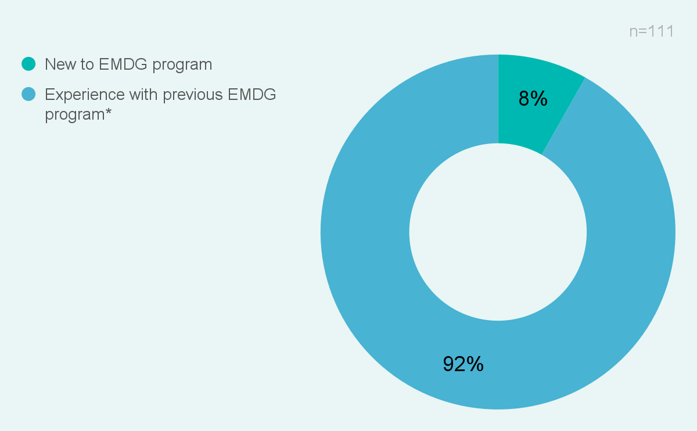
- 45% were members of the QIP program.
- The remaining 9% were new to the program.
Across all 110 responses, 49% have had more than 10 years’ experience with EMDG, with only 2% having less than a year’s worth of experience

1.2 – Awareness of the program
86% of consultants became aware of the EMDG program through Austrade sources. The remaining 14% learned of the program though external channels or other industry or business networks.

1.3 – How and why exporters engage consultants
The survey found consultants believed exporting businesses engaged them because:
- They had previously submitted an EMDG application with the assistance of consultants (66% of consultants’ clients)
- They had an existing business relationship with the consultant (56%)
- They had contacted consultants specifically for EMDG support (48%).
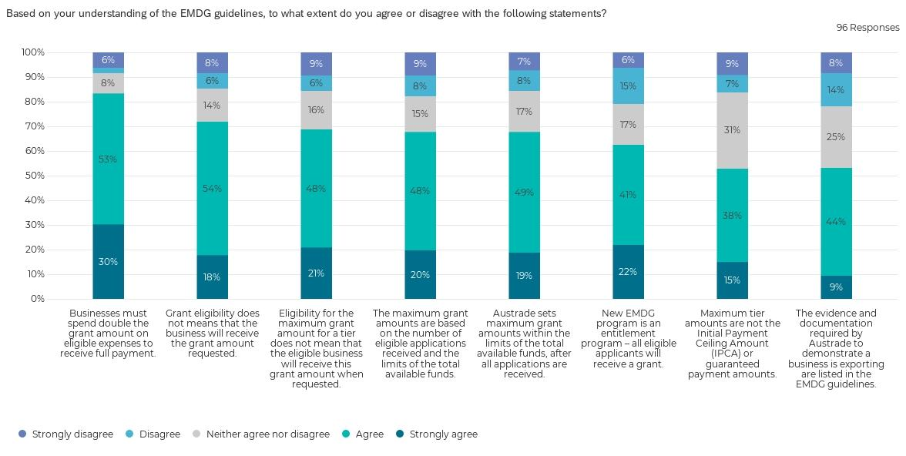
According to consultants, the main reason exporters sought assistance with an EMDG application (rather than self-lodging), was to access consultants’ expertise (89%). Other prominent reasons included businesses being too busy to apply themselves (55%) and applicants who were worried they would complete the application incorrectly and would miss out on the grant (52%).

1.4 – Understanding the EMDG guidelines
The survey sought to test understanding of the EMDG guidelines by the consultant respondents. Almost one in ten consultants – or - 9% disagreed or strongly disagreed with the factually correct statement: “businesses must spend double the grant amount on eligible expenses to receive full payment”.
While 72% correctly agreed with the factually correct statement that grant eligibility does not mean an applicant would receive the full grant amount requested, 28% were not aware of this. And 63% correctly agreed that all eligible applicants would receive a grant, indicating that 37% were not aware the grants are not competitive. This indicated a need to better explain grant amounts and allocation.

1.5 – Helpfulness the EMDG guidelines
Despite their existence, only 53% agreed that evidence and documentation requirements can be found in the EMDG guidelines. This is an area of concern, particularly regarding milestone report evidence and supporting documentation.
Areas for attention are application requirements and grant amounts and fund allocations, with fewer than 50% of consultants finding the guidelines (which contain this information) helpful.
Consultants were asked:

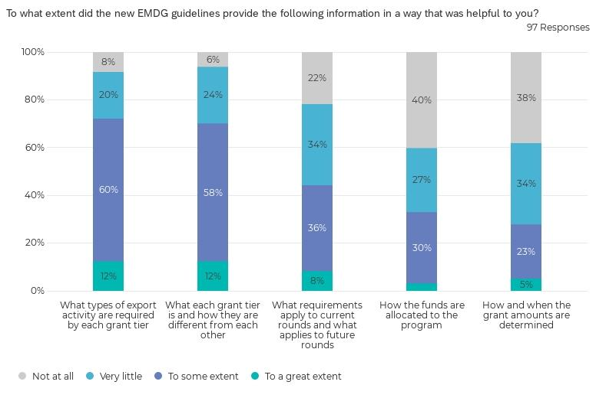

1.6 Experience by consultants throughout the processes
In relation to consultant involvement in application tasks, 89% indicated they provided support filling out the application form and 80% assisted applicants to assess applicant eligibility. Consultants indicated they had very little to no (32%) involvement in record keeping for milestone reports which may not be unusual given the timing of the survey and the newness of the process.

Consultants were asked:
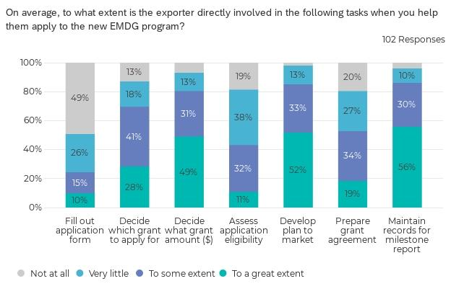

Most consultants reported they liaised with applicants and Austrade as required in addition to completing EMDG applications. In short, consultants saw themselves as playing a liaison and/or promotional role.

1.7 – Ease of completing application tasks
The vast majority indicated completing the application and assessing eligibility (77%) was easy to do. The challenge facing almost a third of consultants was explaining the process and requirements to clients or colleagues - potentially creating opportunity for information to be misinterpreted.

Consultants were asked: “How often did you find it easy to do the following?”
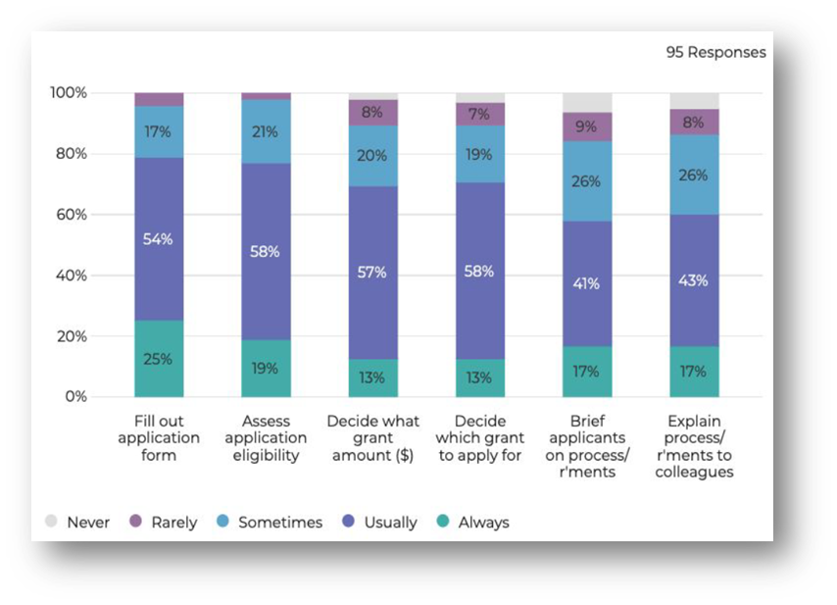

1.8 – Applicant needs and objectives, and perceptions of change
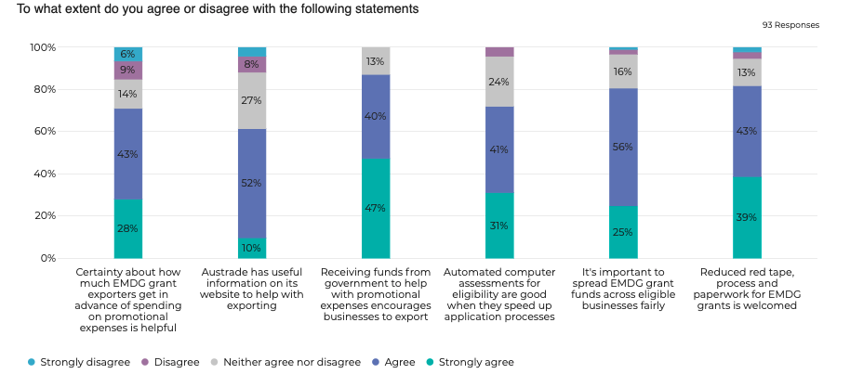
71% of respondents agreed certainty about the amount of EMDG funding in advance is helpful and 87% agreed government funding to support promotional expenses encourages exports.
Interestingly, 82% of respondents approved of the reduce red tape, processes, and paper for EMDG grants, yet this is the demographic also requesting tighter requirements to limit successful applicants from obtaining funds.

1.9 – Expectations of the EMDG program in the future
Applicants and consultants value certainty and predictability. 66% of consultants indicated it would be easier if the grant agreement were in place in advance of the financial year. Receiving funds soon after expenses are incurred is also indicated as being important.
In relation to the next EMDG round, 41% indicated they would submit the same number of applications or more and 40% intended to submit less.
There was widespread support for the program. Consultants believed EMDG helps businesses with overseas marketing expenses (91%) and reduces administrative barriers (77%).

