


EMDG milestone reports - How to input eligible expenses (Expenditure table)

Eligible expense category
- Choose the eligible expense category from the drop-down options.
- You can choose more than one category.
- You cannot select the same category more than once.
- If you have multiple expenses per category (i.e. have hired multiple consultants), you are able to group them in the table and then provide a breakdown later in the report (see figures under ‘Grouping expenses in a category’ below).
- If you are submitting a nil report, select ‘No expenditure’.
- You will be required to upload supporting evidence for each category at the Finalisation tab.

Actual eligible expenditure
- Input the total actual eligible expenditure for the expense category.
- In most cases, this will be the entire amount that was spent for that category in the reporting period.
- If only part of the expenditure is eligible, please apportion this amount and input this as the total.
- GST is not allowed and needs to be removed from the amounts.
- Example: You hire an overseas representative for Belgium, France, Russia, Estonia and Iceland. They are paid $50,000. Because promotional activity expenses for Russia are excluded, the amount to input into the actual eligible expenditure column would be $40,000 (apportioning 20% of the expense to exclude Russia). Note: Costs may be apportioned differently depending on contractual arrangements, the nature of the expense and supporting information available to support the expense.

Grant amount sought
- Input the grant amount you are seeking for the expense category.
- In most cases, this will be 50% of the actual eligible expenditure.
- If you have more than one expense category, the total grant amount sought across all expense categories cannot exceed the maximum grant amount for the reporting period or be lower than the minimum grant amount, as outlined in your Grant Agreement.
- If the total grant amount sought across all expense categories exceeds the maximum grant amount or is less than the minimum grant amount, as outlined in your Grant Agreement, adjustments will need to be made to the individual grant amount sought figures to ensure it does not exceed the maximum grant amount or is not below the minimum grant amount.

Examples

Tier 3 grantee with $80,000 maximum grant amount

Example 1
Eligible expense category | Total actual eligible expenditure for the reporting period (AUD$) | Total grant amount sought for the reporting period (AUD$)
Consultant | $100,000 | $50,000
Short trips to a foreign country | $60,000 | $30,000
Total | $160,000 | $80,000
The total grant amount sought is $80,000 which is the maximum amount as per the grant agreement for Tier 3. That is, the grant amount sought is half of the eligible expenditure for each category.

Example 2
Eligible expense category | Total actual eligible expenditure for the reporting period (AUD$) | Total grant amount sought for the reporting period (AUD$)
Consultant | $50,000 | $25,000
Short trips to a foreign country | $40,000 | $20,000
Total | $90,000 | $45,000
The total grant amount sought of $45,000 is less than $80,000, which is below the maximum grant amount but more than the minimum grant amount of $20,000. Any ‘unused’ grant amount (i.e. the difference between the maximum grant amount per your grant agreement and the amount grant sought in your milestone report) will be lost– you cannot carry over the amount to the next reporting period.

Example 3
Eligible expense category | Total actual eligible expenditure for the reporting period (AUD$) | Total grant amount sought for the reporting period (AUD$)
Consultant | $10,000 | $5,000
Short trips to a foreign country | $20,000 | $10,000
Total | $30,000 | $15,000
The total grant amount sought of $15,000 is less than the minimum grant amount of $20,000. You are not eligible for a grant for this reporting period as you have not met the minimum spend requirement (i.e. you only spent $30,000, not $40,000). If you received an initial payment of $20,000 at the start of the grant year, you will be required to repay it or have it offset against a future grant payment under your existing grant agreement.

Example 4
Eligible expense category | Total actual eligible expenditure for the reporting period (AUD$) | Initial  Total grant amount sought for the reporting period (AUD$) | Revised  Total grant amount sought for the reporting period (AUD$)
Consultant | $80,000 | $40,000 | $20,000
Short trips to a foreign country | $60,000 | $30,000 | $20,000
Free samples | $50,000 | $15,000* | $15,000*
Promotional and advertising material | $50,000 | $25,000 | $25,000
Total | $240,000 | $110,000 | $80,000
The initial input of the individual grant amount sought is $110,000, however the maximum grant amount for a tier 3 is $80,000. Therefore, you need to revise the grant amount sought for each individual category to reduce the total to the maximum grant amount allowed as per your grant agreement. That is, the grant amount sought may not be half of the eligible expenditure for each category* Free samples are capped at $15,000 per reporting period, this is stipulated in your grant agreement and the Round 4 EMDG Grant Guidelines.

Lodging a nil expenditure milestone report
If you did not have any expenditure during the reporting period, you must still lodge a milestone report with nil expenditure stated:
Eligible expense category | Total actual eligible expenditure for the reporting period (AUD$) | Total grant amount sought for the reporting period (AUD$)
No expenditure | $0 | $0
Total | $0 | $0
Please note:
- Your total EMDG 8-year cap and tier yearly limit are calculated for all financial years covered by a grant agreement even if you reported nil activity or did not receive a grant payment.
- This means if you submit a $0 report, or your expenses are below the minimum amount, it will still count towards the 8-year cap and tier yearly limit.
- This is because these calculations are based on the number of grants paid (prior to Round 4) and/or entering into a grant agreement (from Round 4).

Redistribution of costs

Tier 2 grantee with $50,000 maximum grant amount
Eligible expense category | Total actual eligible expenditure for the reporting period (AUD$) | Total grant amount sought for the reporting period (AUD$)
Consultant | $100,000 | $40,000
Short trips to a foreign country | $20,000 | $10,000
Total | $120,000 | $50,000
Short trips to a foreign country were deemed to be ineligible by Austrade. Austrade will redistribute the grant amount sought to the Consultant category as the actual eligible expenditure is enough to receive the maximum grant amount as per your grant agreement.
Eligible expense category | Total actual eligible expenditure for the reporting period (AUD$) | Total grant amount sought for the reporting period (AUD$)
Consultant | $100,000 | $50,000
Short trips to a foreign country | $0 | $0
Total | $100,000 | $50,000

Grouping expenses in a category
If you have multiple expenses under a single eligible expense category, you will need to group the expenses in the expenditure table: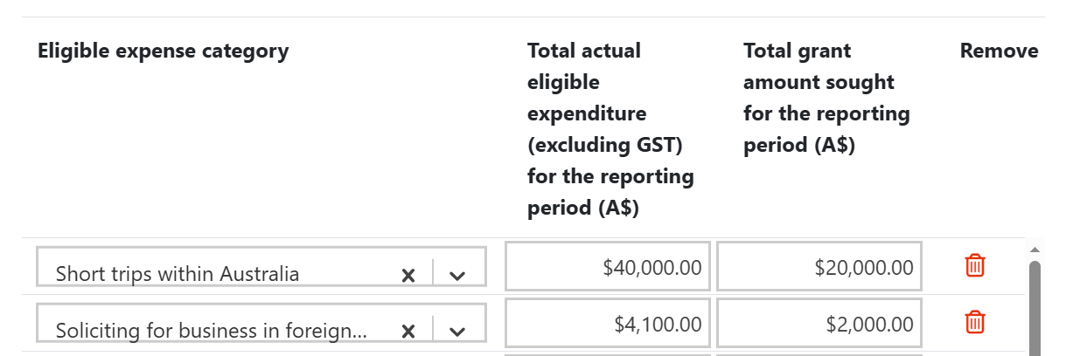
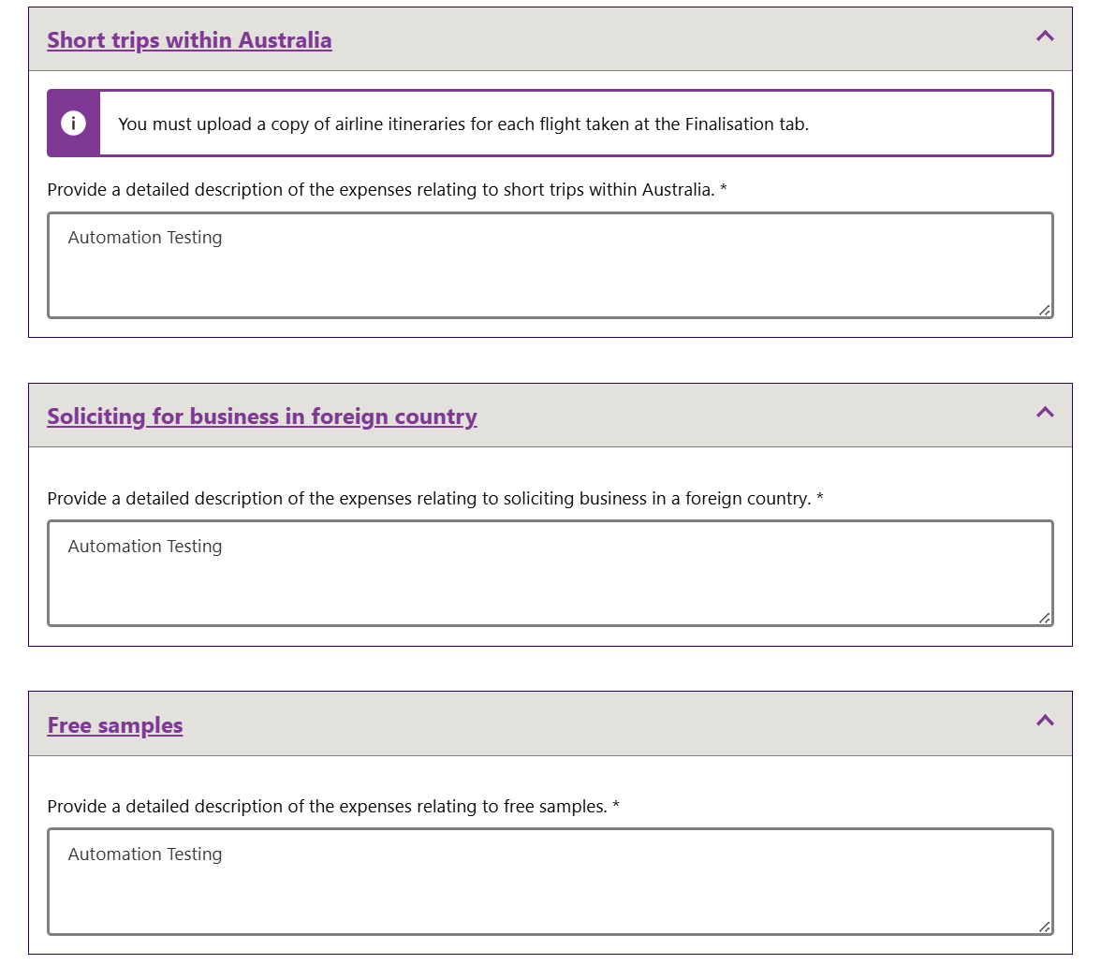
Further information and a breakdown of each of the expenses must be provided in these sections:

