# EMDG Round 4: attachments to online application form – Tiers 1, 2, 3

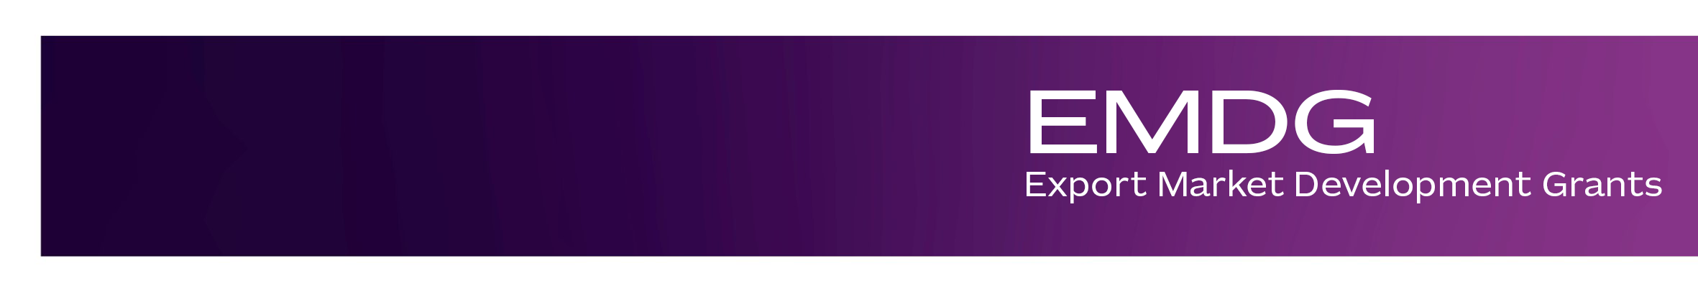

| **Attachment** | **Form required (if applicable)** | **Number of documents to be uploaded** |
| --- | --- | --- |
| **2 years of financial statements related to the ABN that the application is made** | Profit and Loss Statement and Balance Sheet from the last 2 financial years: 2022-23 and 2023-24 | **4** documents:   * **2** x profit and loss statements, 1 for each financial year * **2** x balance sheet documents, 1 for each financial year |
| **Evidence of minimum capacity to spend per financial year** | Bank statements showing you have available funds and are able to spend at least $20,000 on your proposed marketing and promotional activities per financial year | **2** documents:   * **1** x bank statement * **1** x transaction history   You must upload a copy of your most recent bank statement issued in 2024 and your bank account transaction history for the month of November 2024 to demonstrate that you have available funds and are able to spend at least $20,000 on your proposed marketing and promotional activities per financial year. That is, your most recent bank statement in 2024 (e.g. October) and an up-to-date bank account transaction report for the month of November 2024.  The date of your bank account transaction history must be as close as possible to the date of submission of your application. It must show November transactions. |
| **Evidence of compliance with taxation laws during the previous 2 income years** | The type of evidence that Austrade can request is your Business Activity Statement, your Notice of Assessment or your Statement of Account from the last 2 financial years: 2022-23 and 2023-24.  If you are currently on an ATO payment plan, you may mention this in the application form as evidence of compliance with taxation laws. | **2** documents: 1 for each financial year |
| **Tier 1 applicants must provide evidence of export readiness** | Evidence that you have completed relevant export readiness training. This could include a certificate, email or badge provided by the provider confirming your completion of the training.  Evidence that the required test has been completed. This could be a test provided by the training provider and confirmed by Austrade or completion of the Austrade test at the time of application. | Pre-populated into application once you have completed your training |
| **Tier 2 and Tier 3 applicants must provide evidence of export sales** | You must provide at least 2 export sale invoices of your eligible product(s) issued over the course of 2023-24 financial year with 1 being within 18 months of the application. | **2** invoices:   * at least **1** must be issued during the 2023-24 financial year * the other **1** can be after 1 July 2024 as that still falls within the requirement of 18 months of your application submission date   Both invoices can be dated within the 2023-2024 financial year |
| **Service product eligibility submission – must be provided by all SMEs with services other than tourism** | Austrade’s template must be used and it can be found under ‘How to Apply’ section of the [Austrade website](https://www.austrade.gov.au/en/how-we-can-help-you/grants/export-market-development-grants/how-to-apply.html).  If applicable, the form needs to be uploaded to the application form. | **1** document (if applicable) |
| **Goods made outside of Australia submission – must be provided by applicants making goods or providing services outside of Australia** | Austrade’s template must be used and it can be found under ‘How to Apply’ section of the [Austrade website](https://www.austrade.gov.au/en/how-we-can-help-you/grants/export-market-development-grants/how-to-apply.html).  If applicable, the form needs to be uploaded to the application form. | **1** document (if applicable) |
| **Trust deed including any amendments (if applicable) and including current trustee details – must be provided by SMEs that operate as a trust** |  | **1** document (if applicable) |