Australian Trade and Investment Commission

Export Market Development Grants Program Research Report

28 April 2022
PaperGiant

Acknowledgement of Country
Paper Giant acknowledges the Wurundjeri and Boonwurrung people of the Kulin nation, and the Ngunnawal people as the Traditional Owners of the lands on which our offices are located.
We acknowledge the Traditional Owners of Country on which we meet and work throughout Australia. We recognise that sovereignty over the land has never been ceded, and pay our respects to Elders past, present and emerging.

This report contains findings from quantitative (survey) research on the Export Market Development Grants (EMDG) program. This document has been made accessible.

Contents
Export Market Development Grants Program Research Report 1
Acknowledgement of Country 2
Quantitative Research Findings 4
Overview 4
Definitions of terms 4
Survey overview 4
Survey methodology 5
Survey participation 5
Identifying cohorts 5
Survey development 5
Data analysis 6
Cohort characteristics 6
Who we invited 6
Who responded 8
Key findings 9
What are the characteristics of EMDG grant writers? 9
How do grant writers and exporters become aware of the EMDG program? 12
How do grant writers understand and apply EMDG guidelines? 14
How did grant writers experience the new EMDG program? 17
What do grant writers expect of EMDG in the future? 22
How do QIP and Non QIP grant writers experiences differ? 26

Quantitative Research Findings
This section of the report features research findings from the quantitative EMDG survey

Overview

Definitions of terms
We have defined important terms as follows:

EMDG
The Export Market Development Grants (EMDG) scheme prior to 30 June 2021. The EMDG scheme allows export businesses to claim promotional expenses after they have spent them.

New EMDG
The EMDG program after 1 July 2021. The new EMDG program is a forward-looking grant program with simplified eligibility and reporting requirements.

Grant writers
A cohort of 248 individual grant writers (representing 203 grant writing businesses) who have engaged in the EMDG program were identified as the representative sample for this research. Of this sample, there were 110 qualified survey completes.

Quality Incentive Program (QIP)
For the EMDG prior to 2021, any grant writers who lodged five or more claims in a grant year were invited by Austrade to participate in the voluntary consultant Quality Incentive Program.
QIP grant writers were able to lodge EMDG applications during the extended lodgement period. The QIP program does not exist for the new EMDG program.

Survey overview
The Export Market Development Grants (EMDG) program helps Australian businesses to grow their exports in international markets. Applicants may be the operators or staff members of export businesses.
These businesses may also engage external grant writers to complete their EMDG application. Austrade seeks to better understand the experience, behaviours and pain-points of grant writers who have applied for EMDG on behalf of an export business.
This report contains data captured from a survey with a representative sample of grant writing businesses who have engaged with the EMDG program, from a cohort of 247 individual grant writers, representing 203 grant writing businesses.
The survey covered the following topic areas:
- Individual and business characteristics (questions to provide demographic/context, e.g. level of program engagement, nature of their role, relationship to applicant, program dependency)
- Engagement with the new EMDG program (questions to determine their awareness, understanding and knowledge of key program changes and their intended benefits)
- Experience with the new EMDG program (questions to understand their program-related experiences before and since the introduction of the new program; any pain points or areas where needs were/were not met)
- Program outlook for the new EMDG program (questions to determine their engagement with, and intention/confidence in continuing to be involved with the EMDG program in the short to medium term)

Survey methodology

Survey participation
We conducted a quantitative study, surveying grant writers between 9 and 16 March 2022.
Survey respondents were owners and employees of Australian grant writing businesses who completed an application in the 2021 EMDG program.
We achieved a sample of 110 respondents, which is a response rate of 45%. This includes respondents who answered all (n=93).
The sample includes representation of:
- Non-QIP grant writers - 46% (n=51)
- QIP grant writers - 45% (n=50)
- New grant writers who had submitted an application in 2021 but not previously - 8% (n=9)

Identifying cohorts
To provide a comparative analysis we compared businesses who identified as being part of the QIP program (QIP respondents) with those who didn’t (non-QIP respondents).
For the purposes of this study, non-QIP respondents refers to survey respondents who reported:
- Not being respondents in the QIP program;
- Not knowing if they were participating in the QIP program; or
- Only lodging an application in 2021 after the QIP program had ceased.
All other respondents who identified as participating in the QIP program are referred to as QIP respondents.

Survey development
We engaged stakeholders and considered prior research (including the survey conducted with applicants in January 2022) to inform the development of a 47-question survey.
As many respondents completed the survey in several sittings, we were not able to determine average completion time.
The survey covered:
- Individual and business characteristics;
- Engagement with the new EMDG program;
- Experience with the new EMDG program; and
- Program outlook for the new EMDG program.

Data analysis
- Survey data was analysed using Qualtrics software, including when matching QIP respondents with non-QIP respondents.
- Due to the sample size achieved, descriptive and comparative analysis findings were judged to be generalisable to the population of grant writers who lodged to the previous and new EMDG program.
- Our margin of error is +/- 6.4% for the sample based on a 95% confidence level. The margin of error for within-sample comparisons will vary.
- Because of limited sample, it is not possible to conduct comparative analysis with those who have only lodged an application in 2021.

Cohort characteristics

Who we invited
How they are involved
- All of respondents (n=110) helped exporters apply to the new EMDG program
- 46% (n=50) submitted less than 5 applications to new EMDG program
What they are involved in
- 28% (n=31) are entirely new to the EMDG program
- 72% (n=79) helped exporters claim under the previous EMDG program
- 79% (n=87) helped exporters apply for a Tier 2 grant
- 10% (n=11) applied for grants on behalf of representative bodies

*Includes grant writers who have submitted at least one claim to the previous EMDG reimbursement program.
Number of new EMDG applications they made
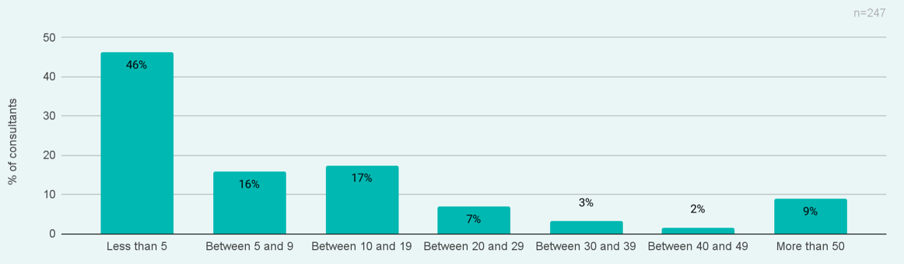

EMDG program experience they have
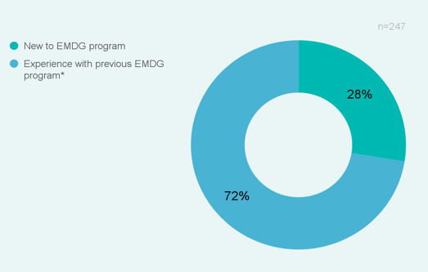
EMDG grant tiers applied to
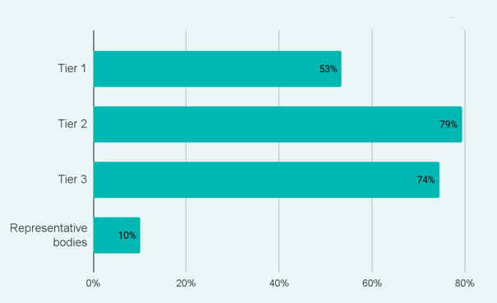

Who responded
How they are involved
- 46% (n=51) submitted less than 5 applications to new EMDG program
What they are involved in
- 92% (n=101) helped businesses claim under the previous EMDG program
- 8% (n=9) are entirely new to the EMDG program
- 66% (n=73) helped exporters apply for a Tier 1 grant
- 16% (n=18) applied for grants on behalf of representative bodies
Grant writers who submitted for the first time in 2021 are underrepresented in this sample.
*Includes grant writers who have submitted at least one claim to the previous EMDG reimbursement program.
Number of new EMDG applications they made
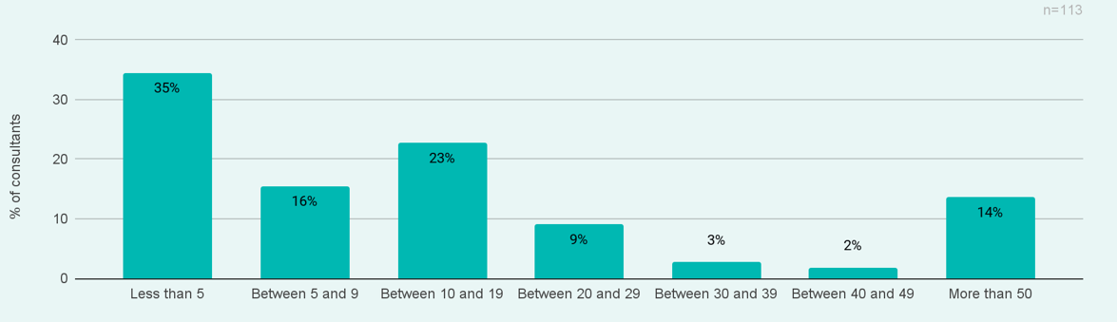

EMDG program experience they have
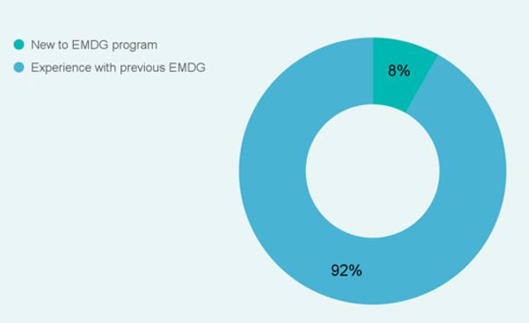

EMDG grant tiers applied to
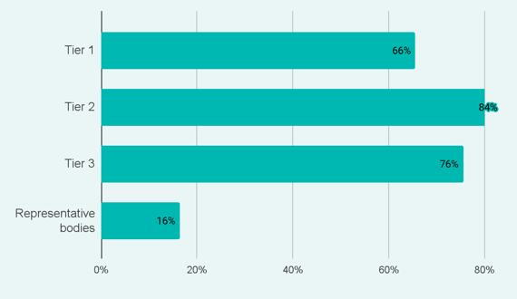

Key findings

What are the characteristics of EMDG grant writers?

Respondent self-identification of cohort
For respondents that submitted EMDG applications prior to July 2021, there was an almost even split between those that identified as QIP participants and those who didn’t.
- 46% of respondents were categorised as Experienced EMDG grant writers (they had submitted applications prior to July 2021, but were not members of the QIP program)
- 45% of respondents were categorised as QIP-participating EMDG grant writers
- 8% of respondents had only submitted applications in the new EMDG (post July 2021)
Some respondents began submitting EMDG applications many years ago.
- Around a third (32%) of respondents first submitted an EMDG claim or application prior to 2015
Table: Type of EMDG grant writer

Experienced EMDG grant writer | QIP-participating EMDG grant writer | New EMDG grant writer
46% | 45% | 8%
110 responses

Table: First submitted an EMDG claim or application

Before 2010 | Between 2010 and 2014 | Between 2015 and 2019 | Since 2020 | Never applied to previous EMDG program
21% | 9% | 32% | 23% | 14%
110 responses

Characteristics of respondents
Respondents were typically business owners (53%) that had significant experience, with almost half having more than ten years’ experience.
- The most common role of respondents was a consultant or accountant (54%)
- There are long periods of tenure, 73% of respondents have been operating in their role for more than 5 years
Table: Employment status

Business owner | Self-employed | Employee | Independent contractor | Other, please specify
53% | 11% | 25% | 8% | 3%
110 responses

Table: Role in business

Executive or senior management | Consultant/ accountant | Business advisor | Other, please specify
33% | 55% | 9% | 3%
110 responses

Table: Length of time in role

Less than 1 year | 1-5 years | 6-10 years | More than 10 years
2% | 25% | 24% | 49%
110 responses

Characteristics of grant writer businesses
Survey respondent businesses vary both in number of employees and the degree to which they specialise in providing services related to EMDG.
- Most businesses are small, having fewer than five employees in total
- For 26% of respondents, most or all of their clients were EMDG applicants

Table: How many people are employed at the business you work for?

Self-employed | Less than 5 | Between 5 and 19 | More than 20
12% | 38% | 31% | 20%
104 responses

Table: Approximately, how many of your clients are EMDG applicants?

Very few of them | Less than half | Half of them | Most of them | All of them
40% | 19% | 15% | 7% | 19%
110 responses

Provision of export services
Grant writing businesses support the delivery of a broad range of export services.
- 50% are involved in developing export reports, plans or strategies
- 48% are involved in securing export supports — subsidies, grants similar to EMDG and/or relevant no-cost services
- Other common services relate to developing relationships with potential overseas buyers or agents (38%) researching markets (35%) and assessing export potential (35%)
- It is less common for them to provide services further in the export journey, such as freight and shipping (3%), duties and taxation (8%), documentation and agreements (10%)
Do these export-related services include any of the following?
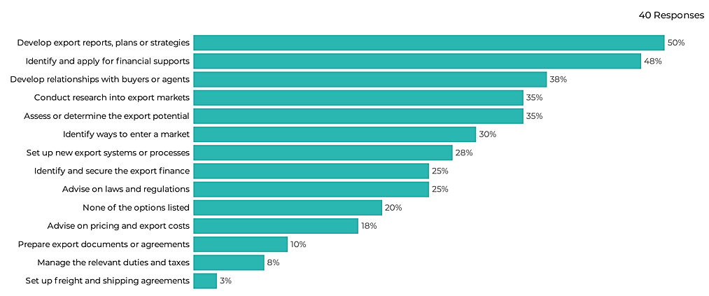

How do grant writers and exporters become aware of the EMDG program?

Awareness of the EMDG program
Most respondents (86%) found out about the new EMDG grant program through some level of contact with Austrade.
- 75% of grant writers reported receiving a direct communication from Austrade
- 48% report hearing about the program via the Austrade website
There are a few channels where respondents found information about EMDG grants other than contact with Austrade.
- Some found information entirely outside of Austrade channels (10%)
- Or exclusively via industry or business networks (4%)

Table: How did you find out about the new EMDG program?

Austrade sources | Outside Austrade channels | Industry or business networks
86% | 10% | 4%
110 responses

How they found out about the new EMDG grant program
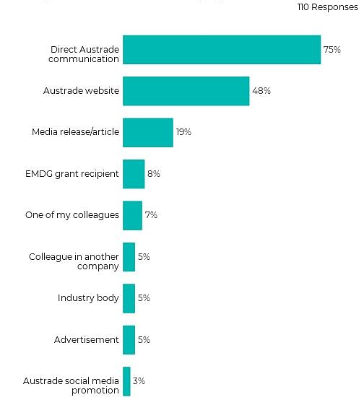

How and why do exporters engage grant writers?
There are diverse pathways through which exporters find and engage with EMDG grant writers.
- Grant writers EMDG clients are largely returning customers or referred by previous customers
- Most grant writers helped exporters with previous EMDG claims (66%)
- Many report that exporters contacted them directly for help (48%)
How did most of your EMDG clients come to know you could help them apply to the new EMDG program?

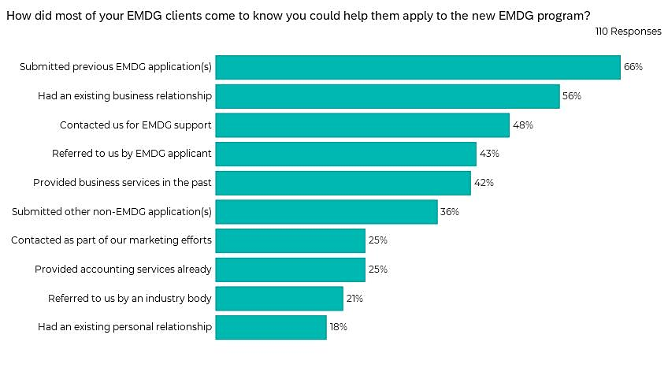

Why exporters engage grant writers
Grant writers and applicants identify the same rationale for using their services.
- In a recent survey* of EMDG applicants, most respondents said they engaged grant writing services to gain from their expertise (77%), while almost half of them (43%) said they worried that they would get it wrong and miss out on this round.
*This survey was administered by Austrade in January 2022.
Grant writers believe that their expertise with the EMDG program is the largest drawcard for their services.
- Most say their clients want their expertise (89%)
- Over half say their clients fear making a mistake and missing out on a grant (52%)
- Clients are reportedly too busy (55%) to apply and feel they have greater certainty of a successful outcome when using their services (50%)

Why did applicants engage your services rather than submit it themselves?
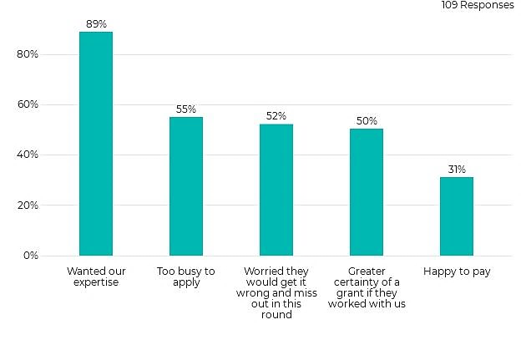

How do grant writers understand and apply EMDG guidelines?

Respondent understanding of key guidelines
There isn’t a consistent understanding of the EMDG program guidelines.
- 83% of respondents suggested that exporters must ‘spend double’ the grant amount
- 72% suggested that eligibility is not indicative of the grant amount they will receive
- 63% suggested that all eligible applicants would receive a grant
- Only half identified that evidence and documentation requirements can be found in the EMDG guidelines

Based on your understanding of the EMDG guidelines, to what extent do you agree or disagree with the following statements?
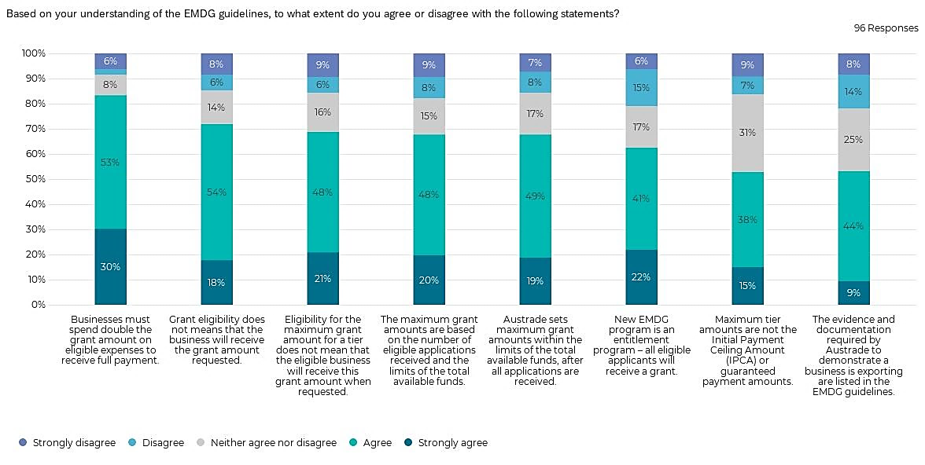

Helpfulness of EMDG guidelines
Survey respondents found aspects of the new EMDG guidelines to be of limited help.
- 56% of survey respondents found guidelines about current and future requirements to be of limited help
- 40% of survey respondents found guidelines about how funds were allocated to be of no help at all
- 38% of survey respondents found guidelines about grant amounts to be of no help at all
Survey respondents found other aspects of the new EMDG guidelines to be helpful.
- 80% of survey respondents found guidelines about types of export activity required by each grant tier to be helpful
- 72% of survey respondents found guidelines about export activity and tiers helpful

To what extent did the new EMDG guidelines provide the following information in a way that was helpful to you?
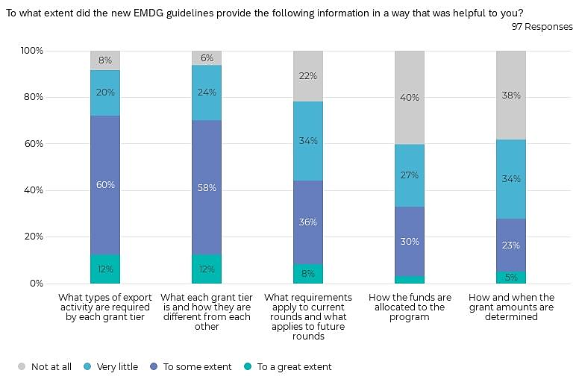

Finding and applying the EMDG guidelines
The majority of survey respondents were able to find and use the EMDG guidelines but thought they were difficult to understand.
- Most survey respondents found the guidelines easily (57%)
- Half said the guidelines were usually or always relevant to the businesses they work with (50%)
- 46% of respondents noted there was usually or always a lack of practical examples in the guidelines
To what extent did you find the new EMDG guidelines to be:
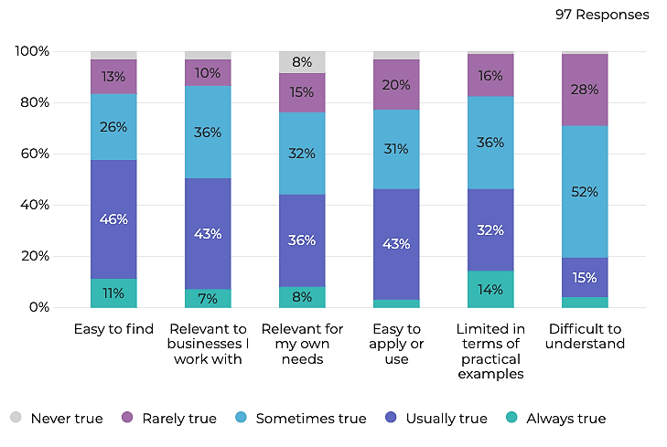

How did grant writers experience the new EMDG program?

Exporter involvement in application tasks
There are substantial differences in the degree to which exporters are directly involved in EMDG application tasks.
- Survey respondents suggested that 49% of their exporter clients did not engage at all with the application form at all
Most grant writers indicated that exporters have at least some engagement in every application task.
- Survey respondents indicated that in most cases the exporter was responsible to some extent for deciding the grant amount (80%) and developing a plan to market (85%)
To what extent is the exporter directly involved in the following tasks when you help them apply to the new EMDG program?
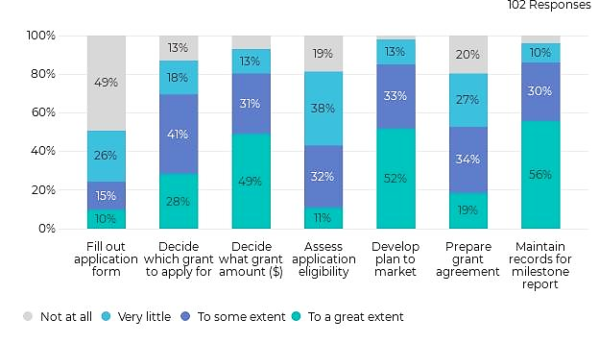

Grant writer involvement in application tasks
Grant writers indicated that they were most involved in assessing application eligibility and completing application forms.
- Grant writers provided substantially more support to exporters in filling the application form (89%) and assessing eligibility (80%) than any of the other application tasks
- Grant writers suggested they had no (9%) or very little (32%) involvement in record keeping for milestone reports

To what extent are you directly involved in the following tasks when you help businesses apply to the new EMDG program?
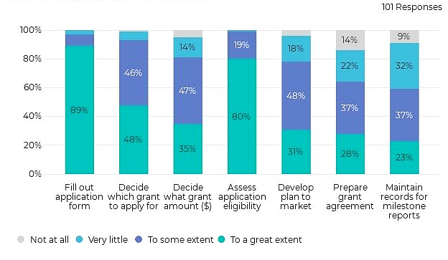

Grant writer involvement in other processes
Grant writers see themselves as playing a liaison and promotional role in addition to EMDG application tasks.
- 86% of grant writers indicated that they liaised with Austrade as part of the new EMDG program
- 77% of grant writers promoted the program to new applicants as part of their role
As part of your involvement in the new EMDG program, did you do any of the following tasks?
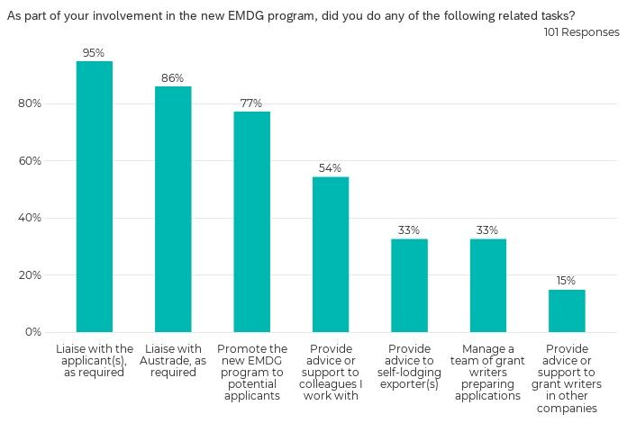

Time spent applying and with clients
There is not a large difference in the average time taken to complete an application for
Tier 1, Tier 2, or Tier 3.
- There are substantial differences in respondent recording of individual time taken, suggesting efficiencies of scale or specialisation
Survey respondents fell into three groups according to time they spent with EMDG clients.
- Survey respondents fell into three groups: those they spend a small portion of their time with EMDG clients, those that spend about half their time with EMDG clients, and those that almost exclusively dealt with EMDG clients
- 56% of survey respondents spent less than 30% of their time with EMDG clients
- 19% of survey respondents spent more than 90% of their time with EMDG clients
Table: What percentage of your overall working hours since 1 July 2021 has been spent with EMDG clients?

Less than 30% | Between 30% and 50% | Between 60% and 80% | More than 80%
56% | 20% | 7% | 17%
108 responses

Hours spent per tier
12 Average number of hours spent for Tier 1 applications
15 Average number of hours spent for Tier 2 applications
13 Average number of hours spent for Tier 3 applications

Ease of completing application tasks
The majority of respondents suggested that it was always or usually easy to complete all steps of submitting applications.
- 79% of respondents indicated that filling the application form was always or usually easy to do
- 77% of respondents indicated that assessing eligibility was always or usually easy to do
- However, processes that involved explaining process or requirements to export businesses or other colleagues were less easy to do

When submitting applications to the new EMDG program, how often did you find it easy to do the following?
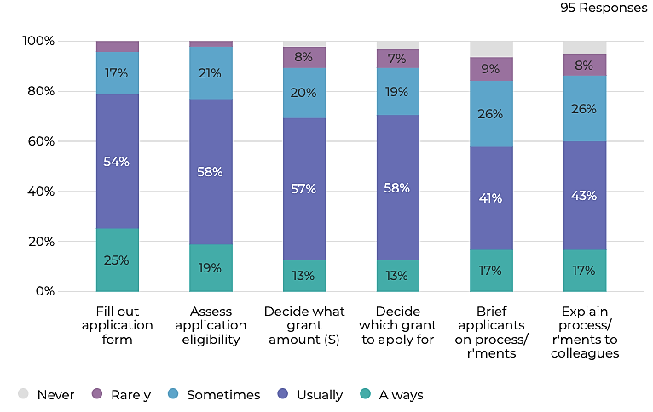

Confidence in application tasks
Survey respondents showed great confidence in their ability to complete applications, assess eligibility and decide appropriate application criteria.
- There was a cohort who were never, rarely or only sometimes confident when briefing applicants on process requirements (27%) and explaining process requirements to their colleagues (29%)
When applying to the new EMDG program, how often did you feel confident about how you were doing the following?
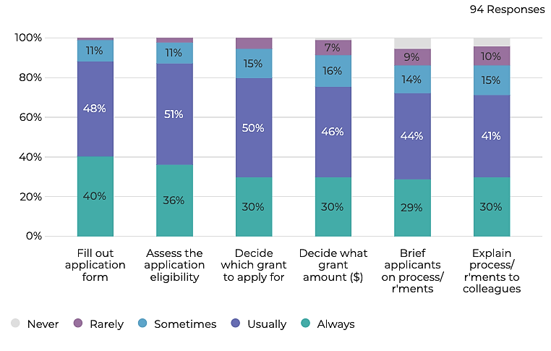

Assessing applicant eligibility
Survey respondents found export experience and expenditure plans the hardest part of assessing applicant eligibility.
- 7% of survey respondents said it was rare to be able to easily assess applicant eligibility in relation to expenditure plans
When applying to the new EMDG program, how often did you find it easy to assess your applicant’s eligibility in relation to the following?
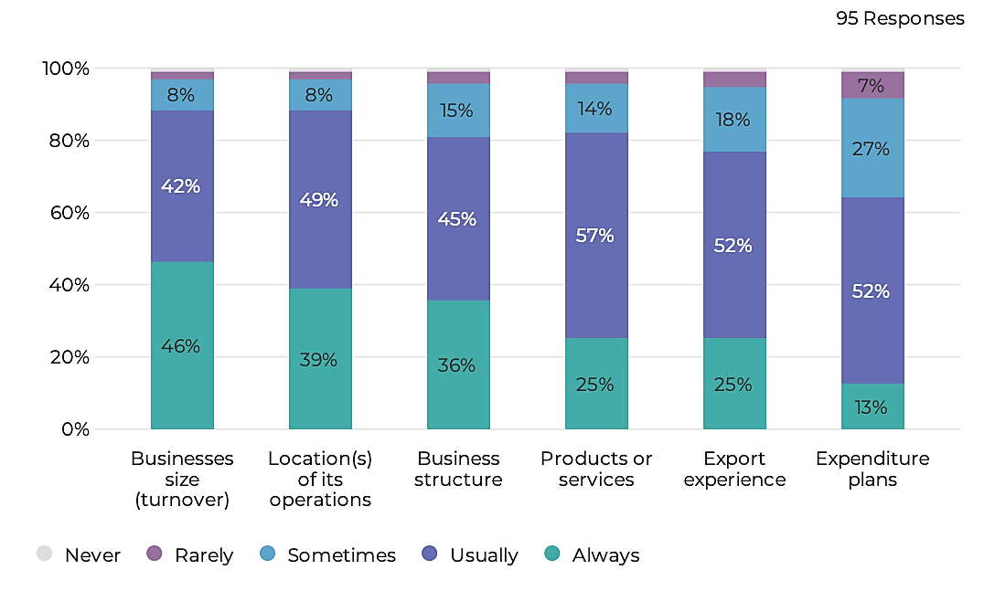

Applicant needs and objectives
Survey respondents believed access to information, including eligible fund allocation to be important.
- The majority of survey respondents (71%) agreed that certainty about how much EMDG grant exporters get in advance of spending is helpful
Please indicate whether you agree or disagree with the following statements
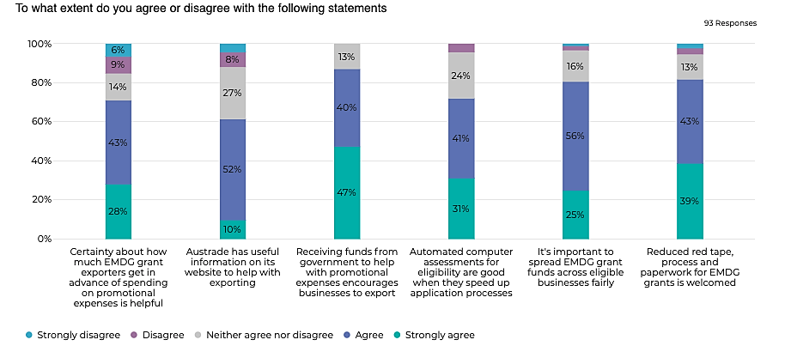

Perceptions of change
Many survey respondents found the new EMDG application process did not necessarily offer simplicity or time savings.
- 37% of survey respondents disagreed that the new EMDG application process was simpler and less time consuming
Please indicate whether you agree or disagree with the following statements
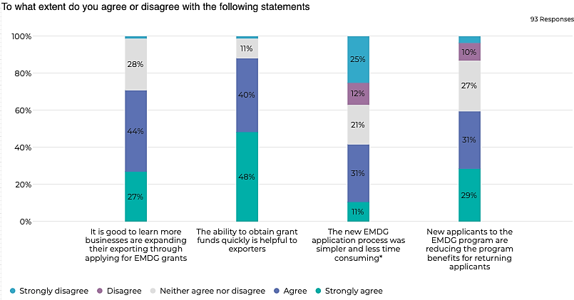
*compared to the reimbursement scheme

What do grant writers expect of EMDG in the future?

Certainty and predictability is valued
Knowing the grant amount in advance of the following financial year is preferable.
- The majority of grant writers (66%) said it would be easier if they had the grant agreement in place in advance of the following financial year. Any application schedule that could enable this would be valued by grant writers.
- Being able to receive funds soon after the expenditure is important too - for this reason, many grant writers (55%) said it would be easier if they were able to provide milestone reports at any time in the grant year.
Grant writers are wary of shorter application periods, or unpredictable opening and closing times.
- Shorter and/or staggered application periods were much less desirable. 69% of grant writers indicated that a short application period of 4 weeks (with significant advance lead time) would make the experience more difficult.

Different scheduling options being considered by Austrade
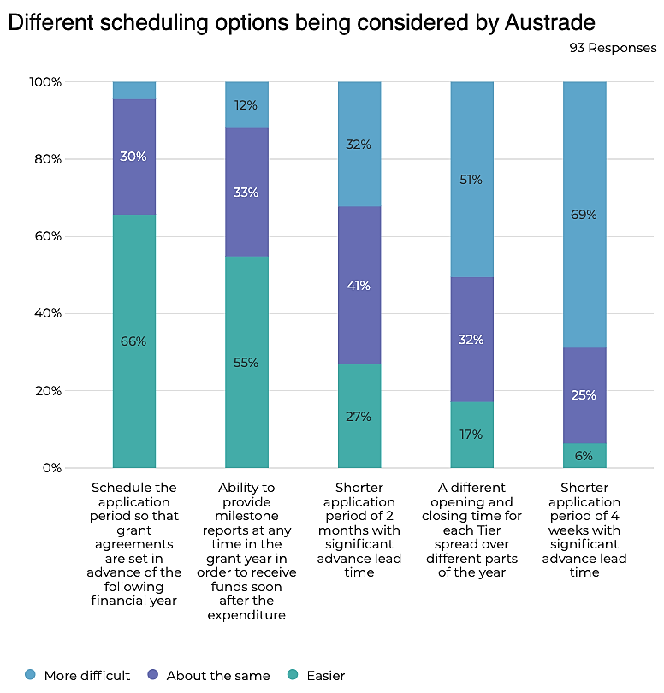

Expectations of future lodgements vary
Most grant writers intend to submit applications in the next round.
- Some are not yet decided (18%), but many grant writers (41%) expect to submit more, or the same amount of, applications in the next grant round.
- However, 40% of grant writers say they will submit less than they did in the inaugural round.
- Survey respondents expect to increase their number of applications from 2,214 in the current round to 2,305 in the next grant round.
- Based on their estimate, the average number of applications per grant writer is projected to increase from 20 to 25*.
Reasons for the reduction in applications is unclear.
- Among those grant writers who expected to submit less applications, only half of them (47%) selected from any one of the suggested reasons provided. This indicates a need to more deeply explore what's driving this expectation.
- That said, 1 in 4 noted the program changes made it less relevant for their clients (26%) and/or less viable for them (24%), and the application process took up too much time (24%).

Do you expect to lodge more, less or the same number of applications in the next round?
40% Less than before

24% About the same

17% More than before

Projected average number of applications per grant writer:
20 In 2021*

25 In 2022*

*This is based on number of applications estimated as part of the survey (#=2,305, average= 22) and the sample-specific data provided by Austrade (#=2,214, average=20).This data excludes respondents who said they were uncertain about the number of applications they would submit in the next round.

Grant writers see great value in their service
Grant writers still believe EMDG needs experts like them.
- Grant writers see themselves as a vital part of the program. Most of them (80%) believe the new EMDG program needs experts like them to support exporters to apply.
- As mentioned already, most grant writers (89%) said their expertise was the reason applicants used their services.
Reforms have increased demand for their services.
- Half of grant writers (51%) believe the new EMDG program has increased demand for their services, to at least some extent.
- Some grant writers also believed the new EMDG program enabled them better support businesses (46%) and reduce the amount of time spent on EMDG applications (41%).
Table: To what extent do you agree or disagree with the following: the program needs experts like me to support exporters to apply?

Strongly disagree | Disagree | Neither agree nor disagree | Agree | Strongly agree
2% | 0% | 18% | 48% | 32%
93 responses

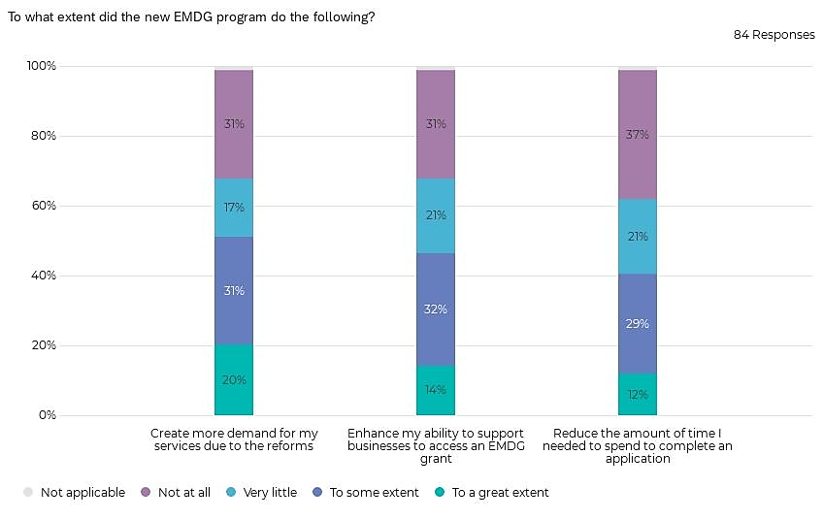
To what extent did the new EMDG program do the following?

There is general support for the EMDG program
EMDG enables exporters to be more ambitious.
- Grant writers believe the program encourages exporters to be more ambitious (83%), but are less convinced exporters would have a less effective marketing plan without the program (50%)
- 1 in 3 grant writers disagree that there is a maximum amount a small or medium-sized business could expect to spend on overseas marketing on an annual basis. This belief may inform views on the relevance of the maximum grant tier amounts.
EMDG helps increase exports and generate jobs.
- The vast majority of grant writers say the new program helps businesses commit to their export efforts (92%) and, in the long run, helps small and medium-sized businesses generate jobs (87%).
- Half of grant writers (53%) say smaller businesses benefit more than larger businesses.
The majority of grant writers value the intentions of the program:
91% Report helping businesses with overseas marketing expenses

77% Report reduced administrative barriers

66% Report helping the automation of processes

How do QIP and Non QIP grant writers experiences differ?

QIP grant writers signal reliance & familiarity
For respondents that had submitted applications for the new EMDG program, there was an almost even split between those that identified as QIP participants (45%) and those who didn’t (55%).
- The vast majority of applications to the new EMDG program comes from QIP participating grant writers with each submitting an average of 37 applications
- 72% of QIP participating grant writers say at least half of their clients are EMDG applicants, indicating heavy reliance and familiarity with the program
Average number of applications to the new EMDG program
37 QIP grant writers

6 Non QIP grant writers

*This is based on number of applications estimated as part of the survey (#=2305, average= 22) and the sample-specific data provided by Austrade (#=2214, average=20).

Table: Type of EMDG grant writer

Non QIP grant writer | QIP grant writer
55% | 45%
110 responses

Table: Approximately, how many of your clients are EMDG applicants?

 | All of them | Most of them | About half of them | Less than half of them | Very few of them
Non QIP grant writer | 7% | 0% | 8% | 25% | 60%
QIP grant writer | 34% | 16% | 22% | 12% | 16%

However, they have similar experience & autonomy
QIP grant writers were as likely to be business owners (54%) as other grant writers (52%). Both also had significant experience, with almost half having more than ten years’ experience (50% and 48%, respectively).
- The most common role for QIP grant writers and Non QIP grant writers was a consultant or accountant (58% and 52% respectively).

Table: Employment status

 | Business owner | Self-employed | Employee | Independent contractor | Other
Non QIP grant writer | 52% | 13% | 25% | 7% | 3%
QIP grant writer | 54% | 8% | 24% | 10% | 4%

Table: Role in business

 | Executive or senior management | Consultant/ accountant | Business advisor | Other, please specify
Non QIP grant writer | 33% | 52% | 12% | 3%
QIP grant writer | 32% | 58% | 6% | 4%

Table: Length of time in role

 | Less than 1 year | 1-5 years | 6-10 years | More than 10 years
Non QIP grant writer | 5% | 25% | 22% | 48%
QIP grant writer | 0% | 24% | 26% | 50%

Their clients engage them for similar reasons
Both QIP and Non QIP grant writers believe that their expertise with the EMDG program is the largest drawcard for their services.
- Most say their clients want their expertise (92%, QIP vs 86% Non QIP)
- About half say their clients fear making a mistake and missing out on a grant (60%, QIP vs 56% Non QIP)
*In a recent survey of EMDG applicants, most respondents said they engaged grant writing services to gain from their expertise (77%), while almost half of them (43%) said they worried that they would get it wrong and miss out on this round. The survey was administered by Austrade in January 2022.

Why did applicants engage your services rather than submit it themselves?*
Non QIP grant writers
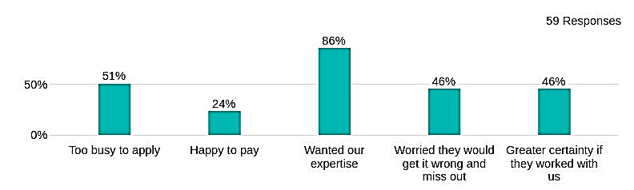
QIP grant writers

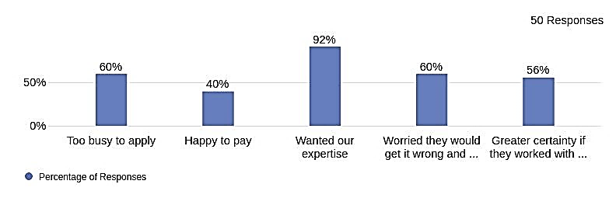

QIP participants find the guidelines less helpful
QIP grant writers are more likely to report difficulty or limitations in their experiences of the EMDG guidelines.
- 62% of Non QIP grant writers always or usually find the EMDG guidelines easy to use or apply, compared to 29% of QIP grant writers

Table: To what extent did you find the EMDG guidelines: Easy to apply or use

 | Always true | Usually true | Sometimes true | Rarely true | Never true
Non QIP grant writer | 6% | 56% | 25% | 12% | 1%
QIP grant writer | 0% | 29% | 38% | 29% | 4%

Table: To what extent did you find the EMDG guidelines: Difficult to understand

 | Always true | Usually true | Sometimes true | Rarely true | Never true
Non QIP grant writer | 4% | 8% | 44% | 42% | 2%
QIP grant writer | 4% | 24% | 60% | 11% | 0%

Table: To what extent did you find the EMDG guidelines: Limited in practical examples

 | Always true | Usually true | Sometimes true | Rarely true | Never true
Non QIP grant writer | 12% | 21% | 50% | 17% | 0%
QIP grant writer | 18% | 44% | 20% | 16% | 2%

QIP grant writers identify more development needs
QIP grant writers were more likely to report opportunities for development, whether by efficiency or easy to follow guidelines.
- Over half (56%) of QIP grant writers disagree that the EMDG guidelines are straightforward and easy to follow
Table: The application process is short and efficient to complete

 | Strongly agree | Agree | Neither agree nor disagree | Disagree | Strongly disagree
Non QIP grant writer | 6% | 40% | 30% | 20% | 4%
QIP grant writer | 5% | 16% | 19% | 40% | 21%

Table: The EMDG guidelines are straightforward and easy to follow

 | Strongly agree | Agree | Neither agree nor disagree | Disagree | Strongly disagree
Non QIP grant writer | 8% | 44% | 28% | 14% | 6%
QIP grant writer | 7% | 21% | 16% | 40% | 16%

QIP grant writers find tasks more challenging
QIP grant writers were more likely to be impacted by the changes of the new EMDG program.
- 33% of QIP grant writers report that they never find it easy to prepare a grant agreement

When applying to the new EMDG program, how often did you find it easy to do the following?
Table: Preparing a grant agreement

 | Always | Usually | Sometimes | Rarely | Never
Non QIP grant writer | 12% | 40% | 32% | 4% | 12%
QIP grant writer | 3% | 29% | 31% | 4% | 33%

Table: Reviewing or advising on a grant agreement

 | Always | Usually | Sometimes | Rarely | Never
Non QIP grant writer | 16% | 42% | 26% | 8% | 8%
QIP grant writer | 4% | 36% | 24% | 16% | 20%

Non QIP grant writers report greater direct benefit
Non QIP grant writers are more likely (than QIP grant writers) to report time savings or enhanced ability.
- 17% of Non QIP grant writers report noticeable reduction in the time needed to complete an application (to a great extent)
- 22% of Non QIP grant writers report noticeable change in their ability to support businesses to access an EMDG grant (to a great extent)
Table: Reduce the amount of time I need to spend to complete an application

 | To a great extent | To some extent | Very little | Not at all | Not applicable
Non QIP grant writer | 17% | 41% | 22% | 20% | 0%
QIP grant writer | 7% | 16% | 21% | 53% | 3%

Table: Enhance my ability to support businesses to access an EMDG grant

 | To a great extent | To some extent | Very little | Not at all | Not applicable
Non QIP grant writer | 22% | 41% | 15% | 22% | 0%
QIP grant writer | 7% | 23% | 28% | 40% | 2%

However, they are optimistic about service demand
QIP grant writers attribute their skills and experience as important to the process of applying for an EMDG grant.
- The vast majority (93%) of QIP grant writers report that the program needs experts like themselves to support exporters to apply
Table: The program needs experts like me to support exporters to apply

 | To a great extent | To some extent | Very little | Not at all | Not applicable
Non QIP grant writer | 22% | 48% | 28% | 0% | 2%
QIP grant writer | 44% | 49% | 7% | 0% | 0%

Table: Create more demand for my services due to the reforms

 | To a great extent | To some extent | Very little | Not at all | Not applicable
Non QIP grant writer | 17% | 27% | 22% | 34% | 0%
QIP grant writer | 23% | 35% | 12% | 28% | 2%

Prepared by PaperGiant
hello@papergiant.net
papergiant.net

Melbourne
Level 3
2 Russell Street
Melbourne VIC 3000
Australia

Canberra
Ngunnawal Country
Level 3
17-21 University Avenue
Canberra ACT 2601
Australia

ABN
76 155 179 534

