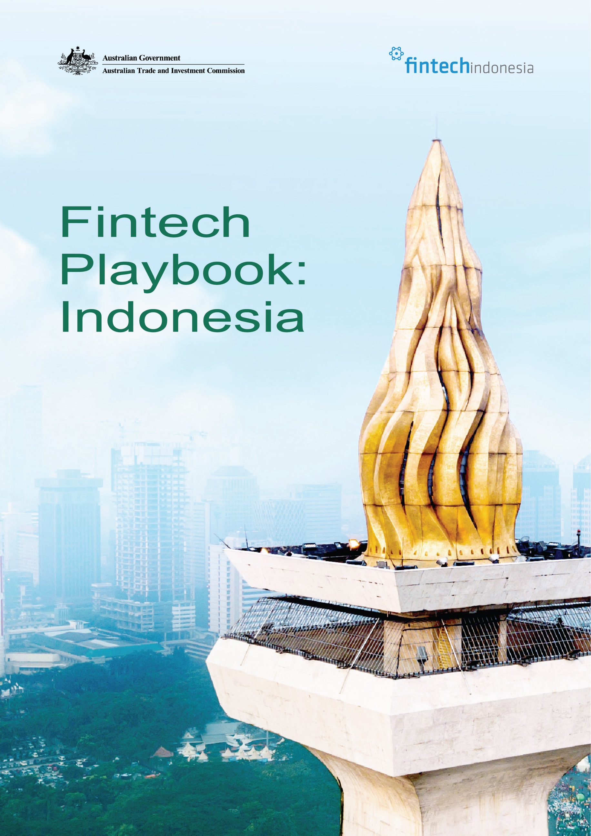



Contents

Foreword 4
Executive Summary 6
Overview of Indonesia Digital
Finance Landscape 7
Digital Finance Development in Indonesia 7
Key Market Segments & Emerging Trends 12
Digital Infrastructure Landscape 14
(Untapped) Opportunities and Challenges 18
Digital Finance as a Growth
Enabler for the Real Sector 18
Key Areas of Opportunity 19
Identifying Pain Points 20
Unlocking Co-Innovation Opportunities in
Indonesia’s Digital Finance Landscape 22
Gaps in local capabilities 22
Lessons learned on co-innovation and
localisation in Indonesia 25
Market Entry Strategies 27
Localisation and Pricing Model 28
Regulatory Landscape 29
Support from AFTECH and Ecosystem Players 39
Strategic Recommendations 40
Entering Indonesia’s Fintech
Market: Do’s and Don’ts 40
Appendices 41

Fintech Playbook: Indonesia 3



Foreword - AUSTRADE

As Indonesia accelerates its digital transformation, financial technology (fintech) is playing a pivotal role in shaping how individuals and businesses connect, transact, and thrive. The evolution of Indonesia’s digital finance ecosystem mirrors the country’s broader economic progress; dynamic, inclusive, and increasingly sophisticated.

For Australia, Indonesia’s growth story represents not just a neighbouring

opportunity, but a strategic partnership grounded in shared values of innovation, collaboration, and trust. Our two countries are natural digital partners: Australia is a mature and innovative digital nation, ranked 2nd in this region and 6th globally for our fintech capabilities. Australia offers deep expertise in regulatory technology,
cybersecurity, artificial intelligence, and data governance, while Indonesia brings a vast consumer base, rapid adoption, and a strong commitment to financial inclusion.

This Indonesia Fintech Playbook, developed jointly by Austrade and the Indonesia Fintech Association (AFTECH) as part of the Australian Government’s dedicated Indonesia Technology Landing Pad program, reflects our collective ambition to bridge these strengths. It provides Australian fintech players with practical insights into Indonesia’s fintech landscape: the opportunities, pathways to market, and the partners who make sustainable growth possible.

Fintech is more than technology; it is an enabler of inclusive prosperity. By deepening cooperation, collaboration, and partnerships between our ecosystems, we can foster a more secure and resilient digital finance environment that supports businesses of all sizes and empowers communities across both nations.

Austrade is proud to collaborate with AFTECH on this initiative and to support Australian firms exploring opportunities in Indonesia through programs such as the Indonesia Landing Pad. Together, we aim to turn knowledge into connection, and connection into impact, unlocking new pathways for innovation, investment, and shared growth.

Sincerely,

Lauren Adams
Trade and Investment Commissioner and Southeast Asia Strategic Lead for Technology The Australian Trade and Investment Commission (Austrade)

4 Fintech Playbook: Indonesia
4 Fintech Playbook: Indonesia



Foreword - AFTECH

As Indonesia accelerates its digital transformation, fintech is emerging as a key enabler linking innovation with real-sector productivity. Redefining how growth, access, and opportunity are created across the nation. The Indonesia Fintech Association (AFTECH) is proud to present the Indonesia Fintech Playbook, developed in collaboration with Austrade, as a bridge for Australian innovators and investors
to co-create, scale, and thrive within Indonesia’s dynamic digital economy.

Home to more than 280 million people, Indonesia is one of the world’s fastest-growing digital economies. Fintech lies at its centre, redefining how individuals and businesses access, transact, and invest. With over 200 members spanning 25 business models, from payments and lending to insurance technology (InsurTech), digital banking, and regulatory technology (RegTech), AFTECH represents this dynamic transformation. Concepts such as digital trust, embedded finance, and cross-border data flows are no longer buzzwords; they are the foundations of Indonesia’s future economy, driving our ambition toward high GDP growth by 2029 and the Indonesia Emas 2045 vision.

Australia and Indonesia are natural partners. Australia brings innovation, technology, capital, and expertise; Indonesia offers scale, rapid adoption, and a vibrant consumer base. Together, both countries can co-develop digital infrastructure, deploy AI-driven risk tools, and advance open finance to foster inclusion and trust.

This Playbook serves as a practical guide — highlighting where opportunities lie, how to navigate the regulatory landscape, and why partnership with local players is key. For Australian companies, Indonesia is not merely a market, but a living testbed for innovation and a launchpad for regional growth.

By building bridges between our ecosystems, we can unlock new frontiers in fintech, strengthen digital trust, and deliver shared prosperity for both nations.

Sincerely,

Pandu Sjahrir
Chairman, AFTECH

Fintech Playbook: Indonesia 5
Fintech Playbook: Indonesia 5

Executive Summary

The Australian Trade and Investment Commission (Austrade)–Indonesia Fintech Association (AFTECH) Indonesia Fintech Playbook was developed through joint research, member interviews, and focus group discussions involving regulators, investors, and fintech companies from both countries. It offers practical insights for Australian businesses seeking to participate in Indonesia’s fast-evolving digital finance landscape.

Indonesia’s Digital Finance at a Glance
With more than 280 million people and rapidly rising digital adoption, Indonesia is among the world’s most dynamic fintech markets. The sector has evolved beyond payments into lending, digital banking, insurance technology (InsurTech), innovative credit scoring (ICS), and open finance, creating strong demand for inclusive, technology-driven financial solutions.

Opportunities for Australian Firms Australian companies can bring global expertise in regulatory technology (RegTech),
cybersecurity, AI-based fraud detection, digital identity, cross-border payments, and Small and Medium Enterprises (SME)-focused Business-to-Business (B2B) solutions. These align closely with Indonesia’s priorities to deepen financial inclusion, enhance risk management, and strengthen the foundations of digital trust.

Key Challenges to Navigate
Success requires understanding Indonesia’s regulatory complexity, managing cybersecurity and data-privacy risks, addressing infrastructure gaps, and competing in a highly localised market. Products and services must be adapted for affordability, mobile-first use, and cultural relevance. Building long-term partnerships with credible local players, rather than short-term transactions, is crucial to sustained growth.
Pathways to Entry and Collaboration Australian firms should engage early with local associations, particularly AFTECH, and leverage Austrade’s Indonesia Landing Pad to connect with regulators, investors, and partners. Pilot projects, co-innovation programs, and participation in regulatory sandboxes can serve as effective first steps to validate models and build trust.
Expanding beyond Jakarta and Java presents untapped potential for inclusive market growth.

Shared Prosperity through Co-Creation
By combining Indonesia’s scale and diversity with Australia’s innovation and expertise, both nations can co-develop solutions that advance financial inclusion, enhance consumer protection, and strengthen regional digital resilience. This Playbook is an invitation to co-create — turning innovation into impact and partnerships into progress.

6 Fintech Playbook: Indonesia

Overview of Indonesia Digital Finance Landscape

Indonesia’s digital finance ecosystem is among the most dynamic in Asia, driven by rapid technology adoption, a young and growing consumer base, and strong policy support. With more than 280 million people, rising internet penetration, and a vibrant fintech sector, Indonesia is expanding financial inclusion and creating new opportunities in payments, lending, insurance, wealth management, and digital banking.
This section outlines market development, key trends, regulation, digital infrastructure, and the role of associations such as the AFTECH, to help Australian businesses and policymakers identify areas for partnership and sustainable innovation.

Digital Finance Development in Indonesia
After a decade of rapid growth fuelled by innovation and optimism, Indonesia’s digital finance ecosystem is entering a new era, one defined by maturity, collaboration, and deeper integration across industries. According to Bank Indonesia (BI), the COVID-19 pandemic significantly accelerated adoption, with the value of digital banking transactions rising from Indonesian Rupiah (IDR) 27,036 trillion in 2019 to IDR 40,000 trillion in 2021. Over the same period, electronic money (e-money) transactions increased from IDR 5.2 to 7.1 billion. This momentum has continued in the post-pandemic years, making digital finance a central part of everyday economic activity. As of August 2025, the value of e-money transactions reached IDR
300.384 trillion, with a total transaction volume of approximately 2.79 billion, underscoring the growing role of e-money as a preferred payment instrument across Indonesia’s digital economy.

Alongside digital payments, Indonesia’s licensed peer-to-peer (P2P) lending industry continues its rapid expansion and structural maturation. As of December 2024, total loan disbursement reached IDR 742.49 trillion, up from IDR 155.9 trillion in 2019, with the number of registered borrowers exceeding 130 million. By February 2025, outstanding financing stood at approximately IDR
80.07 trillion, a 31 percent year-on-year increase, while the non-performing loan ratio remained stable at around 2.78 percent. The industry is now entering a consolidation and compliance phase under Financial Services Authority Regulation (POJK) 40/2024, where a few large platforms dominate the market and niche players increasingly focus on productive Micro, Small,

and Medium Enterprises (MSMEs) and regional segments. Sustained growth is expected to come from stronger risk management and deeper collaboration with banks, other financial institutions (such as insurance companies), credit ratings, as well as technology partners.

Although Indonesia’s fintech sector also weathered a period of “tech winter,” marked by tighter funding and increased investor caution, industry players continued to demonstrate strong resilience. Growth persisted across key segments, driven by the widespread adoption of Quick Response Code Indonesian Standard (QRIS), the continued expansion of digital lending, including P2P lending and Buy Now Pay Later (BNPL), and rising participation in online investment and digital asset platforms. These trends show that even amid global funding constraints, Indonesia’s fintech ecosystem has maintained solid momentum, underpinned by robust domestic demand and supportive regulation.

Despite this progress, AFTECH Annual Members Survey (AMS) 2025 reveals that most fintech companies remain concentrated in Java, particularly Jakarta, which accounts for
86.89 percent, followed by the Bogor, Depok, Tangerang, and Bekasi (Bodetabek) area at 5.74 percent, and Surabaya at 3.28 percent. In terms of income, the majority of consumers fall within the middle-income bracket of IDR 5–10 million per month (33 percent), while higher-income groups earning above IDR 10 million collectively represent more than one-third of the market. This composition suggests that fintech in Indonesia is not only a mass-market phenomenon but also increasingly appealing to affluent consumers who demand higher service quality and personalisation.

7 Fintech Playbook: Indonesia

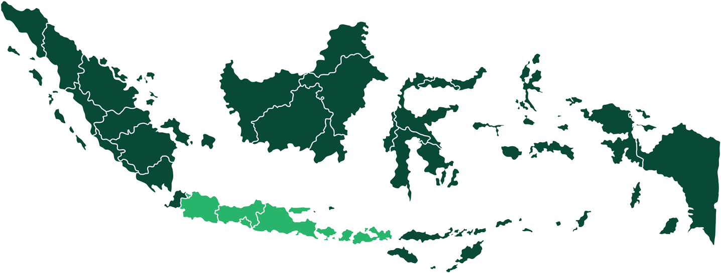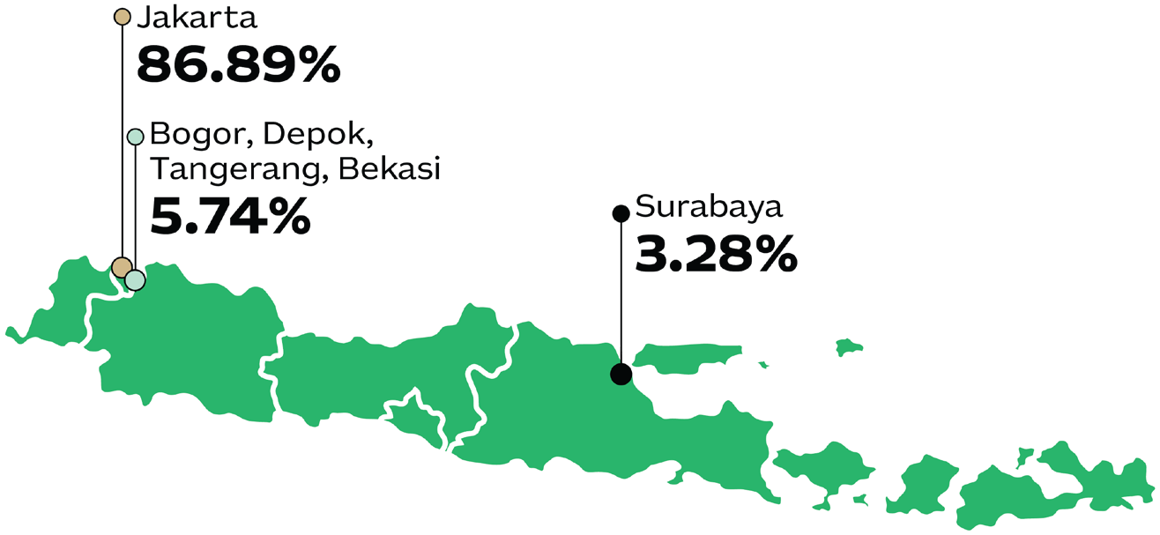
Graph 1.1 Demographic composition of Indonesia's Fintech Company showing a map of Indonesia and the percentage of Indonesia's Fintech Company distribution with 86.89% in Jakarta, 5.74% in Bogor, Depok, Tangerang, Bekasi, and 3.28% in Surabaya,
Source: AFTECH Annual Members Survey (AMS) 2024-2025

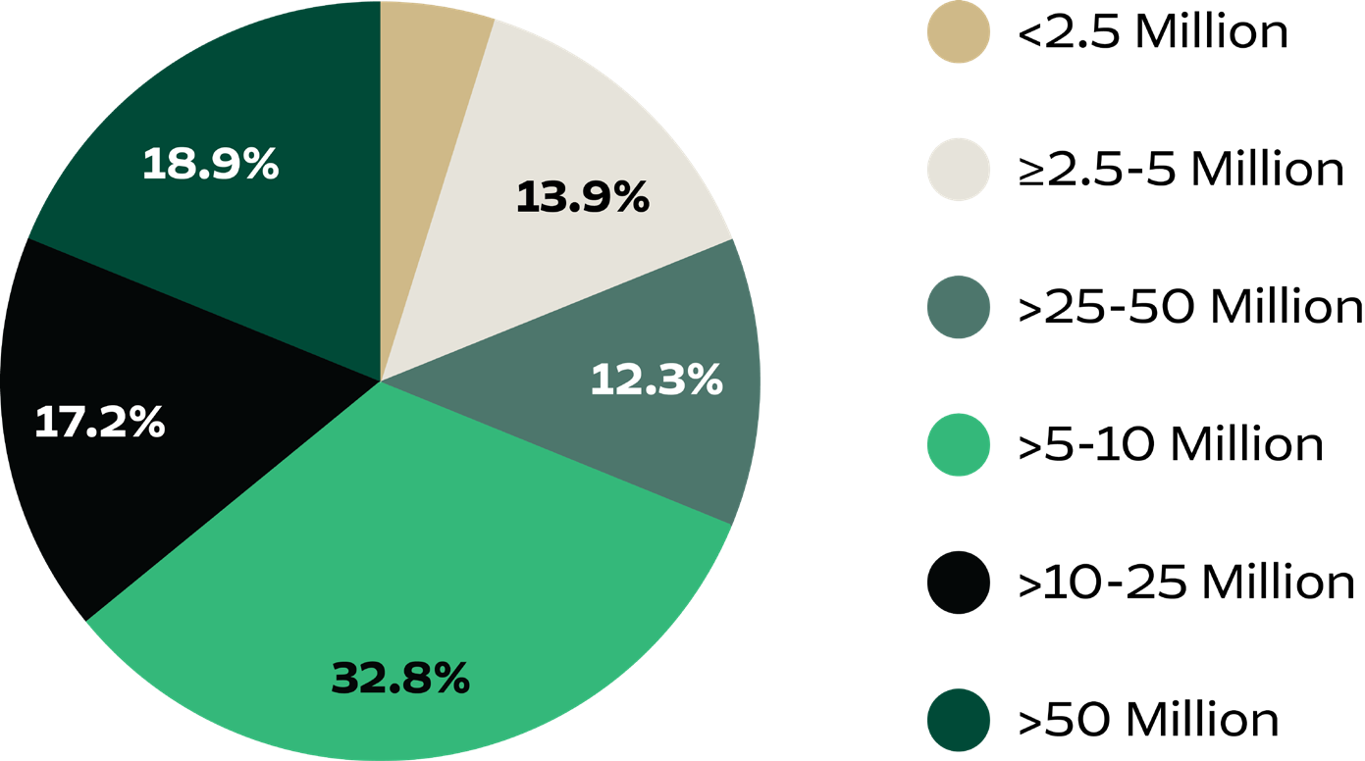

Graph I.2 Demographic Composition of Indonesia’s Fintech Consumer by Income (2024-2025) showing a pie chart consisting of 4,9% earning < Rp. 2.5 Million, 13,9% earning > Rp. 2.5 - 5 Million, 32,8% earning > Rp. 5 – 10 Million, 17,2 % earning > Rp. 10 – 25 Million, 12,3% earning > Rp. 25 – 50 Million, and 18,9% earning > Rp. 50 Million.
Source: AFTECH Annual Members Survey (AMS) 2024-2025

Fintech Playbook: Indonesia 8

t

Indonesia’s fintech business models have also become increasingly diversified over the years. While 2019 was dominated by payment systems, P2P lending, innovative credit scoring (ICS), and insurance technology (InsurTech), by 2025 the landscape has expanded to include digital banking, digital identity, BNPL, digital asset (including crypto asset, digital gold), and securities crowdfunding (SCF). According to the latest AFTECH AMS, payment systems remain the largest segment, representing 20.49 percent of all fintech firms.
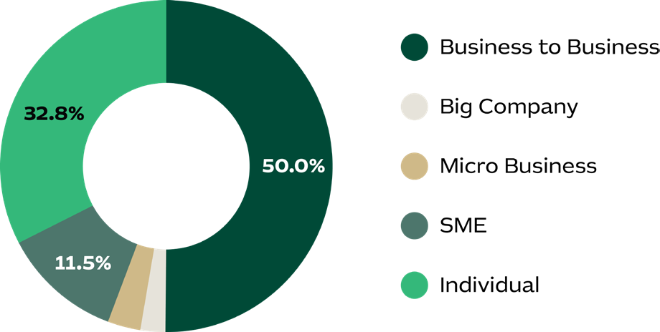


Another defining trend is the growing maturity of Indonesia’s fintech ecosystem, reflected in a clear shift toward B2B models. Based on
AFTECH AMS 2024-2025, around half of fintech providers now primarily serve B2B markets,
a significant increase compared to previous years. Meanwhile, 33 percent cater to individual consumers and 12 percent focus on SMEs.
This evolution suggests that as the market consolidates, fintech firms are moving beyond retail services to provide infrastructure, data, and technology solutions that enable broader digital transformation across industries.

Graph I.3 Demographic Composition of fintech users segment showing pie chart consisting of 2,85% big company, 2,85% micro business, 11,5% SME, 32,8% individual and 50,0% business to business.
Source: AFTECH Annual Members Survey (AMS) 2024-2025

`

9 Fintech Playbook: Indonesia



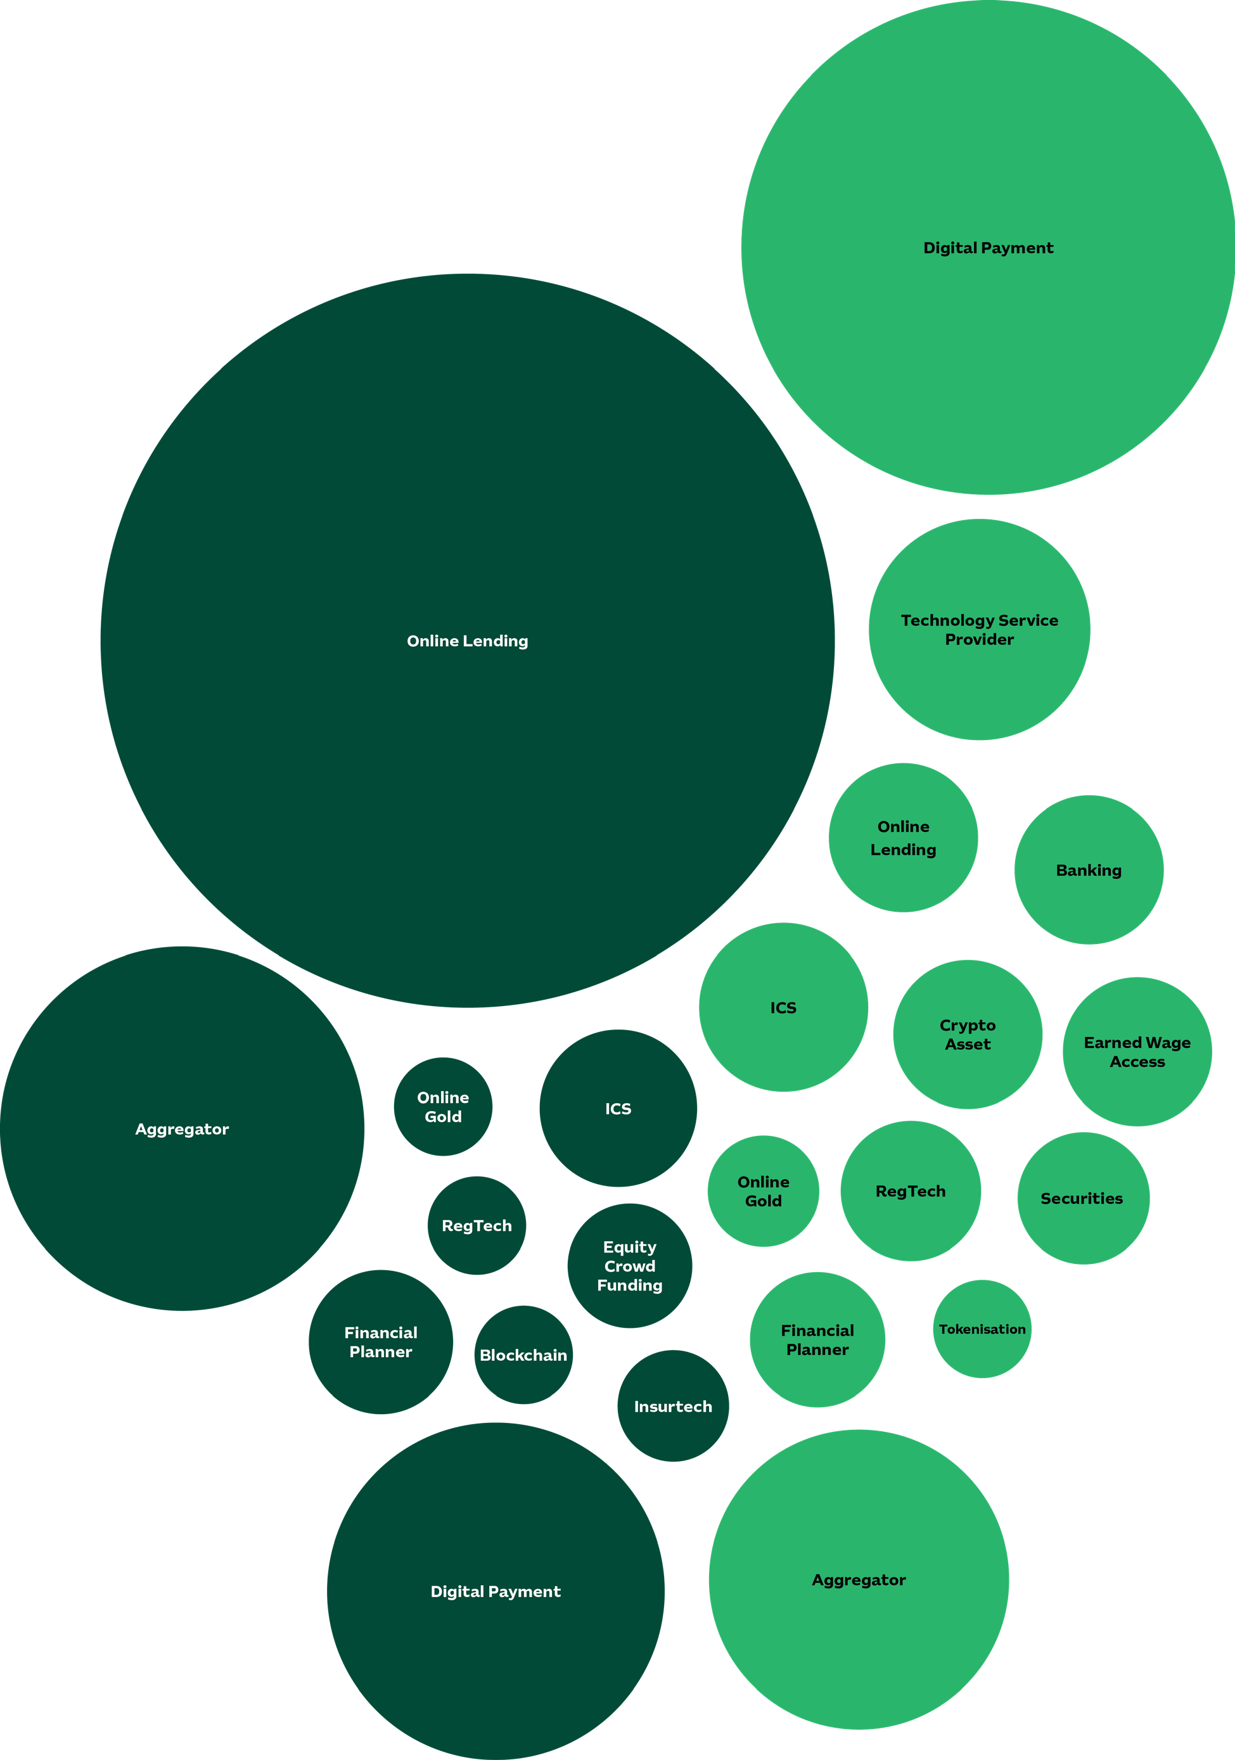
Graph I.4 Development of Indonesia’s Fintech and Ecosystem (2019-2025) showing several circular shape of various sizes containing writings of different business models including online lending, digital payment, aggregator, and more.

2019

2025

Fintech Playbook: Indonesia 10

The adoption and development of fintech services in Indonesia, particularly in service innovation, are closely linked to the country’s digital infrastructure accessibility and the application of emerging technologies such as blockchain and artificial intelligence (AI). Findings from in-depth interviews and Focus Group Discussions (FGDs) show that most fintech institutions develop their core capabilities in-house while outsourcing selectively to accelerate deployment. Data from AFTECH AMS confirm this trend: in 2022-2023, around 40 percent
of respondents reported building technology internally, and this figure rose to 66.39 percent in 2024-2025, reflecting the sector’s growing technological maturity and its shift toward greater self-reliance and innovation capability.

In terms of infrastructure, FGDs revealed that many fintech firms continue to rely on
external providers for key components such as cloud infrastructure, payment gateways, and digital signatures. AFTECH AMS data reinforce this trend: in 2022-2023, 66.7 percent of respondents reported using cloud infrastructure, and by 2024 the figure remained high at 60.31 percent, alongside e-KYC (64.12 percent) and big data (48.85 percent). Many companies also adopt hybrid infrastructure models that combine in-house systems with local data centres and third-party providers, balancing control, scalability, and efficiency. Specific digital finance infrastructure, such as fraud detection systems, open credit enablement networks, and income validators, are increasingly recognised as essential to manage risks and support the delivery of secure and inclusive financial services.

Since 2022, Indonesia’s digital economy has faced a “tech winter,” characterised by declining global funding, tighter investor scrutiny, workforce downsizing, and several startup closures. According to the e-Conomy SEA 2024 report, deal flows slowed as investors shifted focus from rapid growth to profitability and operational efficiency. AFTECH AMS 2024 further highlights persistent ecosystem gaps, including geographic concentration, uneven infrastructure, limited financial literacy, and data protection concerns — conditions that have pushed fintech firms to recalibrate and prioritise sustainability and compliance.

These challenges have also been reflected in the broader regional investment climate. According to DealStreetAsia and Kickstart Ventures (2025),



the Philippines edged out Indonesia in equity funding value during the first half of 2025, securing United States Dollar (USD) 86.4 million across 15 deals, compared to Indonesia’s USD 78 million from 34 deals. Across Southeast Asia, total funding fell to USD 1.8 billion across 229 deals in First Half (H1) 2025, a 21 percent decline from the same period in 2024, largely due to investor caution amid regional uncertainties and macroeconomic pressures.

Compounding the impact of the tech winter, Indonesia’s digital ecosystem also faced declining investor confidence following several high-profile fraud cases involving major fintech firms. Although regulators and law enforcement authorities have acted decisively — including the arrest of founders and key perpetrators — rebuilding trust within the investment community remains an ongoing process. Nevertheless, the industry continues to demonstrate resilience, supported by the Financial Sector Development and Strengthening Law (UU P2SK) and broader regulatory reforms. These frameworks have laid the foundation for sustainable growth and deeper integration of fintech into Indonesia’s digital economy.

11 Fintech Playbook: Indonesia

Key Market Segments & Emerging Trends
Building on Indonesia’s evolving fintech ecosystem and increasing market maturity, fintech adoption is largely driven by the productive-age population. Most users fall within the 26–35 age group (48.36 percent), followed by those aged 36–45 (31.97 percent), reflecting the country’s economically active demographic. Meanwhile, younger consumers aged 18–25 account for 13.11 percent and are emerging as a key growth segment, signaling long-term expansion of the fintech market across generations.

Consumers by Age
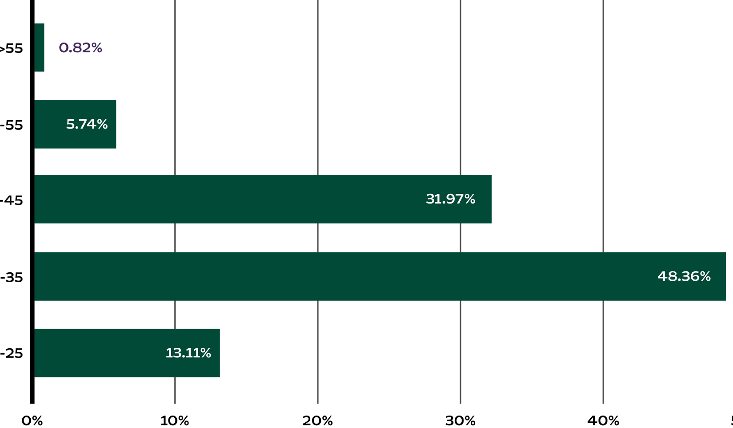

Graph I.5 Indonesia’s Fintech User Demographics by Age Group (2024-2025) showing diagram consisting of consumers’ age with 0.8% at >55 years old, 5,74% at 55 years old, 13,11% at 25 years old, 31,97% at 45 years old, and 48,36% at 35 years old.
Source: AFTECH Annual Members Survey (AMS) 2024-2025

Fintech Playbook: Indonesia 12

While fintech adoption in Indonesia is strongly driven by the productive-age population, its geographic reach remains uneven. Approximately 73.77 percent of users are in Jakarta, 20.49 percent in other regions of Java, and only 5.74 percent outside Java. This concentration highlights significant untapped potential for expansion into rural and semi-urban markets, areas that are increasingly connected through rising smartphone penetration and growing demand for accessible digital financial services.

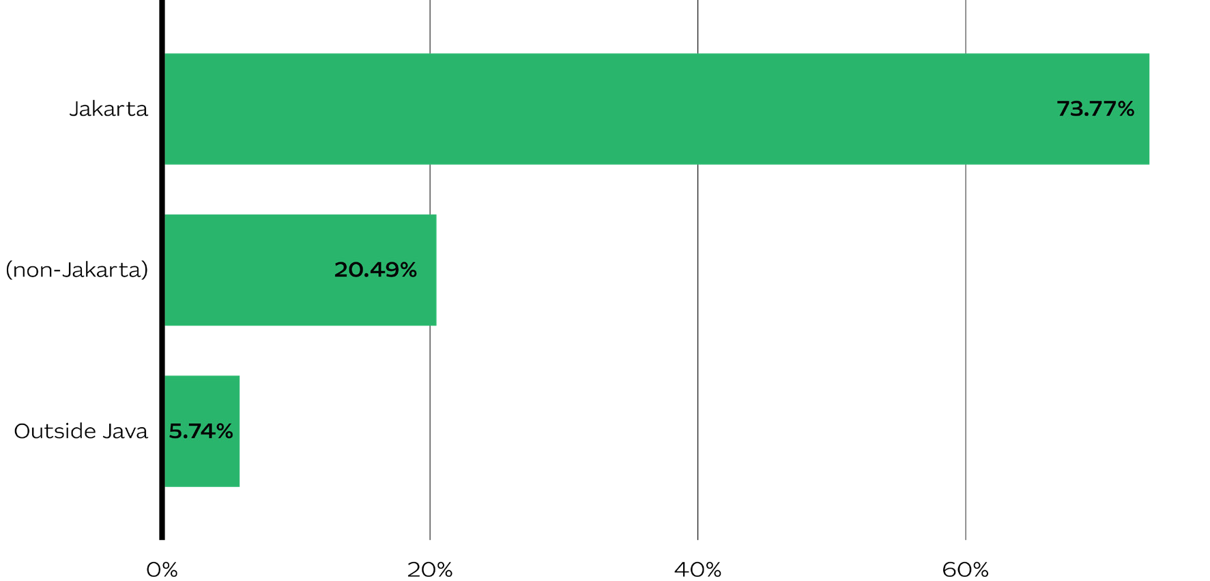

Graph I.6 Market Share Distribution of Fintech Players (2024-2025) showing diagram consisting of 5,74% outside of Java, 20,49% non-Jakarta, and 73,77% Jakarta.
Source: AFTECH Annual Members Survey (AMS) 2024-2025

The dominance of productive-age and higher-income consumers presents strong
opportunities for the growth of lifestyle finance products such as wealth management, retail investment, and flexible credit. The increasing share of B2B and SMEs services also reflects a structural shift toward embedded finance, positioning fintech firms as both service providers and ecosystem enablers.

Insights from FGDs and in-depth interviews further indicate that infrastructure development, particularly in areas such as cloud infrastructure, blockchain, and AI-powered solutions for
fraud detection, risk assessment, and data management, will play a pivotal role in driving Indonesia’s next phase of fintech growth. Business models expected to sustain strong momentum include digital lending, digital payments, digital banking, insurtech, and regtech, among others.

Fintech in Indonesia is thus entering a new phase, evolving from a driver of financial innovation into an integral part of everyday life for millions of Indonesians. The industry is set to integrate more deeply with the broader national digital ecosystem through digital identity, standardised payment systems, and cloud-based operations. As fintech services become increasingly embedded in daily transactions, from saving and payments to investment and insurance, they are reshaping consumer habits and expectations around convenience, security, and trust. To fully realise this potential, continued progress in digital financial literacy, consumer protection, and cross-sector collaboration will be essential to ensure inclusive participation and sustainable growth.

13 Fintech Playbook: Indonesia

Digital Infrastructure Landscape
Indonesia’s digital infrastructure continues to underpin fintech expansion; however, significant disparities remain between urban and rural areas. According to the Centre for Indonesian Policy Studies (CIPS, 2025), only around 30 percent of Indonesia’s territory is currently covered by fibre optic networks, creating uneven connectivity beyond Java. AFTECH AMS 2024-2025 echoes this finding, with 65.22 percent of respondents perceiving the urban–rural connectivity gap as moderate, 31.88 percent as large, and only 2.90 percent as small.

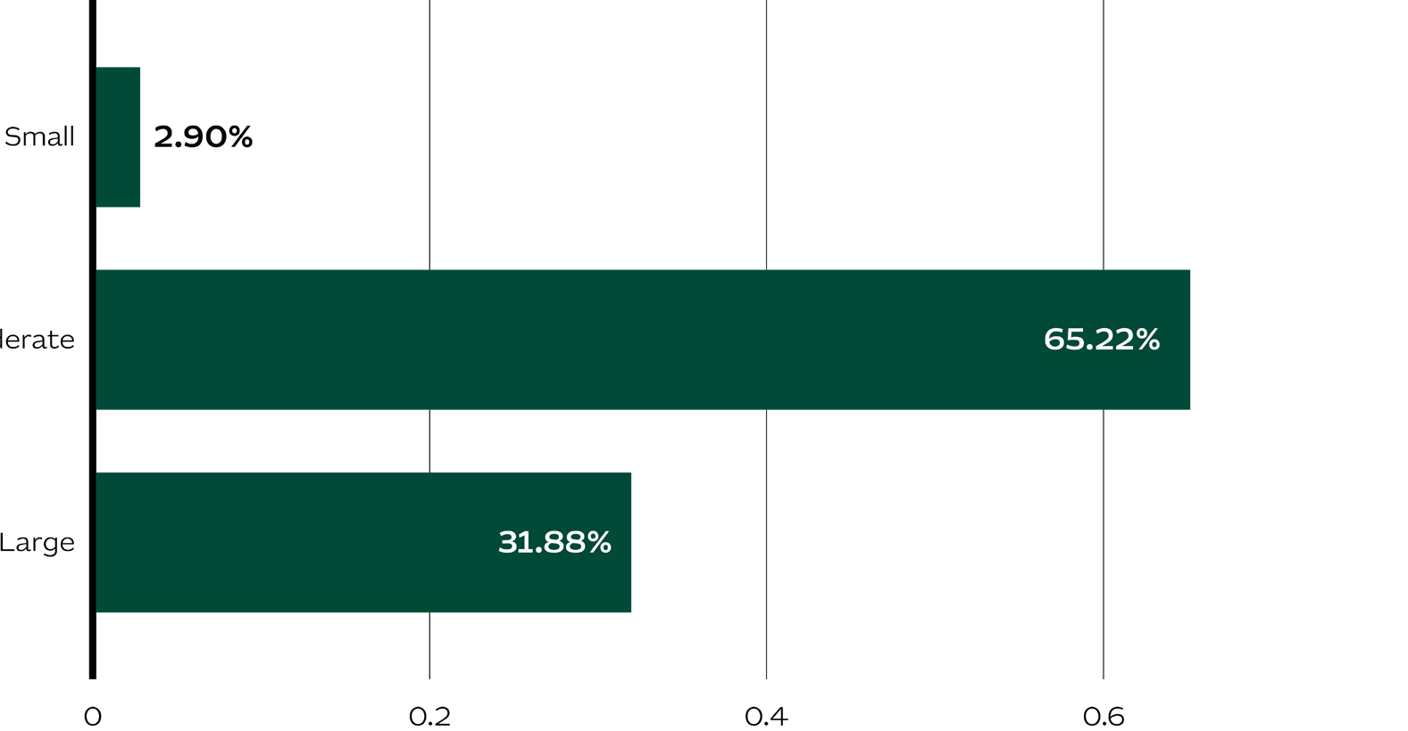

Graph I.7 Perceived Magnitude of Urban–Rural Digital Infrastructure Disparity in Indonesia (2024-2025) showing diagram consisting of 2,90% small, 31,88% large, and 65,22% moderate.
Source: AFTECH Annual Members Survey (AMS) 2024-2025

According to Indonesian Internet Service Providers Association (APJII’s) Internet Survey 2025, Indonesia’s internet penetration reached
80.66 percent, with Java at 84.69 percent and Maluku & Papua at 69.26 percent. Urban areas recorded 82.73 percent penetration compared to
78.57 percent in rural regions. Data from Statistik Telekomunikasi Indonesia 2024 show that Fourth Generation of Cellular Network Technology (4G) coverage has reached over 96 percent of the population, supported by more than 640,000 base transceiver stations (BTS) nationwide. However, Fifth Generation of Cellular Network Technology (5G) deployment remains limited to major cities such as Jakarta, Surabaya, Medan, and Denpasar, with national coverage still below 5 percent. Average fixed broadband speeds stand at around 40 megabits per second (Mbps), while satellite internet providers such as Starlink have begun operating in remote areas, offering speeds of 40–50 Mbps.
These developments demonstrate solid progress in Indonesia’s digital infrastructure. Yet, key challenges remain, particularly in expanding 5G networks, improving broadband quality, and increasing network density outside Java. These gaps continue to affect fintech accessibility and adoption, highlighting the need for targeted strategies to bridge connectivity and infrastructure divides.

For digital finance infrastructure, BI has taken significant steps to strengthen the national payment system through initiatives such as Bank Indonesia Fast Payment (BI-FAST) and the National Standard for Open Application Programming Interfaces Payments (SNAP). BI-FAST, operational since December 2021, provides a real-time payment infrastructure that enhances efficiency, affordability, and interoperability across the financial ecosystem. Meanwhile, SNAP serves as a national open

Fintech Playbook: Indonesia 14

Application Programming Interfaces (API) standard designed to promote interoperability and innovation between banks and fintechs. As outlined in the Blueprint Sistem Pembayaran Indonesia/Indonesia Payments System Blueprint (BSPI) 2030, both initiatives are central to building a fast, secure, and integrated national payment system that supports the growth of the digital economy and financial inclusion.

Building on these foundations, Indonesia’s broader digital finance ecosystem still requires complementary infrastructure to ensure secure,
inclusive, and sustainable service delivery. Critical components include fraud identification systems, open credit enablement networks, and income validation mechanisms that enhance trust and risk management. According to AFTECH AMS 2024-2025, 64 percent of respondents cited high implementation costs as a major barrier to infrastructure development. This underscores the importance of continued multi-stakeholder dialogue: to determine who should host and maintain these systems, how they should be financed, and how their long-term sustainability can be ensured.

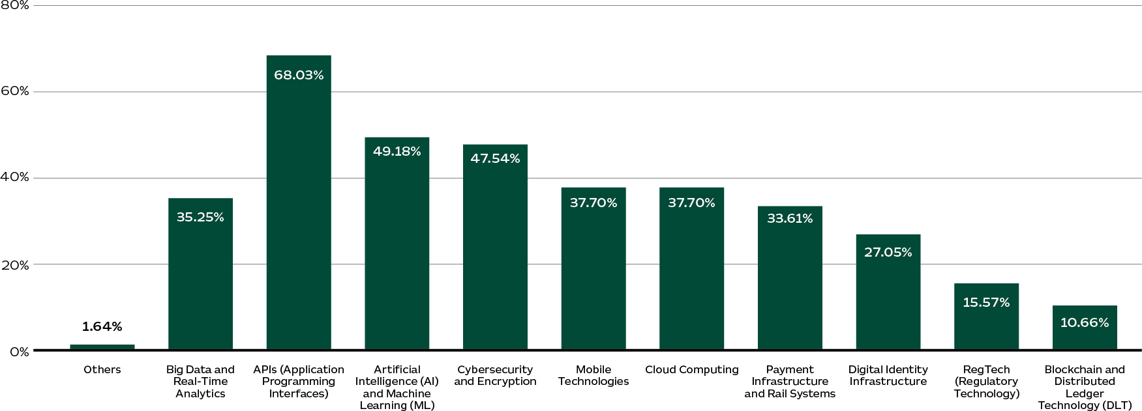

Graph I.8 Perceived Magnitude of Urban–Rural Digital Infrastructure Disparity in Indonesia (2024-2025) showing diagram consisting of 1.64% others, 10,66% blockchain and distributed ledger technology (DLT), 15,57% RegTech (Regulatory Technology), 27,05% Digital Identity Infrastructure, 33,61% Payment Infrastructure and Rail Systems, 35,25% Big Data and Real-Time Analystics, 37,70% Cloud Computing, 37,70% Mobile Technologies, 47,54% Cybersecurity and Encryption, 49,18% Artificial Intelligence (AI) and Machine Learning (ML), and 68,03% APIs (Application Programming Interfaces).
Source: AFTECH Annual Members Survey (AMS) 2024-2025

Images are for decorative only

15 Fintech Playbook: Indonesia


Images are for decorative only

Another important aspect of Indonesia’s fintech infrastructure concerns the technologies most commonly adopted by industry players. According to AFTECH AMS 2024-2025, fintech firms in Indonesia rely primarily on APIs, used by 68.03 percent of respondents, followed
by AI and Machine Learning (ML) at 49.18 percent, and cybersecurity at 47.54 percent. Mobile technologies and cloud computing are each utilised by 37.70 percent of firms, while payment infrastructure adoption stands at
33.61 percent. Digital identity, RegTech, and blockchain remain less common but continue to show gradual growth. Despite this upward trend, the CIPS Policy Studies (2025) notes that cloud deployment still faces regulatory and security challenges, underscoring the need for clearer policies on on-premises, off-premises, and hybrid data storage.
In parallel, digital talent remains a persistent challenge across Indonesia’s broader digital economy. AFTECH AMS 2024 identified critical skill shortages in data analytics and cybersecurity; by 2025, the most acute gaps had shifted toward Artificial Intelligence and big data (65.57 percent), cybersecurity (42.62 percent), and data, analytics, and financial literacy (27.87 percent). These findings highlight the structural need for stronger collaboration among government, industry, and academia to build a future-ready digital workforce capable of sustaining fintech innovation and infrastructure development.

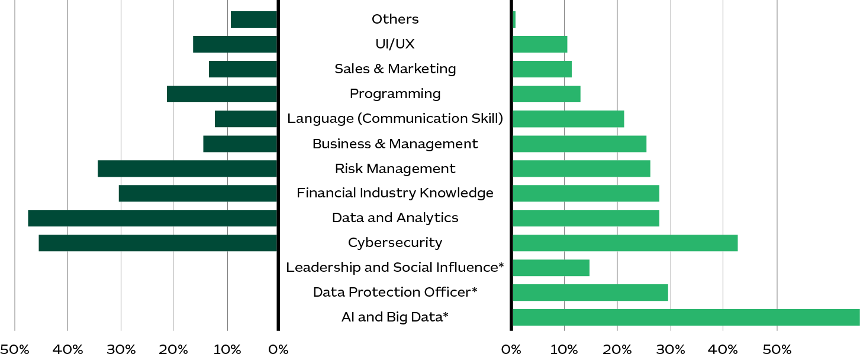
2024

*new skill

Graph I.9 Comparison of Talent Skill Gaps in 2024 and 2025 showing two diagrams with one consisting of 2024 key talent skill gaps including cyrbersecurity at 45%, and Data and Analytics at 48%; while the others diagram consist of 2025 key talent skill gaps including cyrbersecurity at 43% and Data and Analytics at 28%. Booth diagram show others talent gaps with statistycs differing from one another.
Source: AFTECH Annual Members Survey (AMS) 2023-2024 & 2024-2025

Fintech Playbook: Indonesia 16


Images are for decorative only

According to a joint research by AFTECH and the CIPS (2024), Indonesia has built a strong digital foundation through broadband network expansion, the development of the Palapa Ring, and the implementation of key national systems such as BI-FAST, the SNAP Open API, and the National Data Centre. However, access to and the quality of digital infrastructure remain uneven across the archipelago. This disparity directly affects digital financial inclusion, as communities in frontier, outermost, and underdeveloped regions (known as 3T areas) continue to face barriers related to connectivity, affordability, and low levels of digital literacy.
High internet costs, limited fixed broadband penetration, covering only around 15 percent of households, and persistent energy constraints in remote regions have further deepened the digital divide. These structural challenges underscore the need for continued investment and collaboration to ensure that Indonesia’s digital infrastructure can support inclusive, secure, and sustainable growth in the financial sector.

17 Fintech Playbook: Indonesia

(Untapped) Opportunities and Challenges

Indonesia’s digital finance ecosystem has demonstrated impressive growth. Yet, its development has not been fully leveraged to accelerate priority real sectors, as outlined in the Asta Cita and Government’s National Medium-Term Development Plan (RPJMN) 2025–2029, which calls for deepening financial markets to support broader financial inclusion. Digital finance holds significant potential to improve efficiency in areas such as supply chain financing, cross-border payments, and health financing.

However, persistent challenges related to regulatory frameworks, cybersecurity, and scalability, compounded by a large unbanked population of approximately 97.74 million adults (2021 World Bank), including around 62.9 million MSMEs without formal bank accounts, and limited digital transformation among financial institutions, where only 17 of over 100 commercial banks are fully digitalised, continue to constrain its alignment with RPJMN priorities for sustainable growth and inclusive access.

This chapter examines the role of digital finance as a growth enabler, identifies untapped opportunities, and highlights critical pain points based on recent industry data and stakeholder insights.

Digital Finance as a Growth Enabler for the Real Sector
Industry stakeholders view digital finance as an essential partner linking conventional financial services to evolving real-sector needs, promoting operational efficiency and innovation across multiple ecosystems. Traditional banks are increasingly partnering with fintech to leverage their active digital user bases and deliver value-added services such as supply chain financing and employee benefit platforms for corporate clients. Similarly, digital banks play a pivotal role in facilitating offline-to-online (O2O) transitions through community-focused products, shared savings accounts, ultra-micro loans, and integrated MSME solutions in tier-2 and tier-3 cities.

Digital payment providers continue to record robust growth, with QRIS adoption reaching 57 million users and 39.3 million merchants (93 percent MSMEs) by June 2025. In ICS, fintechs demonstrate how alternative data from e-commerce and

telecommunications help expand credit access for underbanked MSMEs and consumer lending segments. This approach improves risk assessment, reduces write-offs, and complements traditional credit registries in Indonesia’s emerging credit information ecosystem.

Financial aggregators function as digital marketplaces for savings, credit cards, and insurance products, simplifying user comparisons and targeting younger demographics through social-media-based engagement. Meanwhile, the growing securities-crowdfunding sector empowers SMEs with alternative capital-raising channels that support entrepreneurship and inclusive financing.

Despite these advances, stakeholders note that significant opportunities remain untapped. Expanding reach, deepening collaboration, and strengthening integration across sectors are key to amplifying the impact of digital finance on Indonesia’s real economy.

18 Fintech Playbook: Indonesia

Key Areas of Opportunity

Expansion into Underserved Segments and Regions
FGDs and in-depth interviews reveal that payments system fintech leaders see considerable potential among rural and low- to middle-income groups, where cash usage and low financial literacy still dominate. Deploying community-based products and targeted education initiatives, such as digital banks offering combined personal-and-business accounts and digital literacy programs, can accelerate adoption, driving transaction volumes and financial inclusion beyond Java.
In parallel, the use of alternative data in innovative credit scoring, drawing on e-commerce and telecom footprints, can broaden SME credit access, reduce write-offs, and refine behavioural-based risk profiling in consumer lending.

Cross-Sector and
Cross-Border Collaboration
Fintech companies increasingly view partnerships across sectors, as well as between fintech, banks, and non-financial entities, as key growth avenues. Integrating payment systems with e-commerce or healthcare ecosystems can, for instance, support preventive-care financing and streamline vendor management through digital processes. Automation and AI adoption in the real sector reduce paperwork and enhance productivity.
As frameworks such as BI’s BSPI 2025 mature, opportunities are emerging for seamless API integrations, interoperable QR-code payments, and regional cross-border efficiencies that mirror successful models elsewhere in Southeast Asia.
Images are for decorative only

Product Innovation and Ecosystem Integration
Traditional banks increasingly regard fintech collaboration as vital to evolving into lifestyle “super-apps” that integrate investment, insurance, and commerce features to meet diverse consumer needs. Insurtech players highlight innovations such as actuarial AI for fraud detection in health insurance, while crypto-asset exchanges explore Web3 solutions, real-world-asset tokenisation, staking, and bank-linked investment products, to capitalise on Indonesia’s young, tech-savvy population.

Certificate authorities emphasise federated digital identity systems for fraud prevention and authentication, enabling use cases from invoice verification to tax-related signatures through integrations with Human Resources Information System (HRIS) platforms. Collectively, these innovations illustrate how fintech is evolving from a disruptor into an enabler, boosting productivity through shared fraud-detection databases, AI-driven transaction monitoring, and adaptive, compliant models that extend inclusion to underserved markets.

Insights from industry players underscore fintech’s collaborative potential, not merely as a source of disruption, but as a catalyst that enhances productivity, fosters trust, and extends access across Indonesia’s economic landscape. By strengthening coordination between digital finance and the real
sector, and by addressing critical questions of “who hosts, who funds, and how to sustain” shared digital infrastructure, Indonesia can unlock fintech’s full potential as a driver of inclusive and sustainable growth.

Fintech Playbook: Indonesia 19


Regulatory Framework and Industry Standards

Identifying Pain Points
Despite its growth-enabling potential, Indonesia’s digital finance ecosystem continues to face substantial challenges in delivering services effectively. Pain points: ranging from regulatory hurdles and cyber risks to scalability constraints, often arise because rapid innovation has outpaced supporting infrastructure and oversight. This imbalance has been reflected in
a series of high-profile defaults, fraud incidents, and systemic vulnerabilities. Common concerns raised by stakeholders, such as escalating deepfake threats, low user literacy, and broader economic slowdowns, reinforce the urgency of coordinated, multi-stakeholder responses as fintech penetration deepens across Indonesia.

Insights from in-depth interviews and FGDs reveal that relatively rigid requirements for mature players, coupled with some ambiguous rules for emerging ones, create significant barriers to entry and growth. Minimum-capital thresholds and foreign-ownership restrictions further add to regulatory complexity.
E-wallet providers cite how BI’s standardisation efforts, while necessary, have challenged the establishment of new entities, and sandbox entry rules often act as deterrents for early-stage innovators. Within InsurTech, stakeholders point to the absence of dedicated regulations for third-party administrators (TPAs) in the health ecosystem, while certificate-authority providers highlight some inconsistency on enforcement and sectoral silos that limit regtech adoption.
Even after passing the regulatory sandbox, ICS and Financial Aggregator (FA) firms continue to face lengthy licensing procedures. EWA operators also remain in a regulatory grey zone without formal oversight from either Financial Services Authority (OJK) or BI.
Overall, licensing remains one of the most pressing challenges, and regulators themselves acknowledge friction in bank-fintech partnerships due to differing risk appetites and business-model conflicts. Stakeholders consistently call for adaptive, principle-based regulation that balances consumer protection with innovation speed amid increasing scrutiny.

20 Fintech Playbook: Indonesia

Cyber Risks, Fraud, and Scams
Scalability and Infrastructure Limitations

Escalating threats from deepfakes and account takeovers to gambling-related fraud demand stronger defences and coordinated action. Yet, the absence of shared fraud databases continues to expose vulnerabilities, especially across interconnected sectors.
Interviews and FGDs reveal that e-wallet providers emphasise the importance of frontline monitoring, governance loops, and unified verification systems to combat cyber threats and high Know-Your-Customer (KYC) costs.
InsurTech firms cite rising cases of hospital fraud and claims manipulation, while certificate authorities advocate transitioning from basic One-Time Password (OTP) methods to advanced authentication mechanisms and lament institutional silos that hinder collective fraud prevention.
The National Cyber and Encryption Agency (BSSN) reported 3.64 billion anomalous traffic incidents between January and July 2025. Meanwhile, the Indonesia Anti Scam Centre (IASC) recorded IDR 5.6 trillion in scam-related financial losses from November 2024 to September
2025. These figures underline the need for stronger data-protection measures, unified fraud-response systems, and shared intelligence networks. Regulators have begun promoting cybersecurity forums and technical guidelines, while Australian technology partners have also highlighted opportunities to address Indonesia’s persistent data-protection gaps.
Structural infrastructure gaps, particularly limited internet penetration and unstable connectivity in tier 2/3 cities and regions outside Java, frequently cause payment disruptions and erode user trust. Limited capital and funding access further constrain scalability. Talent shortages intensify these challenges, with deficits not only in numbers but also in critical competencies such as cybersecurity, AI, and data analytics.
Challenges related to entrepreneurial and managerial skills also add to governance weaknesses and business-continuity risks. Many fintech firms struggle with capital management and adaptive strategies, leading to operational slowdowns or closures. Stakeholders advocate targeted government incentives: tax reliefs, innovation-funding programs, and support
for priority sectors, to encourage investment in high-tech and labour-intensive fintech projects. AFTECH members also link low non-
Java penetration to cash dominance and limited rural infrastructure, while venture capitalists emphasise liquidity constraints and the importance of robust technology foundations. Australian firms, meanwhile, highlight the need for higher-quality data and cloud infrastructure to support secure scalability. Collectively, these perspectives underscore the urgency
of collaborative efforts to foster sustainable, inclusive, and scalable digital-finance growth.

Addressing these structural pain points requires collaborative partnerships, standardised data-sharing mechanisms, and targeted technology investments. Strengthening interoperability, cybersecurity, and funding ecosystems will be key to unlocking Indonesia’s full digital-finance potential, paving the way for sustainable co-innovation with international partners, including Australian technology providers and investors.

Fintech Playbook: Indonesia 21

Unlocking Co-Innovation Opportunities in Indonesia’s Digital Finance Landscape

Across Indonesia’s digital finance value chain, no single player can or should deliver every process end-to-end. The greater imperative is to build workflows that are efficient, interoperable, and outcomes driven. Reducing friction across systems and improving user experiences requires collaboration rather than competition. This presents a strong opportunity for co-innovation, where international expertise complements local infrastructure to close gaps in adoption, compliance, and scalability.

This chapter identifies key capability gaps within Indonesia’s digital finance ecosystem that Australian fintech providers are well positioned to fill. It draws lessons from earlier localisation efforts and aligns Australian strengths with Indonesian needs. By leveraging these insights, Australian firms can design targeted market-entry strategies that both advance Indonesia’s digital economy and contribute to more inclusive regional growth.

Gaps in Local Capabilities
Indonesia’s fintech sector has expanded rapidly but continues to face structural capability gaps. Insights from FGDs and interviews highlight fragmented e-KYC processes, underdeveloped credit-scoring systems, weak fraud-risk management, inconsistent governance, and a shortage of advanced technologies such as AI, cybersecurity, and RegTech, as well as the skilled talent to support them. These weaknesses raise operational costs, limit MSMEs and underbanked access, and erode investor confidence.
International stakeholders, particularly from Australia, view these challenges as opportunities for partnership. With Indonesia’s strong local distribution networks but limited depth in infrastructure and risk management, the ecosystem can benefit from collaborations that deliver technology transfer, regulatory know-how, and innovation expertise. Such cooperation can strengthen resilience, enhance trust, and support the transition toward a more sustainable, secure, and inclusive digital-finance ecosystem.


Festival Ekonomi Keuangan Digital Indonesia (FEKDI) 2025

22 Fintech Playbook: Indonesia

Table III.1 Key Capability Gaps and Potential Areas for Australia–Indonesia Collaboration

Capability Gap Description of Gap |  | Potential Contribution from Australia  Provide affordable and scalable e-KYC and regtech solutions that enable secure digital identity verification, enhance deepfake protection, and improve interoperability across financial platforms.
Efficient e-KYC Systems | FGDs with fintech players highlight that e-KYC standards remain fragmented. Smaller firms rely heavily on costly third-party vendors, while regulators have yet to issue consistent technical guidelines,  thus limiting interoperability and increasing compliance costs.
Alternative Credit Scoring | Fintech lenders and investors note limited access to alternative data sources  (telecommunications, e-commerce, utilities) due to unclear regulations. This restricts scoring models for MSMEs and unbanked segments, leaving them underserved. | Introduce big-data analytics and AI-driven credit scoring models that leverage alternative datasets (telco, e-commerce, utilities) to expand credit access and improve financial inclusion.
Fraud and Risk Management | FGDs reveal the absence of shared fraud databases and coordinated fraud-  identification systems. Many startups lack the resources to build internal detection tools, leaving them vulnerable to financial crimes. | Deploy AI-powered fraud detection tools, centralised fraud databases, and integrated risk analytics platforms to strengthen financial-crime prevention across institutions.
Governance and Compliance Monitoring | Venture capital stakeholders report inconsistent governance practices and poor data quality, which undermine investor confidence and scalability. Compliance remains largely reactive and manual. | Introduce compliance automation tools and regtech platforms for real-time monitoring, reporting, and governance standardisation.
Advanced Technology Backbone | While awareness of AI, big data, and cloud computing is growing, adoption remains limited. Barriers include talent shortages, regulatory uncertainty, and cloud-security concerns. | Offer AI-as-a-service, cloud-based infrastructure, and technical capacity-building programs to accelerate innovation and digital transformation.

Fintech Playbook: Indonesia 23

End-to-End Cybersecurity | Regulators and industry stakeholders cite shortages of Security Operations Centre (SOC) analysts, relatively weak early-warning systems, and limited incident-response capacity. Phishing, malware, and multi-channel fraud have intensified since the pandemic. | Provide cyber threat intelligence platforms, SOC-as-a-Service models, and customised cybersecurity training programs to build a resilient defence ecosystem.
Digital Talent Development | FGDs consistently underscore the shortage of skilled professionals in AI, data science, cybersecurity, and regtech. Limited structured training and certification pathways slow technology adoption. | Establish joint training programs, certification partnerships, and knowledge-transfer initiatives between Australian institutions and Indonesian stakeholders to build a sustainable digital talent pipeline.
Insurance Innovation for Real Sector Growth | Insurance penetration remains low and integration with the real sector is  limited. MSMEs and emerging businesses lack tailored risk-mitigation products, constraining growth and resilience. | Facilitate collaboration with Australian InsurTechs and insurers to co-develop innovative products, embed insurance in digital financial services, and strengthen sectoral resilience.
Pension Fund Management via Fintech | Pension participation remains low, particularly among informal workers, leaving much of the workforce without long-term financial planning. Accessible, flexible pension solutions are limited. | Partner with Australian fintech and pension providers to design and deliver micropension and digital pension solutions, drawing on Australia’s superannuation expertise to expand coverage and inclusion.

24 Fintech Playbook: Indonesia

Lessons Learned on Co-Innovation and Localisation in Indonesia
Experience shows that successful market entry for international fintech firms in Indonesia requires more than simply replicating global products. Companies must adapt their offerings to local culture, comply with regulatory frameworks, and build digital trust with both consumers and regulators. Findings from FGDs and interviews reaffirm that localisation and co-innovation are central to long-term sustainability and inclusive growth.

Product Adaptation
1
Alignment with Indonesia’s cultural context and regulatory framework is essential for Australian fintech companies entering the market. This includes using clear Bahasa Indonesia, designing user interfaces that reflect local preferences, and adopting pricing models that align with consumer behaviour. Integration with QRIS, the national payment standard, is also mandatory for interoperability. Such adaptation not only enhances user experience but also strengthens market acceptance and facilitates regulatory compliance.

Working with Local Digital Infrastructure Provider
Integration with Indonesia’s national digital infrastructure is equally critical. Linking
e-KYC systems to the national electronic ID (e-KTP) streamlines verification processes, while QRIS ensures interoperability across payment providers. In addition, data centres
and recovery facilities must be located within Indonesian jurisdiction to comply with local data-sovereignty requirements. To achieve market acceptance, companies should engage early and continuously with regulators such as OJK and BI to ensure compliance with
national standards and support smooth service deployment across the ecosystem.

 Price Considerations
Pricing remains a decisive factor for market success in Indonesia, where price sensitivity is high, particularly among lower and middle-income groups. Australian fintech companies should explore tiered pricing structures or flexible payment options that cater to diverse consumer needs while maintaining service quality. Affordable solutions that reflect the purchasing power of Indonesian users can significantly boost adoption and long-term retention. Introducing freemium models
or discounted introductory rates may also increase early traction, helping build user trust and loyalty.
 Cultural Understanding Understanding and respecting local culture is key to embedding fintech services into daily life. Products must be intuitive and reflect local norms, payment habits, and languages. Fintech
solutions that simplify access while aligning with Indonesian social values, such as community cooperation and family financial planning, are likely to gain stronger engagement. For instance, services that enable payments for daily essentials or support MSMEs financing aligned with community-based economic activities can deepen trust and user connection.

 Regulatory Awareness
Operating in Indonesia requires a thorough understanding of the regulatory landscape.
OJK and BI play critical roles in supervising fintech operations, while the UU P2SK and other digital-finance regulations shape compliance expectations. Australian firms must ensure full adherence to these frameworks and maintain open communication with regulators. Proactive engagement not only helps prevent compliance issues but also aligns business strategies with Indonesia’s broader financial inclusion and digital-economy goals, allowing fintech companies to scale sustainably and responsibly.

 Choosing the Right Partner
Selecting the right local partner is crucial for navigating Indonesia’s complex market dynamics. Collaboration with local banks, telecom operators, and technology providers accelerates market entry and provides valuable operational insights. Partnerships with associations such as AFTECH also offer access to networks, industry resources, and regulatory guidance, supporting smoother integration. Local partners can provide a deep understanding of consumer behaviour and help foreign entrants tailor products to market needs more effectively.

Fintech Playbook: Indonesia 25

In Indonesia’s fast evolving fintech landscape, co-innovation and localisation are not optional, they are prerequisites for success. Companies that adapt to local infrastructure, comply with evolving regulations, and build trust through culturally attuned and affordable solutions will be best positioned to capture Indonesia’s growth potential and contribute meaningfully to a more sustainable, inclusive digital-finance ecosystem.








Images are for decorative only

26 Fintech Playbook: Indonesia

Market Entry Strategies

Entering Indonesia’s fintech market requires a structured and well-calibrated approach that balances regulatory compliance, cultural adaptation, and trust-building with local stakeholders. Insights from FGDs and in-depth interviews suggest that success in Indonesia depends not only on innovative products but also on strategic execution and strong partnerships that align with the country’s regulatory and cultural landscape.

 Building Strategic Partnerships
Strategic partnerships are the foundation of successful market entry. Rather than relying on a single alliance, firms should cultivate a network of partnerships across the ecosystem, including banks, payment providers, telecommunications companies, and industry associations such as AFTECH. Collaborations with local law firms and consultants can further facilitate regulatory engagement, ensure smoother licensing processes, and improve product adoption. Strong partnerships help international fintech gain credibility, local insight, and policy alignment early in their market journey.

 Role of Systems Integrators
Systems integrators play a pivotal role in bridging international fintech solutions with Indonesia’s diverse and fragmented ecosystem. They help connect global technologies to local banking systems, payment rails, and regulatory infrastructure, ensuring interoperability and smoother deployment. By leveraging systems integrators, foreign fintech firms can reduce compliance risks, accelerate localisation, and achieve faster scalability within Indonesia’s complex financial environment.

 Pilot Programs
Pilot programs offer an effective pathway for market entry when structured with clear performance metrics, well-defined outcomes, and scalability plans. Cost-sharing as part of Proof of Concept (POC) models are often
preferred over free pilots, as they demonstrate mutual commitment and promote sustainable collaboration. Successful pilot programs not only validate product-market fit but also help firms refine compliance strategies and technical integrations before full-scale expansion.

 Regulatory Sandbox
Participation in regulatory sandboxes under the supervision of OJK or BI allows fintech firms to test innovative models in a controlled environment. This approach reduces legal uncertainty, enables early dialogue with regulators, and enhances institutional credibility. Sandbox participation typically lasts one year, during which companies gain valuable insights into operational and compliance requirements. Graduating from the sandbox signals regulatory readiness and strengthens trust with both policymakers and potential partners.

27 Fintech Playbook: Indonesia

To succeed in Indonesia, fintech firms must pursue a partnership-driven, regulation-aligned, and culturally attuned strategy. Combining innovation with compliance, collaboration, and local understanding will enable international players, including Australian fintechs, to build lasting impact in Indonesia’s rapidly evolving digital finance ecosystem.
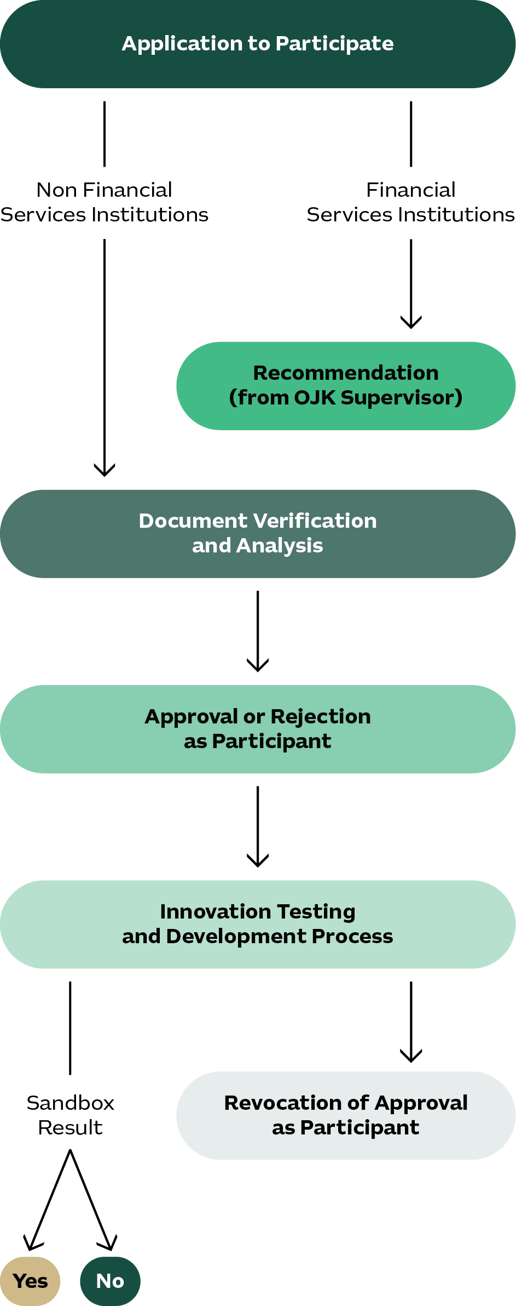

Graphic IV.1 OJK Regulatory Sandbox Process Flow with process chart showing the flow starting from Application, Recommendation, Document Verification and Analysis, Approval or Rejection, Innovating Testing and Development Process, ending with either sandbox result or revocation of approval.
Source: Indonesia Financial Services Authority (OJK)
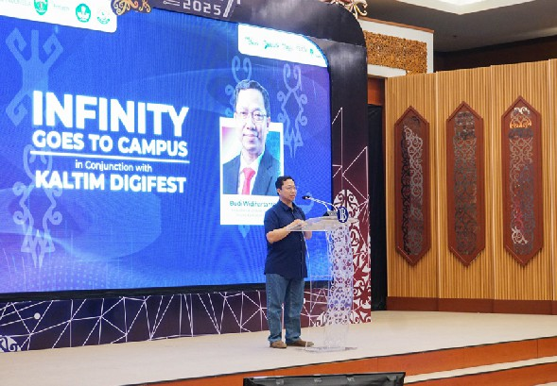

Localisation and Pricing Model
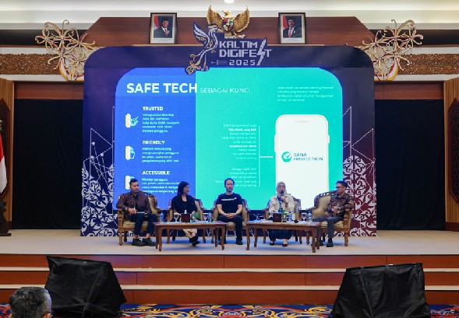
Market entry also requires thoughtful localisation of pricing strategies. FGDs reveal that Indonesian consumers are highly price-sensitive but place strong value on reliability and security. Software-as-a-Service (SaaS) models with tiered pricing are becoming increasingly attractive, particularly for SMEs-oriented fintech solutions. Australian companies should adopt flexible models that balance affordability with long-term revenue growth, ensuring alignment with local purchasing power while reinforcing confidence in service quality.

Ultimately, successful market entry into Indonesia requires more than regulatory compliance and product-market fit. Australian fintech firms should leverage systems integrators, build strategic alliances, structure pilot programs effectively, and explore participation in regulatory sandboxes to validate innovations. Adapting pricing strategies to local market conditions enhances competitiveness and brand trust.
Infinity Goes to Campus Samarinda - 2025
By viewing market entry as a process of co-innovation and partnership, rather than a one-way export of products, companies can achieve both commercial viability and long-term credibility within Indonesia’s fintech ecosystem.

Fintech Playbook: Indonesia 28

Regulatory Landscape
Indonesia’s regulatory landscape for fintech and the digital economy is evolving rapidly, reflecting the government’s ambition to promote innovation while maintaining stability and consumer protection. Current priorities are guided by a series of strategic frameworks, licensing structures, and industry codes of conduct designed to ensure responsible growth and interoperability across the ecosystem.

OVERVIEW OF INDONESIA’S REGULATORY LANDSCAPE
  Strategic Direction |   Licensing and |   Code of Ethics
for Financial and Digital Economy Development | Supervision | and Industry Collaboration

Strategic Direction for Financial and Digital Economy Development

Indonesia’s digital finance policies are anchored in several key national frameworks, among others:
- White Paper on the National Strategy for Indonesia’s Digital Economy Development 2030, which outlines the vision for
a digitally empowered and globally competitive economy.
- Digital Roadmap of the Ministry of Communication and Information Technology (Kominfo) 2021–2024, focusing on digital infrastructure, human capital, and innovation acceleration.
- BSPI 2030, which provides the foundation for interoperability, security, and inclusiveness in digital payments.
- Roadmap for Financial Sector Technology Innovation (ITSK), Digital Financial Assets, and Crypto Assets 2024–2028, which defines regulatory priorities for emerging financial technologies, including blockchain, crypto assets, and alternative credit systems.
Together, these documents serve as Indonesia’s master plan for building a trusted, inclusive, and innovation-driven digital economy.
 Licensing and Supervision
Indonesia’s fintech sector operates under a multi-regulatory framework led by OJK and BI. Under UU P2SK, both institutions share responsibilities for the licensing and supervision of ITSK. OJK oversees ITSK activities in areas such as lending, investment, insurance, and data-driven financial services, while BI regulates ITSK activities related to payment systems and monetary stability.
Together, they maintain a coordinated framework that promotes innovation, ensures consumer protection, and safeguards financial stability across the digital finance ecosystem.

The following are key regulations currently governing fintech activities in Indonesia:
- Bank Indonesia Regulation (PBI) No. 23/6/ PBI/2021 on Payment Service Providers.
- POJK, including:
  - POJK No. 40 of 2024 on P2P Lending;
  - POJK No. 17 of 2025 on SCF;
  - POJK No. 46 of 2024 on BNPL and Digital Banking;

  - POJK No. 3 of 2024 on ITSK;
  - POJK No. 29 of 2024 on ICS;

29 Fintech Playbook: Indonesia


Images are for decorative only

- POJK No. 4 of 2025 on Financial Services Aggregator Businesses (FA);

- POJK No. 27 of 2024 on Digital Financial Asset Exchange and Crypto Assets;

- POJK No. 28 of 2022 on Digital Insurance Services.

In addition to the above, all entities that operate, manage, or provide digital platforms and electronic systems used to process, store, or transmit electronic data within Indonesia must comply with the Regulation of the Minister of Communication and Digital (Komdigi) No. 5 of 2025 on Electronic System Providers (PSE). This regulation applies to both domestic and foreign digital service providers serving Indonesian users, ensuring compliance with standards on data localisation, digital trust, and user protection.

Attention should also be given to Indonesia’s broader legal frameworks, including the Information and Electronic Transactions Law (UU ITE), the Personal Data Protection Law (UU PDP), and the UU P2SK, particularly during company establishment or when forming partnerships with Indonesian entities. These frameworks collectively reinforce digital security, data
privacy, and ethical business conduct in the fintech ecosystem.

Once operational, fintech companies in Indonesia are required to uphold strict standards on consumer protection, data privacy, and anti-money laundering (AML) compliance, while actively contributing to financial literacy and inclusion. Regulatory agencies, including OJK, BI, and Komdigi collaborate closely with industry associations such as AFTECH to ensure ongoing compliance, transparency, and innovation within Indonesia’s rapidly evolving digital finance ecosystem.

Codes of Ethics and Industry Collaboration

To facilitate market integration and promote responsible innovation, industry associations play an important self-regulatory role. These associations implement codes of ethics and conduct that act as a secondary line of defense within the digital finance ecosystem. They collaborate with regulators to strengthen compliance, prevent misconduct, and enhance trust among consumers and investors.

Fintech Playbook: Indonesia 30

Table IV.I Key Industry Associations in Indonesia’s Digital Finance Ecosystem

Established in 2020, ALUDI is appointed by OJK as the association for IT-based crowdfunding platforms. It has nearly 20 member institutions operating in the securities crowdfunding and investment-based funding segments.

Indonesia Crowdfunding Association
(ALUDI)

Established in 2019, AFSI is appointed by OJK as the association for Islamic
fintech. It represents nearly 100 members encompassing fintech companies that offer Sharia-compliant financial services.

Indonesia Sharia Fintech
Association (AFSI)

Established in 2016, AFTECH is the first and largest association representing fintech companies operating in Indonesia. It is officially appointed by OJK as the recognised association for Digital Financial Innovation (IKD)- now referred to as ITSK. AFTECH has over 200 members across 25 business models, including technology providers, telecommunications companies, and banks. It also serves as an industry partner to Bl, and Ministries (such
as: Komdigi, Ministry of Planning & Development/Bappenas, etc) for digital economy and finance related topic.

Indonesia Fintech Association
(AFTECH)

Formed through a 2023 merger between the Indonesian Blockchain Association (ABI) and the Indonesian Crypto Traders Association (ASPAKRINDO), the unified association represents over 60 members across the digital asset and blockchain ecosystem. The association supports the regulatory development of Indonesia's digital-asset industry. ABI is also one
of the associations officially appointed by OJK to represent the digital asset segment within Indonesia's digital finance ecosystem.

Indonesian Blockchain and Crypto Asset Association (ABI/ASPAKRINDO)

Established in 2010, ASPI is the sole Self-Regulatory Organisation (SRO) for Indonesia's payment system industry,
officially recognised by Bl. It has over 200 members comprising both banks and non-bank payment service providers.

Indonesian Payment
System Association (ASPI)

Established in 2019, AFPI is designated by OJK as the association for P2P Lending providers in Indonesia. It currently represents around 100 member companies engaged in both productive and consumer lending business models.

Indonesian Peer-to-Peer
Lending Association (AFPI)

31 Fintech Playbook: Indonesia

To facilitate a clearer understanding of Indonesia’s current fintech regulatory framework, the following tables present a consolidated overview of key regulations categorised by topic and business model. The tables are divided into two sections: Part A, which outlines primary fintech sector regulations, and Part B, which highlights cross-sectoral regulations relevant to fintech operations and compliance.

Table IV.2 (Part A) Key Fintech Regulations by Topic and Business Model

UU No. 4/2023 on PPSK
Umbrella Regulation for Fintech Business
POJK No. 40 of 2024 on
Information Technology-Based Collective Funding Services
Peer-to-Peer (P2P) Lending

PBI No. 23/6/PBI/2021
on Payment Service Providers

Payment Services (PJP)
Securities
Crowdfunding (SCF)
POJK No. 57 of 2020
as amended by POJK No. 17 of 2025 on Securities Offering Through Information Technology-Based Crowdfunding Services
Financial Aggregator Businesses (FA)

POJK No. 4 of 2025 on FA
Innovative Credit Scoring (ICS)

POJK No. 29 of 2024 on ICS
ITSK-Based Fintech Businesses

POJK No. 3 of 2024 on the Implementation of ITSK
POJK No. 27 of 2024 on
AKO-AK; OJK Circular Letter (SEOJK) No. 20 on the Implementation of Digital Financial Asset Trading
Trading of Digital Financial Assets and Crypto Assets (AKD-AK)
lnsurtech
POJK No. 36 of 2024 on
amendments to POJK No. 69/ POJK.05/2016 concerning the Business Conduct
of Insurance Companies, Sharia Insurance Companies, Reinsurance Companies, and Sharia Reinsurance Companies
Buy Now, Pay Later (BNPL)
POJK No. 46 of 2024 on the Development and Strengthening of Financing Companies, Infrastructure Financing Companies, and Venture Capital Companies.
Additional BNPL regulation is under preparation

Fintech Playbook: Indonesia 32

Table IV.2 (Part B) Additional Cross-Sector Regulations Relevant to Fintech
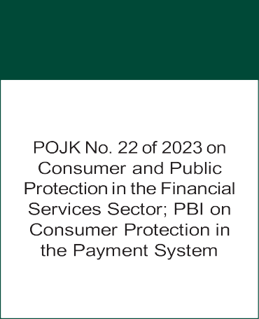
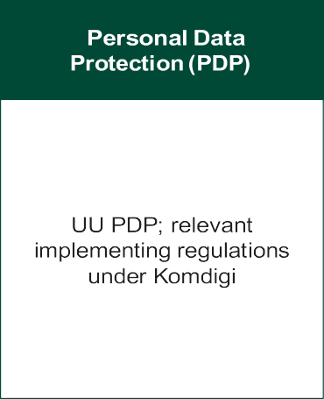
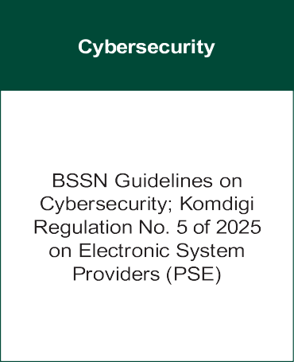
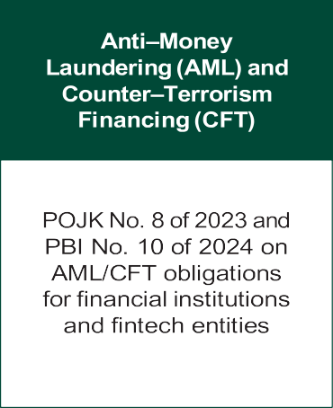
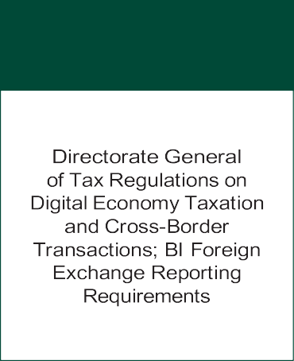
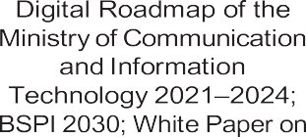



Consumer Protection

Taxation and Reporting

Implications for Australian Companies
A deep understanding of Indonesia’s evolving regulatory environment is essential for achieving long-term success in its fintech sector. Early engagement with local partners such as AFTECH and other recognised industry associations helps new entrants navigate licensing procedures, align products with national standards, and build credibility with regulators. By combining regulatory awareness, ethical alignment, and strategic partnerships, Australian tech or fintech providers can ensure both successful market entry and sustainable operations within Indonesia’s fast-growing digital economy.

The initial step in establishing a presence in Indonesia involves registration with the
Investment Coordinating Board (BKPM), followed by obtaining a principal license from the relevant financial regulator, either OJK or BI, depending on the business model. Companies are expected to comply with all licensing and operational requirements in collaboration with trusted local partners. The Austrade, together with local associations, plays a pivotal role in providing guidance, facilitating partnerships, and supporting the adoption of sound governance and compliance practices.

Once ready to formally enter the market, fintech firms must establish a Limited Liability Company with Foreign Investment (PT PMA), the required legal structure for foreign-owned businesses in Indonesia. While the process is clearly defined, it can be administratively complex and time intensive. Key steps include registering the entity

33 Fintech Playbook: Indonesia

with the Ministry of Law and Human Rights, obtaining a Tax Identification Number (NPWP), and applying for business licenses through the Online Single Submission (OSS) system. Depending on the nature of the fintech service, additional approvals may be required from OJK, BI, or the Komdigi to ensure compliance with financial, data, and digital-service regulations.

Foreign investors are permitted to hold majority ownership in Indonesian fintech firms up to 85 percent or more for publicly listed entities under Law No. 25 of 2007 on Investment and the Limited Liability Company Law. However,
ownership thresholds and licensing requirements differ across subsectors (Table V.2). For example, digital lending, payments, digital banking, and aggregator businesses each fall under specific regulations with distinct capital and compliance requirements. Approval from the relevant regulators: OJK, BI, or Komdigi is mandatory before operations commence.
While the regulatory process can seem complex, collaborating with experienced local partners: including Austrade, fintech association such as AFTECH, and reputable legal or consulting firms, can greatly simplify market entry. These partnerships provide practical support in navigating Indonesia’s regulatory landscape, structuring ownership arrangements, and engaging effectively with relevant authorities.
Such collaboration not only accelerates compliance but also helps new entrants establish credibility and trust within the local ecosystem.


Ultimately, entering Indonesia’s fintech market is more than a regulatory exercise—it is a strategic journey of partnership and adaptation. Companies that invest in understanding local dynamics, tailor their business models to Indonesian needs, and build strong relationships with key stakeholders will be best positioned for sustainable growth and long-term success.

Images are for decorative only

Fintech Playbook: Indonesia 34


Table IV.3 Licensing and Ownership Requirements for Key Fintech Sectors in Indonesia

Payment Services (PJP)

Peer to Peer Lending

Entity:
Company (PT-PMDN/PMA) - BI License
Initial Capital:
Category (1) IDR 15 billion
Category (2) IDR 5 billion
Category (3) IDR 5 billion - 1 billion
Foreign ownership minimum 5 percent up to 85 percent with 49 percent voting rights for a public company, if under 5 percent it will be a domestic stock unless it’s a foreign company and traded outside of the Indonesian stock exchange, and local minimum 15 percent.
Change of ownership and acquisition requires approval by BI.
Others:
Member of ASPI, PSE Certificate, Certificate ISO 27001, and other Standard Operating Certificates
Entity:
Company (PT-PMDN/PMA) - OJK License
Initial Capital:
IDR 25 billion, Foreign ownership maximum 85 percent, and local 15 percent. Equity minimum IDR 12.5 billion.
Allowed to change of ownership and acquisition after 3 years of being licensed, and need to be approved by OJK.
Others:
Member of AFPI, PSE Certificate, Certificate ISO 27001, and other Standard Operating Certificates

Securities Crowd Funding

Entity:
Company (PT-PMDN/PMA) - license OJK
Initial Capital:
Minimum IDR 25 billion, Foreign ownership maximum 49 percent, and local 51 percent.
Change of ownership and acquisition needs approval by OJK.
Others:
Member of ALUDI, PSE Certificate, Certificate ISO 27001, and other Standard Operating Certificates

Entity:
Business Model Under the Financial Sector Technology Innovation (ITSK) Framework
Company (PT-PMDN/PMA) - OJK License
Initial Capital:
No specific amount, depends what fintech business models, IDR 500 billion - 10 billion.
Foreign ownership is a maximum of 85 percent, and local 15 percent.
Change of ownership and acquisition needs approval by OJK.
Others:
Member of AFTECH, PSE Certificate, Certificate ISO 27001, and other Standard Operating Certificates

35 Fintech Playbook: Indonesia

ICS

Financial Service Aggregator

Entity:
Company (PT) - OJK License
Initial Capital:
Minimum IDR 5 billion. Foreign ownership is a maximum of 85 percent, and local 15 percent.
Change of ownership and acquisition requires approval by OJK.
Others:
Member of AFTECH, PSE Certificate, Certificate ISO 27001, and other Standard Operating Certificates
Entity:
Company (PT-PMDN/PMA) - OJK License

Initial Capital:
Minimum IDR 500 million.
Foreign ownership is a maximum of 85 percent, and local 15 percent.
Change of ownership and acquisition requires approval by OJK.
Others:
Member of AFTECH, PSE Certificate, Certificate ISO 27001, and other Standard Operating Certificates

Digitally Enabled Insurance Services

Digital Financial Asset Exchange

Entity:
Company (PT-PMDN/PMA) - OJK License
Initial Capital:
No specific amount, equity up to IDR 5 billion
Not specifically allowed to change ownership and acquisition, but possible by requesting approval from OJK.
Others:
Member of AFTECH, Member DAI, PSE Certificate, Certificate ISO 27001, and other Standard Operation Certificates
Entity:
Company (PT-PMDN/PMA) - OJK License Minimum, founded by 11 companies and not affiliated.
Initial Capital:
Minimum IDR 1 trillion
Foreign ownership (company) maximum 40 percent and individual local/foreign maximum 10 percent.
Change of ownership and acquisition requires approval by OJK.
Others:
Member of AFTECH, PSE Certificate, Certificate ISO 27001, and other Standard Operating Certificates

Fintech Playbook: Indonesia 36

Digital Financial Asset Clearing Guarantee and Settlement Institution

Digital Financial Asset Depository Manager

Entity:
Company (PT-PMDN/PMA) - OJK License
Initial Capital:
Minimum IDR 500 billion, with minimum equity 80 percent from capital.
Foreign ownership (company) maximum 40 percent and individual local/foreign maximum 10 percent.
Change of ownership and acquisition requires approval by OJK.
Others:
Member of AFTECH, PSE Certificate, Certificate ISO 27001, and other Standard Operating Certificates

Digital Financial Asset Trader
Entity:
Company (PT-PMDN/PMA) - OJK License
Initial Capital:
Minimum IDR 100 billion, with minimum equity 50 billion from capital.
Foreign ownership (company): 1 foreign individual/company only can invest in one trader business.
Change of ownership and acquisition requires approval by OJK.
Others:
Member of AFTECH, PSE Certificate, Certificate ISO 27001, and other Standard Operating Certificates
Entity:
Company (PT-PMDN/PMA) - OJK License
Initial Capital:
Minimum IDR 250 billion, with minimum equity 80 percent from capital.
Foreign ownership: Not Specific, but allowed.
Change of ownership and acquisition requires approval by OJK.
Others:
Member of AFTECH, PSE Certificate, Certificate ISO 27001, and other Standard Operating Certificates

Buy Now Pay Later (BNPL)
Entity:
Company (PT-PMDN/PMA) - OJK License
Initial Capital:
IDR 250 billion for conventional financing, and IDR 100 billion for a syariah financing company.
Foreign ownership is a maximum of 85 percent, and local 15 percent.
Allowed to change of ownership and acquisition after 3 years of being licensed, and needs to be approved by OJK.
Others:
Member of Indonesia Multi Finance Association (APPI), PSE Certificate, Certificate ISO 27001, and other Standard Operation Certificate

37 Fintech Playbook: Indonesia

Digitally Enabled Banking Services

Certificate Authority

Entity:
Company (PT-PMDN/PMA) - BI License
Initial capital:
IDR 10 trillion
Foreign ownership up to 99 percent, and local 1 percent.
Change of ownership and acquisition requires approval by BI.
Others:
Member of ASPI, Member AFTECH, PSE Certificate, Certificate ISO 27001, and other Standard Operation Certificates
Entity:
Company (PT-PMDN/PMA)/Foreign Company - Komdigi License
Initial capital:
No specific amount, but have financial capability in the form of assets of at least IDR 30 billion and submit proof of financial capability in the form of a copy of a financial statement audited by an independent auditor.
Not specifically allowed to change ownership and acquisition, but possible by requesting approval from MINISTRY OF COMMUNICATION AND DIGITAL AFFAIRS (KOMDIGI).
Others:
Member AFTECH, PSE, and PSrE Certificate, Certificate ISO 27001, and other Standard Operation Certificate

Indonesia’s regulatory framework seeks to balance foreign participation with national interests, ensuring that investment in fintech, particularly in critical financial infrastructure and consumer-facing services, supports sustainable and secure market development.
Stricter ownership and control rules apply to entities considered systemically important. Foreign professionals may be employed in specialised or advisory roles, subject to approval and time limitations set by OJK, BI, or Komdigi.

Fintech Playbook: Indonesia 38

Support from AFTECH and Ecosystem Players
AFTECH is Indonesia’s first and largest fintech association, representing more than 200 companies across 25 business models: from payments and lending to digital banking, InsurTech, ReGtech, and AI. Since its founding in 2016, AFTECH has been a leading force in promoting responsible innovation, financial
inclusion, and digital economy growth. Recognised globally as a model for industry governance, AFTECH bridges the public and private sectors through advocacy, collaboration, education, and research. Its International Service Desk assists global firms entering Indonesia by offering policy insights, stakeholder introductions, and mission facilitation, serving as a trusted gateway to the country’s fintech ecosystem.

Austrade, the Australian Government’s trade and investment agency, complements this role
by supporting Australian businesses expanding into Indonesia. It provides market intelligence, strategic guidance, and connections with regulators, associations, and partners, helping companies navigate local requirements and reduce entry risks.

A key initiative under this collaboration is the Indonesia Landing Pad, launched in June 2024 to help Australian tech and fintech scale-ups enter one of the world’s fastest-growing digital markets. The program offers tailored regulatory guidance, ecosystem access,
and curated introductions to regulators, investors, accelerators, and potential partners. By leveraging Austrade’s global reach and AFTECH’s local expertise, the initiative enables Australian companies to test strategies, validate opportunities, and build lasting partnerships, strengthening their foothold in Indonesia’s dynamic fintech and digital economy landscape.


Images are for decorative only

39 Fintech Playbook: Indonesia

Strategic Recommendations

Entering Indonesia’s Fintech Market: Do’s and Don’ts
Indonesia’s young, digital-savvy population presents vast opportunities for fintech innovation. Yet, success in this dynamic market demands careful preparation, cultural understanding, and regulatory alignment. The following actions, and pitfalls, outline key lessons for Australian companies entering Indonesia’s fintech ecosystem.

What to Do

- Understand the market and its opportunities: Use resources such as Austrade's Indonesia Fintech Playbook and the Indonesia Landing Pad Program to gain insights, guidance, and access to trusted networks.

- Prepare to play the long game: Enter the market with a long-term vision. Be patient, commit fully, and invest in sustainable impact rather than short-term gains.

- Engage local associations: Join local association such as AFTECH to connect with regulators, industry peers, and advocacy platforms that can facilitate regulatory engagement and ecosystem integration.

- Choose the right partners: Conduct thorough due diligence and partner strategically. Trusted local allies are key to navigating Indonesia's regulatory and cultural landscape.

- Adapt locally: Respect Indonesia's culture, consumer behavior, and business practices. Tailor communication, products, and operations to align with local norms.

- Know your regulations: Seek legal and regulatory advice early, and engage proactively with OJK, Bank Indonesia (Bl), and the Ministry of Communication and Digital Affairs (Komdigi) to ensure full compliance.

- Localise your offerings: Customise language, user experience, customer support, and payment methods. Integrate with national systems like QRIS and major e-wallets to enhance accessibility.

What Not to Do

- Don't just copy-paste your business model: Avoid directly transplanting Australian approaches. Pricing, customer behaviour, and regulatory contexts differ significantly.

- Don't bypass regulations: Resist shortcuts, especially in areas like licensing, consumer protection, and data governance. Compliance builds long-term trust.

- Don't neglect relationships: Business in Indonesia is relationship driven. Maintain ongoing engagement and trust rather than relying on one-off transactions.

- Don't overlook culture: Communication style and etiquette matter. A respectful, localised approach builds credibility and rapport.

- Don't rely solely on expatriates: Local teams provide vital insights into customer needs, regulatory nuances, and cultural expectations.

40 Fintech Playbook: Indonesia

Appendix

AFTECH & Its Services
Indonesia Fintech Association (AFTECH) is Indonesia’s first and largest fintech and digital economy association, serving as the central platform connecting innovation, governance, and collaboration across the nation’s digital finance ecosystem. With over 200 members across 25 business models, AFTECH represents not only fintech startups but also banks, payment companies, telcos, cloud and AI providers, and other technology enablers — reflecting the full spectrum of Indonesia’s digital economy.

AFTECH’s strength lies in its governance, advocacy, and ecosystem leadership. Guided by respected leaders through its Executive, Supervisory, and Ethics Boards, AFTECH ensures transparency and accountability. Through 24 active departments, it engages closely with regulators and policymakers on key areas including payments system, lending, cybersecurity, Environmental, Social, and Governance (ESG) finance, and digital identity.

Anchored on four strategic pillars: Public Policy (IFPP), Community Collaboration (IFCC), Financial Literacy & Education (IFLE), and Knowledge & Intelligence (IFKI), AFTECH continues to strengthen Indonesia’s fintech ecosystem. From 2021–2025, it has held over 600 regulatory engagements, contributed 60 policy inputs, organised 250+ events, and developed five Codes of Conduct alongside the Regulatory Compliance System (RCS).

To represent Indonesia’s diverse digital finance landscape, AFTECH offers five membership categories: Permanent, Observing, Honorary, Supporting, and Extraordinary Members, accommodating both local and international participants in Indonesia’s growing fintech ecosystem.

To foster growth and collaboration, AFTECH facilitates policy dialogue, knowledge sharing, and business networking through five professional communities, 30+ ecosystem partners, and regular industry events. Members also benefit from capacity-building programs, policy updates, and governance tools such as the RCS and investor business matching initiatives.

AFTECH’s impact is also reflected in its flagship national events, National Fintech Day, National Fintech Month (BFN), Indonesia Fintech Summit & Expo (IFSE), and Indonesia Digital Bank Summit (IDBS), which serve as major platforms for collaboration, innovation, and policy discussion.

Recognised by OJK, Bank Indonesia BI, and Communications and Digital Ministry (Komdigi), AFTECH is the officially appointed association for Financial Sector Technology Innovation (ITSK) and a trusted partner in promoting responsible, inclusive, and sustainable digital finance.

Through its International Service Desk, AFTECH also supports global fintechs expanding into Indonesia by providing market insights, regulatory guidance, and curated introductions to ecosystem partners, fostering cross-border collaboration and innovation in one of the world’s most dynamic digital markets.

For more information, contact


Fintech Playbook: Indonesia 41

Austrade & Its Support
The Australian Trade and Investment Commission (Austrade) is the Australian Government responsible for growing Australian business and education internationally, and attracting foreign direct investment into Australia. Austrade is also responsible for Australia’s tourism policy and its programs under THRIVE 2030.

Austrade helps Australian companies expand overseas by offering market insights, strategic advice, and connections to trusted networks—reducing risks while identifying growth opportunities. For Australian fintech and technology companies, Austrade serves as both guide and connector to regulators, associations, and partners in Indonesia.

In October 2025, we celebrate two years since the launch of the Australian Government’s Invested: Australia’s Economic Strategy to 2040 – a strategy focused on growing Australia’s two-way trade and investment with Southeast Asia, including a focus on the technology sector as one of ten priority sectors.

To bring this strategy to life, Austrade launched an expanded Southeast Asia technology landing pad program – establishing dedicated landing pads in Jakarta and Ho Chi Minh, as well as a dedicated Southeast Asia Fintech program delivered through our established landing pad in Singapore.

Launched in June 2024 to support Australian tech scaleups entering one of the world’s fastest-growing digital economies, the program provides participants with insights, advice, tools and strategies to navigate the Indonesia technology landscape and opportunities.

Through local ecosystem partnerships, the Landing Pad helps companies test strategies, validate opportunities, and build relationships with both industry and policymakers. By combining Austrade’s global reach with deep in-country networks, the program lowers barriers and boosts the chances of long-term success in Indonesia’s dynamic Fintech and digital economy market.

Visit Us:


Find out more about Australia’s Fintech Capabilities:


42 Fintech Playbook: Indonesia

