

# Robotics, Autonomous Systems and AI Australian Defence Industry Report and Matrix

## Overview

Australian companies are leaders in defence-related robotics technologies. This includes niche, low-cost robotic systems for small and mid-sized applications in land, sea and air domains. Australian pioneers are also leveraging Artificial Intelligence (AI) to increase the persistence, range, autonomy and teaming capabilities of defence vehicles. This combination of robotics and AI has created an emergent defence-industry subsector – Robotics, Autonomous Systems and Artificial Intelligence or RASAI.

Thanks to our mining and transport industry, Australian companies are already world leaders in field robotics. When combined with advanced manufacturing capabilities, this means Australian companies are now creating new RASAI capabilities quickly. What’s more, the Australian defence capability budget – worth A$270billion over the next decade – is being channelled towards advanced defence systems. This presents huge opportunities for defence-related RASAI platforms in Australia.

This report analyses Australia’s domestic expertise in RASAI. The Capability Matrix identifies Australian companies that have export-ready RASAI capabilities and fast-evolving expertise. The Matrix will help overseas defence companies find partners who have relevant skills. The Matrix will also help global defence customers to assess areas of RASAI expertise in Australia’s civil-defence ecosystem.

## Global market trends and opportunities

The global defence robotics market – the core customer for RASAI technologies – was worth A$19.5 billion in 2020 ([Source: Defence Robotics – Global Market Trajectory and Analytics Report, February 2022](https://www.researchandmarkets.com/reports/2255364/defense_robotics_global_market_trajectory_and?utm_source=BW&utm_medium=PressRelease&utm_code=ct8f54&utm_campaign=1685141+-+Global+Defense+Robotics+Market+Trajectory+%26+Analytics+Report+2022%3a+Autonomous%2c+Smart+Military+Robots+Set+to+Operate+along+Real+Warfighters&utm_exec=chdo54prd)). With a projected compound annual growth rate of 9.5%, the defence robotics market will likely be worth A$32.8 billion by 2026.

The associated market for unmanned aerial vehicles (UAVs) is also growing quickly – and pivoting towards the Asia-Pacific region. The cumulative market for UAVs for the decade from 2021 is estimated at A$223 billion. During this period, the Asia-Pacific region is projected to account for 38% of global military aircraft purchases. This includes China and India, and the rapid projected adoption of combat UAVs ([Source: Global Military UAV Market 2021–2031, October 2021](https://www.researchandmarkets.com/reports/5458435/global-military-unmanned-aerial-vehicle-uav)).

## The role of RASAI in Defence

RASAI is now the focus of significant research investment around the world. Its appeal is that it can upgrade capabilities across all defence domains. This includes space, and electronic and cyber warfare. Some research and development has already resulted in real-world applications.

RASAI technologies are proven game changers. They can fulfill numerous, laborious activities currently undertaken by servicemen and servicewomen. These include activities that are dirty, dull, dangerous and dear. RASAI-based systems can also act as force multipliers: they enable a small number of teams or platforms to achieve a military effect far greater than those numbers traditionally allow.

## RASAI and Australian defence

The Australian Defence Force (ADF) is an early adopter of robotics technologies. This is partly because of local expertise. Australia’s agriculture and mining industries have organically developed world-leading autonomous systems to help run commercial operations in vast, remote areas. This means many companies described in this report have already created dual-use, civil-military RASAI technologies.

The ADF wants RASAI technologies to help replace, augment or revolutionise current capabilities. This makes Australia’s Department of Defence an enthusiastic investor in RASAI platforms – targeting these types of technologies through $3 billion in defence innovation program funding. It also makes Defence a partner for dynamic local innovators. Defence envisages using robots in multiple platforms, payloads and control systems. Domestic expertise in artificial intelligence will prove especially valuable.

In practical terms, the ADF’s current focus is to use RASAI to improve mission outcomes. The ADF also believes that integrating RASAI capabilities into backend activities will enhance frontline military capability. Therefore, RASAI is also gaining traction in non-combat areas – including defence logistics, training and predictive maintenance.

## Australian capabilities: land, sea, air – and beyond

Commercial research in Australia is helping to advance the capabilities of RASAI platforms. This includes advances in the basic parameters of autonomous platforms: size, weight, power, and cost (SWaP-C). These advances mean that domestic RASAI capabilities are helping to accelerate the adoption of autonomous systems in Australia’s military forces.

Australia’s defence industries recognise the potential for RASAI to be integrated with emerging technologies, in particular:

* hypersonic vehicles
* additive manufacturing
* neural interfaces.

The Australian Department of Defence is exploring the potential integration of RASAI technologies to enhance the warfighting capabilities of the ADF. These range in type, from perception and control system attacks to information warfare and platform destruction.

## Future platforms

The next generation of RASAI platforms will include advanced vision-based AI and advanced swarming enabled systems. Developing these technologies will enable robotics and autonomous systems to deliver persistent, wide-area operations on land, in the air and at sea. They will powerfully augment current human-based systems, especially in monitoring and surveillance.

Australian companies are helping to create these future platforms. The Australian companies described in this matrix have developed new RASAI capabilities in recent years across multiple domains. They are dynamic and enterprising. They are looking for opportunities to partner with global defence companies to augment potential and create game-changing capabilities.

## RASAI Defence Industry Capability Matrix

RASAI systems are created through the convergence of numerous technologies. For the purpose of presenting this Capability Matrix we have devised a taxonomy clustering the technical expertise in Australian industry around four primary areas:

* Edge platforms
* Decision aids
* Agents
* Social protocols

Additionally, capabilities are mapped against their domain of operation: air, land, sea and digital. We encourage you to search for companies of interest by exploring the wide array of RASAI technologies included in the Matrix. If you would like to get in touch with any of the companies listed, feel free to reach out to us using the contact details listed.

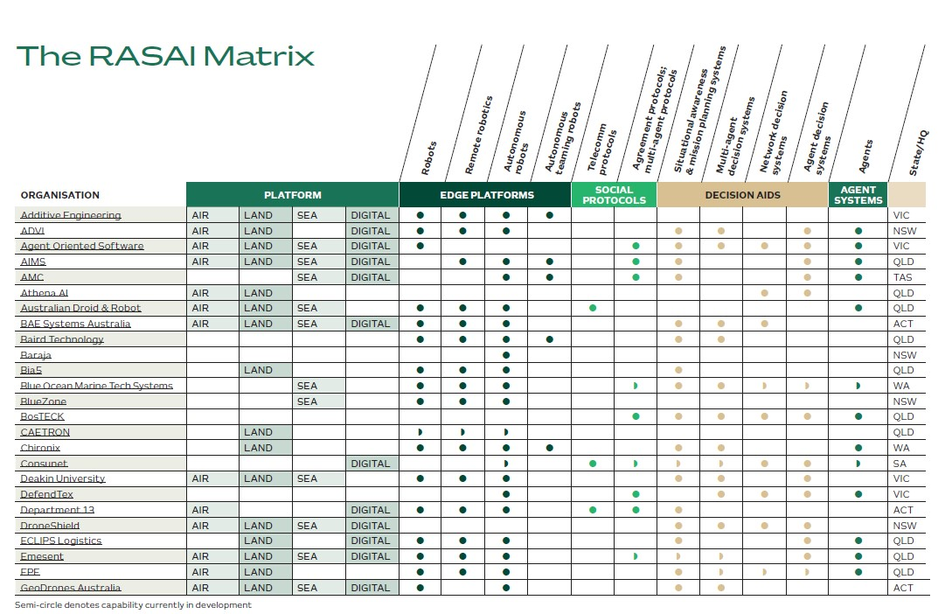

The table shows a directory listing of 25 Australian companies with export-ready RASAI capabilities. It specifies each company's primary type of technical expertise (edge platforms, decision aids, agents, social protocols) and their maturity in this field (some capability is marked as 'in development'). Technical expertise is further broken down into subcategories.

**The companies listed in this image are:**

1. Additive Engineering (VIC)
2. ADVI (NSW)
3. Agent Oriented Software (VIC)
4. AIMS (QLD)
5. AMC (TAS)
6. Athena AI (QLD)
7. Australian Droid & Robot (QLD)
8. BAE Systems Australia (ACT)
9. Baird Technology (QLD)
10. Baraja (NSW)
11. Bia5 (QLD)
12. Blue Ocean Marine Tech Systems (WA)
13. BlueZone (NSW)
14. BosTECK (QLD)
15. CAETRON (QLD)
16. Chironix (WA)
17. Consunet (SA)
18. Deakin University (VIC)
19. DefendTex (VIC)
20. Department 13 (ACT)
21. DroneShield (NSW)
22. ECLIPS Logistics (QLD)
23. Emesent (QLD)
24. EPE(QLD)
25. GeoDrones Australia (ACT)

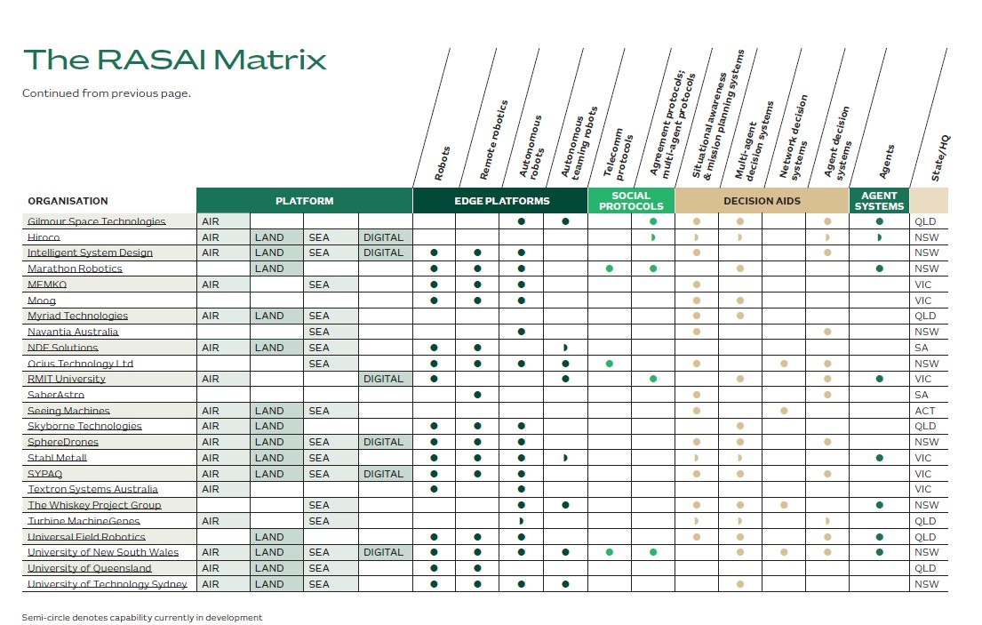

The table shows a directory listing of 24 Australian companies with export-ready RASAI capabilities. It specifies each company's primary type of technical expertise (edge platforms, decision aids, agents, social protocols) and their maturity in this field (some capability is marked as 'in development'). Technical expertise is further broken down into subcategories. The companies listed in this image are:

* 1. Gilmour Space Technologies (QLD)
  2. Hiroco (NSW)
  3. Intelligent System Design (NSW)
  4. Marathon Robotics (NSW)
  5. MEMKO (VIC)
  6. Moog (VIC)
  7. Myriad Technologies (QLD)
  8. Navantia Australia (NSW)
  9. NDE Solutions (SA)
  10. Ocius Technology Ltd (NSW)
  11. RMIT University (VIC)
  12. SaberAstro (SA)
  13. Seeing Machines (ACT)
  14. Skyborne Technologies (QLD)
  15. SphereDrones (NSW)
  16. Stahl Metall (VIC)
  17. SYPAQ (VIC)
  18. Textron Systems Australia (VIC)
  19. The Whiskey Project Group (NSW)
  20. Turbine MachineGenes (QLD)
  21. Universal Field Robotics QLD)
  22. University of New South Wales (NSW)
  23. University of Queensland (QLD)
  24. University of Technology Sydney (NSW)

## Austrade

The Australian Trade and Investment Commission (Austrade) accelerates the growth of exporters, attracts foreign investors and stimulates the visitor economy. Through our network of 1,200 experts in 67 international offices, we give Australian businesses a competitive edge in the global marketplace. Connect Austrade at:

## [**www.austrade.gov.au**](http://www.austrade.gov.au)

## [**defence@austrade.gov.au**](mailto:defence@austrade.gov.au)

## [**Linkedin**](https://www.linkedin.com/company/australian-trade-commission/mycompany/verification/)

## [**Twitter**](https://twitter.com/Austrade?ref_src=twsrc%5Egoogle%7Ctwcamp%5Eserp%7Ctwgr%5Eauthor)

## Trusted Autonomous Systems

Trusted Autonomous Systems (TAS) is Australia’s first Defence Cooperative Research Centre. It is uniquely equipped to deliver research into world-leading autonomous and robotic technologies. Its goal: to enable trusted and effective cooperation between humans and machines. Trusted Autonomous Systems aims to improve the competitiveness, productivity, and sustainability of Australian industry through industry-led projects with real translation

opportunities to move technology rapidly from universities into industry and ultimately into leading edge capability for the Australian Defence Force. Contact TAS at:

[**www.tasdcrc.com.au**](http://www.tasdcrc.com.au)

[**info@tasdcrc.com.au**](mailto:info@tasdcrc.com.au)

[**LinkedIn**](https://www.linkedin.com/company/tasdcrc/?originalSubdomain=au)

[**Twitter**](https://twitter.com/tasdcrc?lang=en)