Industry Data and Expert Analysis (IDEA)  
Working Group

Recommendations Report

April 2022 – April 2023

Acknowledgment of Country

The Australian Government acknowledges the Traditional Owners and Custodians of Country throughout Australia and acknowledges their continuing connection to land, water and community. We pay our respects to them, their Elders past and present, and the continuation of cultural, spiritual and educational practices of Aboriginal and Torres Strait Islander peoples.

Acknowledgments

The Australian Government values the important contribution by all stakeholders in developing this recommendations report.

Austrade wishes to acknowledge the IDEA Working Group members, Griffith Institute for Tourism, Griffith University, and the many individuals, businesses, industry representatives and government officials who provided input and generously contributed their time and insights to the IDEA Working Group work program.

We look forward to the continued collaboration and contribution of our stakeholders as the recommendations in this report are considered by government and industry.

Executive summary

The IDEA Working Group was established as part of the governance framework for   
THRIVE 2030, Australia’s national long-term visitor economy strategy. The Working Group’s purpose, as contained in its terms of reference, was to identify information gaps and potential solutions to data deficits in Australia’s visitor economy. The Working Group, comprised of industry, community and government representatives and experts, over 12 months initiated 4 data and research projects and provided input to 2 projects.

The Working Group’s major project involved developing long-term progress indicators for the visitor economy, referred to as the Longitudinal Indicators for the Visitor Economy (LIVE) framework. The LIVE framework aims to increase awareness of dimensions considered important for the sustainable development of the visitor economy. The IDEA Working Group’s recommended framework of leading and lagging indicators, from economic, social, and environmental domains, represents a more wholistic perspective of Australia’s visitor economy than current commonly used metrics.

This shift to a broader set of indicators is consistent with national and global developments related, for example, to green economy, net zero, and empowering local communities. The successful implementation of the LIVE framework will illuminate the intersections and interactions of the different dimensions and thereby more clearly reveal the overall health of the visitor economy.

The Working Group also undertook projects to explore financial transaction data, psychographic profiles and international tourism data hubs, and oversaw TRA projects related to mobility data and business events.

The IDEA Working Group recommends:

1. **Implementing and publishing the Longitudinal Indicators for the Visitor Economy (LIVE) framework** – A Project Coordination Committee (PCC) should be established to lead the implementation of an online dashboard with launch expected by mid-2024.
2. **Establishing a proof of concept to further explore financial data** – This should explore a financial transactions dataset and the application of the data for the purpose of reporting the visitor economy spend.
3. **Refining a mobility data product for official release** – Mobility data should be pursued to inform official domestic and international visitation estimates.
4. **Establishing a model to estimate the volume of business events** – TRA should investigate whether there are adequate data sources to enable an estimation of business events volume and economic contribution.
5. **Expanding research focused on environmental and social measures of tourism** – Increase research on environmental and social aspects of tourism to complement and provide greater context to the LIVE framework.
6. **Including the LIVE framework in the THRIVE 2030 strategy if revised at the end of the Recovery phase (2024)** – The indicators should be embedded into the national visitor economy policy to allow long-term monitoring and reporting.

Background

The IDEA Working Group was established as part of the implementation governance for the government’s long-term tourism strategy, THRIVE 2030. This report summarises the outcomes and advice of the Working Group and fulfils the requirements of the Working Group’s terms of reference[1].

The IDEA Working Group’s mission was to identify information gaps and potential solutions to data and information deficits in Australia’s visitor economy, and to deliver a set of long-term progress indicators for the visitor economy. The Working Group was established for 12 months from April 2022 to April 2023, and this report was finalised in May 2023.

The Working Group was comprised of 13 industry, community and government representatives and experts, and a Chair, each appointed by the CEO of the Australian Trade and Investment Commission.

IDEA Working Group members:

* Dr Garth Taylor (Chair), Head, Tourism Research Australia
* Evan Saunders, Vice President, Global Tourism and Hospitality Sales, Near
* Dr Grace Pan, Strategic Development and Research Director, Tourism & Events Queensland
* Denise Ulbrick, Manager, Research, Tourism and Events Strategy and Reform, Department of Jobs, Skills, Industry and Regions (DJSIR), Victoria
* Rob Dougan, Executive General Manager, Strategy and Research, Tourism Australia
* Paul Fleming, Research and Insights Specialist, Tourism Tasmania
* Jan Hutton, CEO, Australian Tourism Data Warehouse
* Garrick Bryant, Head of Data Strategy, Sydney Airport
* Professor Leo Jago, Chair, Business Events Council of Australia
* Peter Clay, General Manager, Research and Insights, Caravan Industry Association of Australia
* Carol Giuseppi, Community member, Former General Manager, Accommodation Association of Australia
* Amanda Clark, Program Manager, Physical Environment Accounts and Statistics, Australian Bureau of Statistics
* Professor Sally Cripps, Director of Technology, Human Technology Institute, University of Technology Sydney
* Adele Labine-Romain, National Tourism, Hospitality Leisure Sector Lead and Partner with Deloitte Access Economics

Meetings

The IDEA Working Group conducted 7 meetings (1 in-person, 6 virtual).

All meetings commenced with an acknowledgement of traditional custodians together with an outline of the purpose of the group as reflected in the terms of reference. The terms of reference contained 6 responsibility areas. The Working Group identified that one of the responsibility areas, the specific requirement of establishing a framework for long-term progress indicators, would require ongoing attention because of the time-limited nature of the Working Group.

Summaries of the Working Group’s meetings and communiques are available online from the [THRIVE 2030 IDEA Working Group](https://www.austrade.gov.au/about/consultation/thrive-industry-data-and-expert-analysis-working-group#:~:text=The%20THRIVE%202030%20Industry%20Data,areas%20in%20Australia's%20visitor%20economy.&text=build%20investor%20confidence.) web page.

Attachment A contains the attendance record for all meetings.

Project findings

The IDEA Working Group initiated 4 data and research projects and provided oversight to 2 further TRA projects.

These projects researched or explored complementary datasets and/or data products that, alone or combined with existing data sources, could potentially support a broader and more insightful interpretation of Australia’s visitor economy. Each project was guided by and was consistent with the ABS Data Quality Framework.

A short summary of these projects and any findings is presented below. Further project details are at Attachment B.

* Project 1, Longitudinal Indicators for the Visitor Economy (LIVE) framework – The main body of work delivered by the Working Group was the conceptual LIVE framework for measuring the long-term progress of Australia’s visitor economy. The proposed LIVE framework was informed by earlier research by the Griffith Institute for Tourism, namely A new indicator framework for Australia’s visitor economy. The LIVE framework was also informed by the United Nations World Tourism Organization (UNWTO) framework for [Measuring the Sustainability of Tourism](https://www.unwto.org/tourism-statistics/measuring-sustainability-tourism).

The proposed LIVE framework recommends 3 separate pillars – economic, social and environmental (Figure 1) – for monitoring the visitor economy’s performance. It also recognises the importance of governance and other institutional elements needed for a healthy visitor economy.

The proposed framework’s emphasis on social and environmental factors highlights how critical they are for a successful visitor economy. For example, overcrowding resulting in diminished visitor experiences and liveability for residents (social), and the long-term threat of climate change (environmental) are each as relevant to the measure of the visitor economy’s health as the number of, or expenditure by, visitors (economic).

The Working Group considered over 70 indicators to measure visitor economy performance and prioritised them in high, medium and low categories (Attachment C). The long list was further assessed and condensed into an initial short-list of 21 indicators (Figure 1). The Working Group expects the initial shortlist to evolve over time as community and policy priorities emerge.

Figure 1. Conceptual LIVE framework

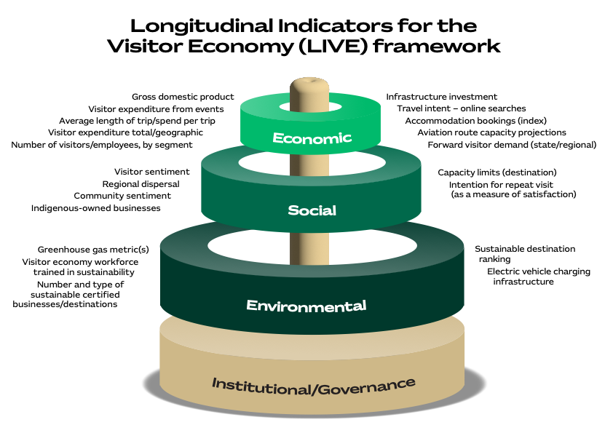

* Project 2, International tourism data hubs – This project explored tourism data hubs across 30 OECD countries and proposed 9 matters for consideration and 11 recommendations for the LIVE framework. As guided by the recommendations, the Working Group’s focus on indicators included social and environmental metrics. Other parts of the tourism data hubs project will inform TRA’s work on diversifying the data sources used to measure tourism and increase efforts in the measurement of business event information.   
    
  The recommendations also form part of the context for the LIVE framework, such as focusing on usability (user-friendliness of the tool) and identifying potential partners for data sources and to assist in the implementation.
* Project 3, Helix Personas – The Working Group investigated the potential integration of psychographic profiles and National Visitor Survey (NVS) data.   
     
  The psychographic profiles proposed to be used are known as the Helix Personas, 54 different personas (or mindsets) developed by Roy Morgan Research. Aligning the personas with the rich NVS data could, for example, assist with understanding a target audience, how to find them, which media should be used to reach them and the style of messaging that will resonate best with those consumers.  
    
  This enhancement to the NVS was projected to provide another dimension for exploring and utilising existing NVS data by making it more applicable to marketing, product development and investment decisions. With input from the Working Group, TRA moved forward with integrating the Helix Personas with the NVS datasets. In March 2023, TRA made the new datasets available to state tourism organisations for testing.
* Project 4, AFL Grand Final Brisbane – The project explored the capacity of CommBank iQ to use large financial datasets to produce visitor economy measurements related to the 2020 AFL Grand Final in Brisbane.  
    
  Some limitations were identified with the data related to, for example, expenditure on pre-paid items and cash transactions. However, overall, there are very likely to be specific uses for financial transactions data as a complementary source to measure elements of the visitor economy. For example, insights can be drawn from the data for events and locations, including spend behaviours on site and in surrounding precincts.
* TRA project 1, Mobility data – Movement is at the core of all tourism, so measuring movement is at the core of measuring tourism. TRA provided updates over 3 IDEA Working Group meetings on a mobility data project TRA had initiated to measure population movement.   
    
  TRA’s mobility data project explores the potential for data outputs to complement national surveys to improve official domestic visitor statistics; for event measurement; and for information on overnight trip travel paths and day trips. The project has demonstrated its capacity to replicate NVS definitions for domestic overnight and day trip travel as shown in testing over the period January 2019 to November 2022. Due to the large sample size and nature of the mobility data (i.e. apps and GPS), the movement aspect of visitation can be measured with a high degree of precision and at finer levels of geography. The data is also available quickly, within 10 days of the reference period.  
     
  TRA highlighted challenges in relation to the measurement of international travel and noted that further detailed investigation is required in this part of the visitor economy.
* TRA project 2, Business events data – TRA explained that measuring tourism events data was a priority for the Australian Government and that the Government had allocated $2 million to include business events data in international and national datasets. An extensive set of questions were included in the International Visitor Survey (IVS) and NVS from 2 January 2023 to capture data on business events. These questions were developed in consultation with industry and the initial findings are expected to be available in early 2024 (i.e. after 9 months of data collection is available), and one year of data capture will be available in April 2024.   
    
  A second phase of data collection will be required, targeting bespoke surveys at multiple event types and geographies. This will allow for a comprehensive modelling exercise to derive business events estimates, expected to be completed in 2024-25.

Consultations and contributions

The Working Group’s recommendations were developed with input from industry, academia, and government, as in the examples listed below.

LIVE framework

* TRA hosted a blue-sky session on 27 July 2022 in Canberra, with approximately 20 academic and government representatives, to gather additional feedback on considerations for the LIVE framework. As part of this session, the group was presented 2 visual representations of the framework for discussion. There was strong support for the United Nations Sustainable Development Goals (Figure 6) hierarchical structure. This feedback was consistent with feedback from Working Group members.
* A team of experts at the Griffith Institute for Tourism developed an initial set of indicators for consideration and prioritisation by the Working Group. Two experts from the Griffith Institute for Tourism, [Associate Professor Sarah Gardiner](https://experts.griffith.edu.au/9529-sarah-gardiner), Director Griffith Institute for Tourism, and [Dr Susanne Becken](https://experts.griffith.edu.au/19036-susanne-becken), Professor of Sustainable Tourism, provided regular advice on the development of the proposed LIVE framework. They attended several Working Group meetings (and sub-committee meetings) to present their research on A new indicator framework for Australia’s visitor economy and to support the development of the LIVE framework.
* The conceptual framework for the LIVE indicators was developed in consultation with various industry representative groups, as well as the [Australian Standing Committee on Tourism (ASCOT)](https://www.directory.gov.au/portfolios/foreign-affairs-and-trade/australian-trade-and-investment-commission-austrade/australian-standing-committee-tourism) and the Tourism Research Committee (TRC).
* [Dr Stefan Hajkowicz](https://people.csiro.au/h/s/stefan-hajkowicz) and [Dr Alexandra Bratanova](https://people.csiro.au/B/A/Alexandra-Bratanova) from Data 61, CSIRO, are specialists in multiple criteria decision analysis. They shared their experiences and observations of the challenges and opportunities in data integration tasks, to inform the implementation process of the LIVE framework.

Helix Personas project

* John Ellenberger, Head of Partnerships, Roy Morgan Research, the developers of the Helix Personas, was consulted regarding the implementation of the Helix Personas project and to explain the uses for the data to members.

CommBank iQ project

* Emmanuel Alfieris, Simon Johnson, Michael Peel, Wade Tubman, Annie Liao and Utsav Nag conducted the CommBank iQ project and presented the findings at a number of Working Group meetings.

International data hubs project

* The international data hubs project was conducted by Associate Professor Sarah Gardiner and Dr Margarida Abreu Novais and their associates at the Griffith Institute for Tourism, Griffith University.

Business events project

* The business events project and related development of survey questions were guided by [Andrew Hiebl](https://aacb.org.au/team), CEO of the Association of Australian Convention Bureaux, and [Dr Leo Jago](https://www.specialevents.com.au/dr-leo-jago-oam-appointed-independent-chair-of-beca/), Chair of the Business Events Council of Australia Board of Directors.

Mobility data project

* DSpark CEO Paul Rybicki was consulted to explain the mobility data and its uses to Working Group members.

VisScope

* VisScope Directors Mark Dalton, Mark Griffiths, and technical director Bradley Rasmussen were consulted on the challenges of layering multiple datasets for determining visitor economy outcomes.

Recommendations

1. Implement and publish the Longitudinal Indicators for the Visitor Economy (LIVE) framework

Use the conceptual LIVE framework (Figure 1), prioritised indicators (at Attachment C), and the data hubs research recommended findings (project 2 at Attachment B), to inform the development of a dashboard/online data portal. It is recommended a Project Coordination Committee (PCC) be established to coordinate the implementation of the project. The PCC would include TRA and be supported by an academic consultant and data specialists. The first iteration of the LIVE dashboard should be developed and published within a year to generate confidence in the industry and governments. The LIVE dashboard can then be improved and updated over time.

The PCC is to consider and recommend methods and datasets for long-term monitoring of the proposed indicators. This may include using readily available and existing data sources or developing new data sources or indices.

The initial set of indicators to be published within a year should be informed by the prioritised indicator list (Attachment C). Leading and lagging indicators should be sourced for the 3 categories of economic, social and environmental. This initial set of indicators and measures should be decided in consultation with stakeholders. The PCC should develop a consultation plan and consider which industry stakeholders to engage with before the dashboard is developed.

The visual presentation and web development processes are projected to be significant. A dashboard concept should be developed before the LIVE project is implemented. An example of an existing indicator framework data portal is the   
[EU Tourism Dashboard](https://tourism-dashboard.ec.europa.eu/?lng=en&ctx=tourism) developed by the European Commission, which categorises several tourism indicators under 3 separate pillars (Figure 2). The summary statistics have been presented as wheels, with further statistics presented on each of the indicators within the portal. Data can be analysed by year and country.

Figure 2. EU Tourism dashboard summary statistics

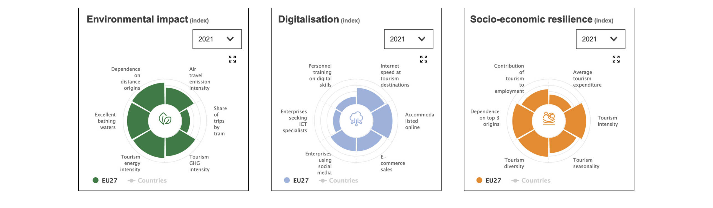

Figure 3 provides an example of summary statistics for air travel emissions, one of the indicators within the environmental impact pillar.

Figure 3. EU Tourism dashboard summary statistics for air travel emission intensity indicator

An example of the European Union Tourism Dashboard summary for air travel emission intensity. The dashboard provides a brief description of the indicator and its methodology, and a graph showing year on year change. 

The description and methodology for this indicator is "an estimate of the amount of CO2 emitted per air passenger per reporting country. It is calculated by dividing the amount of CO2 emitted by all passenger flights by the number of passengers within a year." The included graph shows an increase of emission intensity from 2019 to 2020, followed by a small decrease from 2020 to 2021.


Another example of a dashboard measuring global and regional tourism performance is the [UNWTO Tourism data dashboard](https://www.unwto.org/tourism-data/global-and-regional-tourism-performance) (noting this dashboard focuses on economic performance). The PCC should take the EU’s and UNWTO’s tourism data representations into account as it considers Australia’s LIVE framework.

The release of the LIVE portal should be accompanied by a communications plan to increase awareness and uptake.

Once released, data updates to the portal should occur regularly, based on data availability and resourcing.

It is recommended the dashboard and included measures also undergo revisions and updates beyond the initial release. Future updates should continue to consider for future inclusion the prioritised indicators at Attachment C. Revisions should always involve industry engagement prior to implementation as social and policy priorities change.

2. Establish a proof of concept to further explore financial data

The CommBank iQ project indicated that, with some non-trivial limitations, event-specific details could be determined using a representative financial transaction dataset. It is recommended that the proof of concept extend to exploring whether financial data could also indicate visitor economy estimates for a geographical location.

As a first step, it is recommended that TRA commence a project using banking or credit card data to measure visitor economy activity in Tasmania. Tasmania has a range of other data sources that can be used to validate the data, for example the Tasmanian Visitor Survey. This project would add to the findings of the AFL Grand Final project by exploring another financial transaction dataset and application of the data.

The proof of concept should attempt to define a synthetic expenditure profile for traveller cohorts, with a view to matching that synthetic profile with a synthetic movement profile from survey and mobility data (i.e. combined telecommunications GPS and apps data) source.

The measurement of both domestic and international spend should be attempted in future projects.

3. Refine a mobility data product for official release

TRA’s mobility project demonstrated the potential for well-defined data to improve official domestic visitor statistics and produce event measurement and information on overnight trip travel paths and day trips. Given the large appetite for more granular movement statistics, it is recommended that TRA refines this data to the point that estimates are considered acceptable for publication. The focus on domestic estimates should continue in the first instance, with international estimates revisited later. The next steps would include continuing to refine general methodology and liaising with state and territory counterparts to resolve geography-related questions. TRA should aim to publish mobility-related domestic visitor data as soon as possible.

4. Establish a model to estimate the volume of business events

Together with including business events data in international and national data sets, TRA should investigate whether the volume of business events can be estimated through modelling. This would require research on other business event data collections including from event venues and delegates, in consultation with industry.

TRA could further incorporate information from the IVS and NVS business event questions to provide an even more comprehensive understanding of business events in Australia. The end goal should be to publish this information on the TRA website.

5. Expand research focused on environmental and social measures of tourism

The LIVE framework will include social and environmental indicators. To expand on this work, the Working Group recommends TRA increase its focus on research and reporting relating to the social and environmental dimensions of tourism. Such future publications would ideally support and enhance the understanding of the metrics published in the LIVE framework.

6. Include the LIVE framework in the THRIVE 2030 strategy if revised at the end of the Recovery phase (2024)

The indicators should be embedded into the national visitor economy policy to allow long-term monitoring and reporting.

Attachment A:  
Meeting attendance record

|  | | | **Meeting number** | | | | | | |
| --- | --- | --- | --- | --- | --- | --- | --- | --- | --- |
| **Name** | **Position** | **Organisation** | **1** | **2** | **3** | **4** | **5** | **6** | **7** |
| **Dr Garth Taylor** | Head | Tourism Research Australia | 🗸 | 🗸 | 🗸 | 🗸 | 🗸 | 🗸 | 🗸 |
| **Evan Saunders** | Vice President, Global Tourism & Hospitality Sales | Near | 🗸 | 🗸 | * | 🗸 | 🗸 | 🗸 | 🗸 |
| **Dr Grace Pan** | Strategic Development and Research Director | Tourism & Events Queensland | 🗸 | 🗸^ | 🗸 | 🗸 | 🗸 | 🗸 | 🗸 |
| **Denise Ulbrick** | Manager, Research, Tourism and Events Strategy and Reform | Department of Jobs, Precincts and Regions (DJPR), Victoria | 🗸 | 🗸 | 🗸 | 🗸 | 🗸 | 🗸 | 🗸 |
| **Rob Dougan** | Executive General Manager, Strategy and Research | Tourism Australia | 🗸 | 🗸 | 🗸 | 🗸 | 🗸 | 🗸 | 🗸 |
| **Paul Fleming** | Research and Insights Specialist | Tourism Tasmania | 🗸 | * | 🗸 | 🗸 | 🗸 | 🗸 | 🗸 |
| **Jan Hutton** | CEO | Australian Tourism Data Warehouse | 🗸 | 🗸 | * | 🗸 | 🗸 | * | 🗸 |
| **Garrick Bryant** | Head of Data Strategy | Sydney Airport | 🗸 | 🗸 | 🗸 | 🗸 | * | 🗸 | 🗸 |
| **Professor Leo Jago** | Chair | Business Events Council of Australia | 🗸 | 🗸 | 🗸 | 🗸 | 🗸 | 🗸 | 🗸 |
| **Peter Clay** | General Manager, Research and Insights | Caravan Industry Association of Australia | 🗸 | 🗸 | 🗸 | 🗸 | 🗸 | 🗸 | 🗸 |
| **Carol Giuseppi** | Community member | Former General Manager, Accommodation Association of Australia | 🗸 | 🗸 | 🗸 | 🗸 | 🗸 | 🗸 | 🗸 |
| **Amanda Clark** | Program Manager, Physical Environment Accounts and Statistics | Australian Bureau of Statistics (ABS) | 🗸 | 🗸 | * | 🗸 | * | 🗸 | 🗸 |
| **Professor Sally Cripps** | Director of Technology, Humans and Technology Institute | University of Technology Sydney | * | 🗸 | 🗸 | 🗸 | 🗸 | 🗸 | * |
| **Adele Labine-Romain** | National Tourism, Hospitality Leisure Sector Lead and Partner | Deloitte Access Economics | 🗸 | 🗸 | 🗸 | 🗸 | 🗸 | 🗸 | 🗸 |

* Apology received

^ Proxy sought and approved

Attachment B:  
Project summaries

Project 1: Longitudinal Indicators for the Visitor Economy (LIVE) framework

The Working Group was responsible for delivering recommendations on long-term progress indicators for Australia’s visitor economy.

Progress of the visitor economy has, to date, typically been measured and understood in economic terms. For example, an annual increase in expenditure by tourists or investment in tourism-related fixed assets is generally acclaimed and viewed as a proxy for improvement in the health of the tourism sector.

In reality, the health of the visitor economy is much less one-dimensional. Visitor sentiment, for example, is a psychosocial characteristic: how visitors feel about Australian destinations and experiences will motivate their future visitor activities. Positive sentiment may result in a future positive economic outcome but the current indicator of any such potential outcome is a psychosocial metric (i.e. sentiment) rather than an economic metric.

Likewise, ecological protections and sustainability practices implemented by tourism businesses align with environmental motivations. Environmental motivations may lead to positive future economic outcomes: for example, an accredited ecotourism destination may gain some additional promotional benefit because of being accredited, which in turn may lead to additional economic outcomes. However, the real-time indicator of any such future economic outcome is an environmental metric (i.e. the number and type of accredited facilities) rather than an economic one.

Economic measurements will remain critically important to policy makers and businesses, but those economic measurements can only be understood in their context, which requires a range of related indicators. The proposed LIVE framework offers an innovative, diverse, and resilient set of leading and lagging indicators, encompassing economic, social and environmental metrics, to bring context to the core economic measurements.

The LIVE framework was developed over the one-year duration of the Working Group. At meeting 2, the Griffith Institute for Tourism presented their research on [A new indicator Framework for Australia’s visitor economy](https://www.griffith.edu.au/__data/assets/pdf_file/0031/1363396/GIFT-Indicator-Framework-FINAL-Report-18.10.19.pdf), a body of work commissioned by Austrade in 2019. The research demonstrated that almost all monitoring and reporting of Australia’s visitor economy was focused on economic indicators. The report instead recommended the development of a tourism indicators framework to reflect the ‘triple bottom line’ of People, Planet and Profit (Figure 4). The report noted that tourism’s socio-cultural and economic benefits can sometimes be attended by negative social and environmental outcomes such as overcrowding and impacts to natural environments.

Figure 4. Outline of Griffith Institute for Tourism’s indicator framework for Australia’s visitor economy

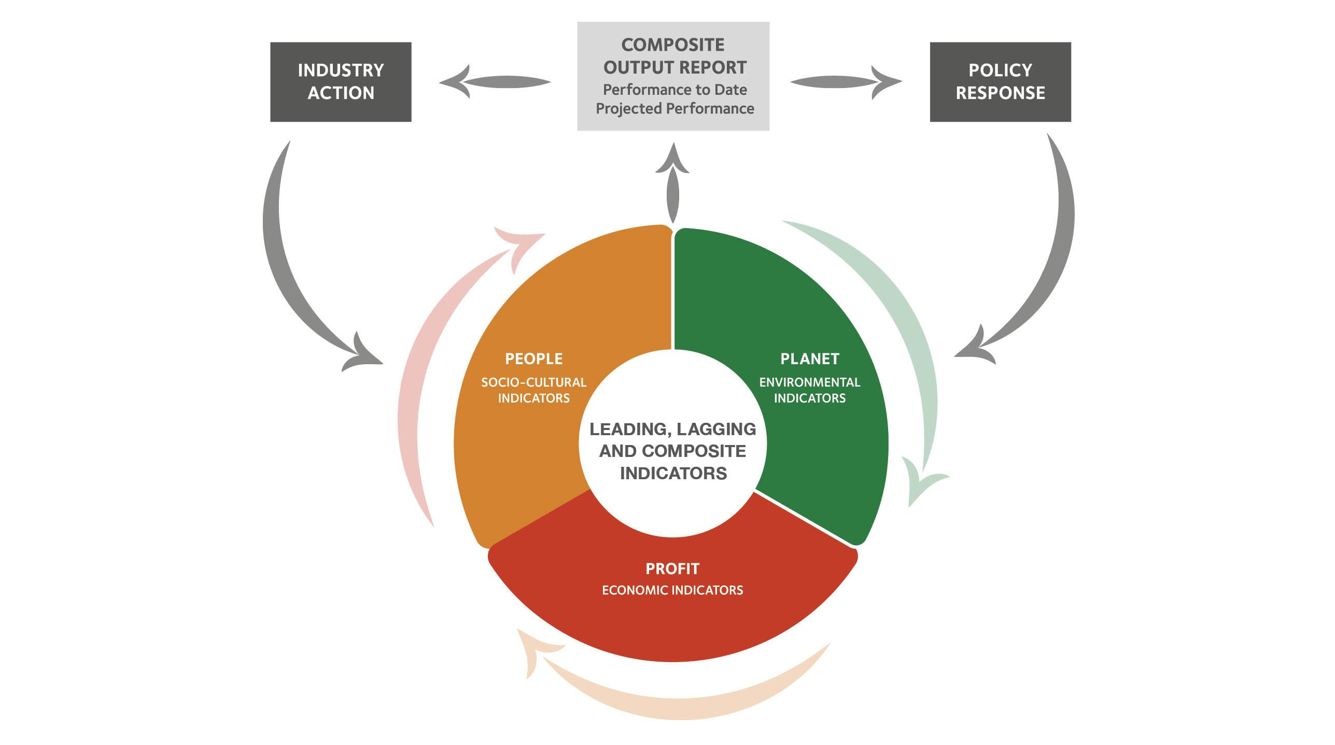

Other national and global developments related to climate change and general environmental awareness also point to an increasing focus on tourism-specific measurements. The UNWTO has produced a framework for Measuring the Sustainability of Tourism and Tourism for Sustainable Development Goals, both of which advocate for promoting tourism as a driving force towards economic growth, inclusive of development and environmental sustainability.

Several countries are broadening their focus to include at least some social and environmental indicators. For example, the [World Economic Forum](https://www.weforum.org/reports/travel-and-tourism-development-index-2021/explore-the-data) is developing a sustainability index; the European Commission has the [EU Tourism Dashboard](https://tourism-dashboard.ec.europa.eu/?lng=en&ctx=tourism); Portugal has the [Sustainable Tourism Indicator System (SITS)](https://travelbi.turismodeportugal.pt/en/sustainability/sustainability/); and New Zealand has the [Sustainable Tourism Explorer](https://teic.mbie.govt.nz/ste/) (Figure 5).

Figure 5. New Zealand’s Sustainable Tourism Explorer indicators main grouping

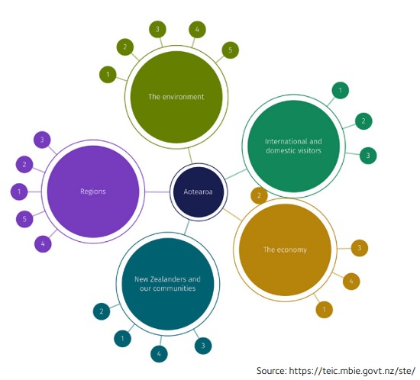

*Source:* [*https//teic.mbie.govt.nz/*](https://teic.mbie.govt.nz/)

[*Sustainable Tourism Indicator System (SITS),*](https://travelbi.turismodeportugal.pt/en/sustainability/sustainability/) *travelBI by Turismo de Portugal*

During Meeting 3, Griffith Institute for Tourism led the Working Group through a blue-sky session to gather insights and aspirations from members for the initial input to an Australian indicator framework. Members were divided into two work parties and input was sought on the philosophy of the indicator framework and scope and scale of the potential indicators. Priority areas and principles that should apply were also discussed. The groups discussed 2 visual representations of the indicators. The United Nations Sustainable Development Goals representation at Figure 6 received a high level of positive feedback. The Working Group further consolidated its preferences at Meeting 4.

Figure 6. Graphical representation of the UN Sustainable Development Goals

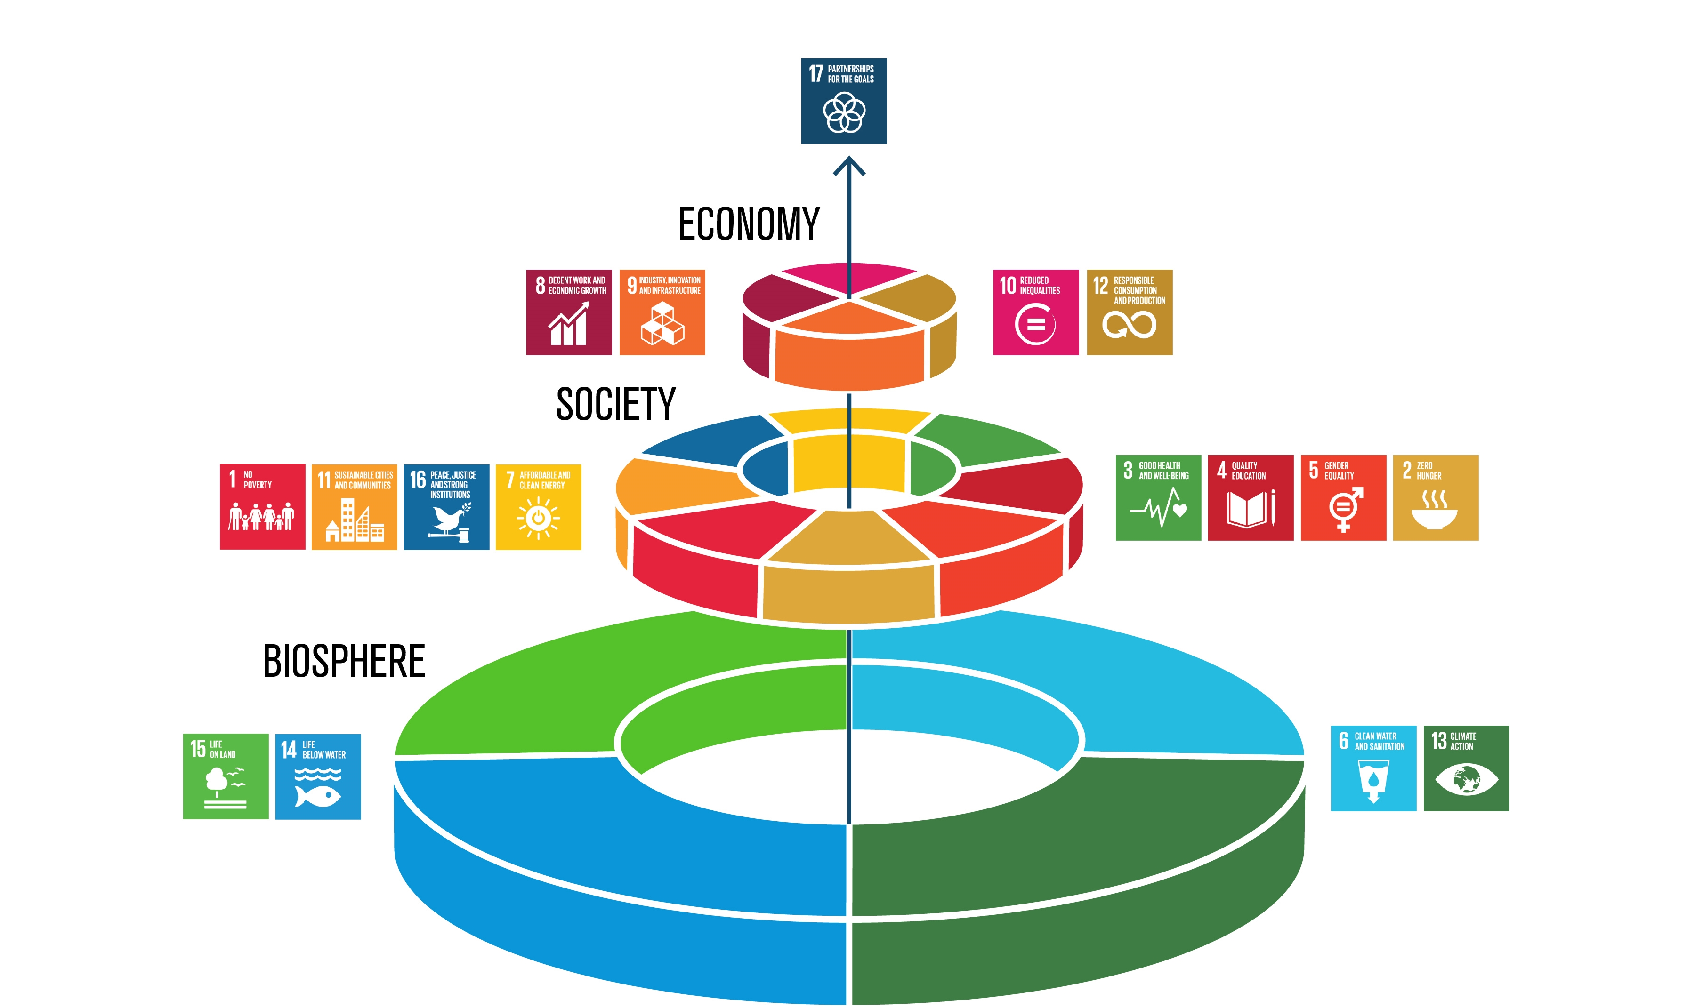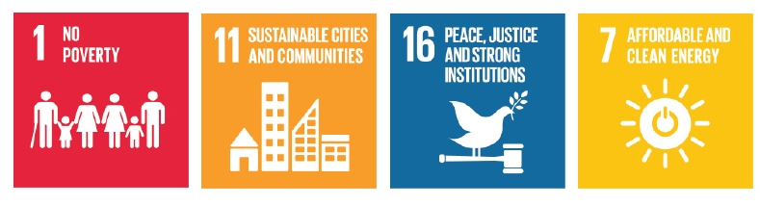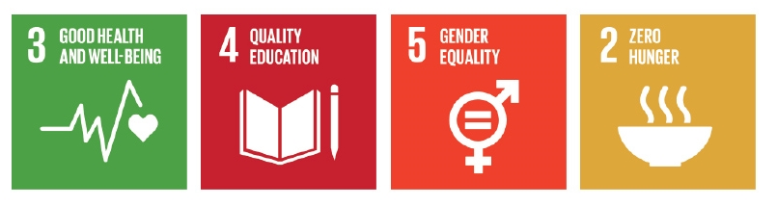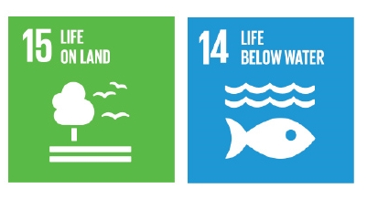

[*The SDGs wedding cake*](https://www.stockholmresilience.org/research/research-news/2016-06-14-how-food-connects-all-the-sdgs.html)*, Stockholm Resilience Centre*

Prior to meeting 5, a facilitation sub-committee (FSC) was formed to prepare and facilitate an in-person LIVE framework workshop to be held at the next meeting. The FSC was made up of IDEA Working Group members Adele Labine-Romain, Dr Grace Pan, Carol Giuseppi and Prof. Leo Jago, and was supported by Associate Prof. Sarah Gardiner and Prof. Susanne Becken from Griffith Institute for Tourism. The FSC asked Sarah Gardiner and her team to develop a preliminary list of indicators for measuring tourism that could be prioritised by the group. The indicators proposed by Griffith Institute for Tourism were categorised under the 3 pillars of economic, social and environmental. The FSC further refined the list and distributed it to Working Group members in the days prior to meeting 5 asking them to consider whether key indicators were missing.

At meeting 5, members revisited the Tourism 2020 indicators, targets and data sources and discussed the THRIVE 2030 targets, priorities, and success measures for context. The group was also presented a list of 9 key ‘tourism aspirations’ developed by Griffith Institute for Tourism and overseen by the FSC (Figure 7) and were asked to consider these when prioritising the preliminary indicators.

Figure 7. Key tourism aspirations (guided by Tourism 2020 and THRIVE 2030)

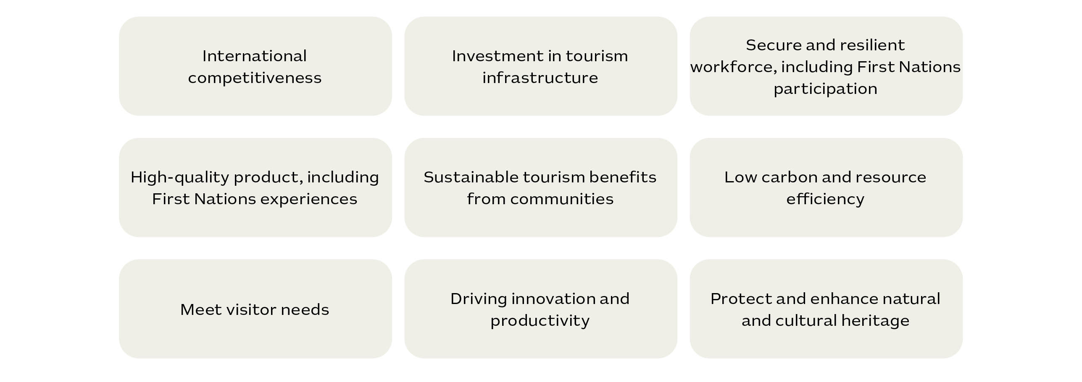

Within the context of the previous targets and proposed aspirations, the group discussed each of the indicators and ranked them in high, medium, or low priority groupings. Members also combined indicators and added new indicators during this process. Indicators were ranked separately under each of the 3 pillars: economic, social, and environmental. The full list of indicators and their rankings are at Attachment C.

The prioritised indicators were later developed into an initial conceptual framework: the final conceptual model is shown at Figure 8. Given its popularity among members, the United Nations Sustainable Goals framework was used as the foundation for the development of Figure 8.

At meeting 6, members discussed the conceptual framework and the number of indicators that should be presented as a guide for the implementation team. Members supported the visualisation, though improvements were recommended, and agreed that the complete list of over 70 indicators needed to be reduced to a manageable number for the development of a dashboard. There was consensus that there needed to be greater than 12 items (one of the options presented) to allow for innovation and adequate coverage of the 3 pillars.

Members noted that there would likely be two main uses of the data that forms the indicators. First, some data with regular monitoring could act like a lever for generating necessary change. For example, corrective actions could be taken where the indicators showed negative trends. The other use was for long-term monitoring and to raise awareness of changes. The final list of indicators is to be guided by the conceptual framework and prioritised list, but final selection will be made by a proposed Project Coordination Committee in consultation with stakeholders based on the availability of data to measure the indicators.

At meeting 7, there were further adjustments discussed for the indicator list and presentation of the conceptual LIVE framework, including the addition of a central foundation that included items connected to all 3 pillars, the group arrived at the below final product.

Figure 8. Conceptual LIVE framework



Project 2: International tourism data hubs

An international tourism data hubs research project was initiated in response to member survey feedback on data developments in competitor countries (an online survey was sent to members prior to meeting 1). The project, initiated after discussion at Meeting 2, explored tourism data hubs in OECD countries and identified that 30 countries had some form of tourism data or tourism insights access point, and 7 had no identifiable tourism data access point. Of the 30 countries with at least some form of tourism data access point, 5 were found to have more advanced models.

Griffith University was engaged to deliver the project. The project report included 9 matters to consider and 11 recommendations alongside a collection of data sources for further consideration.

Figure 9 shows the data metrics represented in the data hubs of other OECD countries and ranks them by most common and suggested areas for further consideration for Australia.

Figure 9. International tourism data hub metrics

Bar chart displaying Australia's current data sources: accommodation data; tourism flow; profile of key source markets; trip/traveller characteristics; tourism employment; and visitor expenditure. 
Outlines data sources for further consideration for Australia: movement; response to COVID; tourism attractions; business events; visitor satisfaction; sustainability indicators; tourism businesses; community connection; and benchmarking against competitors. 

*Source: Griffith University, Queensland Australia*

After the data hubs project was completed, business events data and sustainability indicators were discussed for inclusion in the LIVE framework. Other recommendations intended to be considered in the development of the LIVE indicator dashboard include focusing on usability (the user-friendliness of the tool); embracing the power of social media data; capturing real time insights and diversification of data sources; and identifying potential partners (government or commercial for potential data sources, data analytics and technology partners). A summary of the recommendations is below.

### International tourism data hubs recommendations

This review and analysis of existing tourism data hubs and data products delivered 11 recommendations in support of the IDEA Working Group efforts to develop the LIVE framework and, potentially, a tourism data hub for Australia.

1. Most countries focus on economic measures of tourism; however, some countries are broadening their focus to include environmental and social indicators (e.g., New Zealand and Portugal). This review also identified some new data sources (e.g., Austria is analysing TripAdvisor data to measure consumer perception of visitor experiences/ attractions and benchmarking experiences with each other; Spain is using mobile phone data to monitor tourist traffic origin and mobility).

2. Create a stand-alone data hub: Stand-alone data hubs that have unique names and locations are easier to find, separate from the national tourism or equivalent website.

3. Enable a single point of access: While some countries have multiple tourism data hubs, a single and streamlined initiative that centralises all different reporting and insights can assist in avoiding duplication of efforts.

4. Expand the reach and influence of tourism data: Tourism data hubs can host useful data products not only for tourism businesses but also for consumers, the general public and across government and tourism agencies.

5. Focus on usability: The user-friendliness of tourism data hubs is fundamental to their success. Straightforward data categorisation, interactive and collaborative dashboards as well as downloadable resources can create better experiences for users and the increase the value of the data hub.

6. Focus on sustainability: Sustainability appears to be a priority for countries and an area where data hubs can be particularly beneficial by centralising all relevant information in the various domains.

7. Diversification of data sources: There are increasing efforts by countries to increase and diversify data sources. These emerging trends should be considered.

8. Identify potential partners: Several data products are sourced through partnerships with government and/or commercial partnership. The IDEA Working Group should consider potential data sources, data analytics and technology partners in Australia and internationally that could support the potential planned data products and delivery of the data hub. Austria was the only country with a subscription-based service. All other countries investigated offer the tourism data products and hubs at no cost to users.

9. Embrace the power of social media data: Social media feeds can be used for real-time information. In addition, social media content can generate insightful knowledge about tourism markets, community/visitor sentiment, destinations, and attractions.

10. Capture real-time insights: Using live feeds can provide real-time information which is valuable for data users and can help inform government and businesses to effectively respond to live events.

11. Keep updated in this fast-evolving area: This review was conducted in early June 2022. Given the fast-evolving nature of data hubs, it would be valuable to undertake a follow-up analysis to assess how the landscape has developed, with a particular focus on countries that make announcements on updating their data hubs and the five countries identified in this report.

Project 3: Helix Personas

At Meetings 2, 3 and 4, the Working Group explored a potential method to add value to existing NVS data by integrating psychographic profiles with NVS data.

The NVS provides tangible estimates of the spend behaviour and other contemporary travel characteristics of Australian residents, in essence establishing demographic profile data for travellers. The Helix Personas psychographic marketing profiles are widely used through the media landscape and by key stakeholders and aim to unlock a deeper understanding of individual motivations and mindsets.

Helix Personas assign Australians to 54 different groups of people who share similar values, beliefs and attitudes, which are the best predictors of consumer behaviour.

The combination of NVS and Helix Personas is intended to interweave values, attitudes and actual travel behaviour in a way that is expected to allow product developers, marketers and investors to more readily segment consumers and more predictively identify consumer trends.

Helix will help with finding your audience and reaching and talking with this audience. It will help to understand which media channels to use and the messaging to increase effectiveness of marketing.

The project aims to make more market-ready industry information available to governments, businesses, tourism representative bodies and researchers.

There are a total of 54 profiles (or mindsets) in the range of Helix Personas: the high-level grouping is shown in Figure 10, with the full list and descriptions available in RMR’s [Helix personas booklet](https://roymorgan-cms-dev.s3.ap-southeast-2.amazonaws.com/wp-content/uploads/2022/08/30042139/Helix-Personas-Booklet.pdf).

Figure 10. Helix Personas high-level groupings

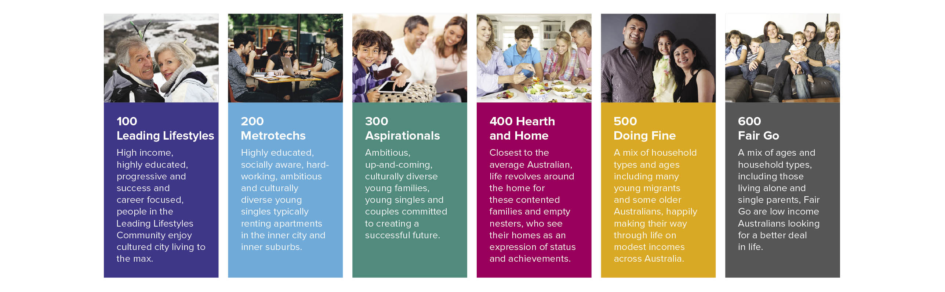

*Provided by Roy Morgan Research*

TRA committed to initiate the project to integrate the Helix Personas with the NVS data and reported back to Working Group members on initial outputs at meeting 6.

At meeting 6, TRA updated members noting that the combined dataset was with state and territory stakeholders for review and testing.

TRA noted it was open to including other information sources to datasets in future, to increase the power of data overall. For example, TRA is open to the idea of including a set of personas to the international visitor dataset or a different set of personas to the domestic visitor dataset.

Project 4: AFL Grand Final, Brisbane

CommBank iQ were engaged to demonstrate their capacity to apply data science to large financial datasets to produce a granular representation of segments of the visitor economy. The practical project selected for this demonstration was to identify visitor economy measurements related to the AFL Grand Final hosted in Brisbane in 2020.

The project concept was initially discussed at Meeting 1, while the more detailed methodology was presented in Meeting 2 and the project outcomes in Meeting 3. The project was able to identify transactions from 14,800 of the roughly 29,000 game attendees and from an additional 17,500 individuals who had visited the precinct around the game venue on the day (note that the transaction data used contained no private information).

The project report showed that around 15% of game attendees were interstate travellers, and 35% were intrastate overnight travellers. It also highlighted a total uplift in consumer expenditure and displayed the potential to use the data to determine categories of visitors (e.g., families; double income no kids; older singles and couples). Figure 11 is an example of the project’s outputs.

Figure 11. Example outcome from Project 4

Example outcome from project 4. It identified 56% of Game Attendees were visitors from interstate and intrastate, while Precinct Patron visitors represented normal visitor traffic in the Precinct area. The left pie chart outlines 44% of game attendees were local; 15% interstate overnight; 6% intrastate daytrip; 35% intrastate overnight. 
The right pie chart outlines 82% of precinct patrons were local; 4% interstate overnight; 4% intrastate daytrip; 10% intrastate overnight.

TRA Project 1: Mobility data solution

At Meeting 1, TRA presented to the Working Group a high-level concept related to the potential for mobility data (combined telecommunications GPS and apps data) to measure population movement. This concept was more deeply explored in Meeting 4, when DSpark, a data analytics firm primarily focused on mobile phone network data, presented to the Working Group together with TRA.

DSpark has been engaged with TRA for 2 years to develop mobile phone network movement data for use in tourism. This data is showing potential for use in domestic tourism statistics with both overnight and day trips now showing alignment with NVS definitions.

Two benefits of the data are that tourism estimates could be provided at a more granular level and could be available in as little as 5 days after the reference period. TRA explained that there is potential for the DSpark data outputs to complement national surveys to improve official statistics, and for event measurement and information on overnight trip travel paths and daytrips.

Challenges were highlighted in relation to the measurement of international travel and further detailed investigation is required in this segment of the visitor economy.

TRA Project 2: Business events data

The international tourism data hubs project (project 2) identified that Australia may benefit from further development and use of business events data. At meeting 6, members were informed that TRA had initiated a project to develop the collection of business events information. The business events section of the IVS and NVS had been refined and expanded to include additional questions in consultation with AACB and BECA. This included refining and broadening the measurement of business event travellers and collecting information on the travel party accompanying the traveller, duration at the event and expenditure relating to the travel.

Collection commenced on 2 January 2023 in both the NVS and IVS, and one year of data capture will be available in April 2024. The end goal is for TRA to combine the survey data with further information collected from event venues and delegates to model business events estimates and publish results on the TRA website.

Attachment C:  
Prioritised indicators

A preliminary set of potential indicators was developed by the Griffith Institute for Tourism and IDEA Working Group members. The IDEA Working Group members prioritised the indicators as shown below. Items included in the conceptual LIVE framework have been highlighted in bald.

Economic indicators

| **Priority** | **Indicator** |
| --- | --- |
| **High** | **Aviation route capacity (seats available, movements)** |
| Airports beyond gateways |
| **Number of visitors total** |
| **Number of visitors by segment (by visa type, purpose, source market, etc.)** |
| **Forward visitor demand – Forward bookings and searches, consumer awareness, consideration and intention to visit, and lead time for destination choice and booking** |
| **Average length of stay/yield, per trip and per stay** |
| **Spatial movement of visitors (dispersal and mobility)** |
| **Visitor expenditure total and regional (domestic/international and daytrip/overnight)** |
| **Visitor expenditure from events (sporting, cultural and business events)** |
| Distribution of yield: geography, seasonality |
| **Gross domestic product (%) / gross value added** |
| Share of global tourism expenditure (competitiveness) |
| **Number of people employed in the visitor economy, FT/PT, quality of jobs** |
| Labour productivity |
| Capital productivity |
| Global position |
| **Medium** | Skills and training level of the visitor economy workforce |
| Number of tourism, hospitality and event graduates (total and by level of qualification) |
| Percentage of women in visitor economy workforce (and level of occupation) |
| Other job vacancies, domestic prep, tracking |
| Number of visitor economy businesses (by size) |
| Visitor economy business entries and exits |
| First Nations participation in the visitor economy workforce |
| **Public and/or private sector visitor economy investment tracking/pipeline (infrastructure)** |
| Investment and innovation in new visitor economy experiences and products (including First Nations) |
| Available inventory / visitor demand |
| Accommodation establishments and rooms (including mainstream and sharing economy) |
| **Accommodation rates for mainstream (incl. average daily room rate (ADRR), revenue per available room (RevPAR)) and average length of stay (ALOS)** |
| Tourism transport mix |
| **Low** | Visitors seeking health and medical assistance |
| Cruise ports (ship visits, mobility mapping, disembarkment of visitors) |
| Government and industry collaboration to deliver THRIVE 2030 |
| Open data |
| Business event data gap — convention centre occupancy |
| Data security, privacy |
| Innovation (e.g. start-up activity) |

Social indicators

|  |  |
| --- | --- |
| **Priority** | **Indicator** |
| **High** | **Visitor sentiment (quality of experience)** |
| **Community sentiment (social licence) (engagement)** |
| Quality of life (residence) |
| Community support for tourism (includes events and extends to infrastructure) |
| **Number of visitor nights in a regional tourism region (international and domestic)** |
| **Indigenous owned businesses** |
| Cultural heritage protection (tangible and intangible) |
| **Capacity limits / demand management / visitor contribution to life in Australia** |
| Accessibility for people with disabilities (number and type of offering) |
| Diversity of tourism organisation boards (age, gender, ethnicity, etc.) |
| **Medium** | **Dispersal / spread of visitors** |
| **Low** | Homelessness in the destination |
| Crime against visitors |
| Crime by visitors |
| Percentage of women as CEO of tourism organisations |
| Staff wellbeing (relates to retention) |

Environmental indicators

|  |  |
| --- | --- |
| **Priority** | **Indicator** |
| **High** | **Competitiveness of sustainable destination status (potentially use the World Economic Forum as a benchmark)** |
| Visitor perception around environmental status of destination |
| Tourism $ contribution to nature conservation |
| Investment into protected areas and increases in infrastructure and park maintenance budgets |
| **Greenhouse gas emissions (total / per visitor / per dollar)** |
| Energy consumption per visitor |
| Water consumption per visitor |
| Digital environmental considerations |
| Commitments by businesses or states regarding carbon reduction targets |
| **Certified businesses/destinations (e.g., carbon action)** |
| Business adoption of sustainable quality control tools and accreditation |
| **Visitor economy workforce trained in sustainability** |
| **Medium** | Consumer sentiment towards nature conservation |
| **Electric vehicle infrastructure** |
| Pipeline of green technology and infrastructure |
| Volume of sustainable aviation fuel in the pipeline (production) / (% new aircraft) |
| Visitor participation in nature-based experiences |
| Visitor contribution to regenerative activities |
| Indigenous perspective – caring for country |
| Consumer willingness to pay (for nature-based experiences and sustainability initiatives) |
| **Low** | Industry resilience (risk management, insurance and contingency plan readiness) |
| Insurance – share underinsured |
| Recovery time from a disaster event |
| Percentage of food sourced locally (within Australia and the local area) |

Institutional/governance indicators

|  |
| --- |
| **Indicator** |
| Competitive digital capability |
| Innovation |
| Resilience – risk and contingency plans |
| National policy settings (e.g. THRIVE 2030) |

1. IDEA Working Group terms of reference, <https://www.austrade.gov.au/content/dam/austrade-assets/global/wip/austrade/documents/industry-data-and-expert-analysis-working-group-terms-of-reference-2022.docx>