

Trade Identity Policy Framework

**2024**

**Contents**

Introduction 3

Scope 4

Current issues 7

Opportunities for improvement 9

Vision and principles 11

Governance 14

Appendix A – Definitions 15

# Introduction

The Simplified Trade System (STS) mandate is to simplify Australia’s cross-border trade regulations. As part of this, Government identified reforms to the way individual traders and trading businesses are identified that would improve the trader experience and enhance border protection. This framework is built upon, and leverages, whole-of-government identity and digital identity policies and sets a policy foundation for future trade identity reforms.

The Australian Government, through the STS reforms, is committed to delivering a simpler cross- border trade environment for Australia that improves the trader experience while strengthening border, biosecurity, and community protection outcomes. Correctly identifying businesses and individuals involved in cross-border trade is fundamental to delivering personalised and streamlined services, facilitating legitimate trade and protecting Australia’s borders.

The existing, fragmented approach to trade identity management, is struggling with a trade environment experiencing increasing volumes and a rapidly changing risk environment. This challenge is noted in the *UN Centre for Trade Facilitation and Electronic Business Report1* which explains:



*“With border authorities only able to inspect around 1% of around 1 billion sea containers and a much smaller proportion of 100 billion parcel shipments per year, the challenge of managing border risk against illicit goods and biosecurity threats has never been greater. Nations that can leverage high integrity data about import consignments can both increase seizures and facilitate legitimate imports”.*

**UN Centre for Trade Facilitation and Electronic Business Report**

Other challenges include: duplicate or inconsistent identities across siloed systems, multiple logins required across various parts of the trader journey and a fragmented view of a trader’s history. This costs trade participants time and money and reduces the ability of regulators to secure Australia’s border.

Being able to leverage identity-based data and better integrate and harmonise identity processes and solutions across agencies will be a critical step in overcoming these challenges.

The development of this trade identity policy framework sits within an ever-shifting regulatory, technology and geo-political environment. A single trade transaction involves a complex web of Australian and foreign individuals, businesses, and intermediaries with some accessing government

1 UN/CEFACT, 2022, WhitePaper_VerifiableCredentials-CBT.pdf (unece.org)

trade systems directly, while others are responsible for storing and transporting goods before, at, or after the border.

## Identity strategies, policies and legislation are emerging at the national level

The Australian, state and territory governments have agreed on a nationally consistent and coordinated approach to identity management, which is set out in the [National Strategy for Identity](https://www.ag.gov.au/national-security/publications/national-strategy-identity-resilience) [Resilience.](https://www.ag.gov.au/national-security/publications/national-strategy-identity-resilience) Key aims of the Strategy are to make it harder to steal identities, promote interoperability between the systems used in different jurisdictions and ensure inclusion of vulnerable groups.

In February 2024, Commonwealth Government and state and territory ministers agreed to update the 2016 National Identity Proofing Guidelines*,* an immediate initiative under the 2023 National Strategy for Identity Resilience.

In November 2023, the Australian Government introduced the [Digital ID Bill 2023](https://www.digitalidentity.gov.au/legislation) to Parliament, to provide a legislative basis for individuals to have a secure, convenient, voluntary and inclusive way to verify their identity for use in online transactions with governments and businesses. This legislation will be a significant driver in the design and development of trade identity processes and solutions in the future and is likely to come into effect as the Digital ID Act later in 2024. The Australian Government’s own whole-of-government (WofG) digital identity service, myGovID, is increasingly the way individuals and businesses are accessing Australian government services. However, Government must manage identity information carefully in order to retain the confidence of individuals and businesses accessing government services.

In the last few years, state and territory governments have also developed strategies, policies, and standards to support identity management and digital service delivery. This was accelerated in response to COVID-19 with many jurisdictions developing their own identity and digital identity services. The new federal Digital ID Act, 2024 will set the framework to allow in the future more state and territory identity services, as well as private services, to be used to access Australian government services and vice versa.

## International initiatives, standards and model laws have emerged which can support mutual recognition and interoperability

Multilateral organisations such as the World Trade Organisation, OECD, G20/B20, APEC, and the UN are all engaged in work programs to facilitate trade through enhanced identity and digital identity standards and policies. The United Nations Commission on Trade Law (UNCITRAL) *Model Law on the Use and Cross-border Recognition of Identity Management and Trust Services 2022* (MLIT) is one such example that sets an international framework within which jurisdictions can recognise each other’s identity processes and credentials. Australia has an opportunity to contribute to, and leverage, the work of these multilateral organisations.

Additionally, Australia’s trading partners continue to reform cross-border trade processes apace with Singapore, New Zealand, South Korea, the EU, the US, and others investing in trade systems and processes to drive down costs for trade participants and government. Australia needs to do likewise to ensure our international competitiveness.

While the current state of identity management in Australia is facilitating trade and ensuring regulatory compliance, it is not as effective or efficient as it could be. Additionally, current Australian approaches

to identity do not address all the unique needs of the trade environment, such as the identification of overseas trade participants. This Framework, therefore, focuses on trade-specific identity needs, while also aligning with WofG and international identity best practice.

This Framework was co-designed by the Simplified Trade System Implementation Taskforce (STS Taskforce), Australian Border Force (ABF) and the Department of Agriculture, Fisheries and Forestry (DAFF), with input from the Digital Transformation Agency (DTA), Australian Taxation Office (ATO), Department of Finance, and Attorney General’s Department. It was informed by research and consultation with business, and federal, state and territory government officials.”

**Purpose**

The purpose of the Framework is to set a policy foundation for ongoing identity reforms across the trade domain that facilitate legitimate trade, better manage risk at the border and move from a transaction-based identification model to one that identifies entities at their first interaction with government and is enduring across subsequent interactions.

For business, the Framework will support trade-identity approaches that:

* ensure a more consistent, personalised, connected, and streamlined user experience
* reduce the need for representatives of businesses to prove who they are multiple times
* enhance service delivery, privacy, and security.

For trade regulators, the Framework will support trade identity approaches that:

* support more targeted interventions
* support compliance activities and enhance government approaches to risks
* assist to mitigate illicit and fraudulent activity across the supply chain
* ensure greater traceability and connectivity of trade participants and their transactions
* uplifts identity information integrity across the trade domain.

For the economy, the Framework will:

* establish a foundation for future trade modernisation initiatives involving trade identity
* support national and international interoperability and mutual recognition in trade identity
* advocate for WofG identity reforms that are fit for purpose in the trade domain.

This Framework defines a vision for trade identity, as well as guiding principles for cross-border trade agencies designing and developing identity requirements and solutions as part of the STS reforms. It will also help relevant state, territory, and international governments, as well as trade participants needing to understand the future direction of reforms in trade identity.

# Scope

This Framework covers **‘trade identity’**, which is broader than digital identity. It extends beyond just the system access needs of those engaging directly with government systems, to include identity information of those interacting with government across the supply chain. This trade identity information is necessary to support service delivery, trade facilitation, risk mitigation, regulatory compliance, and enforcement activities.

For the purpose of this Framework, entities can include both individuals and businesses they represent. The diagram below categorises key entities in cross-border trade.

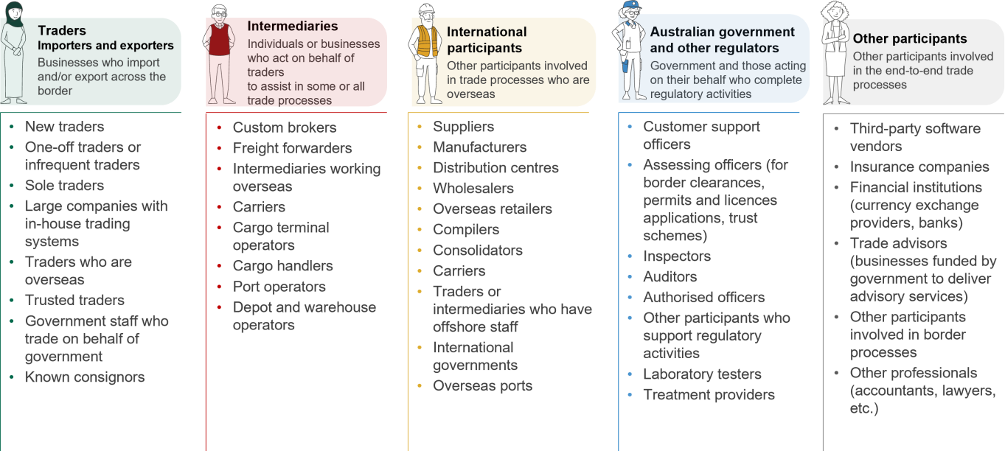

This Framework is focused on trade-specific identity needs built on the foundations of WofG identity and digital identity policy. The Framework will interact with trade-specific trust frameworks such as the Cross-Border Trade Data Sharing Framework, Fit and Proper Persons (FPP) Policy Framework, and accredited client programs that provide greater assurance and provenance of participating entities.

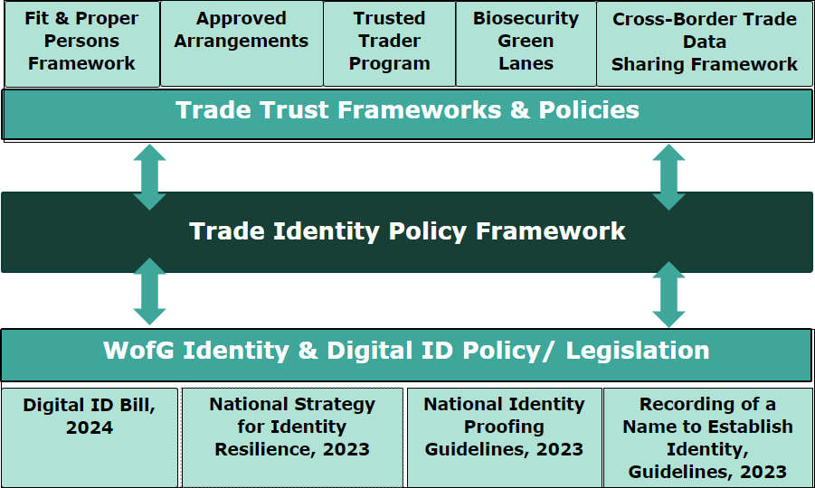

Illustrative only, not designed to be a comprehensive list of all relevant polices or programs the Framework will interact with.

This Framework operates within existing legislation, including the *Privacy Act 1988, Customs Act 1901, Export Control Act 2020, Australian Border Force Act 2015,* and *Biosecurity Act 2015.* This Framework does not override legislation*.*

### Not in scope for this Framework are:

* passenger or traveller identities
* identification of goods, consignments, places, or things (for example, vessels or ports)
* specific regulatory or legislative changes
* design of specific technical solutions
* in-depth analysis of the identity processes for each type of trade transaction.

# Current issues

Consultation with businesses, trade agencies, and regulators has identified the following issues with the current process of identifying those involved in cross-border trade.

## Issues for business

|  |
| --- |
| **Duplication of effort**  Current identity processes regularly rely on manual checks for individual transactions. This means a trader may be requested to submit the same information multiple times at varying levels of detail to access different government trade services. As each check is conducted at the transaction level, previously provided information is not used effectively.  For example, in industry consultation conducted in 2023, Australia Post said: “*Current trade-related processes require businesses to submit identity information to the government multiple times. This is duplicative, expensive and time consuming.”* |
| **Complex relationships**  An intermediary may work on behalf of multiple businesses, requiring them to access government systems with unique authorisations to conduct their role. However, current government systems and processes are not yet sophisticated or flexible enough to handle these various authorisation requirements, making it difficult for intermediaries to efficiently conduct their business.  For example, current WofG authorisation services (like the ATO’s Relationship Authorisation Manager) provide one level of authorisation enabling the identification of an entity acting on behalf of a second  entity, but many trade transactions are more complex. |

|  |
| --- |
| **Privacy and security concerns**  Trade participants have concerns about how their personal and business information is managed by government. Due to these privacy and security concerns, some trade participants are hesitant about digital identity solutions being used to access government trade systems.  For example, the government’s myGovID is used for both business and personal interactions with government, prompting scheduled future updates to the service to address this concern. |
| **Alternative pathways**  Current identity processes do not meet the needs of the full range of cross- border trade participants. Convenient alternate pathways are not always available to international participants and those who may not have access to, or prefer not to access, digital pathways.  For example, overseas participants that need to be identified for Australian government trade compliance purposes are unable to use existing WofG digital identity solutions, meaning manual, paper-based and bespoke  processes are required. |



## Issues for government agencies



|  |
| --- |
| **Inconsistent data and verification**  Agencies are reliant on the quality of identity information they receive from trade participants. The current lack of data standardisation makes it challenging to verify the identity of trade participants and can result in manual and time-consuming identity verification processes. Low assurance in the validity of identity information provided by trade participants can make it difficult to gain a comprehensive view of cross-border trade risks.  Additionally, current manual processes can increase supply chain vulnerabilities by creating opportunities for trade participants to provide false or misleading information.  For example, the Integrated Cargo System accepts identity data in free-text fields, meaning the risk of a single entity having duplicate entries is high. |
| **Limited visibility of identity across the supply chain**  There are currently limitations in sharing data, including identity information, between government agencies. This makes it difficult for regulators to have visibility of a trade participant’s activities across the supply chain. It can result in regulators not always having the information they need to make informed risk assessments.  For example, when a company declares bankruptcy to avoid the payment of owed-government revenue and then creates a new trading entity, unlinked |

|  |
| --- |
| or unshared identity data means ‘malicious’ actors are more difficult to identify. |
| **Complex accountabilities**  One of the most complex areas of trade identity lies in the number of entities involved in a transaction. Accountability for goods can shift depending on stage of the supply chain. The identity of entities who have custody or access to goods that remain subject to border controls needs to be precise for regulators to effectively manage and address risks.  For example, identifying individuals behind machine-to-machine transactions is challenging and identification of transport or warehouse workers is not always required, despite their access to goods. |
| **Out of date systems**  Many trade identity processes rely on legacy trade systems and data standards that are no longer fit-for-purpose. An ICT Scoping Study conducted by the STS Taskforce in 2022 revealed that over 50% of key IT systems that support trade are over 15 years old. Additionally, many key systems capture unstructured and unlinked data, use outdated authentication methods, have limited interoperability, and are nearing capacity limits.  In industry consultation in 2023, the Freight & Trade Alliance and Australian Peak Shippers Association noted: *“we see a need to move away from Digital Certificates mandated for the use of the Australian Border Force (ABF) Integrated Cargo System (ICS) to standardise identification and the digital agreement of terms and conditions in line with other government departments. This appears to be dated (and expensive) technology, first*  *introduced in 2004 as a part of the exports phase of the ICS…”* |



# Opportunities for improvement

Correctly identifying businesses and individuals involved in cross-border trade is fundamental to delivering personalised and streamlined services, facilitating legitimate trade and protecting Australia’s border.

A more effective identity approach for **businesses and individuals** needs:

* A single way to access government trade services, removing the need to maintain multiple government trade accounts.
* A simple and secure way to verify their identity and provide identity information one time only, providing a seamless experience.
* Robust systems giving trade participants confidence that their identity data is managed securely and that strong privacy controls are in place.
* Manual and offline alternatives for individuals who cannot or do not use a digital identity.
* Options to access services and support when and how they need it.

For **government agencies** it needs:

* Greater assurance that entities accessing trade systems are who they say they are.
* Provision of high-integrity identity information to support regulator service delivery, trade facilitation and compliance activities.
* A single and connected view of trade participants interacting with trade systems, as well as their linkages to other entities in the supply chain interacting with the goods being traded.
* Efficient and timely access to relevant government systems to reduce duplicative processes such as having to sign into multiple trade systems multiple times to undertake regulator activities.

# Vision and principles

The trade identity vision is aligned with the broader STS vision to **create a simpler cross-border trade environment for Australia**.

## Vision

*Trade identity processes and solutions are* ***convenient,*** *accessible, and easy to use with trade participants only needing to prove their identity to government once.*

*These identity processes and solutions are* ***optimised*** *to facilitate legitimate trade, protect Australia’s borders, and are fit for the unique needs of a cross-border trade environment. They are* ***proportionate*** *and scaled to the variables that influence risk, to reduce the burden on trade participants.*

*Harmonised and streamlined identity processes and solutions across government enable a more* ***connected*** *view of trade participants. This drives both business and regulator benefits through a better understanding of entity relationships and their connections to goods, transactions, and consignments across the supply chain and reduces the need for businesses to provide information multiple times.*

*A whole-of-trade approach to identity management ensures trade participant data is* ***secure*** *and protected through security and privacy controls.*

*All trade participants requiring a trade identity, credential, or accreditation can apply for this, through a common and consistent process to support* ***inclusive*** *trade.*

*Digital and non-digital pathways are available to access government trade services, ensuring that it is*

***voluntary*** *for individuals to access government services via a digital identity.*

*Identity policies and solutions are designed to be integrated and* ***interoperable*** *across multiple platforms, services, industry and trading partners, supporting mutual recognition and improved border efficiencies.*

## Principles

The following principles provide guidance for the development of policies, processes and systems that achieve the future trade identity vision. The principles have been informed and are aligned with WofG identity principles but have been framed within a cross-border trade context. In addressing the identified issues, the Framework principles balance protecting Australia’s borders with facilitating legitimate trade.

**Convenient** - *Trade identity processes and solutions are* ***convenient,*** *accessible, and easy to use. Participants only need to ‘tell us once’ their identity information.*

* Trade identity processes and solutions will be designed to be simple, easy, and intuitive.
* Individuals will be able to choose to set up and use a digital identity to access trade services.
* Trade participants will be able to navigate seamlessly across agency services without re-entering or providing their details multiple times.
* Trade identity processes and solutions will enable the delivery of a more personalised service and holistic view of a participant’s trade transactions for both business and government.

**Related current state issues:** Duplication of effort.

…

**Secure** - *A whole-of-trade approach to identity management ensures trade participants’ data is*

***secure*** *and protected through security and privacy controls.*

* Trade identity solutions and processes will ensure participants’ data is transmitted, shared, stored, used, and disposed of lawfully and securely.
* Sharing and storage of participant data will only take place where legally permissible.
* Best practice cyber security protocols will be implemented to enhance system integrity and mitigate cyber risks.

**Related current state issues:** Privacy and security concerns.

…

**Inclusive** – *All trade participants requiring a trade identity, credential, or accreditation can apply for this through a common and consistent process to support* ***inclusive*** *trade.*

* Trade identity policies, processes and solutions adequately consider accessibility and digital literacy to remain inclusive of all trade participants.
* There is adequate training and support for all trade participants during the rollout of future identity solutions.
* Trade identity processes and solutions will be affordable and not cost-restrictive.

**Related current state issues:** Privacy and security concerns, alternative pathways.

…

**Voluntary** – *Digital and non-digital identity pathways will be available to access government trade services.*

* Identity information can be provided through a variety of means, both digital and non-digital.
* Alternative ways to verify identity must not result in a substantially less favourable service.
* Clear and consistent information will be available on how trade participants’ information will be used.
* Where not restricted by regulatory requirements, trade participants will have authority and visibility over their data.

**Related current state issues:** Alternative pathways

…

**Optimised -** *Trade identity requirements, policies and processes are* ***optimised*** *to facilitate legitimate trade, protect Australia’s borders, and are fit for the unique needs of a cross-border trade environment.*

* Decisions on trade identity policies, processes and solutions will consider potential value to businesses and individuals, including opportunities to reduce duplication and provide improved trade services, while also protecting the Australian border.

**Related current state issues:** Out of date systems, duplication of effort.

…

**Proportionate -** *A whole-of-trade approach to identity processes and solutions considers the complexity and nuance of the cross-border trade environment, the different variables that influence risk, and* ***appropriately scale*** *the level of identity information required from entities.*

* Decisions on trade identity policies, processes and solutions will consider the facilitation of legitimate trade and scale according to trade risks.
* Trade identity information and required levels of assurance will be proportionate to an entity's access requirements, responsibility, and risk profile.
  + Agencies will conduct their own risk assessments but should aim for consistency of approaches, where practical.
* Whole-of-trade approaches and solutions involving the collection and use of identity information will account for the complex and changing trade environment and be flexible enough to adapt with it.

**Related current state issues:** Complex accountabilities, inconsistent data and verification, alternative pathways.

…

**Connected** – *Harmonised and streamlined WofG trade identity processes and solutions enable a more* ***connected*** *view of trade participants, including their entity relationships, relationship to goods and consignments, and trade transactions, across the cross-border trade environment.*

* Trade identity information will be captured and linked across the trade environment to provide a comprehensive view of an entity and their connections across trade.
* Trade identity information will be collected to establish a record of a trade participant at the first interaction, or when they are referred to in an interaction, streamlining identity processes and reducing duplicative records across trade regulators.
* Identity policies, processes and solutions will recognise and take account of the complex relationships between entities in the supply chain to ensure a more holistic and connected view of the trade participant.

**Related current state issues:** Complex relationships, limited visibility of identity across the supply chain.

…

**Interoperable** - *Identity processes, policies and solutions are designed to be integrated and* ***interoperable*** *across multiple platforms, services, governments, industry and trading partners, supporting mutual recognition and improved border efficiencies.*

* Identity policies, processes and solutions will be designed and developed for interoperability, and in alignment with the Australian Government’s Digital ID Act, 2024.
* The collection, authentication and use of identity information will be lawful, and where possible, align with international standards to facilitate interoperability and easier information sharing with business, state and territory governments, and international partners.
* Identity processes, policies and solutions will be interoperable, and where possible aligned to international standards and best practices.

**Related current state issues:** Out of date systems, limited visibility of identity across the supply chain.

…

# Governance

The STS Unit will oversee governance of the Framework through STS governance arrangements, including implementation, reviews, and consultation. The Framework will be made externally available on relevant agency websites.

Industry and trade businesses will be consulted where material changes occur.

# Appendix A – Definitions

Within this Framework, the following definitions apply:

* **‘Identity’** is the attributes and information that can be bound to an entity that allows the entity to be sufficiently distinguished within a cross-border trade particular context.
* **‘Trade identity’** is identity information that supports the service delivery, trade facilitation, regulatory compliance and enforcement actions and risk mitigation activities of trade regulators in cross-border trade.
* **‘Digital identity’** describes a distinct electronic representation of an entity enabling access to online trade services.
* **‘Entity’** describes an individual, business or organisation possessing separate and distinct legal rights. In the context of this Framework an ‘entity’ is synonymous with ‘participant.’
* **‘Participant’** describes the range of trade actors across the supply chain participating in a cross-border trade transaction. This includes individuals, as well as individuals acting on behalf of another entity in a professional or business capacity, as well as businesses and other entities that may or may not directly engage with government.
* **‘Individual’** describes someone acting as a private citizen.